Index

|  |  |  |  |
| --- | --- | --- | --- |
| S. No | Name | Date | Sign |
|  | Installation | 12/10/22 |  |
|  | Basic Commands to start with MySql | 12/10/22 |  |
|  | To create & describe table | 12/10/22 |  |
|  | Write sql command for implementing alter and drop | 12/10/22 |  |
|  |  |  |  |
|  |  |  |  |
|  |  |  |  |

Program 1

Q: Basic Commands to start with MySql

1. Show databases

**Command:** show databases;

**Output:**

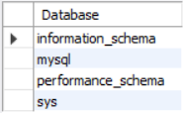

1. Use mydb

**Command:** use mysql;

**Output:**



1. Create database mydb

**Command:** create database mydb;

**Output:**



1. Show tables

**Command:** show tables;

**Output:**

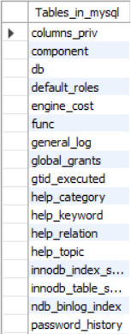

1. Select database()

**Command:** select database();

**Output:**



**Command:**

**Output:**

Program 2

Q: To create & describe table

1) **Command:**

create table student

(

Student int;

Fname varchar(20);

Lname varchar(20);

Marks int;

)

**Output:**



2) **Command:**

desc student;

**Output:**

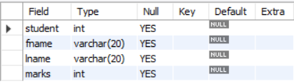

Program 3

Q: Write sql command for implementing alter and drop

1)

**Command: alter table student rename to student123;**

**Output:**

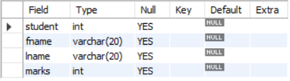

**Command:** **alter table student123 rename column fname to firstname;**

**Output:**

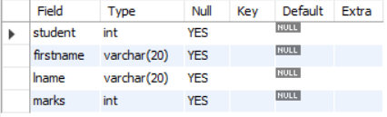

**Command:** **alter table student123 add grade char(1);**

**Output:**

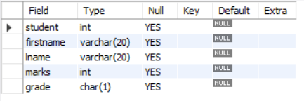

**Command:** **alter table student123 modify grade varchar(20);**

**Output:**

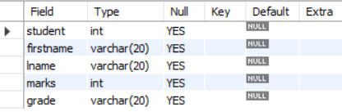

**Command:** **alter table student123 drop column lname;**

**Output:**

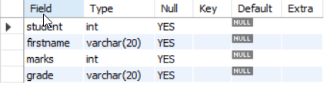

**Command:** **create table copy_st as select * from student123;**

**Output:**

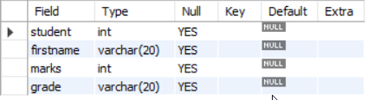

**Command:** **drop table student123;**

**Output:**



Program 2

Q:

Program 2

Q:

Program 2

Q: