PROGRAMMING QUESTION OF WEB TECHNOLOGY-

Ques-4- Create a HTML webpage which displays the following That is, different courses available in

your institute with their subjects. Show the use of Ordered and Unordered list.

Program:

<html>

<head>

<title>assignment question 4</title> </head>

<marquee ><b>DELHI SKILL AND ENTREPRENEURSHIP UNIVERSITY</b></marquee>

<body style="margin:0; padding-top:0;">

<h1><b>COURSES</b></h1>

<pre> <ol type="1">

<li> <b>BBA</b></li>

<p>Bachelor of Business Administration or BBA is one of the most popular bachelor's degrees.<br>

This degree course is about the management of a business, company or organisation. <br>

You are taught skills and in-depth knowledge of the business world, and all the intricate aspects of running a business.</p><br>

<ol type="A">

<li><b>Subjects</li></b>

<ul type="disc">

<li>ITB</li>

<li>Computer Applications</li>

<li>Financial Accounting</li>

<li>E-commerce</li></ul>

<li><b>Eligibility criteria</li></b>

<P>Bachelor of Business Administration or BBA is one of the most popular bachelor's degrees.<br>

This degree course is about the management of a business, company or organisation.<br>

You are taught skills and in-depth knowledge of the business world, and all the intricate aspects of running a business.<br></p>

</ol>

<li><b>BCA</li></b>

<p>The full form of BCA is bachelor's in Computer Application. <br>

BCA is a 3-year undergraduate degree programme that focusses on knowledge on the basics of computer application and software development.<br>

A BCA degree is considered to be at par with a BTech/BE degree in Computer Science or Information Technology.<br> <ol type="A" start="3">

<li><b>Subjects</li></b>

<ul type="disc">

<li>C++</li>

<li>Computer Applications</li>

<li>java</li>

<li>Computer Networks </li></ul>

<li><b>Eligibility criteria</li></b>

<p>Students must have a 50% or above aggregate score in 10+2 in any stream <br>

with English, Mathematics as compulsory, and computer science as an additional or core subject. <br>

The reserved category student can get relaxation of 5% marks.<br></p> </ol>

<li><b>B.COM</b></li>

<p>B.Com degree comprises similar subjects as taught in Class 11 and Class 12 Commerce course.<br>

Some of the subjects taught during a BCom degree course include Business Laws,<br>

Accountancy, Taxation, Economics, Entrepreneurship, Mathematics, etc.<br></p>

<ol type="A" start="5">

<li><b>Subjects</li></b>

<ul type="disc">

<li>Technical Communication</li>

<li>EVS</li> <li>E commerce</li>

<li>Cost accounting </li></ul>

<li><b>Eligibility criteria</li></b>

<p>B.Com degree comprises similar subjects as taught in Class 11 and Class 12 Commerce course.<br>

Some of the subjects taught during a BCom degree course include Business Laws,<br>

Accountancy, Taxation, Economics, Entrepreneurship, Mathematics, etc.<br></p>

</ol>

</ol>

</body>

</html>

Output:

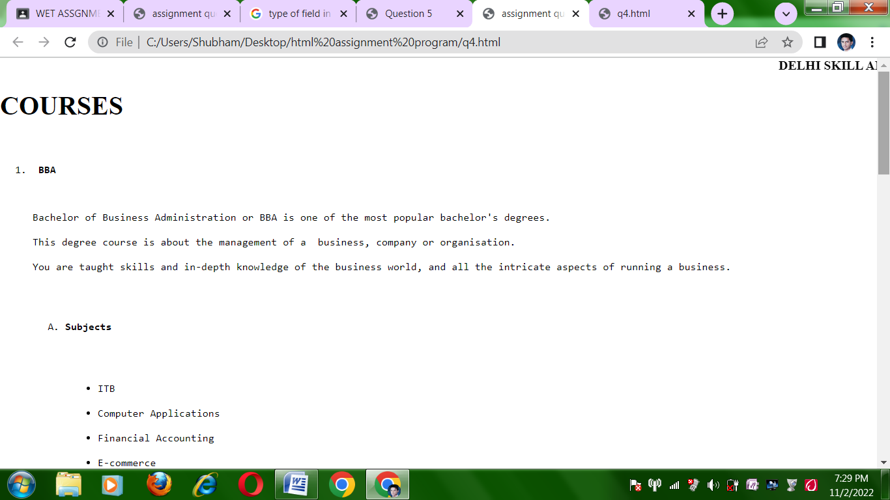

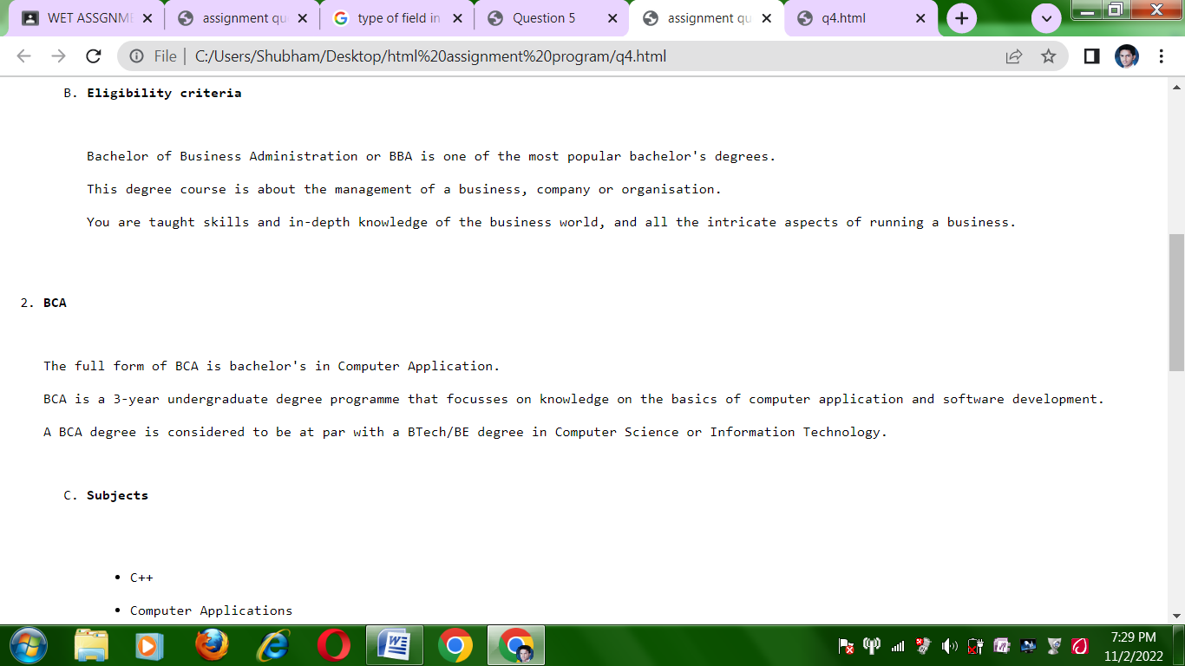

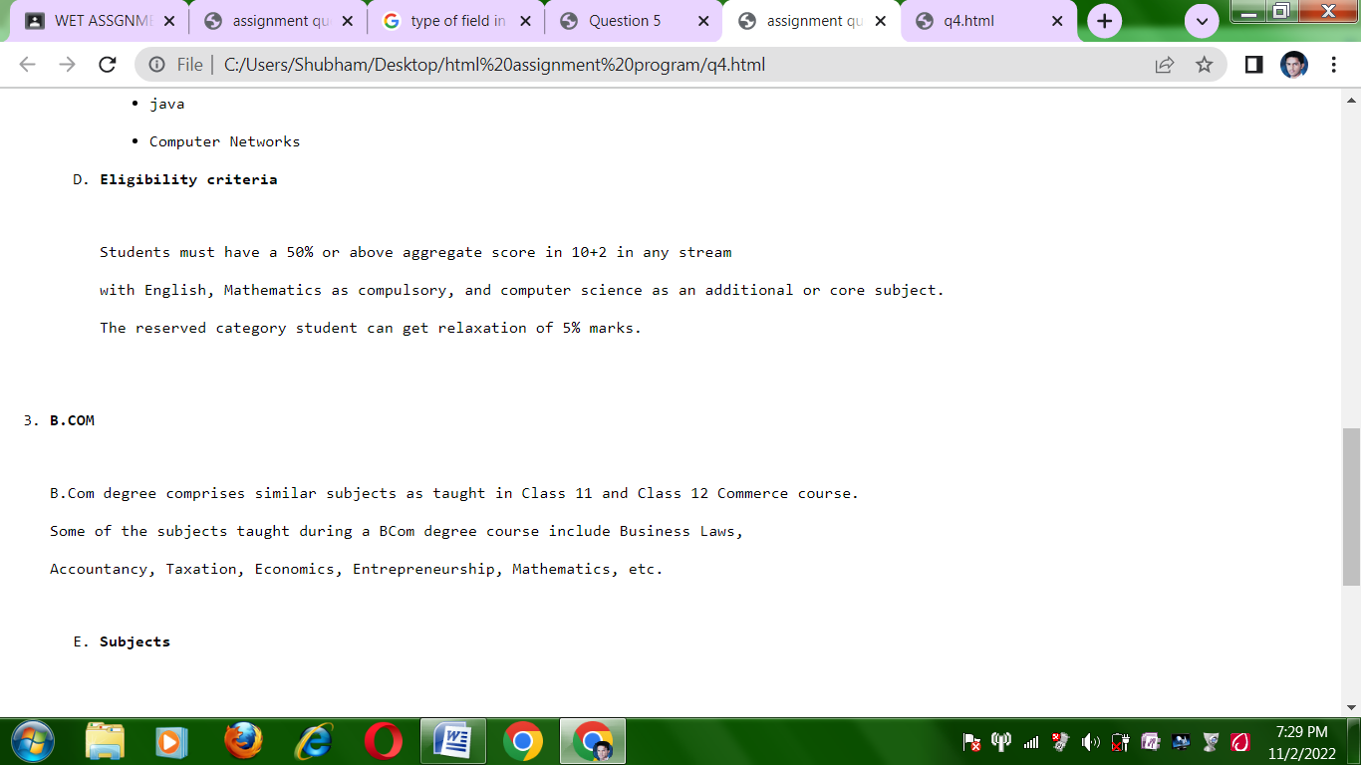

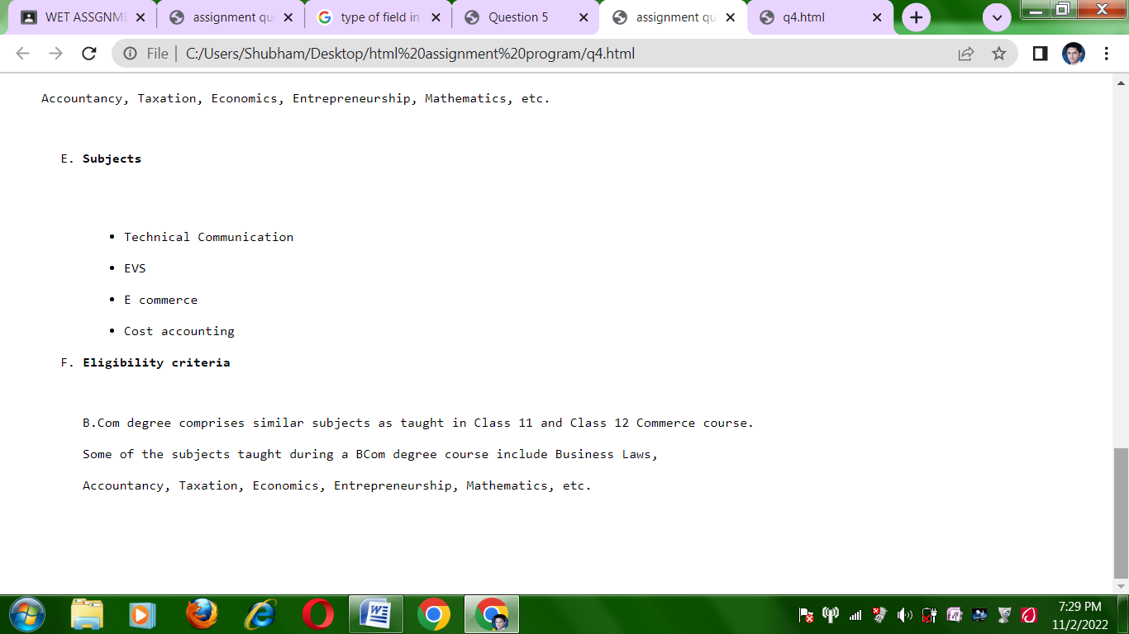

Ques-5 create the given table using html table tag.

Program:

<html>

<head>

<title>Question 5</title>

</head>

<body>

<table rules="all" border="3">

<pre>

<tr>

<td>1</td>

<td rowspan=3>menu <br>

<ul type="disc">

<li>list</li>

<li>tables</li>

<li>forms</li>

</ul>

</td>

<td>Lists are used to group together related pieces of information so they are clearly associated with each other and easy to read.</td>

<td>1. ordered list<br>2. unordered list</td>

</tr>

<tr>

<td>2</td>

<td>A table is an arrangement of information or data, typically in rows and columns, or possibly in a more complex structure. </td>

<td>1. merging of rows is rowspan<br>2. merging of columns is colspan</td>

</tr>

<tr>

<td>3</td>

<td>A form is a document with spaces (also named fields or placeholders) in which to write or select, for a series of documents with similar contents.</td>

<td>1.Textfield<br>2.Number field<br>3.E-mail field<br></td>

</tr>

</table>

</body>

</html>

Output:

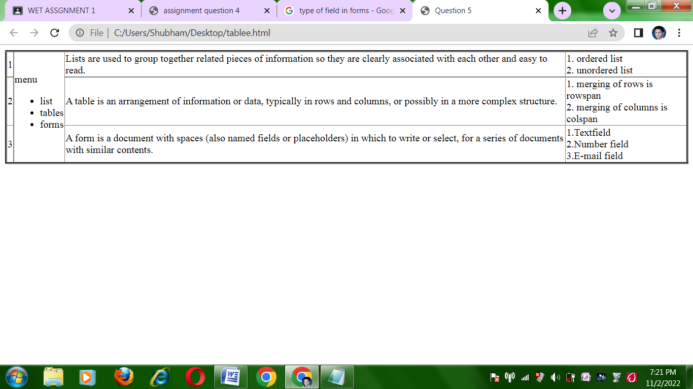

Ques 6. Design a form using Forms Tag

Program:

<html>

<head>

<title>forms</title>

</head>

<body>

<h1 font text align="center">Application form</h1>

<pre>

<form>

<ol type="1">

<li>First Name:</li> <input type="text" name="firstname"><br>

<li>Last Name:</li> <input type="text" name="lastname"><br>

<li>Father's Name:</li> <input

type="text"name="fathername"><br>

<li>Highest Qualfication:</li> <select>

<option value="Undergraduate">undergraduate</option>

<option value="Postgraduate">postgraduate</option>

<option value="doctorate">Doctorate</option>

</select><br>

<li>Date Of Birth:</li> <input type="date" name="dob"><br>

<li>correspondance attendance:</li> <textarea

name="attendace" rows="5" columns="40"></textarea>

<li>Subject Preferred:</li> <select>

<option value="c++">C++</option>

<option value="python">Python</option>

<oprion value="wte">WTE</option>

</select><br>

<li>Gender:</li> <input type="Radio" name="gender" value="male"

checked>male<br>

<input type="Radio" name="gender" value="female"

>female<br>

<input type="Radio" name="gender" value="others"

>others<br>

<li>Remarks:</li> <textarea name="remarks" rows="5"

columns="40"></textarea>

<input type="submit" value="submit">

</pre>

</ol>

<form>

</body>

</html>

Output:

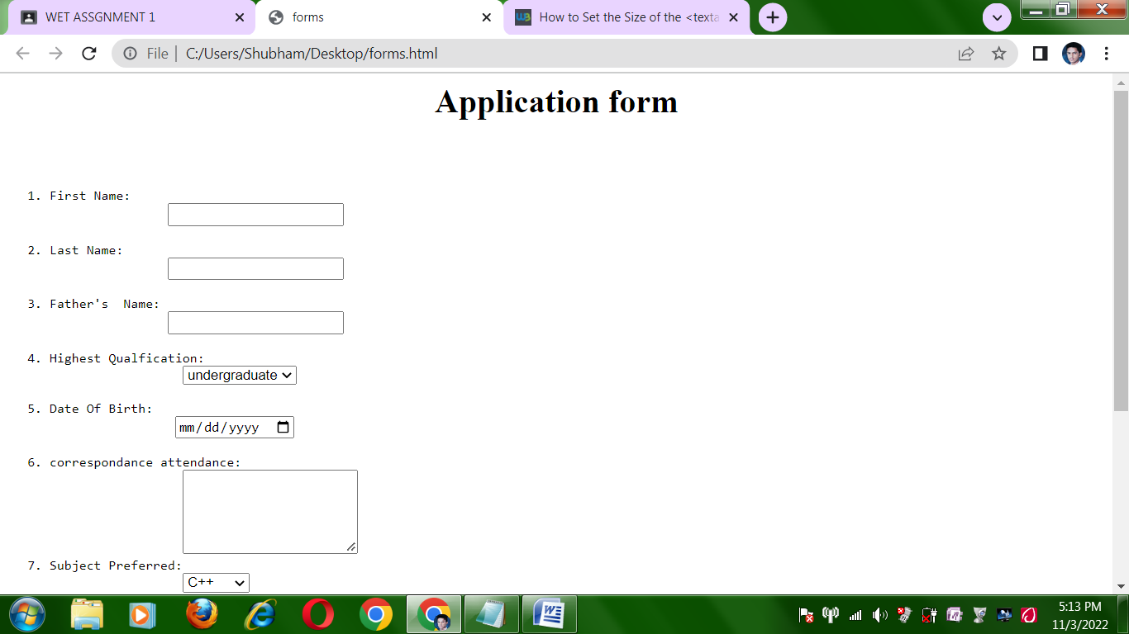

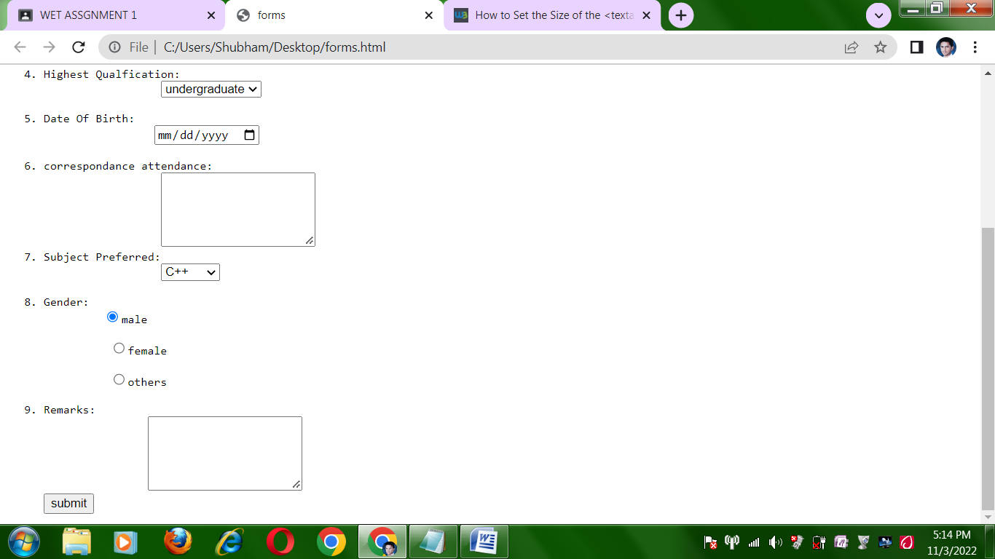

Ques7: Design a HTML webpage (Two frame division) of your favourite movie. Give an attractive

background color and image. (USE FRAMES).First frame would contain the image of the movie and

the second frame contains the description of the movies. Image of movie should be in hyperlink to

open about it in second frame.

Program:

#1 <html>

<head>

<title>movieimg</title>

</head>

<body>

<a href="http://image.com" target="_blank"> <img src="C:\Users

\Shubham\Downloads/uri.jpeg" style="border:2; "></a>

</body>

</html>

#2 <html>

<body>

<pre>

<p><b>Uri: The Surgical Strike is a 2019 Indian Hindi-language military

<br>action film written and directed by debutant Aditya Dhar and<br>

produced by Ronnie Screwvala under the RSVP Movies banner.<br>

...

Uri: The Surgical Strike<br>

Country India<br>

Language Hindi<br>

Budget 25 crore<br>

Box office est. 359.73 crore<br>

</pre>

</body>

</html>

#3 <html>

<head>

<title>frames</title>

</head>

<frameset cols="50%,50%">

<frame src="movieimg.html"/>

<frame src="moviedes.html"/>

</frameset>

</html>

Output:

