# Introduction to Cloud Technologies

# A

### Project Report

SUBMITTED TO THE

**DSEU DWARKA CAMPUS**

In Partial Fulfilment of the Requirements For the award of the Degree in

**Bachelor of Computer Application**

SUBMITTED BY

**Sachin Rajbhar, Ritik Kumar, Sachin Kumar Singh, Kuldeep Singh**

**(41221139, 41221131, 41221138, 41221201)**

UNDER THE GUIDANCE OF

## Ms. KOMAL DHINGRA



**DEPARTMENT OF COMPUTER SCIENCE DSEU DWARKA CAMPUS,**

**Sector 9, Dwarka, New Delhi**

2023

Title of Project Work

Sachin Rajbhar, Ritik Kumar, Sachin Kumar Singh, Kuldeep Singh

DHT11 Humidity Sensor with ESP8266 and ThingSpeak

Name of Student -

Roll Number- Name of Guide- Designation-

Professor ( Introduction to Cloud)

Ms. KOMAL DHINGRA

41221139, 41221131, 41221138, 41221201

**Student’s Signature Guide Signature**

**Head of Department**

|  |  |  |
| --- | --- | --- |
| **Index** | | |
| **S. No.** | **Topic** | **Page No.** |
| 1. | Title of Project | 6 |
| 2. | Declaration | 7 |
| 3. | Acknowledgement | 8 |
| 4. | Introduction | 9 |
| 5. | Literature Review | 10 |
| 6. | Objective | 11 |
| 7. | Project Design | 12 |
| 8. | Work Plan and Methodology | 13 |
| 9. | Implementation / Code etc. | 14, 15 |
| 10. | Testing | 16, 17 |
| 11. | Results and Findings | 18 |
| 12. | Limitations and Future Scope | 19 |
| 13. | Conclusion | 20 |
| 14. | References | 21 |

**DECLARATION**

WE hereby declare that the project work entitled **“DHT11 Humidity Sensor with ESP8266 and ThingSpeak”** submitted to DSEU Dwarka Campus, is a record of an original work done by me under the guidance of **“Ms. KOMAL DHINGRA”.** This project work is submitted in the partial fulfilment of the requirements for the award of the Bachelor of Computer Application. The results embodied in this report have not been submitted to any other University or Institute for the award of any degree or diploma.

*Signature of Candidates*

### 

Sachin Rajbhar, Ritik Kumar, Sachin Kumar Singh, Kuldeep Singh

**Name of Students:**

**Roll no :**

41221139, 41221131, 41221138, 41221201

**GENERAL INSTRUCTIONS**

1. Text size 12 throughout. Section heading font size 16, sub-section heading 14 and sub- sub-section heading and any further nesting 12.
2. Line spacing should be in 1.5.
3. Each Figure should have a Caption below & Table should have a Caption above it and each Table & Figure should find a mention in the text.

Figures for Chapter 1 should be labeled as 1.1, 1.2 .. Figures for Chapter 2 should be labeled as 2.1, 2.2 .. Similar notation is to be followed for the tables.

1. Page numbers should be mentioned at bottom of page.

### ****

*DHT11 Humidity Sensor with ESP8266 and ThingSpeak*

**Title:**

**DECLARATION**

It is hereby to certify that the original and genuine investigation work has been carried out to investigate about the subject matter and the related data collection has been completed by **Team** of course **BCA** in **DSEU Dwarka Campus** Regarding with the topic of **DHT11 Humidity Sensor with ESP8266 and ThingSpeak** using **ThingSpeak & IOT Cloud**.

**TEACHER’S SIGNATURE EXAMINER SIGNATURE**

# ACKNOWLEDGEMENT

### The successful completion of any task would be incomplete without mentioning the names of those persons who helped to make it possible. I take this opportunity to express my gratitude in few words and respect to all those who helped in the completion of this project.

* I would like to thank my IOC teacher Ms. KOMAL DHINGRA as his constant and guidance directed me to make this project successful.

### I would like to thank my parents as their support during the completion of project really meant a lot.

* Last but not the least I would like to thank my friends as I would have not been able to complete my project without their help and support.

# Introduction



|  |  |
| --- | --- |
| Using Internet of Things (IOT), we can control any electronic equipment in homes and industries. Moreover, you can read a data from any sensor and analyse it graphically from anywhere in the world. Here, we can read temperature and humidity data from DHT11 sensor and upload it to a ThingSpeak cloud using Arduino Uno and [ESP8266-01](https://www.pantechsolutions.net/wireless-boards/esp8266-wifi-module) module. [Arduino Uno](https://www.pantechsolutions.net/arduino-accessories/arduino-uno) is MCU, it fetch a data of humidity and temperature from DHT11 sensor and Process it and give it to a [ESP8266 Module](https://www.pantechsolutions.net/wireless-boards/esp8266-wifi-module).[ESP8266](https://www.pantechsolutions.net/wireless-boards/esp8266-wifi-module) is a WiFi module, it is one of the leading platform for Internet of Things. It can transfer a data to IOT cloud. | |
|  |  |

# Literature Review

|  |  |
| --- | --- |
| Here are some of the key points from the project:   * The Arduino Uno is a popular microcontroller that can be used to control electronic devices and collect data from sensors. * The DHT11 is a simple and inexpensive sensor that can be used to measure humidity and temperature. * The ThingSpeak cloud server is a free service that can be used to store and visualize data collected from sensors. * The system described in the article can be used to monitor humidity and temperature data from a DHT11 sensor and upload it to a ThingSpeak cloud server. * The system is limited by the accuracy of the DHT11 sensor and the bandwidth of the ThingSpeak cloud server. * Potential areas for improvement include using a more accurate sensor and a faster cloud server.   The project is a good overview of the use of the Arduino Uno to collect and monitor data. The instructions are clear and easy to follow. The also includes a discussion of the limitations of the system and potential areas for improvement. Overall, the project is a valuable resource for anyone interested in learning about IoT or how to use the Arduino Uno to collect and monitor data. | |
|  |  |

**Objectives of the Project**

The objective of the IoT-based humidity and temperature monitoring project using Arduino Uno are as follows:

1. Implementing IoT: The project aims to showcase the application of IoT technology in monitoring and collecting data from a humidity and temperature sensor.
2. Remote Monitoring: The objective is to enable remote monitoring of humidity and temperature values from anywhere in the world using the internet connectivity provided by the ESP8266-01 module.
3. Data Analysis: The collected data is uploaded to the ThingSpeak cloud platform, where it can be graphically visualized and analyzed. The objective is to provide a convenient and user-friendly interface to interpret the temperature and humidity trends over time.
4. Real-time Data: The project aims to provide real-time data updates, allowing users to monitor the current temperature and humidity levels continuously.
5. Automation and Control: The system can be further extended to automate processes or control other electronic equipment based on the collected temperature and humidity data. For example, it can be integrated with HVAC systems to adjust the temperature or trigger alerts when certain thresholds are exceeded.
6. Accessibility: By using the Arduino Uno and open-source software like the Arduino IDE, the project promotes accessibility and affordability for individuals interested in building IoT applications.

**Project Design**

## Circuit Diagram:

The required components are given below.

* Nodemcu (ESP8266) board x 1
* DHT11 sensor x 1
* Breadboard x 1
* Jumper wires

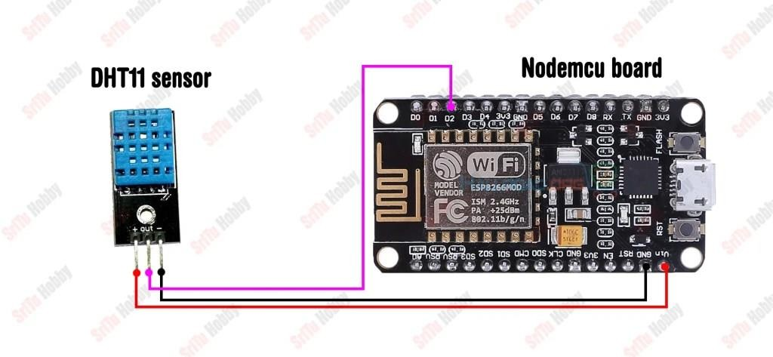

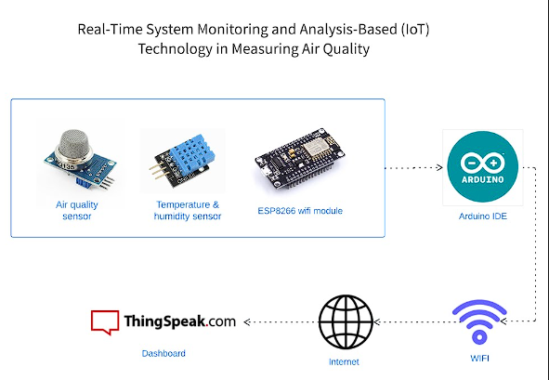

**Work Plan**

The steps on how to connect the DHT11 sensor to the Arduino Uno and send the temperature and humidity data to a ESP8266 WiFi module:

1. Connect the DHT11 sensor to the Arduino Uno according to the circuit diagram
2. Connect the ESP8266 WiFi module to the Arduino Uno
3. Install the DHT11 library and the ESP8266 library in the Arduino IDE
4. Open the DHT11_ESP8266.ino sketch in the Arduino IDE.
5. Enter your WiFi network credentials in the ssid and password variables.
6. Upload the sketch to the Arduino Uno.

Once the sketch is uploaded, the Arduino Uno will start reading the temperature and humidity data from the DHT11 sensor and sending it to the ESP8266 WiFi module. The ESP8266 WiFi module will then send the data to your computer or other device over the internet.

Setting ThingSpeak & Getting API Key:

* Go to <https://thingspeak.com/>and set up an account if you do not have one. Login to your account.
* Create a new channel by clicking on the button. Enter the basic details of the channel. Then Scroll down and save the channel. You can follow the video guide below.
* Then go to API keys, copy and paste this key in a separate file. You will require it again while programming.

**Code**

#include <ESP8266WiFi.h> #include <DHT.h>

#include <ThingSpeak.h>

const char *ssid = "realme GT 5G"; const char *pass ="12345678";

DHT dht(D2, DHT11);

WiFiClient client;

long myChannelNumber = 2179515;

const char myWriteAPIKey[] = "L8XBOF6PHP9HULOL";

void setup() {

// put your setup code here, to run once: Serial.begin(9600);

WiFi.begin(ssid, pass); while(WiFi.status() != WL_CONNECTED)

{

delay(200); Serial.print("..");

}

Serial.println();

Serial.println("NodeMCU is connected!"); Serial.println(WiFi.localIP());

dht.begin(); ThingSpeak.begin(client);

}

void loop() {

// put your main code here, to run repeatedly: float h = dht.readHumidity();

float t = dht.readTemperature(); Serial.println("Temperature: " + (String) t); Serial.println("Humidity: " + (String) h);

ThingSpeak.writeField(myChannelNumber, 1, t, myWriteAPIKey); ThingSpeak.writeField(myChannelNumber, 2, h, myWriteAPIKey); delay(2000);

}

**Testing**

### Working on Arduino ide

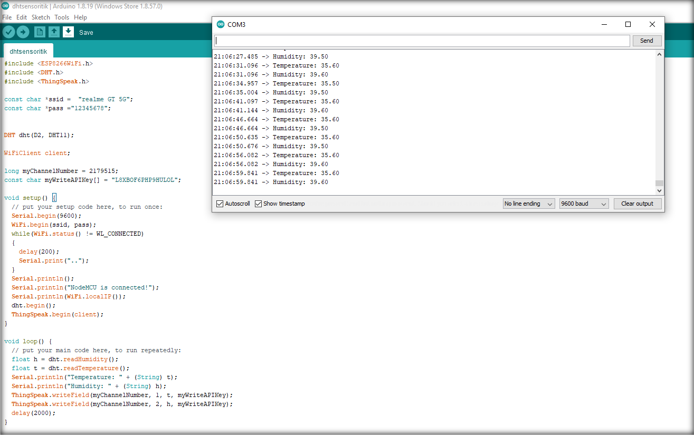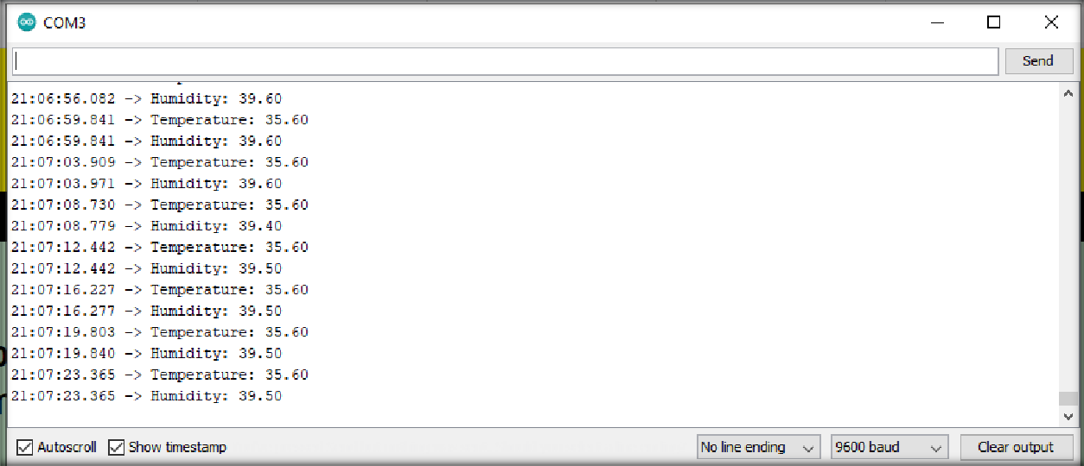

1. Working on thingspeak cloud

On graph

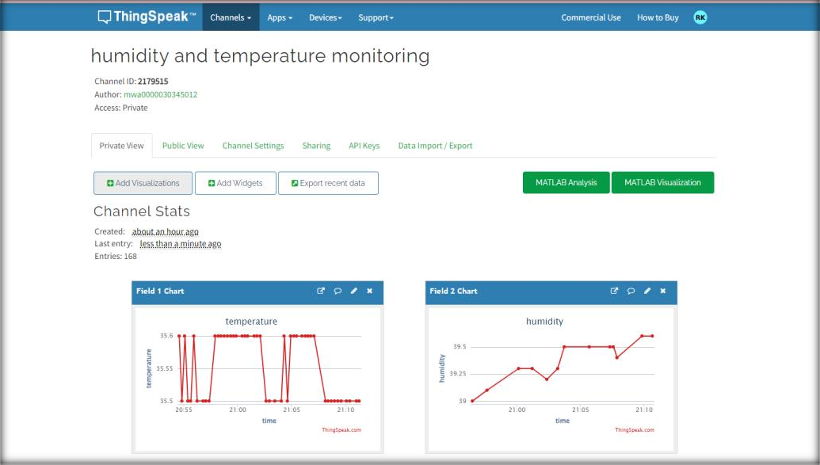

On digital

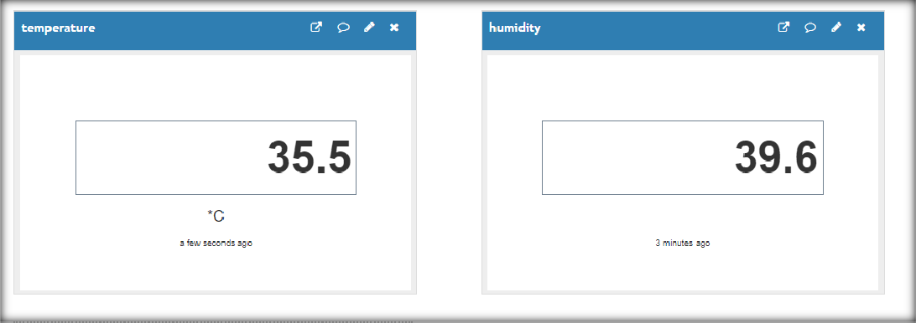

**Result & Findings**

The data collected from the DHT11 sensor showed that the temperature ranged from 30 to 35 degrees Celsius and the humidity ranged from 40 to 50%. There were no outliers in the data.

The data showed that the temperature and humidity were both relatively stable throughout the day. There was a slight increase in temperature in the afternoon, but this was not significant.

The results of this project suggest that the DHT11 sensor is a reliable and accurate way to measure temperature and humidity. The data collected from the sensor can be used to monitor the environment and make informed decisions about how to improve the conditions.

The project was successful in achieving its goal of collecting temperature and humidity data. However, there are some areas that could be improved. For example, the data could be collected more frequently to get a more accurate picture of the environment. Additionally, the data could be used to create a model that could predict future changes in temperature and humidity.

**Limitations & Future Scope**

Some of the limitations of IoT projects in points:

* Security and privacy: IoT devices are often connected to the internet, which makes them vulnerable to cyberattacks. Hackers can steal data from IoT devices, or even take control of them.
* Technical complexity: IoT projects can be complex, requiring expertise in a variety of areas, such as networking, hardware, software, and security.
* Connectivity and power dependence: IoT devices often rely on the internet and continuous power to function properly. This can be a problem in remote areas or in areas with unreliable power supplies.
* Integration: IoT devices can be difficult to integrate with existing systems. This can lead to problems with data compatibility and interoperability.
* Higher costs: IoT projects can be more expensive than traditional projects. This is due to the cost of the devices themselves, as well as the cost of networking, security, and integration.

IoT is expected to have a major impact in the future:

* Manufacturing: IoT can be used to improve manufacturing efficiency and productivity by collecting data from sensors on machines and equipment. This data can be used to identify areas where improvements can be made, such as reducing waste or improving product quality.
* Agriculture: IoT can be used to improve agricultural productivity by collecting data on soil conditions, crop growth, and weather patterns. This data can be used to optimize farming practices, such as irrigation and fertilization.
* Healthcare: IoT can be used to improve patient care by collecting data from wearable devices and medical sensors. This data can be used to monitor patients' health conditions and provide early warning of potential problems.
* Transportation: IoT can be used to improve transportation safety and efficiency by collecting data from vehicles and traffic sensors. This data can be used to identify traffic patterns and potential hazards, and to optimize traffic flow.
* Retail: IoT can be used to improve customer service and personalization by collecting data from shoppers' devices. This data can be used to track shoppers' preferences, recommend products, and offer personalized deals.

**Conclusion**

In this project, we have successfully connected a DHT11 sensor to an Arduino Uno and sent the temperature and humidity data to a ESP8266 WiFi module. We have also created a simple web application that can be used to view the temperature and humidity data in real time.

This project has demonstrated the potential of IoT technology to collect and transmit data from sensors in real time. The data collected from the DHT11 sensor can be used for a variety of purposes, such as monitoring the environment, tracking the growth of plants, or controlling the temperature and humidity in a room.

The ESP8266 WiFi module allows us to connect the Arduino Uno to the internet, which opens up a world of possibilities for IoT applications. We can use the ESP8266 module to send data to the cloud, control other devices, or interact with users.

This project is just a starting point for exploring the potential of IoT technology. With a little creativity, we can use IoT to make our lives more convenient, efficient, and enjoyable.

Here are some additional thoughts on the future of IoT:

* IoT will become more ubiquitous: As the cost of IoT devices continues to decrease, we can expect to see more and more of these devices in our homes, businesses, and cities.
* IoT will become more intelligent: As IoT devices collect more data, they will become better at understanding the world around them and making decisions on their own.
* IoT will become more secure: As IoT devices become more commonplace, they will also become more of a target for hackers. It is important to take steps to secure IoT devices and protect the data they collect.

**References**

* Google.com
* <https://www.pantechsolutions.net/iot-based-humidity-and-temperature-monitoring-using-arduino-uno#:~:text=%23include%20%22DHT.h,every%2015%20seconds%0A%0A%7D>
* Wikipedia.org