|  |  |
| --- | --- |
| sel report | 2023 |



|  |
| --- |
| SEL  Report  Enhancing Workplace Productivity:  A Collaborative Problem-Solving Approach |

|  |  |
| --- | --- |
| Ritik Kumar  Sachin Rajbhar  Sachin Kumar Singh  Vikas  Karmvir | 41221131  41221139  41221138  41221186  41221075 |

|  |  |
| --- | --- |
|  |  |



**Title:** Enhancing Workplace Productivity: A Collaborative Problem-Solving Approach

In this report, we present a comprehensive analysis of a real-life problem-solving scenario focused on improving workplace productivity. The problem was identified as a decline in productivity within a team, and a group consisting of Ritik, Karmvir, Vikas, Sachin, and Varun engaged in a conversation to address the issue. The ideal model of problem-solving was applied to guide the discussion and decision-making process.

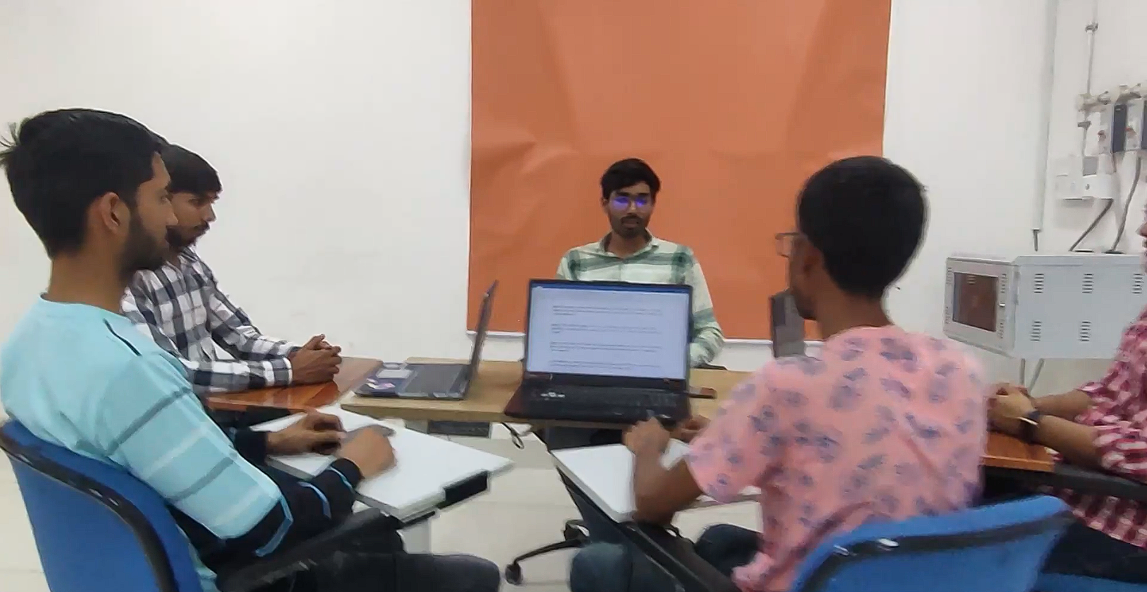

INTRODUCTION

|  |  |
| --- | --- |
|  |  |

|  |
| --- |
| Enhancing Workplace Productivity: IDEAL MODEL  OF PROBLEM SOLVING |

|  |
| --- |
| Problem Solving [ALMBoK.com]  1. Problem Definition and Understanding  The team recognized the decline in productivity and identified three key problem areas: communication, time management, and workflow processes. They acknowledged the need for a thorough understanding of the problem and any constraints or limitations that may affect the proposed solutions.  How Entrepreneurs Can Find The Right Problem To Solve - Forbes India  2. Problem Analysis  The conversation delved deeper into the interdependencies between the identified problem areas. It was revealed that communication issues could lead to misunderstandings and delays, ultimately affecting both time management and workflow processes. The team acknowledged the complexity of the problem and the need for a multifaceted approach.  5 Fun Ways to Teach Cause and Effect in Reading and Writing  3. Generation of Potential Solutions  To address the problem, the team engaged in a brainstorming session, generating several potential solutions. These included implementing a project management tool to streamline task assignments and provide transparency, scheduling regular team meetings to foster communication and address concerns, organizing time management training sessions to improve efficiency, and reviewing and optimizing current workflow processes.  Exploring the Possibilities — Palouse Pathways  4. Evaluation and Selection of Solutions  The team critically evaluated each potential solution, considering their feasibility, effectiveness, and alignment with their goals and constraints. Ultimately, they selected three solutions to implement: (1) implementing a project management tool, (2) scheduling regular team meetings, and (3) organizing time management training sessions.  The team assigned responsibilities for each solution. Karmvir took the lead on implementing the project management tool and providing training, while Vikas facilitated the regular team meetings. Sachin organized time management training sessions, and Varun focused on assessing and optimizing workflow processes. The importance of monitoring progress, gathering feedback, and making necessary adjustments during the implementation stage was emphasized.  Selecting the best solution | Blogs | Sigma Magic  5. Monitoring and Adjustment  Regular check-ins and feedback sessions were scheduled to monitor the effectiveness of the implemented solutions. This allowed the team to identify any challenges, address them promptly, and make necessary adjustments. The importance of continuous monitoring and a proactive approach to improvement was stressed.  Upon successfully implementing the solutions and resolving the problem, the team recognized the importance of reflecting on the entire problem-solving process. They emphasized the need to evaluate the outcomes, identify lessons learned, and identify areas for improvement. This reflective step aimed to enhance the team's problem-solving skills and prepare them for future challenges. |



**Conclusion:**

**Through the application of the ideal model of problem-solving, the team successfully addressed the decline in workplace productivity. The collaborative conversation among Ritik, Karmvir, Vikas, Sachin, and Varun enabled a systematic analysis of the problem, generation of potential solutions, evaluation, and selection of the most suitable solutions, and an organized implementation plan. The team recognized the significance of continuous monitoring, adjustment, and reflection to sustain productivity improvements and foster a culture of continuous improvement within the organization.**

**Recommendations:**

**Based on this problem-solving experience, we recommend organizations adopt a collaborative problem-solving approach, encouraging open dialogue and diverse perspectives. Additionally, integrating regular check-ins and feedback sessions can help identify challenges and make necessary adjustments during the implementation stage. Finally, fostering a culture of reflection and learning enables continuous improvement and enhances problem-solving skills.**

**Overall, the conversation-based problem-solving model proved effective in addressing the workplace productivity issue, emphasizing the importance of thorough problem understanding, critical evaluation of solutions, systematic implementation, and continuous monitoring and reflection.**

***REFRENCES: -***

* Book: The Ideal Problem Solver- A Guide to Improved thinking
* <https://lifeskillsadvocate.com/blog/teaching-the-ideal-problem-solving-method-to-diverse-learners/>
* Wikipedia.org

CONCLUSION