# Raj Dalvi

# 2020BTECS00027

# Q1. Study different Internet Standards and write down a note on each.

1. **Internet Engineering Task Force (IETF)**
   * IETF formulates, publishes and regulates Internet Standards, particularly those related to TCP/IP.
   * The organization is open standard, with no formal memberships. Development of IETF standards is open to all.
   * Any interested person can participate for their development.
   * IETF documents are free and easily available over the Internet.
   * IETF specifications are on individual protocols that may be used in different systems.
   * RFC is innovations that can work with internet

# 2 Internet society (ISOC)

ISOC was founded in the US in 1992 as a non-profit organization to provide support on technical development of the Internet. It presently conducts a range of activities on

* standards
* education
* access, and
* policies.

# Internate Architecture Board (IAB)

IAB is a committee of IETF and an advisory body of ISOC. The board comprises researchers and professionals for developing technical aspects of the Internet. The responsibilities of IAB are −

* + Supervise architectural standards of different networks and IP.
  + Review issues related to Internet Standards.
  + Provide guidance to IETF and ISOC.

# Internet Research Task Force (IRTF)

IRTF is composed of a number of research groups whose overall objective is focused on the long-term development of the Internet. It is a parallel organization to IETF. The participants are individual contributors who have long-term memberships. The research groups work on Internet protocols, applications, technology and overall architecture.

# Q2. Study and install Wireshark: add screenshot of each step of installation with description. Write down information of Wireshark and use of its functionalities in networking study.

**Installation of Wireshark:**

1. Open any browser and type download Wireshark.

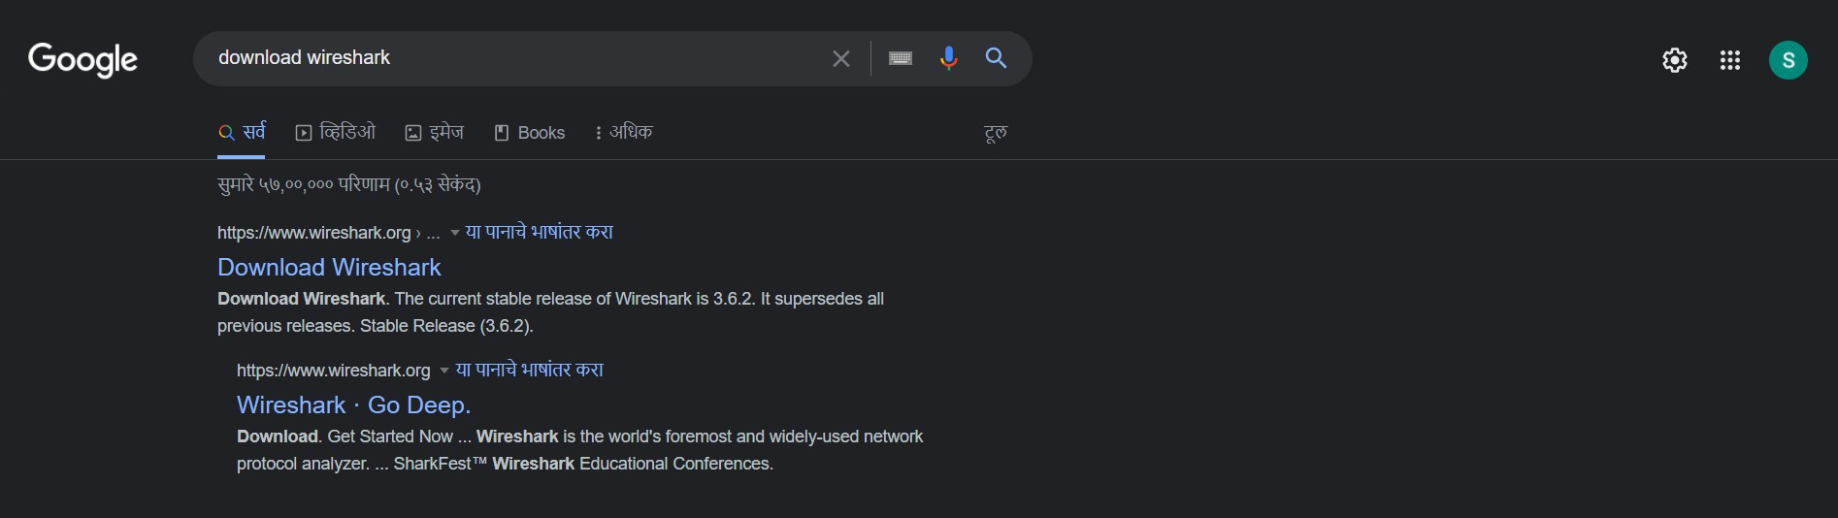

1. Select installer depending on your system architecture.

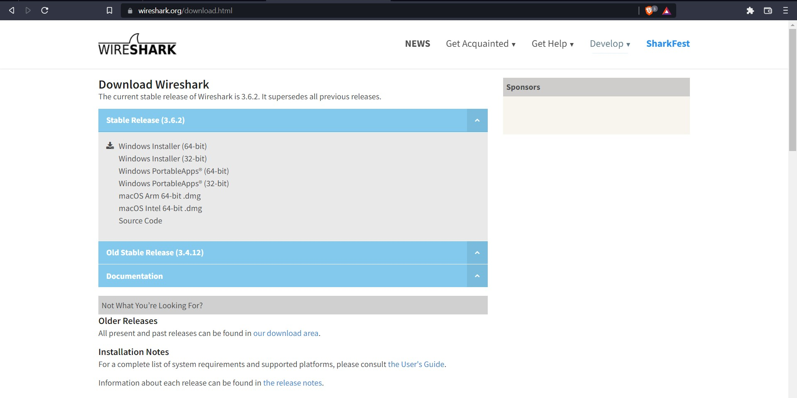

1. The .exe file will be downloaded.

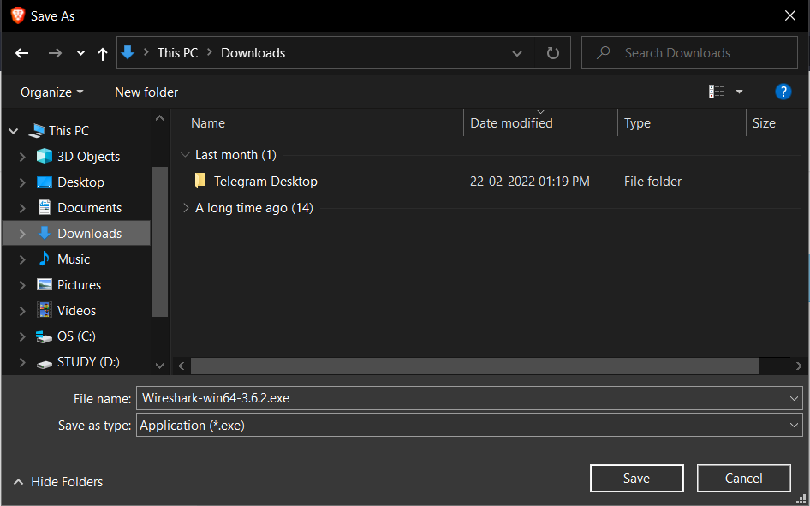

1. Once the download completes, click on .exe file and run the installation wizard.

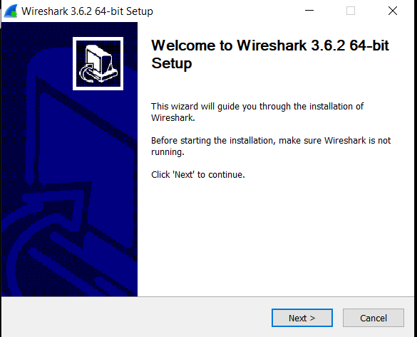

1. Read the licence.

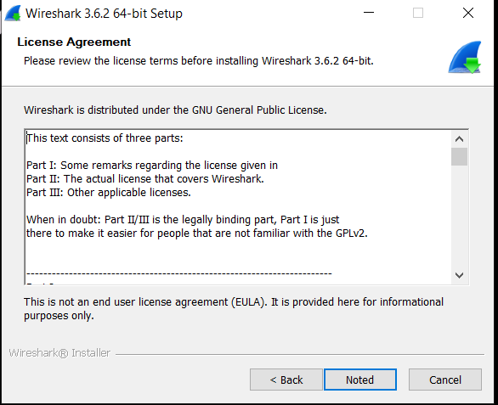

1. Choose which tools to download.

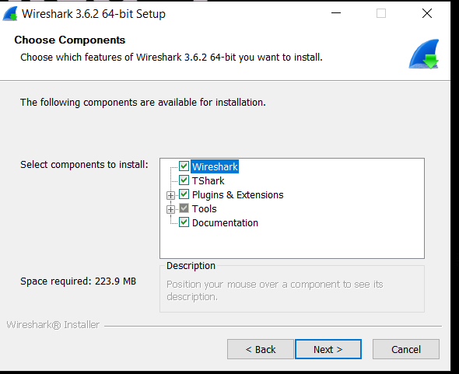

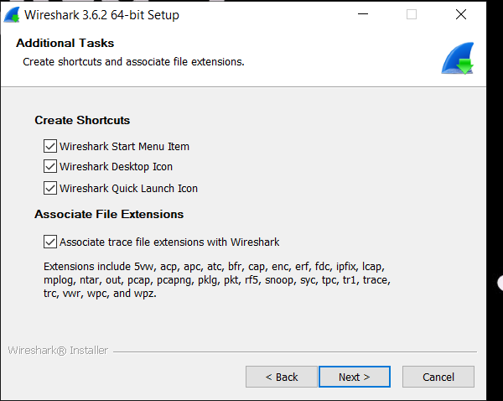

1. Choose installation location.

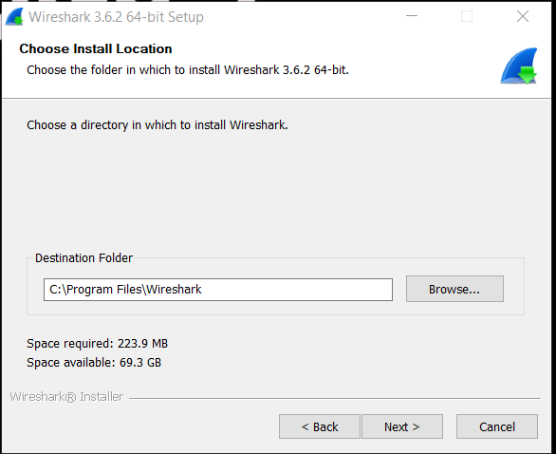

1. Click on next till installation completes.

