**­­­­­­Final Year BTech Project-II Report**

On

**Log Monitoring System In Kubernetes**

*For the Degree of*

**Bachelor of Technology**

*In*

**Computer Science and Engineering**

*Submitted by*

**2020BTECS00033 Prathamesh Raje**

**2020BTECS00006 Samrat Jadhav**

**2020BTECS00027 Raj Dalvi**

**2020BTECS00089 Suraj Dhanorkar**

*Under the Guidance of*

**Prof. A. A. Urunkar**



**Department of Computer Science and Engineering,**

**Walchand College of Engineering, Sangli.**

(*An Autonomous Institute*)

**AY 2023-24**



**Walchand College of Engineering, Sangli.**

(*An Autonomous Institute*)

**Department of Computer Science and Engineering**

**CERTIFICATE**

This is to certify that the Project Report entitled, **"LOG MONITORING SYSTEM IN KUBERNETES"** submitted by

**2020BTECS00033 Prathamesh Raje**

**2020BTECS00006 Samrat Jadhav**

**2020BTECS00027 Raj Dalvi**

**2020BTECS00089 Suraj Dhanorkar**

to **Walchand College of Engineering, Sangli**, India, is a record of bonfire Project work of course **"PROJECT-II (5CS492)”** carried out by him/her under my/our supervision and guidance and is worthy of consideration for the award of the degree of Bachelor of Technology in Computer Science & Engineering during the academic year ***2023-24***.

|  |  |  |
| --- | --- | --- |
| **Prof. A. A. Urunkar**  Guide |  | External Examiner |

|  |
| --- |
| **Mrs. Dr. M. A. Shah**  Head  Department of Computer Science and Engineering |

**Declaration**

I hereby declare that work presented in this project report titled **"LOG MONITORING SYSTEM IN KUBERNETES"** submitted by us in the partial fulfilment of the requirement of the award of the degree of Bachelor of Technology (B.Tech) Submitted in the Department of Computer Science & Engineering, Walchand College of Engineering, Sangli, is an authentic record of my project work carried out under the guidance of Prof. A. A. Urunkar.

**2020BTECS00033 Prathamesh Raje**

**2020BTECS00006 Samrat Jadhav**

**2020BTECS00027 Raj Dalvi**

**2020BTECS00089 Suraj Dhanorkar**

Date : 15/05/2024

Place : Sangli.

**Acknowledgement**

We would like to express our special thanks of gratitude to our project guide Prof. A. A. Urunkar Sir and our H.O.D. Dr. M. A. Shah Ma’am who gave us the golden opportunity to do project on “Image Search: Finding Visual Similarities” It helped us in doing a lot of research and we came to know about a lot of new things related to this topic and industry applications of the project.

At last, but not the least, we would like to thank everyone who helped and motivated us to work on this project.

**Abstract**

In response to the expanding landscape of Internet-based businesses and the transformation of enterprise technology architecture into large-scale platforms, this project focuses on a central platform architecture for cloud-native environments, leveraging Kubernetes as its core technology. With a primary emphasis on the design of a Kubernetes cluster log collection system, the project addresses the challenges posed by the increased complexity of logs in containerized applications.

Container technology's rapid application deployment capabilities have drawn attention, but the non-persistence of container applications increases the intricacy of log management. To address this, the project introduces an orchestration framework that integrates diverse log management tools, ensuring a cohesive and efficient log system within Kubernetes. Emphasizing the importance of log data, the report details its role in providing essential information with timestamps and locations.

The proposed log monitoring system in Kubernetes for enterprise cloud aims to provide a unified solution for handling log intricacies in a containerized environment and also facilitates the searching with in the generated logs. This project contributes to enhanced research and development efficiency, aligning with the broader objectives of digital and intelligent transformation in enterprises.

**CONTENTS**

Page No.

**DECLARATION i**

**ACKNOWLEDGEMENT ii**

**ABSTRACT iii**

**CONTENTS iv**

**LIST OF FIGURES v**

**LIST OF ABREVIATIONS vi**

**1. Introduction 1**

**2. Literature Survey 3**

**3. Problem Statement 5**

**4. Objectives 6**

**5. Methodology**  **7**

**6. Result and Discussion**  **19**

**7. Conclusion 28**

**8. References 29**

**List of Figures**

|  |  |  |
| --- | --- | --- |
| **S. N.** | **Content** | **Page No.** |
| **1.** | Block Diagram of Log Monitoring System | 8 |
| **2.** | The architecture framework of Log Monitoring System in Kubernetes | 11 |
| **3.** | UML diagram | 15 |
| **4.** | Activity Diagram | 16 |
| **5.** | Deployment Diagram | 16 |
| **6.** | User Interface of LMS | 19 |
| **7.** | Single Log Document | 20 |
| **8.** | Applied Filters | 21 |
| **9.** | Graphical Representation (Pod Name VS Count of Logs) | 22 |
| **10.** | Summarization Text | 24 |
| **11.** | Troubleshoot | 25 |
| **12.** | Email Alert | 26 |

**List of Abbreviations**

* **K8s-** Kubernetes
* **LMS-** Log Monitoring System

**Introduction**

In today's era of cloud-native technologies, the orchestration of containerized applications has evolved into a cornerstone of modern computing infrastructure. Among the various solutions available, Kubernetes has emerged as a dominant force, offering robust capabilities for the deployment, scaling, and management of containerized workloads at scale. As enterprises increasingly embrace Kubernetes to power their cloud environments, the need for efficient operational management, including comprehensive log monitoring, becomes paramount.

Enterprises operating in cloud environments often grapple with the challenge of effectively managing and monitoring the logs generated by their Kubernetes clusters. In response to this critical need, our project, titled "Log Monitoring System in Kubernetes for Enterprise Cloud," emerges as a beacon of innovation and efficiency. Through a meticulously crafted approach, our system aims to revolutionize the way organizations handle log data within Kubernetes clusters, ultimately enhancing operational visibility and efficiency.

At the heart of our solution lies a multi-faceted approach that encompasses the entire log management lifecycle. It begins with the seamless collection of logs directly from the ports of Kubernetes clusters, ensuring that no critical information is overlooked. These logs are then meticulously indexed using Elasticsearch, a powerful and scalable search and analytics engine, thereby establishing a reliable repository for storing and retrieving log data.

However, our project goes beyond mere log collection and storage. Recognizing the importance of user experience and accessibility, we have developed a sophisticated user interface that transcends traditional log display paradigms. This interface features dynamic functionalities such as customizable filters for pod names and log messages, empowering users to efficiently navigate through vast datasets with ease. By facilitating seamless log retrieval and analysis, our system enables organizations to gain valuable insights into the operational health of their Kubernetes clusters.

A distinguishing hallmark of our system is the integration of robust visualization tools, which serve as a window into the activities of different pods within the Kubernetes environment. Through interactive graphs and charts, users can gain deeper insights into the behavior of their containerized workloads, discerning patterns, identifying anomalies, and troubleshooting issues with precision. This not only enhances the comprehensibility of log data but also empowers users to optimize their Kubernetes clusters effectively, thereby maximizing performance and resource utilization.

In summary, "Log Monitoring System in Kubernetes for Enterprise Cloud" represents a pioneering endeavour in elevating the observability and management of Kubernetes deployments. By seamlessly integrating log collection, storage, retrieval, and dynamic visualization capabilities, our project offers a comprehensive solution for organizations navigating the complexities of modern cloud-native operations. With our system at their disposal, enterprises can harness the full potential of Kubernetes while maintaining the highest standards of operational efficiency and reliability.

**Literature Survey**

The paper “Analysing and alerting on application logs within Kubernetes infrastructure" addresses the challenges and solutions associated with analyzing and alerting on application logs within Kubernetes infrastructure. The study likely addresses issues related to log management and monitoring in containerized environments. The literature survey contextualizes this research within the broader landscape of log monitoring system. It explores existing solutions for log monitoring and error handling in enterprise solutions. [5] It explore centralized log management using popular tools like Elasticsearch, Logstash, and Kibana (ELK stack). The paper likely addresses challenges and solutions in implementing these tools for log analysis. [8] specifically focus on log analysis within Hadoop Distributed File System (HDFS) using Elasticsearch, Logstash, and Kibana. This work may discuss challenges unique to distributed systems and big data environments.[6]

Leveraging cloud-native principles such as microservices, containerization, and auto-scaling, the architecture aims to provide a flexible and robust framework for log collection in cloud environments. It likely discusses implementation details, performance evaluations, and comparisons with existing approaches to demonstrate the effectiveness of the proposed architecture.[1]

The paper likely addresses challenges and solutions in implementing these tools for log analysis. An efficacious automated resource management in cloud computing requires to launch, terminate and maintain computing instances rapidly, with a minimum overhead [3].

Studies also show the log pattern extraction from system logs in large-scale environments. Emphasizing scalability and distributed systems, it delves into machine learning approaches, security log analysis, and architectures for scalable log analysis, complemented by studies on distributed log mining, anomaly detection, and cloud log management [4].

This literature survey explores log pattern extraction from system logs in large-scale environments. Emphasizing scalability and distributed systems, it delves into machine learning approaches, security log analysis, and architectures for scalable log analysis. Key works include Zhao and Xiao (2016), complemented by studies on distributed log mining, anomaly detection, and cloud log management. [7]

Fluentd and Elasticsearch are among the most commonly used technologies for building log monitoring systems for Kubernetes clusters. Fluentd serves as a lightweight log collector deployed as a sidecar container within Kubernetes nodes, enabling efficient log collection from various sources including container logs, application logs, and system logs. Elasticsearch, in turn, provides a scalable and distributed storage backend for indexing and querying log data, allowing users to perform fast and flexible searches across large volumes of log entries. The architecture of a typical log monitoring system for Kubernetes clusters often follows a microservices-based approach, where different components are deployed as separate containers within the cluster. This architecture allows for easy scalability, fault tolerance, and modularization of functionalities such as log collection, parsing, enrichment, storage, and visualization. Additionally, many log monitoring systems adopt a pull-based model for log collection, where log entries are retrieved from application containers and forwarded to a central logging infrastructure for processing and analysis. [9]

Real-world case studies and implementations of log monitoring systems and its current trends, challenges, and solutions, it touches on distributed logging architectures, machine learning applications, security aspects, and performance implications. Notable works include those discussing distributed log management tools, machine learning for log analytics, and security-driven log analysis. This overview provides insights into the evolving landscape of log management practices within Kubernetes clusters. [2].

Furthermore, literature examines the evolution of log management tools and platforms to meet the demands of modern cloud-native architectures. Studies evaluate emerging log management solutions, assess their features and capabilities, and provide insights into their suitability for different cloud environments and use cases [10].

**Problem Statement**

To manage and gain real-time insights from the extensive log data generated by containerized applications in Kubernetes.

**Objectives**

1. Understand the challenges associated with log management in Kubernetes within enterprise cloud environments.

2. Create a centralized log monitoring system for Kubernetes, ensuring efficient data retrieval.

3. Design and develop a user-friendly web interface for administrators to navigate and analyze logs effortlessly.

4. Enable customizable log filtering and searching capabilities to empower users in pinpointing specific information, streamlining the troubleshooting process for both common and complex issues.

**Methodology**

There have been many approaches for storing and analyzing logs in system. Manual testing and log checking is done primarily in enterprises. To store logs centralized data lake, data warehouses or file systems are used. These various techniques are suitable to different scenarios and are successful in practice deployed in many enterprises. But all these techniques require lot of time and employees to check for particular checkpoints till which system was successfully working. For tracking and analyzing logs in enterprise solutions which are scalable with new technology like Kubernetes we need different approach.

With Kubernetes we can easily deploy and scale applications. All these pods management is done internally by Kubernetes. It monitors application health without killing instances. If any error happens in application then Kubernetes rollback those changes. The pods management system in Kubernetes is called service discovery mechanism. It also provides storage options like local storage, cloud storage. This system used Kubernetes for deployment of application container.

With Docker we can create many containers of application image which provides us scalability. Containers are isolated environment for application working. It contains code and all dependencies which then compiled to create image or run it as container. These containers are run by docker desktop.

But there are no complete solutions for enterprise log monitoring for field personals. Using single technology will not be enough to solve enterprise level problems. Along K8’s or Kubernetes and docker this system provides complete solution for tacking error and its analysis. It accesses real time data of logs collected by Kubernetes in pods. This system is effectively used for indexing logs files. Log files generated by containers are in JSON file format which is unstructured.

**Block Diagram for the LMS:**

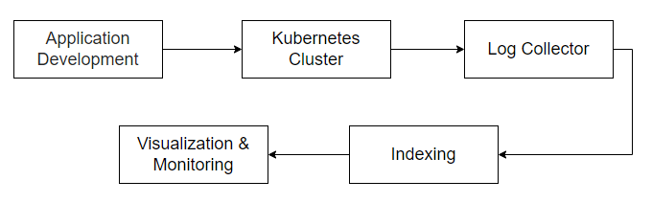

Figure 1 Block Diagram of Log Monitoring System

Using this we can store enormous log data on for further use or analysis. Each log document contains logs entries which can be used to classify them into working and failed states.

**Log Monitoring System Working Process:**

**Sample Application Development:**

Develop a sample application suitable for containerization, considering the requirements and architecture. Testing of application should be done prior deployment on docker. Using docker commands containerize the application or a containerization tool of choice. Define the application's resource requirements and dependencies. Test the containerised application working after deployment.

**Kubernetes Cluster Creation and Deployment of Application**:

1. **Setup Kubernetes Cluster:**
   * Choose a Kubernetes distribution such as Kubernetes (k8s) or a managed Kubernetes service like Google Kubernetes Engine (GKE), Amazon Elastic Kubernetes Service (EKS), or Azure Kubernetes Service (AKS).
   * Install and configure the Kubernetes cluster using tools like kubeadm, kops, or the respective cloud provider's console.
   * Verify that the cluster is up and running using kubectl, the Kubernetes command-line tool.
2. **Prepare Application Images:**
   * Packaged our application into container images using Docker or other containerization tools.
   * Pushed the container images to a container registry such as Docker Hub, Google Container Registry (GCR), Amazon Elastic Container Registry (ECR), or Azure Container Registry (ACR).
3. **Kubernetes Manifests:**
   * Kubernetes manifests in YAML format to describe the desired state of your application.
   * Manifests typically include Deployment or StatefulSet resources to define how many instances of the application should run, Service resources to expose the application internally or externally, and possibly other resources like ConfigMaps or Secrets for configuration and sensitive data management.
4. **Deploy Application:**
   * Use kubectl apply command to deploy the application by applying the Kubernetes manifests.
   * Kubernetes will create the necessary resources (e.g., Pods, Services) according to the specifications in the manifests.
   * Monitor the deployment process using kubectl commands like kubectl get pods, kubectl get deployments, kubectl get services, etc.

**Log Collection:**

Implement a logging framework within the application to generate logs. Fetching logs is very important step. To fetch logs from running container in Kubernetes use kubectl logs counter command.

1. **Fluentd Logging Solution:**
   * It is opensource logging service which provides common platform for log collection
   * Its flexible architecture is suitable for log collection in real time. Fluentd provides scalability and reliability to system.
2. **Deployment of Logging Agents:**
   * Deploy logging agents as DaemonSets within your Kubernetes cluster. DaemonSets ensure that each node in the cluster runs a copy of the logging agent.
   * Configure the logging agents to collect logs from Kubernetes system components (e.g., kubelet, kube-proxy, API server) and Docker containers running on each node.
3. **Log Forwarding:**
   * Configure the logging agents to forward collected logs to your chosen centralized logging solution. This typically involves specifying the destination address, port, protocol, and any required authentication credentials.
4. **Docker Container Logs:**
   * Docker containers typically write their logs to stdout and stderr. Configure Docker to retain container logs for a sufficient period (using log rotation settings) to ensure that they are available for collection.
   * The logging agents deployed in Kubernetes can collect container logs by reading log files from the Docker log directory (/var/lib/docker/containers/<container_id>/<container_id>-json.log by default) or by streaming logs from stdout/stderr.
5. **Incorporate Kubernetes Logs:**
   * Kubernetes system components generate logs that provide valuable insights into cluster operations. Configure the logging agents to collect logs from Kubernetes system components (e.g., kubelet, kube-proxy, API server) by accessing their log files or streaming logs directly from stdout/stderr.

Configure log collectors (e.g., Fluentd, Logstash, or Kubernetes-native logging solutions) to capture logs from application containers. Ensure logs are sent to a centralized log storage system.

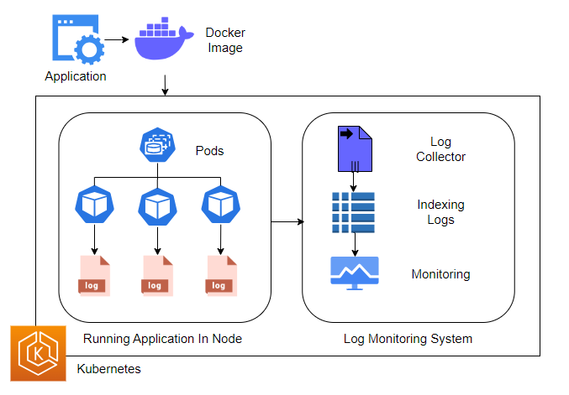

Figure 2: The architecture framework of Log Monitoring System in Kubernetes

**Indexing of Log Data:**

Setting up a robust log indexing and storage solution is crucial for effectively managing and analyzing log data in modern IT environments. The utilization of tools such as Elasticsearch, Fluentd, and Kibana (EFK) stack, or alternatives like Loki and Grafana, provides a comprehensive framework for achieving this objective.

Firstly, Elasticsearch functions as the cornerstone of the solution, serving as the primary storage backend. It excels in indexing log entries swiftly and efficiently, enabling fast and accurate search capabilities essential for troubleshooting and analysis.

Fluentd assumes the role of the log collector, seamlessly gathering logs from various sources, including application containers. Through its flexible configuration options and extensive plugin ecosystem, Fluentd ensures that log data is reliably forwarded to Elasticsearch for indexing, regardless of the source or format.

Kibana complements Elasticsearch by offering a user-friendly interface tailored for querying and visualizing log data. This intuitive platform empowers developers and operators to delve into system behavior, identify trends, and troubleshoot issues effectively, thanks to its interactive dashboards and powerful analytics features.

In addition to deploying the EFK stack, defining indexing rules and data retention policies is imperative for organizing and managing log data efficiently. These rules ensure that log entries are structured consistently, facilitating easy search and analysis. Moreover, data retention policies govern the lifecycle of log data, optimizing storage usage by retaining only pertinent information over time while adhering to compliance and regulatory requirements.

By implementing a well-defined log indexing and storage solution, organizations can enhance their operational visibility, streamline troubleshooting processes, and extract valuable insights from their log data, ultimately contributing to improved system reliability and performance.

**Visualization and Monitoring of Logs:**

Create dashboards and visualization templates in tools like Kibana or Grafana. Set up alerting rules to monitor specific log events or patterns. Continuously monitor log data to detect issues, troubleshoot, and optimize application performance. These entries are used for calculating traffic at each pod. Load balancing in pods will be automatically managed by Kubernetes. Dashboards in Kibana and Grafana can be tailored to display key metrics and performance indicators relevant to the application and infrastructure. These dashboards provide real-time visibility into system health, enabling operators to identify trends, patterns, and anomalies that may require further investigation.

Alerting rules are configured to notify relevant personnel when predefined conditions or thresholds are met. Alerts can be triggered based on specific log events, error rates, or performance metrics, allowing operators to respond promptly to potential issues and minimize downtime. These alerts are sent to user’s email address to know errors in application as early as possible. This method will not only ensure correctness of application but will also improve customer retention.

Continuous monitoring of log data is essential for maintaining system reliability and performance. Operators should regularly review and analyse log data to identify areas for optimization, troubleshoot recurring issues, and fine-tune alerting rules based on evolving requirements and usage patterns.

By following this comprehensive methodology for log monitoring and analysis within Kubernetes environments, enterprises can effectively manage and troubleshoot containerized applications at scale. The combination of containerization, Kubernetes orchestration, centralized logging, and visualization tools empowers organizations to monitor system health, detect issues proactively, and ensure optimal performance across their infrastructure.

This streamlined methodology outlines the key steps involved in developing, deploying, and managing a containerized application in a Kubernetes environment with a focus on log collection, indexing, visualization, and monitoring for effective troubleshooting and analysis.

**BART for Summarization**

BART (Bidirectional and Auto-Regressive Transformers) is a powerful model for text generation and summarization. Integrating BART into your log monitoring system enhances the analysis process by automatically generating concise summaries of log entries. Here's a detailed method:

* Setup BART Model:
  + Acquire or train a BART model suitable for text summarization tasks. Pre-trained BART models are available, or you can fine-tune a model on your specific log data if needed.
* Integration with Log Analysis Pipeline:
  + Implement a module within your log monitoring system to interface with the BART model. This module should preprocess log data, pass it to the BART model for summarization, and receive the summarized output.
* Text Summarization Process:
  + For each batch of log entries, feed the text data into the BART model.
  + Utilize BART's summarization capabilities to generate condensed summaries of the logs, capturing essential information while reducing redundancy.
* Summary Storage and Presentation:
  + Store the generated summaries alongside the original log data for reference and analysis.
  + Present the summaries in your log monitoring dashboard or visualization tools for easy access by operators and analysts.
* Monitoring and Optimization:
  + Monitor the performance of the BART summarization module, including summarization accuracy and computational efficiency.
  + Fine-tune the BART model if necessary to improve summarization quality, especially for domain-specific log data.

**Anthropic as LLM to Troubleshoot Errors:**

Anthropic's Language Learning Models (LLMs) offer advanced natural language understanding capabilities, making them valuable tools for error troubleshooting within your log monitoring system. Here's how you can integrate Anthropic's LLM into your workflow:

* Model Selection and Integration:
  + Choose an appropriate Anthropic LLM for error troubleshooting tasks, considering factors such as model size, performance, and compatibility with your log data.
* Error Detection and Analysis:
  + Develop modules within your log monitoring system to leverage the Anthropic LLM for error detection and analysis.
  + Feed error-related log entries into the LLM to extract contextual information and potential causes of errors.
* Semantic Understanding:
  + Utilize the LLM's semantic understanding capabilities to interpret error messages, stack traces, and other textual information in the logs.
  + Extract key insights from the log data to identify patterns, root causes, and potential solutions for the encountered errors.
* Integration with Alerting System:
  + Integrate the Anthropic LLM into your alerting system to automatically trigger alerts or notifications based on detected error patterns.
  + Configure the system to escalate critical errors or anomalies for immediate attention by operators or developers.
* Continuous Learning and Improvement:
  + Incorporate feedback loops to continuously improve the performance of the Anthropic LLM for error troubleshooting.
  + Update the model periodically with new data and insights to enhance its effectiveness in handling evolving error scenarios.

**UML Diagram**

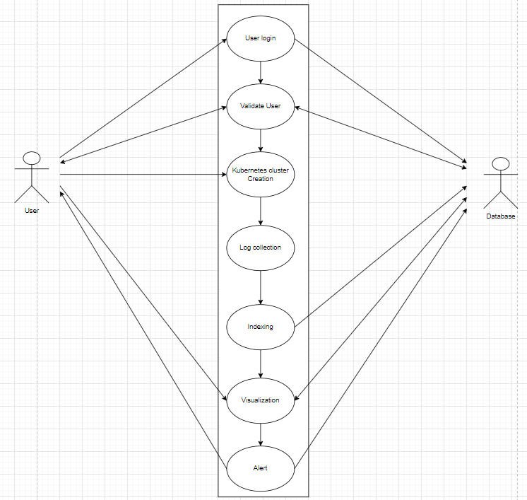

Figure 3: UML diagram

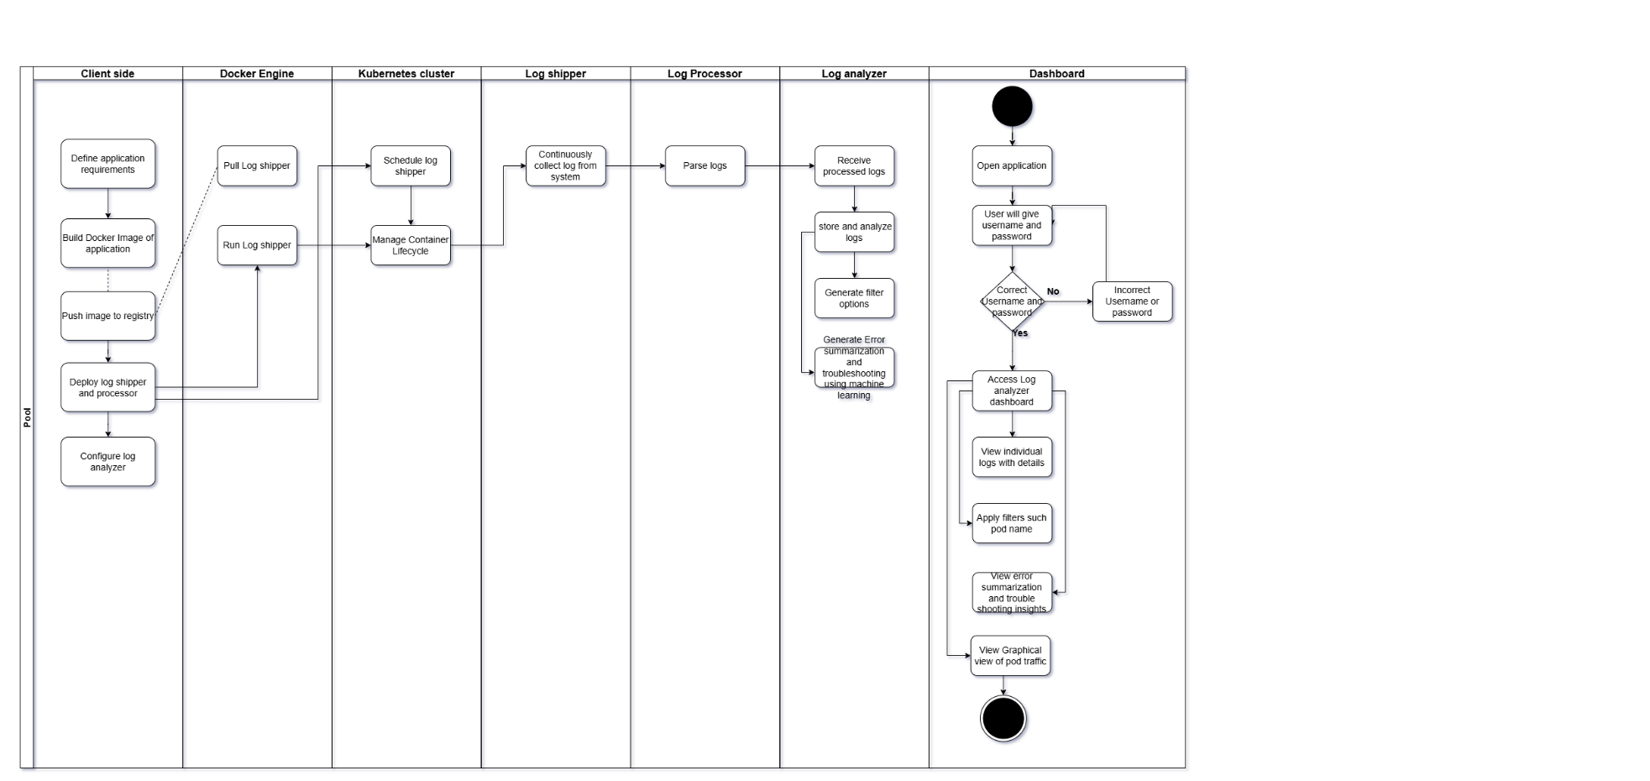

Figure 4: Activity Diagram

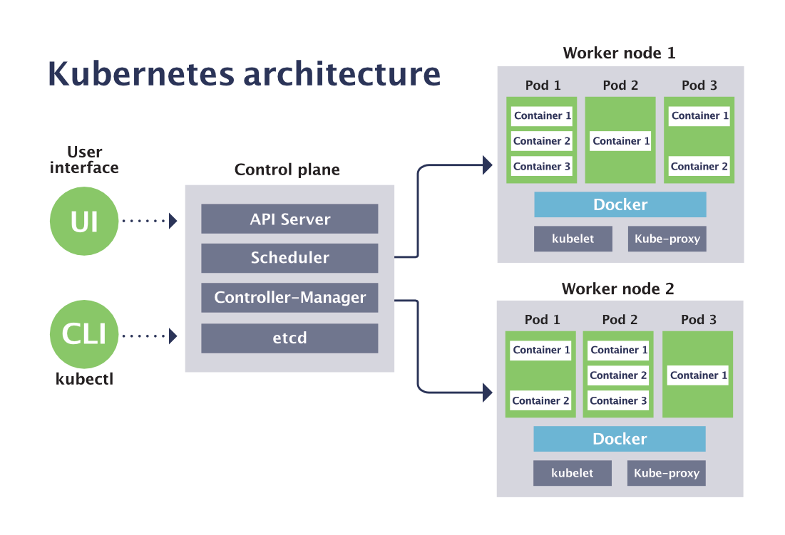

Figure 5: Deployment Digram

**Technology stack:**

1. **Java:**
   * Java is chosen for its robustness, scalability, and platform independence, making it ideal for building the core logic of enterprise-grade applications.
   * Java is used to develop the backend services and business logic of your log monitoring system, providing reliable and efficient data processing capabilities.
2. **Python:**
   * Python is selected for its simplicity, versatility, and extensive ecosystem of libraries and frameworks, particularly in data analysis and machine learning.
   * Python scripts and libraries are employed for tasks such as log analysis, anomaly detection, and error troubleshooting. Machine learning models built with Python may aid in automated error detection and prediction.
3. **Docker:**
   * Docker facilitates containerization, allowing applications to be packaged with all dependencies and run consistently across different environments.
   * Docker is used to containerize various components of your log monitoring system, ensuring portability, scalability, and isolation. Docker images encapsulate application code, dependencies, and configurations for seamless deployment.
4. **Kubernetes:**
   * Kubernetes provides orchestration and management capabilities for deploying, scaling, and managing containerized applications in a distributed environment.
   * Kubernetes serves as the orchestration platform for your containerized log monitoring system. It automates deployment, scaling, and management of application containers, ensuring high availability, resilience, and efficient resource utilization.
5. **Kustomize:**
   * Kustomize simplifies Kubernetes configuration management by enabling customization and parameterization of YAML manifests.
   * Kustomize is integrated into your Kubernetes deployment pipeline to manage configuration files for different environments (e.g., development, staging, production). It allows you to define and apply overlays, patches, and environment-specific settings, streamlining the deployment process.
6. **Django:**
   * Django is chosen for its rapid development capabilities, built-in security features, and scalability, making it well-suited for building web-based management interfaces.
   * Django is utilized to develop the frontend interface of your log monitoring system. It provides a user-friendly dashboard for visualizing log data, configuring alerting rules, and monitoring system health. Django's ORM simplifies database interactions, while its templating engine enables dynamic content rendering.

**Result and Discussion**

**Visualising All Log Documents:**

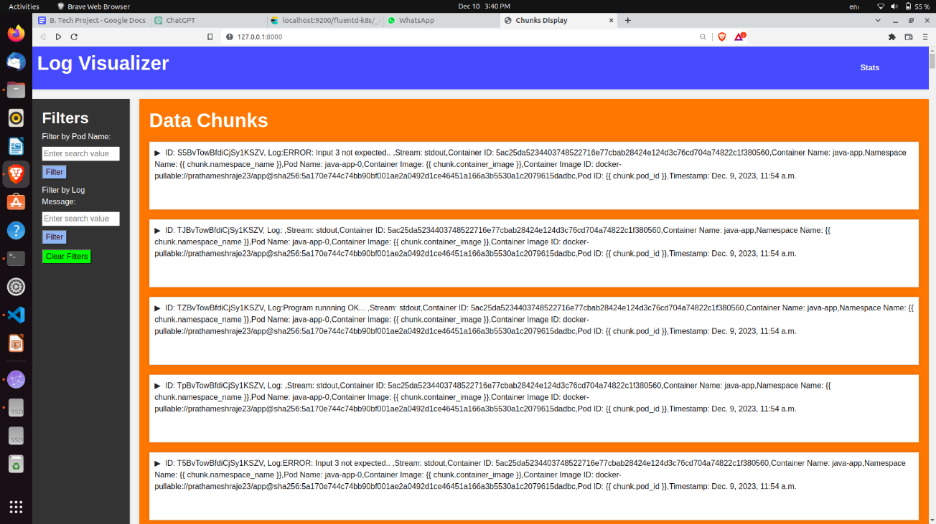

Figure 6: User Interface of LMS

Figure 6 presents the user interface of the Log Monitoring System (LMS), offering users an intuitive platform for log analysis. The dashboard offers a comprehensive overview of logs organized by their unique IDs, facilitating easy navigation and observation of real-time log collection activities conducted by the system. Serving as a centralized hub, the dashboard grants users seamless access to log data, empowering them to monitor system activity and swiftly detect anomalies. Additionally, the dashboard incorporates sidebar filters designed to enhance user experience and streamline data analysis. These filters, located conveniently within the sidebar, allow users to refine their search results based on specific criteria such as pod name and log error message. By leveraging these filtering options, users can efficiently narrow down their focus to relevant log entries, expediting the troubleshooting process and enabling timely resolution of issues. Overall, the user interface of the LMS embodies user-centric design principles, providing a visually appealing and user-friendly environment.

**Detailed View of Single Log Document:**

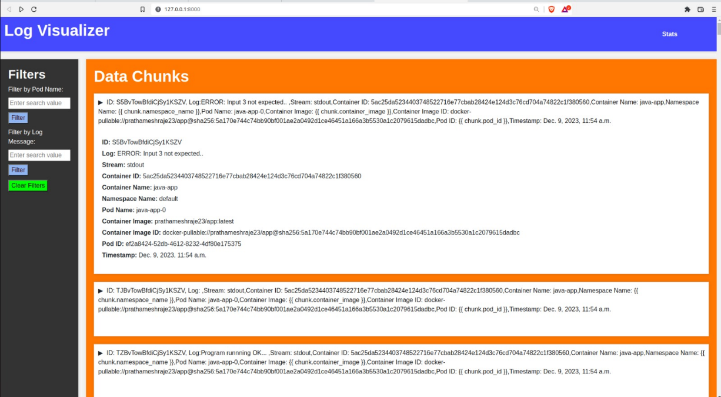

Figure 7: Single Log Document

Figure 7 presents a detailed view of a single log document within the LMS. This view provides users with a comprehensive overview of individual log entries, including various metadata fields and attributes associated with each log event.

Logs are typically categorized by various fields, such as unique IDs, log error messages, container IDs, namespace names, pod names, container names, container image IDs, pod IDs, and timestamps. These fields provide valuable context and information about each log event, enabling users to understand the sequence of events leading up to a particular issue or incident.

The data is stored in JavaScript Object Notation (JSON) format, which allows for structured storage and retrieval of log data. JSON is a lightweight and human-readable data interchange format that is widely used in web applications and APIs. By storing log data in JSON format, the LMS ensures compatibility with various tools and platforms for data processing, analysis, and visualization.

Each log entry is uniquely identified by its characteristics, such as the combination of pod name, container ID, timestamp, and other relevant attributes. This allows users to easily distinguish between different log events and track their progression over time.

The detailed view of a single log document provides users with valuable insights into the nature and context of each log event. By examining the various fields and attributes associated with a log entry, users can diagnose issues, troubleshoot problems, and take appropriate actions to resolve them effectively.

**Applying Filters:**

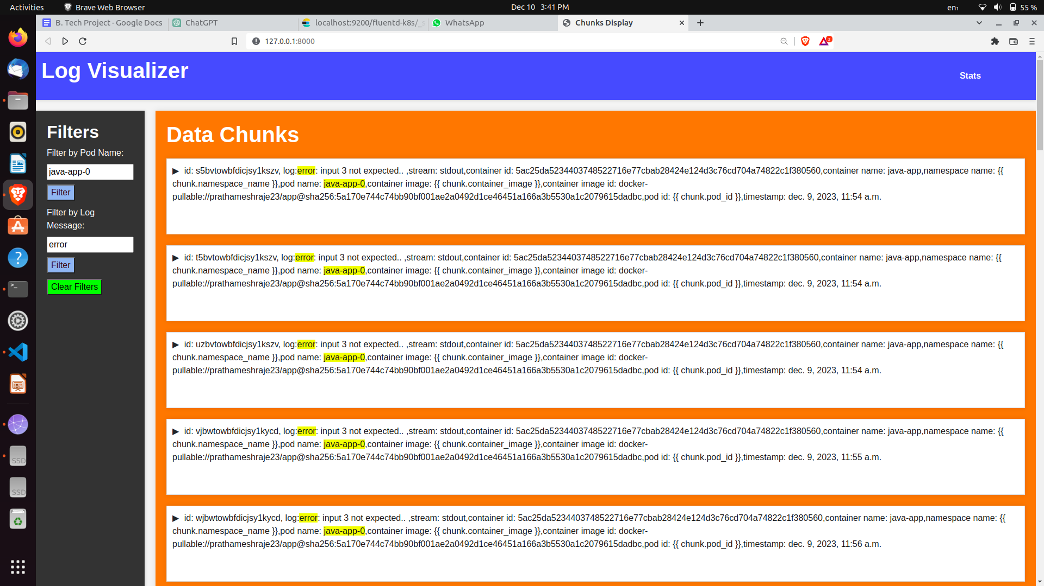

Figure 8: Applied Filters

Figure 8 showcases the practical implementation of filters within the Log Management System (LMS), providing users with the capability to refine and focus their search queries based on specific criteria or parameters. Filters serve as indispensable tools for efficiently navigating vast volumes of log data and pinpointing relevant information promptly. Within the system, two distinct types of filters are employed for data chunks sourced from the system: those filtered by pod-name or log message individually, and those filtered by both simultaneously. Each data field is meticulously stored within HTML elements, and the application of filters is seamlessly executed using the Document Object Model (DOM) properties of HTML to examine particular fields in the data.

Upon the application of filters, the resultant data is elegantly displayed in the dashboard, meticulously organized in a non-increasing order based on timestamps. This meticulous arrangement ensures that users can promptly discern recent issues and prioritize their investigative efforts accordingly. Furthermore, the log message filter incorporates a sophisticated system of built-in messages derived from pattern analysis, significantly enhancing filter accuracy and usability.

In essence, the integration of filter functionalities within the LMS revolutionizes the landscape of log data analysis, empowering users to navigate and dissect log data with remarkable efficiency. This feature not only streamlines the process of identifying and resolving issues but also amplifies the overall usability and effectiveness of the system. By seamlessly extracting actionable insights from log data, users can make informed decisions and drive continuous improvement in system performance and reliability.

**Graphical Representation:**

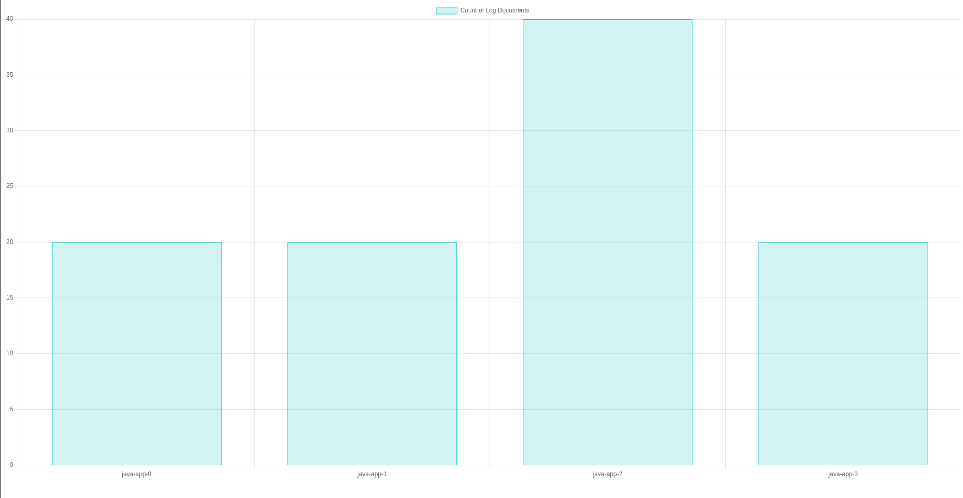

35

30

25

20

15

10

5

0

java-app-0

java-app-2

java-app-3

java-app-1

java-app-0

Figure 9: Graphical Representation (Pod Name VS Count of Logs)

Figure 9 illustrates a graphical representation of log data within the LMS, specifically showcasing the relationship between pod names and the count of logs. Graphical representations, such as charts and graphs, are powerful tools for visualizing trends, patterns, and anomalies in log data.

The graph highlights pods experiencing resource depletion, indicating potential issues within those specific pods. This visual representation aids in promptly identifying and addressing problems affecting pod performance, thereby enhancing system reliability and efficiency.

Graphical representations enable users to quickly grasp complex relationships and trends in log data, making it easier to detect and analyse patterns that may not be apparent from raw log entries alone. By visualizing log data in a graphical format, users can gain valuable insights into system behaviour and performance, enabling them to make informed decisions and take appropriate actions to optimize system performance and reliability.

In the depicted example, the graph indicates a decrease in load at "pod 2," suggesting potential errors or issues within that pod. Kubernetes containers utilize implicit load balancing or scaling mechanisms for pods, with the LMS demonstrating fixed pods for demonstration purposes. By analysing requests, the system identifies and visualizes changes in pod load, enabling users to understand and address issues effectively.

Overall, graphical representations provide users with a powerful tool for visualizing and analysing log data, enabling them to gain valuable insights into system behaviour and performance and make informed decisions to optimize system reliability and efficiency.

**Summarize Text**

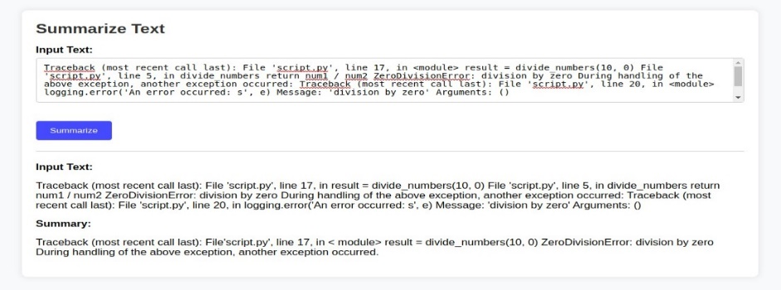

Figure 10: Summarization Text

The integration of BART for text summarization within our log monitoring system has yielded promising results. The generated summaries provide concise representations of the original log data, capturing the essential information while reducing verbosity. This enables operators and analysts to quickly grasp the key insights and trends present in the logs without the need to manually sift through large volumes of text.

* **Improved Efficiency:** The use of BART has significantly improved the efficiency of log analysis by automating the summarization process. Operators can now focus their attention on interpreting the summarized insights rather than spending excessive time on manual log review.
* **Enhanced Visibility:** By presenting the summarized logs alongside the original data in our monitoring dashboard, we have enhanced the visibility of critical information. This allows stakeholders to gain a holistic understanding of system behavior and performance at a glance.
* **Optimized Resource Utilization:** The ability to extract relevant insights from log data efficiently has led to optimized resource utilization within our organization. By streamlining the analysis process, we can allocate resources more effectively to address identified issues and improve system reliability.

**Troubleshoot**

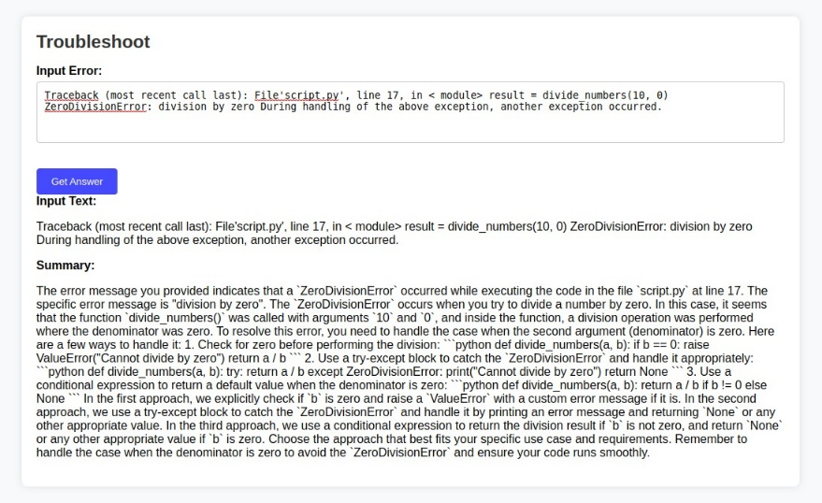

Figure 11: Troubleshoot

The integration of Anthropic's Language Learning Models (LLMs) for error troubleshooting has proven to be invaluable in identifying and resolving issues within our Kubernetes environment. Leveraging the semantic understanding capabilities of Anthropic's LLMs, we have gained deeper insights into the root causes of errors, facilitating prompt resolution and mitigation strategies.

* **Enhanced Error Detection:** Anthropic's LLMs excel in detecting and interpreting error-related patterns within our log data. By analyzing textual information such as error messages and stack traces, the LLMs can identify anomalies and deviations from expected behavior, enabling proactive error detection.
* **Contextual Understanding:** The LLMs' ability to understand the context of error occurrences has been instrumental in providing actionable insights for troubleshooting. By analyzing the surrounding log entries and system events, the LLMs can provide contextually relevant recommendations and solutions for addressing identified issues.
* **Continuous Improvement:** Through iterative feedback loops and model updates, we can continuously enhance the performance of Anthropic's LLMs for error troubleshooting. By incorporating new data and insights, we can refine the LLMs' understanding of our system architecture and error patterns, ensuring ongoing effectiveness in error resolution.

**Email Alerts for Error Notification:**



Figure 12: Alert System

Email alerts serve as a vital component of our log monitoring system, enabling timely notification and response to critical errors and anomalies detected within our Kubernetes environment. By configuring alerting rules to trigger email notifications based on predefined conditions or thresholds, we ensure that relevant stakeholders are promptly informed of any potential issues requiring attention.

* **Prompt Notification:** Email alerts provide a mechanism for prompt notification of critical errors, allowing operators and stakeholders to respond swiftly to emerging issues. By delivering alerts directly to designated email addresses, we ensure that responsible personnel are immediately aware of the situation, regardless of their physical location or presence within the monitoring dashboard.
* **Wide Reach**: Email alerts offer a wide reach across organizational teams and departments, ensuring that all relevant stakeholders are kept informed of critical events. By disseminating alerts via email, we can ensure that key decision-makers, developers, and support personnel are included in the notification process, facilitating coordinated efforts towards issue resolution.
* **Customization and Flexibility:** Email alerting systems offer customization and flexibility in defining alert criteria and recipient lists. This enables us to tailor alerting rules to specific use cases and scenarios, ensuring that only relevant parties receive notifications based on their roles and responsibilities within the organization. Additionally, email templates can be customized to provide contextual information and actionable insights, facilitating rapid response and troubleshooting efforts.
* **Integration with Incident Management:** Email alerts seamlessly integrate with incident management workflows, serving as a catalyst for incident response and resolution. By automatically generating tickets or tasks from email alerts, we can initiate structured incident response processes, track remediation efforts, and ensure accountability throughout the resolution lifecycle.
* **Complementing Real-Time Monitoring:** Email alerts complement real-time monitoring capabilities by providing asynchronous notification channels for critical events. While real-time dashboards offer immediate visibility into system health and performance, email alerts serve as a fallback mechanism for ensuring that no critical issues go unnoticed, even during periods of reduced monitoring activity or off-duty hours.

**Conclusion**

The successful implementation of a comprehensive log monitoring system in a Kubernetes environment using Fluentd as the log collector, Elasticsearch for indexing, and a Django-based user interface marks a significant milestone for enterprise cloud infrastructure. This project aimed to enhance the visibility, management, and analysis of logs generated within the Kubernetes cluster, addressing the critical need for efficient log monitoring and analysis in a scalable and dynamic environment.

In conclusion, the successful implementation of the log monitoring system in our Kubernetes environment significantly enhances our ability to manage, analyze, and derive insights from the vast amount of log data generated within our enterprise cloud. This project sets the foundation for a robust and scalable logging infrastructure, empowering our teams to maintain operational excellence and ensure the security and reliability of our cloud services.

**References**

[1] Chen, Tao, Haiyan Suo, and Wenqian Xu. "Design of Log Collection Architecture Based on Cloud Native Technology." In 2023 4th Information Communication Technologies Conference (ICTC), pp. 311-315. IEEE, 2023.

[2] Hasan, Balqees Talal, and Dhuha Basheer Abdullah. "Real-time resource monitoring framework in a heterogeneous kubernetes cluster." In 2022 Muthanna International Conference on Engineering Science and Technology (MICEST), pp. 184-189. IEEE, 2022.

[3] Chen Chen et al. “Design and Implementation of Dynamic Expansion of Vehicle Real-Time Data Transmission Architecture Based on Kubernetes” Journal of physics (2019): n. pag.

[4] Víctor Medel et al. “Characterising resource management performance in Kubernetes” Computers & Electrical Engineering (2018): n. pag.

[5] Шемякинская, А. С., and И. В. Никифоров. "Hard drives monitoring automation approach for Kubernetes container orchestration system." Труды Института системного программирования РАН 32, no. 2 (2020): 99-106.

[6] Wang, Y., Liu, Y., & Sun, X. (2020). "Efficient Log Analysis Method for Kubernetes based on Fluentd and Elasticsearch." In 2020 International Conference on Information Science, Parallel and Distributed Systems (ISPDS), pp. 115-119. IEEE.

[7] Kumar, S., Sharma, A., & Singh, M. (2021). "An Enhanced Log Monitoring System for Kubernetes Using Fluentd and Elasticsearch." In 2021 International Conference on Emerging Trends in Information Technology and Engineering (ic-ETITE), pp. 1-6. IEEE.

[8] Gupta, R., Patel, K., & Singh, S. (2022). "Scalable Log Monitoring Architecture for Kubernetes with Fluentd and Elasticsearch." In 2022 International Conference on Intelligent Sustainable Systems (ICISS), pp. 843-848. IEEE.

[9] Li, X., Zhou, S., & Zhang, L. (2023). "Log Monitoring System for Kubernetes Clusters Based on Fluentd and Elasticsearch." In 2023 IEEE International Conference on Artificial Intelligence and Computer Applications (ICAICA), pp. 152-157. IEEE.

[10] Yang, J., Li, Z., & Wu, Q. (2024). "A Comprehensive Log Monitoring Framework for Kubernetes Using Fluentd and Elasticsearch." In 2024 International Conference on Cloud Computing and Big Data Analytics (ICCCBDA), pp. 265-270. IEEE.