Azure Databricks workshop – TO Dos

Contents

1. Validate access to Azure 2

2. Create an Azure resource group using az CLI on cloud shell/bash 2

3. Create an Azure storage account using az CLI on cloud shell/bash 2

4. Create storage containers in the storage account using az CLI on cloud shell/bash 2

5. Copy the workshop data to your storage account - storage container nyctaxi-staging 3

6. Provision a blank Azure SQL database in the resource group you created 5

7. Create tables in Azure SQL database from portal query explorer 6

8. Provision Azure Databricks in your resource group, in US East 2 datacenter 7

Appendix 9

A1. Copy all the workshop data with a single command 9

# Validate access to Azure

Ensure you can access your Azure pass, and connect to the Azure subscription provided to you for the workshop. Note: There is just enough credit to do the workshop.

# Create an Azure resource group using az CLI on cloud shell/bash

Name: dew-rg  
Location: US East 2

az group create \

--name dew-rg \

--location eastus2

# Create an Azure storage account using az CLI on cloud shell/bash

Resource group: dew-rg  
Name: dew<yourinitials>sa

az storage account create \

--name <yourStorageAccount> \

--resource-group dew-rg \

--location eastus2 \

--sku Standard_LRS

# Create storage containers in the storage account using az CLI on cloud shell/bash

* 1. Get storage account key listing

az storage account keys list \

--account-name <yourStorageAccount > \

--resource-group dew-rg \

--output table

* 1. Export storage account details

export AZURE_STORAGE_ACCOUNT="<YourStorageAccount>"

export AZURE_STORAGE_ACCESS_KEY="<YourKey>"

* 1. Create storage containers

az storage container create --name nyctaxi-consumption  
az storage container create --name nyctaxi-curated  
az storage container create --name nyctaxi-demo  
az storage container create --name nyctaxi-raw  
az storage container create --name nyctaxi-ref-data  
az storage container create --name nyctaxi-staging  
az storage container create --name nyctaxi-scratch

This is what it should look like in the portal.

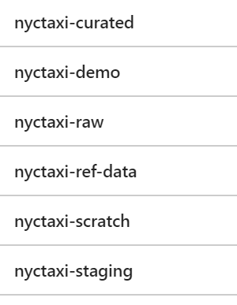

# Copy the workshop data to your storage account - storage container nyctaxi-staging

* 1. Export source storage credentials

These are the storage account details to copy data from. Do not modify this.

export SRC_STORAGE_ACCOUNT="nyctaxidew"

export SRC_STORAGE_ACCESS_KEY="8pzBEhPSUJKcZ+Jol6wWq5wM2RtCQNk75r577kt2ed/LYxmOOiAZdxqN2wMHfN2duhlswqGbT3Pw/YdHtuqngw=="

* 1. Copy reference data

azcopy \

--source https://nyctaxidew.blob.core.windows.net/nyctaxi-staging/reference-data/ \

--destination https://<YourStorageAccount>.blob.core.windows.net/nyctaxi-staging/reference-data/ \

--source-key $SRC_STORAGE_ACCESS_KEY \

--dest-key $AZURE_STORAGE_ACCESS_KEY \

--sync-copy \

--recursive

* 1. Copy transactional data for 2015/2016/2017

azcopy \

--source https://nyctaxidew.blob.core.windows.net/nyctaxi-staging/transactional-data/year=2015/ \

--destination https://<YourStorageAccount>.blob.core.windows.net/nyctaxi-staging/transactional-data/year=2015/ \

--source-key $SRC_STORAGE_ACCESS_KEY \

--dest-key $AZURE_STORAGE_ACCESS_KEY \

--sync-copy \

--recursive

azcopy \

--source https://nyctaxidew.blob.core.windows.net/nyctaxi-staging/transactional-data/year=2016/ \

--destination https://<YourStorageAccount>.blob.core.windows.net/nyctaxi-staging/transactional-data/year=2016/ \

--source-key $SRC_STORAGE_ACCESS_KEY \

--dest-key $AZURE_STORAGE_ACCESS_KEY \

--sync-copy \

--recursive

azcopy \

--source https://nyctaxidew.blob.core.windows.net/nyctaxi-staging/transactional-data/year=2017/ \

--destination https://<YourStorageAccount>.blob.core.windows.net/nyctaxi-staging/transactional-data/year=2017/ \

--source-key $SRC_STORAGE_ACCESS_KEY \

--dest-key $AZURE_STORAGE_ACCESS_KEY \

--sync-copy \

--recursive

5.4. List data copied

az storage blob list \

--container-name nyctaxi-staging \  
--output table

5.5. To copy all the data with a single command  
Refer appendix section A1

# Provision a blank Azure SQL database in the resource group you created

Use a database name and server name that is easy to type up and remember.  
Make a note of the credentials

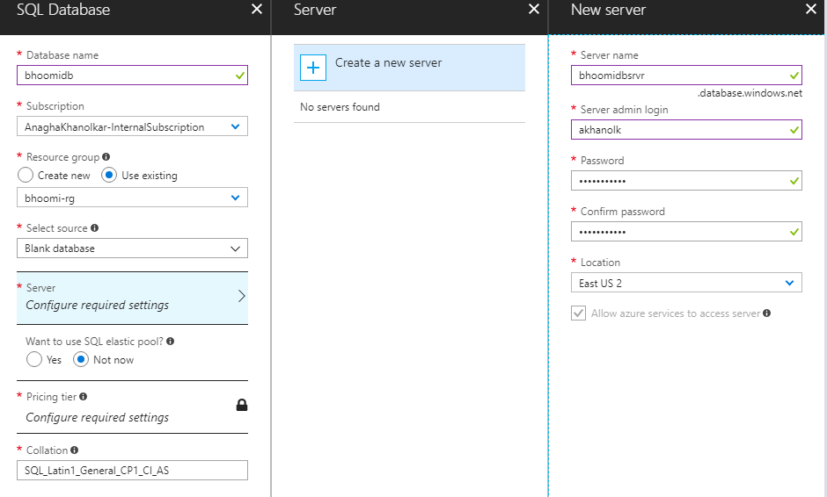

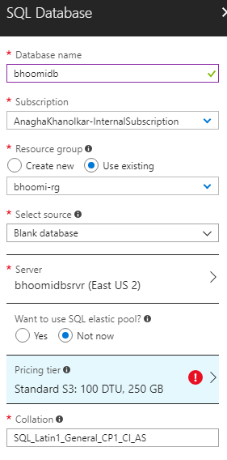

# Create tables in Azure SQL database from portal query explorer

7.1. Trips by year

DROP TABLE IF EXISTS TRIPS_BY_YEAR;

CREATE TABLE TRIPS_BY_YEAR (

TAXI_TYPE VARCHAR(10),

TRIP_YEAR INT,

TRIP_COUNT BIGINT

);

7.2. Trips by hour

DROP TABLE IF EXISTS TRIPS_BY_HOUR;

CREATE TABLE TRIPS_BY_HOUR (

TAXI_TYPE VARCHAR(10),

TRIP_YEAR INT,

TRIP_HOUR INT,

TRIP_COUNT BIGINT

);

7.3. Batch job history

DROP TABLE IF EXISTS BATCH_JOB_HISTORY;

CREATE TABLE BATCH_JOB_HISTORY

(

batch_id int,

batch_step_id int,

batch_step_description varchar(50),

batch_step_status varchar(10),

batch_step_time varchar(25)

);

ALTER TABLE BATCH_JOB_HISTORY

ADD CONSTRAINT batch_step_time_def

DEFAULT CURRENT_TIMESTAMP FOR batch_step_time;

# Provision Azure Databricks in your resource group, in US East 2 datacenter

8.1. Storage account credentials

Make a note of the storage account credentials:  
Name of storage account: e.g. bhoomisa  
Key to storage account: 9S8ZHA……

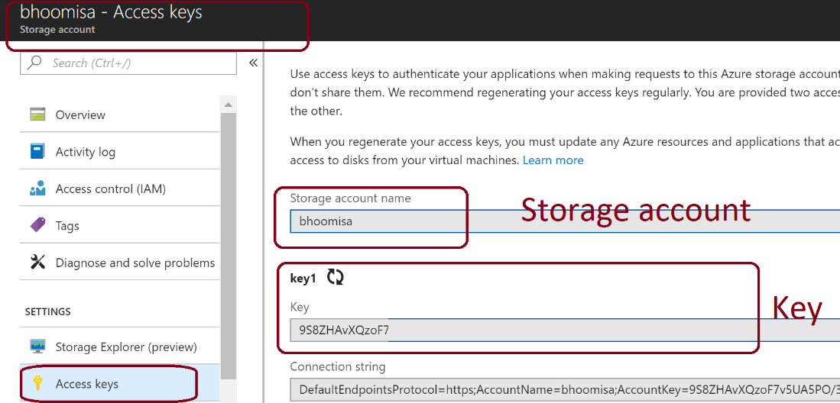

* 1. Provision Databricks and set up a cluster

For the lab – we will use DS13_v2 VM SKU for driver and executors.If you are running against all of the NYC taxi dataset, provision a cluster with DS13_v2 as shown below till you can tune your work to operate with lower SKUs.

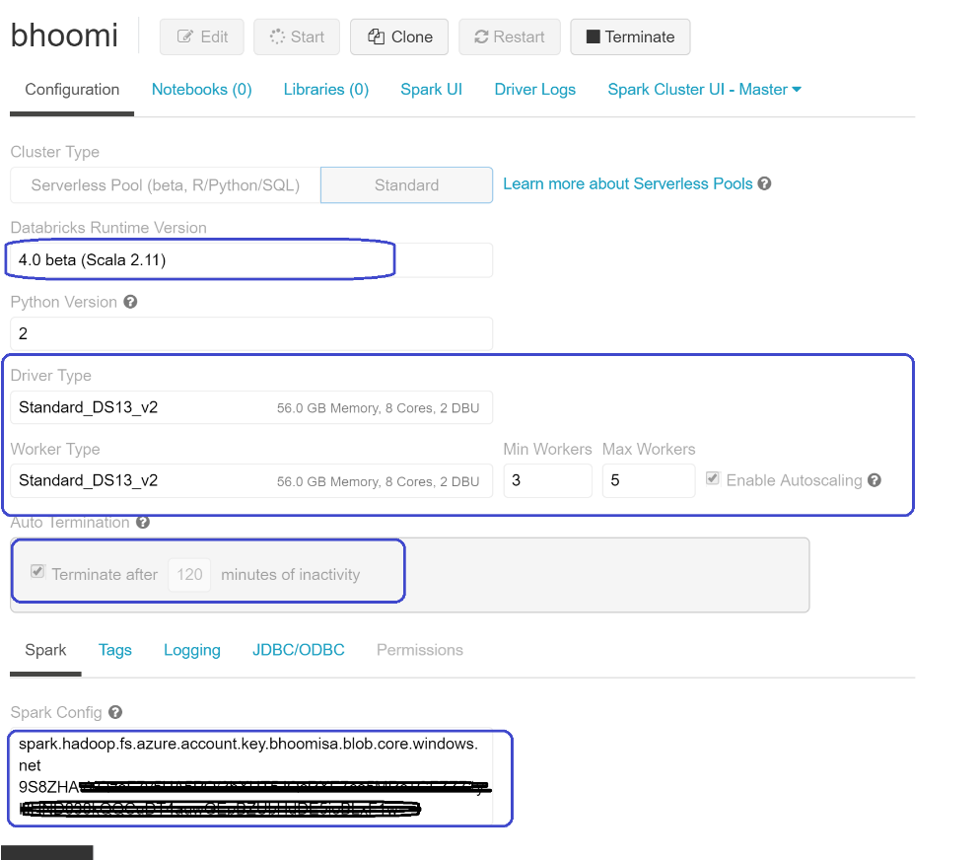

In the Spark config section paste a key value pair that is as follows:

spark.hadoop.fs.azure.account.key.<yourStorageAccount>.blob.core.windows.net <yourKey>

# Appendix

## A1. Copy all the workshop data with a single command

Replace 5.2 and 5.3 with this single command:

azcopy \

--source https://nyctaxidew.blob.core.windows.net/nyctaxi-staging/ \

--destination https://<YourStorageAccountKey>.blob.core.windows.net/nyctaxi-staging/ \

--source-key $SRC_STORAGE_ACCESS_KEY \

--dest-key $AZURE_STORAGE_ACCESS_KEY \

--sync-copy \

--recursive