Azure Databricks workshop – TO Dos

# Validate access to Azure

Ensure you can access your Azure pass, and connect to the Azure subscription provided to you for the workshop. Note: There is just enough credit to do the workshop.

# Create an Azure resource group

Name: mlw-rg  
Location: US East 2

# Create storage account

Resource group: mlw-rg  
Name: mlw<yourinitials>sa

# Create storage containers in the storage account

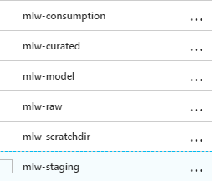

# Download the workshop data to your machine

<https://flightdelayprediction.blob.core.windows.net/workshop-data/WorkshopData.zip>

Unzip the downloaded datasets

1. Install Azure storage explorer in your machine

<https://azure.microsoft.com/en-us/features/storage-explorer/>

Connect to the Azure subscription and navigate to the storage account container, mlw-staging

# Upload the workshop data to the storage container mlw-staging

Using storage explorer, copy the 4 directories to the storage container.

Should look like this..  
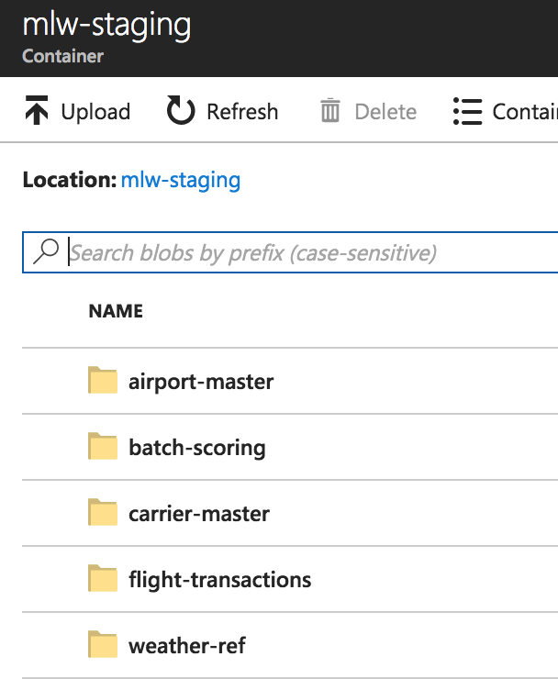

# Provision an Azure SQL database in the resource group you created

Use a database name and server name that is easy to type up and remember.  
Make a note of the credentials

