WIM Terminal — System Overview

Covers the current production path only: basic_interface_ind570.py (PyQt5 GUI) reading from a Mettler-Toledo IND570 weighing terminal wired to a Mettler-Toledo load cell.

1. What the system is
A live weight-display application for a weighbridge/WIM (Weigh-In-Motion) setup:
Mettler-Toledo load cell
│ (analog load signal)
▼
IND570 terminal ← does ADC, scaling, and outputs a weight stream
│ Ethernet (TCP), plain ASCII text
▼
basic_interface_ind570.py ← this application (PyQt5 GUI)
│
▼
On-screen 4-channel display (7-segment style)
The IND570 is the only thing that talks to the load cell directly. The application never touches the sensor signal — it only reads a text stream the IND570 already produces over the network. See ETHERNET_DATA_TRANSMISSION.md for the full detail on that link.

2. Why a "4-channel" layout, with one physical load cell
The UI (ChannelColumn, "4x4 Basic Interface") renders four identical channel columns, but the current hardware is a single IND570 + single Mettler-Toledo load cell feed. All four columns read the same underlying value from SharedState — the 4-channel layout is inherited from an earlier 4-load-cell platform design and kept for UI consistency. There is currently no per-channel hardware wiring; it is one live value replicated across four display columns.

3. Application architecture

3.1 Process / threading model
Component | Type | Responsibility
reader_thread() | Background threading.Thread (daemon) | Owns the TCP socket to the IND570; parses incoming lines; pushes values into SharedState
SharedState | Thread-safe object (threading.Lock) | Holds the latest averaged result, validity flag, byte counter; read/written from both the reader thread and the UI thread
MainWindow (Qt QMainWindow) | Main/UI thread | Builds the window, drives a QTimer at 100 ms to poll SharedState and redraw

The reader thread and the UI thread never touch each other's data directly — everything passes through SharedState's locked push() / snapshot() methods. This is the standard pattern for keeping a Qt UI responsive while a blocking socket read happens elsewhere.

3.2 Startup sequence
- main() creates the QApplication, sets the Fusion style, and constructs MainWindow.
- MainWindow.__init__ builds all UI panels, creates a SharedState(avg_win=100), sets a threading.Event (_running) to signaled, and starts reader_thread as a daemon thread.
- A QTimer fires every 100 ms calling _update_ui(), which is the only place the UI actually reflects new data.
- The reader thread independently loops: connect → read → parse → push, retrying every 2 seconds on failure, for as long as _running stays set.

3.3 Shutdown
MainWindow.closeEvent clears the _running event, which lets the reader thread's loop exit on its next check; the thread is a daemon so it won't block process exit even if it's mid-recv().

4. UI layout
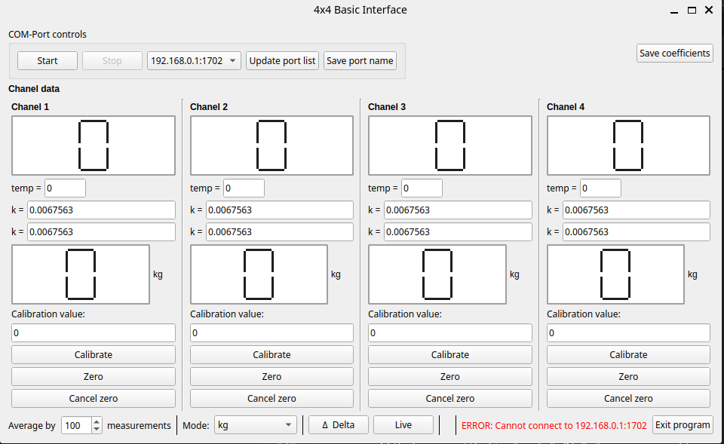

4.1 Top bar — "COM-Port controls"
A QGroupBox with Start / Stop buttons, a port dropdown pre-populated with COM7 and 192.168.0.1:1702, and Update port list / Save port name buttons.
Important: this entire group is cosmetic/legacy. None of these controls read or change the actual connection target — the app always connects to the hardcoded IND570_HOST:IND570_PORT (basic_interface_ind570.py:22-23). Start/Stop do work (they toggle the reader thread via _running), but the COM port dropdown and its buttons are not wired to anything.

4.2 Channel columns (×4)
Each ChannelColumn:
- Title — "Chanel N"
- Top 7-segment display — currently always shows a static "0" (or blank when zeroed); not driven by live data in the current build
- temp = — read-only field, always "0" (no temperature input exists in this system)
- Two "k =" fields — free-text coefficient inputs, default 0.0067563; present in the UI but not read by any calculation in the current code
- Value display (7-segment) + unit label — this is the live figure: shows the averaged/converted weight, updated every 100 ms
- Calibration value field + Calibrate button — sets a per-column additive offset (_cal_offset) applied to that column's displayed value only
- Zero / Cancel zero buttons — per-column blanking (shows " 0" on both displays), independent of the other three columns and independent of the global tare

4.3 Bottom bar
- Average by N measurements (QSpinBox, 1–1000) — live-adjusts the rolling-average window size in SharedState
- Mode dropdown — kg, 2 × kg, Tons, 2 × Tons; scales the live kg value and changes the unit label (see §5)
- Δ Delta — captures current value as a base for all four columns (see §5.1)
- Live — clears the delta base, returns to live display
- Base: … label — shows the currently captured delta base, blank when not set
- Last packages / Bytes on port — status line; shows a red error message if the TCP connection is down
- Exit program — closes the window

5. Modes and calculations
Mode | Displayed value | Unit shown
kg | live averaged kg | kg
2 × kg | live averaged kg × 2 | kg
Tons | live averaged kg (no conversion factor applied) | T
2 × Tons | live averaged kg × 2 | T

Note: Note: "Tons" mode currently displays the same numeric value as kg mode, just with the unit label changed to T — there is no ÷1000 conversion applied in _update_ui or _on_mode_changed. If a true kg→ton conversion is required, this is a code change, not a configuration option.

5.1 Delta (Δ) feature
- Pressing Δ Delta captures the current mode-adjusted value and the current raw kg (_on_delta), storing both as the "base" for every channel column.
- While a base is set, each column's value display shows:
base + (current_raw_kg − base_raw_kg) / 1000
i.e., the base plus a small decimal representing the change since the base was captured — useful for watching small incremental loads relative to a much larger base weight without losing resolution.
- Live clears the base on all columns and reverts to showing the live value directly.

5.2 Per-column Zero / Cancel zero
Independent of Delta: pressing a column's Zero button blanks that column's two displays to 0; Cancel zero resumes normal display. This does not affect the global average, the other columns, or the calibration offset.

5.3 Per-column Calibrate
Typing a number into Calibration value and pressing Calibrate stores it as _cal_offset, added directly to that column's displayed value only (update_value, basic_interface_ind570.py:329-347). It does not affect the underlying averaged kg in SharedState, only what that one column shows.

6. Error / connection states
_update_ui() checks SharedState.valid:
valid | Meaning | UI behavior
0 | No data yet | Status bar unchanged from initial text
1 | Receiving data normally | Status bar shows byte count in black; channel displays update
-1 | Socket exception (connect/read failed) | Status bar shows ERROR: Cannot connect to <host>:<port> in red; channel displays stop updating (last value stays on screen)

The reader thread retries the connection every 2 seconds indefinitely while _running is set — no manual reconnect action is needed if the IND570 or network comes back.

7. Build / packaging
- Entry point: basic_interface_ind570.py
- Dependency: PyQt5 (see requirements.txt)
- Packaging: StrainGauge.spec (PyInstaller) bundles adj_logo_small.png and adj_logo.jpeg alongside the executable, named StrainGauge, windowed (no console)
- CI: .github/workflows/build-windows.yml builds StrainGauge.exe on windows-latest on every push to main and on version tags (v*), uploading it as a workflow artifact and attaching it to the GitHub Release for tagged builds

