**DATA STRUCTURES AND ALGORITHMS PROJECT**



**TOPIC: MULTIPUROPSE SOFTWARE**

**SUBMITTED BY:**

1. **RAJDEEPA CHAKRABARTY 16BCE0732**
2. **NIKHIL JAIN 17BCE2250**

**CONTENTS:**

|  |  |
| --- | --- |
| **ABSTRACT** | **3** |
| **DATA STRUCTURE USED** | **3** |
| **ALGORITHM USED** | **3** |
| **SYSTEM ARCHITECTURE** | **4-5** |
| **SCREENSHOT** | **6-7** |

1. **ABSTRACT:**

We have tried to implement a multipurpose software using which the user is allowed to carry out multiple operations without any user intervention automatically. It runs on a priority basis of the activities as given by the user.

1. **DATA STRUCTURE USED (DOUBLY LINKED LIST)**

Doubly Linked List is a variation of Linked list in which navigation is possible in both ways, either forward and backward easily as compared to Single Linked List. Following are the important terms to understand the concept of doubly linked list.

* **Link** − Each link of a linked list can store a data called an element.
* **Next** − Each link of a linked list contains a link to the next link called Next.
* **Prev** − Each link of a linked list contains a link to the previous link called Prev.
* **LinkedList** − A Linked List contains the connection link to the first link called First and to the last link called Las

1. **ALGORITHM USED:**
   1. **Quick sort**

Quick sort is a highly efficient sorting algorithm and is based on partitioning of array of data into smaller arrays. A large array is partitioned into two arrays one of which holds values smaller than the specified value, say pivot, based on which the partition is made and another array holds values greater than the pivot value.

Quick sort partitions an array and then calls itself recursively twice to sort the two resulting subarrays. This algorithm is quite efficient for large-sized data sets as its average and worst case complexity are of Ο(n2), where **n** is the number of items.

The pivot value divides the list into two parts. And recursively, we find the pivot for each sub-lists until all lists contains only one element.

* 1. **Algorithm:**

**Step 1** − Make the right-most index value pivot

**Step 2** − partition the array using pivot value

**Step 3** − quicksort left partition recursively

**Step 4** − quicksort right partition recursively

* 1. **Why is quick sort used?**

QuickSort is better than other sorting algorithms with same asymptotic complexity O(nlogn) (merge sort, heap sort). Even though quicksort has O(n^2) in worst case, it can be easily avoided with high probability by choosing the right pivot.  
  
1. Its **cache** **performance** is higher than other sorting algorithms. This is because of its in-place characteristic.   
  
2. If Quick sort is implemented well, it will be around **2**-**3 times** **faster** than merge sort and heap sort. This is mainly because that the **operations in the innermost loop**  **are** **simpler**. ( I read this from Algorithm Design Manual Book).   
  
3. No extra memory.

1. **System Architecture :**
   1. **Remove computer virus**

Anti-virus software can be very expensive and doesn't always find new breeds of computer virus. By using the command prompt you can enter the infected drive, locate the virus, render it harmless and delete it from your system for good.

* 1. **Remove write protection**

In write protection mode user is only permitted to view the data in the file. The write facility is disabled.

* 1. **Hide files**

By default Windows hides certain files from being seen with Windows Explorer or My Computer. This is done to protect these files, which are usually system files, from accidentally being modified or deleted by the user. Unfortunately viruses, spyware, and hijackers often hide there files in this way making it hard to find them and then delete them.

* 1. **Checking antivirus working**

If you ever want to test your antivirus software, you can use the EICAR test file. The EICAR test file isn’t an actual virus – it’s just a text file containing a string of harmless code that prints the text “EICAR-STANDARD-ANTIVIRUS-TEST-FILE!” if you run it in DOS. However, antivirus programs are all trained to recognize the EICAR file as a virus and respond to it just as they would respond to an actual virus.

You can use the EICAR file to test your real-time antivirus scanner and ensure it’s going to catch new viruses, but it can also be used to test other types of antivirus protection.

* 1. **Repair corrupted memory card/usb**

A USB flash drives stores all its data in the memory similar to a hard drive. The operating system can, later on, fetch this data when required to be accessed. There can be various issues that may turn your USB drive data inaccessible. Such as if the drive is unmounted improperly from the port then it can lead to data corruption. Another reason for the stores’ data corruption can be invalid data in the Master Boot Record (MBR) or Partition Boot Record (PBR) or directory structure on the USB drive.

There can be various other reasons that may turn your **USB not working**. This may happen either due to physical corruption or logical corruption. The common hardware/physical issues are broken stems and connectors, dead drives (no power supply), broken circuit or NAND gate, not recognised, RAW, need to format, not accessible, and Dead Drives, etc.

* 1. **Recover files from corrupted USB**

We keep a lot of data on memory cards and USB drives. Often, you might even use a high-capacity USB drive as your primary way of [creating backups](https://www.makeuseof.com/tag/best-backup-software-windows/).

When something goes wrong with them, it’s hard not to feel a sense of dread. Is that photo of your dog falling in the swimming pool gone forever?

But alas, you shouldn’t panic. There’s a high chance you can recover your data – you just need to methodically work through few troubleshooting steps

* 1. **Stop internet access**
  2. **Format any drive**

As complicated as that might sound, it's not really difficult to format a hard drive in any version of Windows. This ability is a very basic function that all operating systems have, and Windows makes it pretty easy.

The time it takes to format a hard drive in Windows depends almost entirely on the drive's size, but your computer's overall speed plays a part too.

* 1. **To make your pc talk**

Have you ever wondered how can you make your computer speak whatever you input to it like in the movies? Would it not be fun? If only it was possible! Rejoice, because now it is possible. Well, if you wish to know how to do this, then you have come to the right place. With this trick, you can create a script in Windows which will make your computer speak whatever you input to it.

**Screen Shots 🡪**

Welcome Screen of program

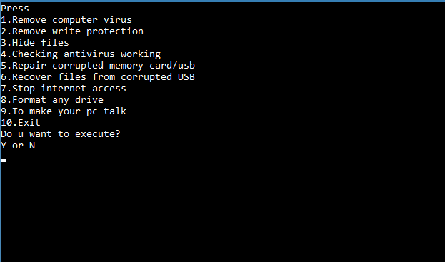

Screen at the time of giving instruction

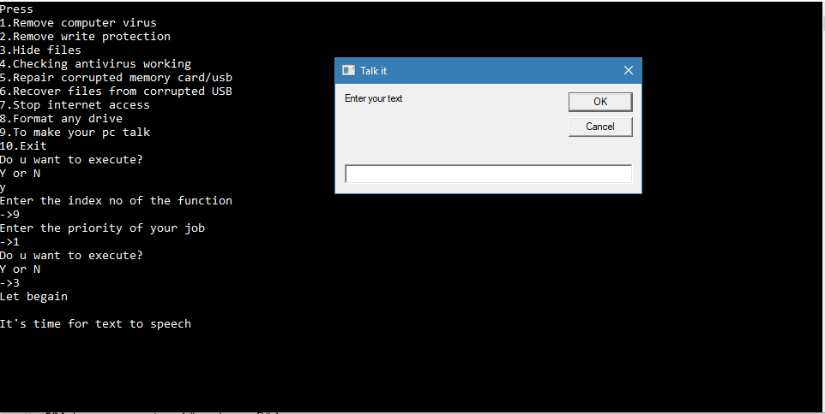

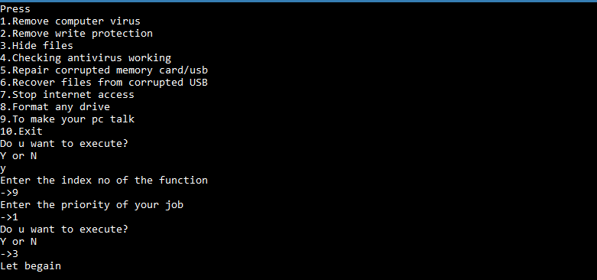

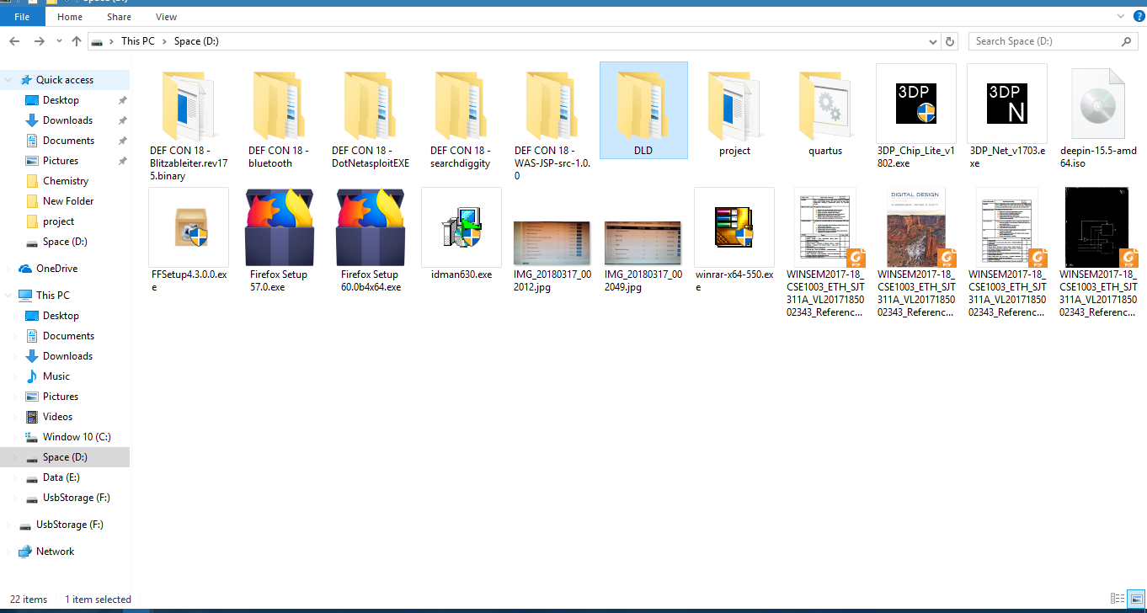

Screen when given job is done

