**EXPERIMENT 1**

**NAME : RAJDEEPA CHAKRABARTY REG NO: 16BCE0732**

1. **TAGS USED IN MY RESUME WEBSITE AND REFERENCES:**
2. <!DOCTYPE> (1ST PAGE AND ALL OTHERS)
3. <html> (1ST PAGE AND ALL OTHERS)
4. <head> (1ST PAGE AND ALL OTHERS)
5. <title> (1ST PAGE AND ALL OTHERS)
6. <body> (1ST PAGE AND ALL OTHERS)
7. <frameset> (1ST PAGE)
8. <frame> (1ST PAGE)
9. <noframes> (1ST PAGE)
10. <a> (2ND PAGE AND MANY OTHERS)
11. <style> (2ND PAGE AND MANY OTHERS)
12. <center> (3RD PAGE AND MANY OTHERS)
13. <font> (4TH PAGE,6th PAGE AND MANY OTHERS)
14. <p> (4TH PAGE AND MANY OTHERS)
15. <sup> (5TH PAGE)
16. <table> (2ND PAGE,5TH PAGE AND MANY OTHERS)
17. <th> (5TH PAGE AND MANY OTHERS)
18. <tr> (2ND PAGE,5TH PAGE AND MANY OTHERS)
19. <td> (2ND PAGE,5TH PAGE AND MANY OTHERS)
20. <tbody> (6th page)
21. <img> (2ND PAGE)
22. <div> (3RD PAGE AND MANY OTHERS)
23. <b> (6TH PAGE)
24. <u> (6TH PAGE)
25. <hr> (5TH PAGE AND MANY OTHERS)
26. <h1> <h3> (3RD PAGE AND MANY OTHERS)
27. <ol> (5TH PAGE)
28. <ul> (6TH PAGE AND MANY OTHERS)
29. <li> (5TH,6TH PAGE AND MANY OTHERS)
30. <form> (10TH PAGE)
31. <input type=”text”> (10TH PAGE)
32. <input type=”radio”> (10TH PAGE)
33. <input type=”button”> (10TH PAGE)
34. <select> (10TH PAGE)
35. <options> (10TH PAGE)
36. <textarea> (10TH PAGE)

I have also used css styles in some of my pages like the 10th page and many others.

1. **CODES :**
2. **1ST PAGE:**

In this page I have used framsets and frames . I have also used an embedded style to include a background image in one of the frames.

<!DOCTYPE html>

<html>

<head>

<title>HTML Target Frames</title>

<style>

.image{

background-image:url("https://media.giphy.com/media/TxVVB6PfWMjE4/giphy.gif");

}

</style>

</head>

<frameset rows="110,*">

<frameset cols = "*">

<frame src = "persinfo.html" name = "menu_page" noresize="noresize" scrolling="no" />

</frameset>

<frameset cols = "300, *">

<frame src = "1pg.html" name = "menu_page" />

<frame src="myimg.html" name = "main_page" noresize="noresize" scrolling="no" />

<noframes>

<body>Your browser does not support frames.</body>

</noframes>

</frameset>

</frameset>

</html>

1. **2ND PAGE:**

In this page I have used embedded style for body selector to set margins.

I have used tables with border,width and height properties. tr,td,th,img, a href displaying the link of my mail are the others tags used in this page.

<!DOCTYPE HTML>

<html>

<head>

<title>My Resume</title>

<style>

body{

margin-left:35px;

margin-right:35px;

}

</style>

</head>

<body text="black" bgcolor="silver">

<table border="0" width="100%" height="20%">

<tr>

<th align="left">

Name :RAJDEEPA CHAKRABARTY<br/>

Birth-date:11-04-1998<br/>

Address :Kolkata,West Bengal<br/>

Phone No :9787888446<br/>

Mail :<a href="mailto:chakrabartyrajdeepa11@gmail.com">chakrabartyrajdeepa11@gmail.com</a><br/>

</th>

<td align="right">

<img src="C:/Users/lenovo/Pictures/rajdeepa.jpg" width="100" height="100" />

</td>

</tr>

</table><br/>

</body>

</html>

1. **3RD PAGE:**

Embedded style has been used with properties like font-family,font-size, text-align,margin,background-color,text etc. center tag has been used. a tag is used to open the various pages in the target frame.div tag is used to create a box model.

<!DOCTYPE html>

<html>

<head>

<title>MY RESUME</title>

<style>

.raj{

font-family:sans-serif;

font-size:25px;

text-align:center;

margin: 75px;

}

.color1{

background-color:black;

text:white;

}

</style>

</head>

<body bgcolor="white">

<center><h1 id="logo">MY RESUME</h1><center/>

<div class="raj">

<a href="edu.html" target="main_page">Education</a></li><br/><br/>

<a href="skill.html" target="main_page">Skills</a></li><br/><br/>

<a href="pro.html" target="main_page">Projects</a></li><br/><br/>

<a href="expe.html" target="main_page">Achievements</a></li><br/><br/>

<a href="preprof.html" target="main_page">Preprofessional Experience</a></li><br/><br/>

<a href="apl.html" target="_blank">Apply</a></li><br/><br/>

</div>

</body>

1. **4TH PAGE:**

In this page embedded style to set backgroung image has been used. font tag is used with properties like font-face and font-family. a tag is used to provide a link to my github.

<!DOCTYPE HTML>

<html>

<head>

<style>

body{

background-image:url("stars.gif");

}

</style>

</head>

<body text="white">

<font size="10px" font face="Times New Roman"><p align="center">ABOUT ME</p></font>

<font size="6px" font face="Times New Roman"><p style="margin:35px">I am a third year Btech CSE student at VIT,Vellore.I love coding and debugging.I am a java enthusiast.I take interest in data science as well. My passion is dance and music.Have a look at my CV.<br/>

ThankYou.<br/>

<blink>Visit my github profile</blink><br/>

<a href="rajdeepa.gihub.com">github</a></p></font>

</body>

</html>

1. **5TH PAGE:**

<!DOCTYPE HTML>

<html>

<head>

<title>My Resume</title>

<style>

body{

margin-left:35px;

margin-right:35px;

}

</style>

</head>

<body text="black">

<h2>ACADEMIC HISTORY</h2>

<hr>

<font size="4px" font face="Times New Roman"><table border="0" width="100%">

<tr bgcolor="aqua">

<td align="left">

<ol>

<li>VELLORE INSTITUTE OF TECHNOLOGY,VELLORE,TAMIL NADU<br/>

Btech in Computer Sc. and Engineering</li><br/>

<li>BHAVANS GANGABUX KANORIA VIDYAMANDIR,KOLKATA,WEST BENGAL<br/>

12<sup>th</sup>CBSE</li><br/>

<li>OUR LADY QUEEN OF THE MISSIONS,KOLKATA,WEST BENGAL<br/>

10<sup>th</sup>ICSE</li><br/>

</ol>

</td>

<td align="right">

July,2018,Present<br/>

9.63/10<br/><br/>

May,2014-Feb,2016<br/>

92%<br/><br/>

March,2001-April,2016<br/>

95.6%<br/><br/>

</td>

</tr>

</table></font><br/>

<a href="myimg.html">Go back to home page</a>

</body>

</html>

1. **6TH PAGE:**

<!DOCTYPE HTML>

<html>

<head>

<title>My Resume</title>

<style>

body{

margin-left:35px;

margin-right:35px;

}

</style>

</head>

<body text="black">

<h2>SKILLS</h2><hr>

<font size="6px" font face="Times New Roman"><table bgcolor="aqua" border="0" width="40%">

<tbody>

<tr>

<td align="left"><b><u>Technical Skills</u></b><br/>

<ul>

<li>Programming(Java,C,Python,html,javascipt,PHP,MySql)</li>

<li>Microsoft Office(Word,Excel,Powerpoint)</li>

</ul>

</td>

</tr>

<tr>

<td align="left"><b><u>Personal Skills</u></b><br/>

<ul>

<li>Verbal and written communication skills</li>

<li>Organised and efficient</li>

<li>Ability to work independent or as a part of a team</li>

<li>Ability to motivate</li>

</ul></td>

</tr>

</tbody>

</table></font>

<a href="myimg.html">Go back to home page</a>

</body>

</html>

1. **7TH PAGE:**

<!DOCTYPE HTML>

<html>

<head>

<title>My Resume</title>

<style>

body{

margin-left:35px;

margin-right:35px;

}

.col{

background-color:aqua;

}

</style>

</head>

<body text="black">

<h2>PROJECTS</h2><hr>

<div class="col">

<font size="6px" font face="Times New Roman"><ul>

<li>Developed an online auction website for sellers and bidders using php and mysql</li>

<li>Developed a multi purpose program using c and windows command line</li>

</ul></font>

</div>

<a href="myimg.html">Go back to home page</a>

</body>

</html>

1. **8TH PAGE:**

<!DOCTYPE HTML>

<html>

<head>

<title>My Resume</title>

<style>

body{

margin-left:35px;

margin-right:35px;

}

.col{

background-color:aqua;

}

</style>

</head>

<body text="black">

<h2>ACHIEVEMENTS</h2><hr>

<div class="col">

<font size="6px" font face="Times New Roman"><ul bgcolor="aqua">

<li>Won 3rd price in DATABASE MANAGEMENT HACKATHON conducted by school SCOPE in 2017.</li>

</ul></font>

</div>

<a href="myimg.html">Go back to home page</a>

</body>

</html>

1. **9TH PAGE:**

<!DOCTYPE HTML>

<html>

<head>

<title>My Resume</title>

<style>

body{

margin-left:35px;

margin-right:35px;

}

.col{

background-color:aqua;

}

</style>

</head>

<body text="black">

<h2>PRE PROFESSIONAL EXPERIENCE</h2><hr>

<div class="col">

<font size="6px" font face="Times New Roman"><p bgcolor="aqua"><b>Data analyst Intern at APT SOFTWARE AVENUES,KOLKATA.</b>(7th May,2018-16th June,2018)<br/>

(Worked on Data Analysis and Data Prediction)</p></font>

</div>

<a href="myimg.html">Go back to home page</a>

</body>

</html>

1. **10TH PAGE:**

<!DOCTYPE HTML>

<html>

<head>

<title>

Job Application

</title>

<style>

body{

margin:35px;

}

#bt

{

background-color:green;

height:50px;

width:100px;

}

</style>

</head>

<body bgcolor="yellow" align="center">

<h1 align="center">Job Application Portal</h1>

<form action="">

<table border="0" width="40%" align="center">

<tr>

<td>First name:</td>

<td> <input type="text" name="firstname" required/><br/><br/></td>

</tr>

<tr>

<td>Last name:</td>

<td><input type="text" name="lastname" required/><br/><br/></td>

</tr>

<tr>

<td>Gender:</td>

<td> <input type="radio" name="gender" value="male" align="center" checked> Male<br/>

<input type="radio" name="gender" value="female" align="center"> Female<br/>

<input type="radio" name="gender" value="other" align="center"> Other<br/><br/></td>

</tr>

<tr>

<td> Companies:</td>

<td> <select name="companies">

<option value="sel" selected>Select Company</option>

<option value="wipro">WIPRO</option>

<option value="tcs">TCS</option>

<option value="techmahin">TECH MAHINDRA</option>

<option value="cog">COGNIZENT</option>

</select><br/><br/></td>

</tr>

<tr>

<td> Job Type:</td>

<td> <select name="companies">

<option value="sel" selected>Select job type</option>

<option value="wipro">WEB DEVELOPER</option>

<option value="tcs">BACKEND DEVELOPER</option>

<option value="techmahin">MANAGER</option>

</select><br/><br/></td>

</tr>

<tr>

<td>CV Link</td>

<td><input type="text" name="cv" value="Paste ur cv link here" required/></td>

</tr>

</table>

</form>

<p> Why should you be offered the job?</p>

<textarea name="message" rows="10" cols="50">

Write at least 100 characters.

</textarea>

<br/>

<br/>

<button id="bt" type="button" onclick="Submitted">SUBMIT</button>

</body>

</html>

1. **SCREENSHOTS:**

**HOME PAGE**

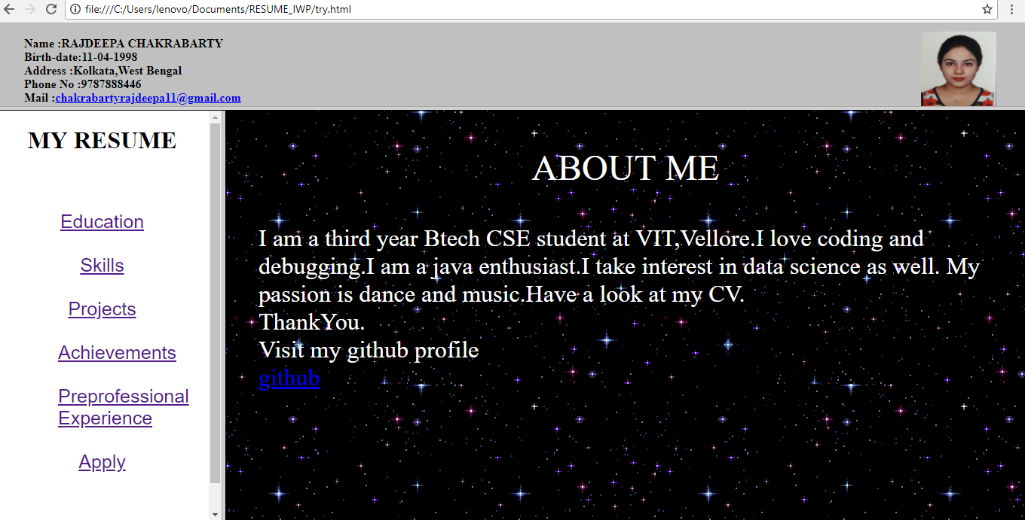

**EDUCATION PAGE**

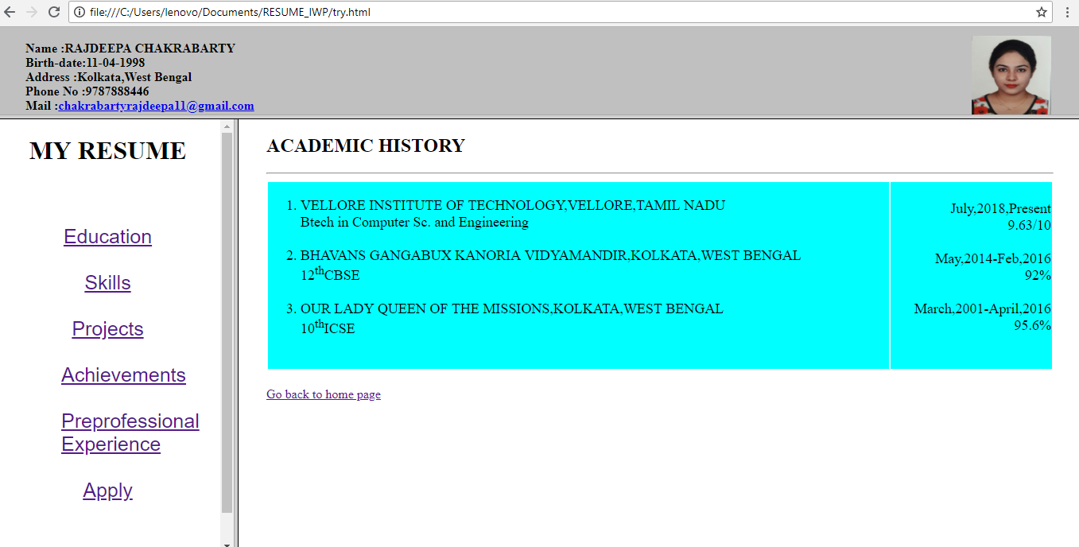

**SKILLS PAGE**

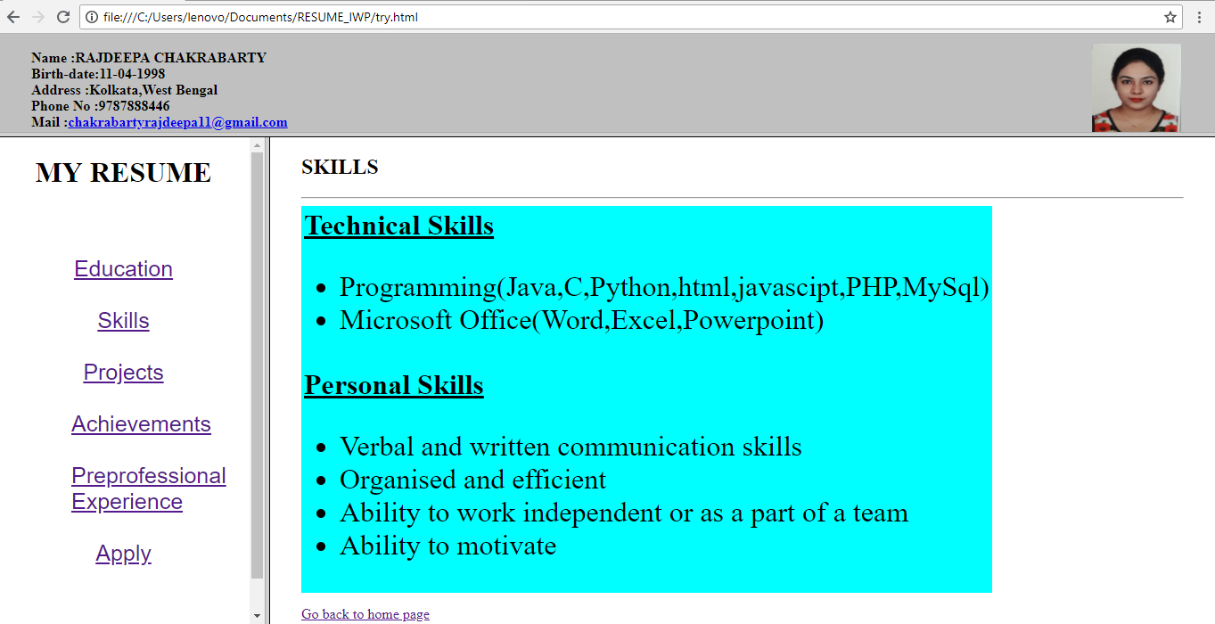

**PROJECTS PAGE**

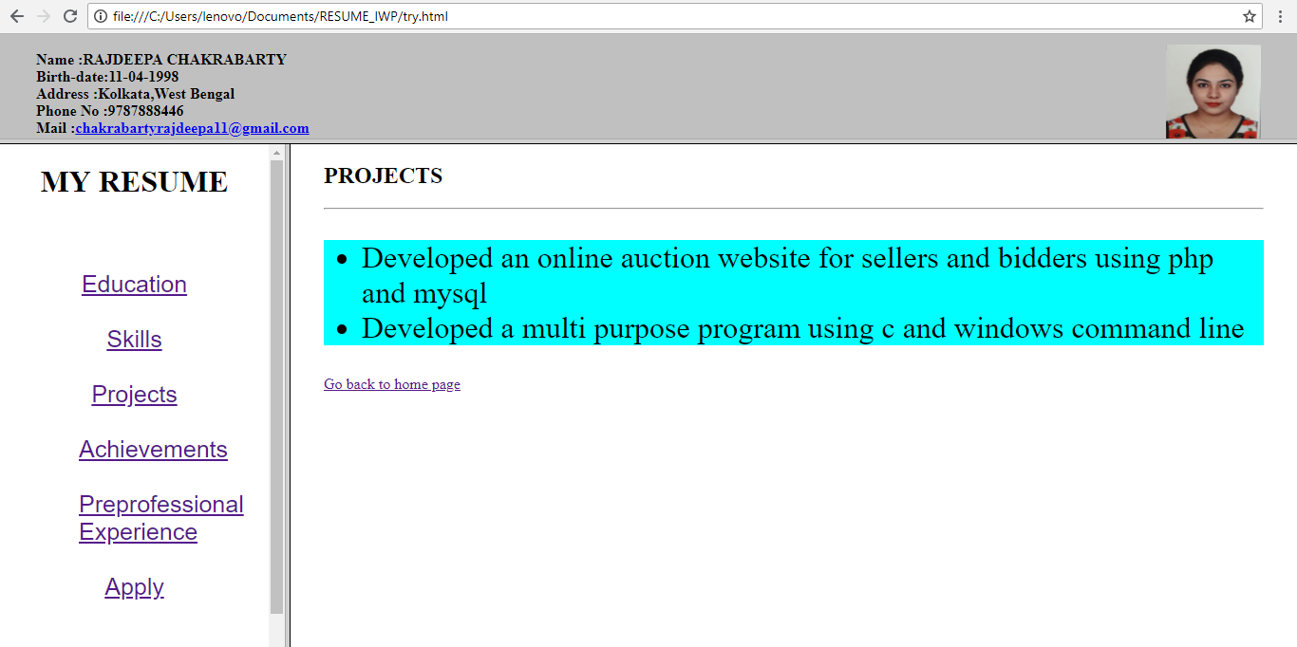

**ACHIEVEMENTS PAGE**

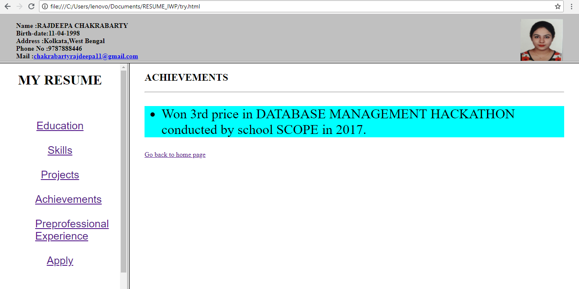

**PREPROFESSIONAL EXPERIENCE PAGE**

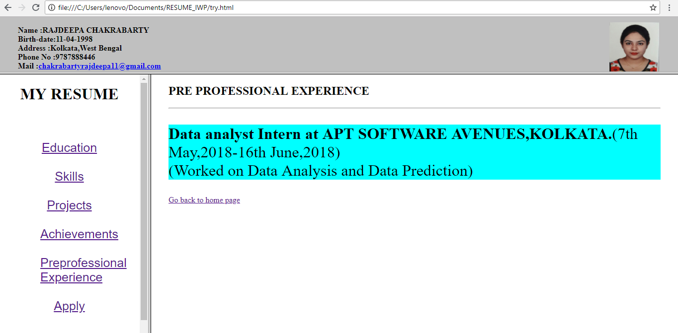

**JOB APPLICATION PAGE**

