COLLISION PATTERNS IN MONTGOMERY COUNTY, MARYLAND STATE
A Study of Seasonal Trends, Role of Speed and Route Safety.

GROUP 3

1. Introduction and Background
Our project is titled “Collision Patterns in Montgomery: A Study of Seasonal Trends, Role of Speed and Route Safety”.
a. Motivation: Hazardous Road conditions threaten many lives around the world. Every year, road crashes account for more than 1.2 million deaths worldwide and even more serious, non-fatal injuries (Rolison, 2020). In places like Texas (and many others world over), robust public transportation infrastructure is sparse, necessitating individuals to commute on their own to fulfill responsibilities, access services and ensure a dignified quality of life. Analyzing such Traffic Collisions datasets can help identify patterns amongst conditions that engender perilous accidents. Our motivation is to create a compelling narrative and story from a complex dataset through effective visualizations to convey the urgency of road safety and accident prevention. These insights can then be applied in the form of policies and traffic interventions during various conditions.
b. Context and Relevance: Within the field of Traffic and Collision Studies, data visualization plays a crucial role in transforming large and obscure data into intelligible visuals. This facilitates efficient analysis and data-backed decision-making. Scholars have concluded that data “efficiently represents distributions and structures of traffic data, revealing hidden patterns and improving the performance of transportation systems” (Wi Chen et al., 2015). Such techniques can be integrated with more advanced technologies such as Principal Component Analysis and Multidimensional Scaling to process multidimensional information across large datasets (Ruan et.al, 2018).
ANY CHANGES: NO (The Introduction and Background remains the same as discussed in Project Part I and Part II.)
c. Objectives and Queries:
Learning Objectives:
- To analyze the Traffic Collisions dataset using data visualization techniques to derive insights.
- To identify factors leading to collisions based on observations, and plan strategies to narrow down the areas needing improvement.
- To recognize accidents hotspots upon careful analysis of dataset.
- To identify drivers’ behavior patterns that lead to collisions and suggest preventive measures.
- To examine relationships between various road and weather conditions, vehicle attributes and collisions.
d. Benefit: Our project can benefit local governments, municipal transportation departments and stakeholders engaged in public safety to raise awareness about collisions across various conditions and intervention measures.
ANY CHANGES: NO (The Objectives also have remained the same, and thankfully helped us remain in line in order to formulate research questions and achieve the final outcome.)
2. Objectives and Goals
Project Goals: Our queries changed based on our learnings and effort to generate insights from the dataset. We determined the following as our queries to answer with visualizations.
- Trends:
  - In which days of the week are there more instances of collisions?
  - How does this data compare over the years?
- Geographic Analysis: Which areas experience more collisions? Does the data highlight hotspots?
- Substance Abuse: How does the usage of various substances affect collision and injury severity?
- Presence of traffic lights and stop signs: Is there a difference in collisions’ occurrence and severity based on the presence or absence of traffic interventions?
- Route Types: Are certain route types more hazardous?
- Weather Impact: Do different weather conditions and subsequent road conditions affect crash/injury severity?
- Vehicle Type: What might this dataset determine about the reliability, or the vulnerability of various auto makers?
ANY CHANGES: NO
3. Datasets
Useful Data characteristic: Crash date and Road names turned out to be very useful attributes as they gave the project the basis for attempting various visualizations as they acted as point of references.
Challenging characteristics: Majority of the data values were dimensions; therefore, additional thought and effort was put plan t creation measures as derived values. It was required for the application of Visualizations as many charts cannot be used without measures values.
Limitation of Dataset
1. Data has been analysed from a single county, had we attained records of other counties or the complete State, it would have added comprehensive details to the analysed report. The broader scope could have offered a more holistic understanding of statewide trends and comparisons.
2. Additionally, the number of available measure values was limited. To enhance the depth of our analysis, we created derived values based on impact scores, adding greater insight to the visualizations.
4. Visualization, Design and Discussion
ANY CHANGES: YES
STORYLINE- The Zero Death Initiative as passed by the Maryland State Government formed as out inspiration to plan the story as it appeared relevant to plan the actions ahead based on the current plan as laid by government and analyse the success rate of the same and make recommendations. Our Project focussed on Montgomery County (due to availability of dataset), and compared the trends, and effectiveness of the initiative. We applied key concepts such a comparison, trend analysis, and forecasting to find answers to questions we asked in initial projects.
- The Worksheet 1 titled ‘Year by Year Crash Count’ shows the year over year trend of collisions from 2021 to 2023.
But on receiving feedback about a problem area (since dataset only includes records for till the month of September for the year 2023, therefore it cannot show a correct trend). It has been updated with the Visualization as shown below titled ‘Month by Month Crash Trend Over the Years’.

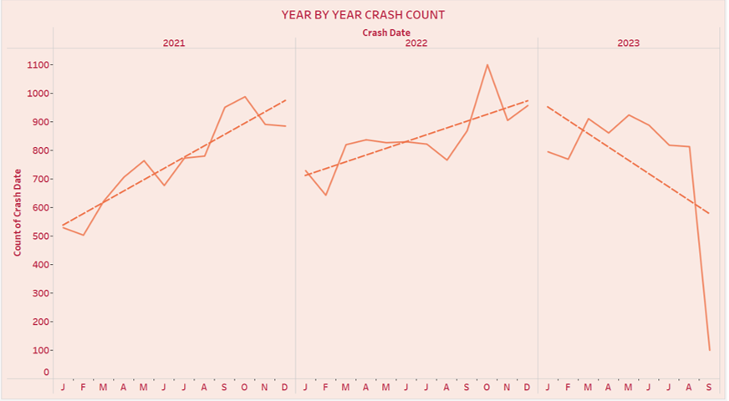

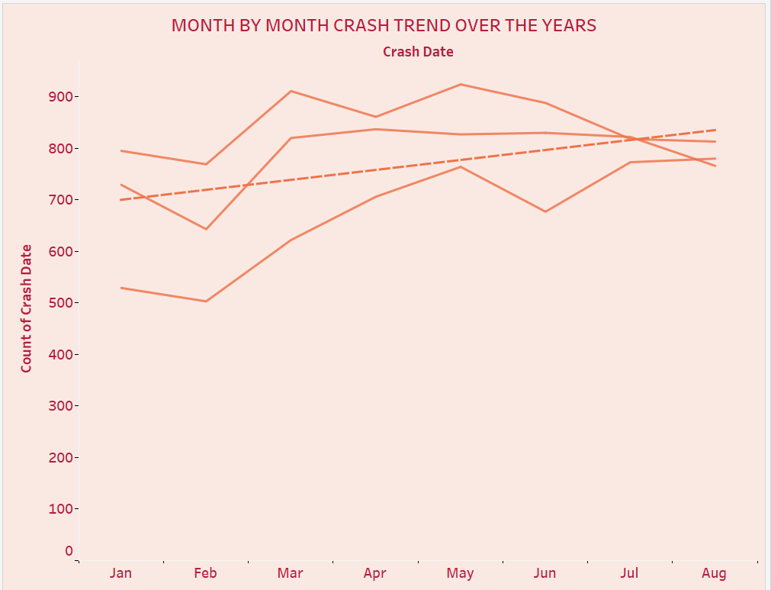
- Another Visualization titled ‘Substance Abuse Crashes by Time of Day’ was changed on receiving feedback, as it was mentioned that such an analysis will be read better when shown through a Line Chart.
A line chart has been introduced with the same Title, also speed limit has been added as a measure value in columns as Line chart could not be applied otherwise.

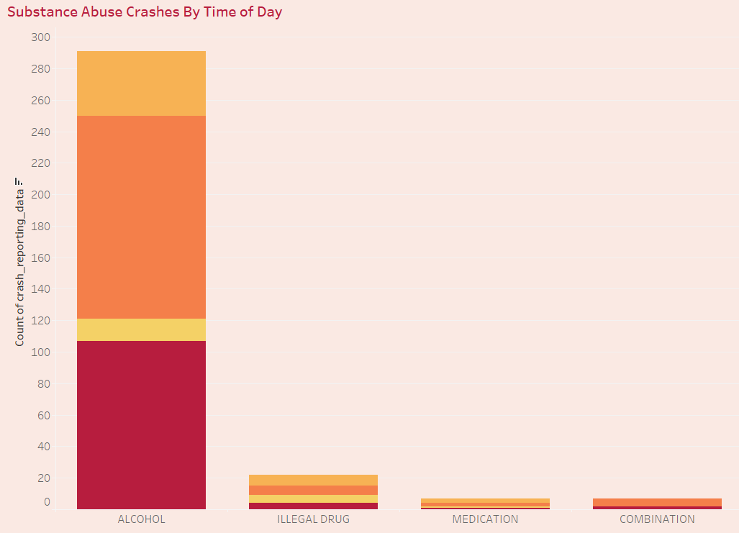

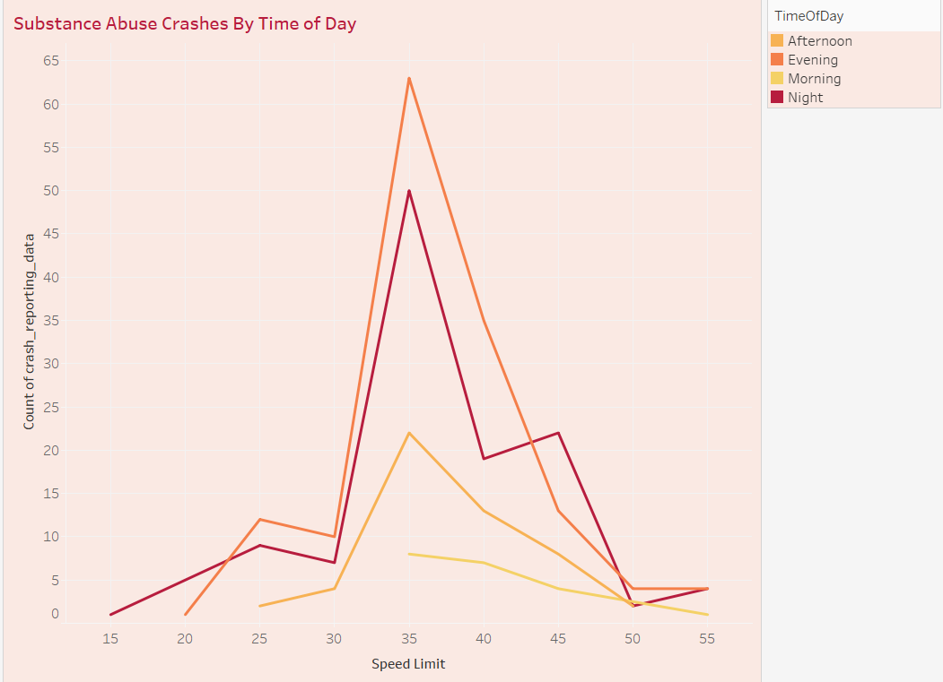

Storytelling Aspect:
The Visualizations have been created to accomplish two of the objectives as outlines by the Maryland State Highway Control Department.
Infrastructure & Impaired Driving

Dashboard 1:
The first set of Visualizations were created to form a Dashboard that draws attention to these three points;
- Timeline: A monthly trend of Crashes to shown over the years and it clearly emphasises that as the year moves towards the ending, the number of collision cases also increase, it shows an upward trend.
- Hotspot regions: The road names that faced the maximum collisions were annotated through a map chart. Top ten roads by collision frequency were filtered to receive the result.
- Causes: The causes for such increase in cases at these regions were attempted to be found using attributes such as “Driver at Fault” and “Traffic Control”

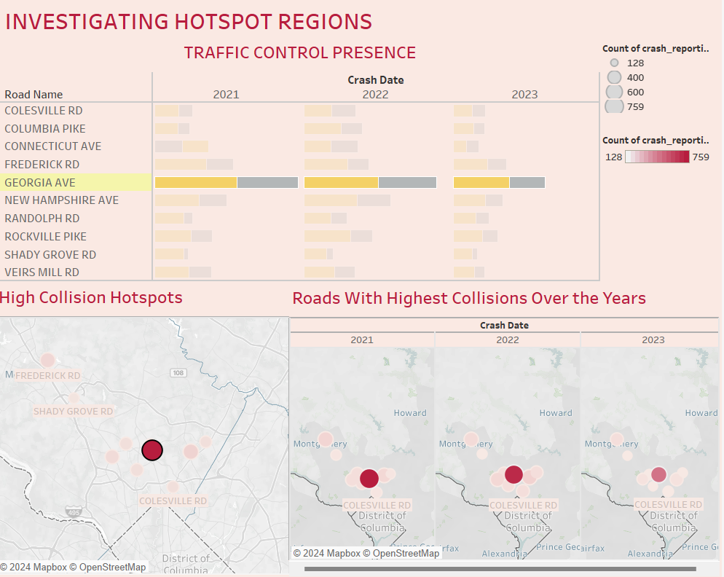

DASHBOARD 2
The next set of worksheets focussed on these hotspot regions (as identified in Dashboard 1) and further focused on finding the impact of intake of substance of any kind on the injury and crash severity, Also, factors such as the time of the day and day of the Week were studied to estimate the peak hours and days that may help in forming policies or safety measures to reduce the number of accidents.

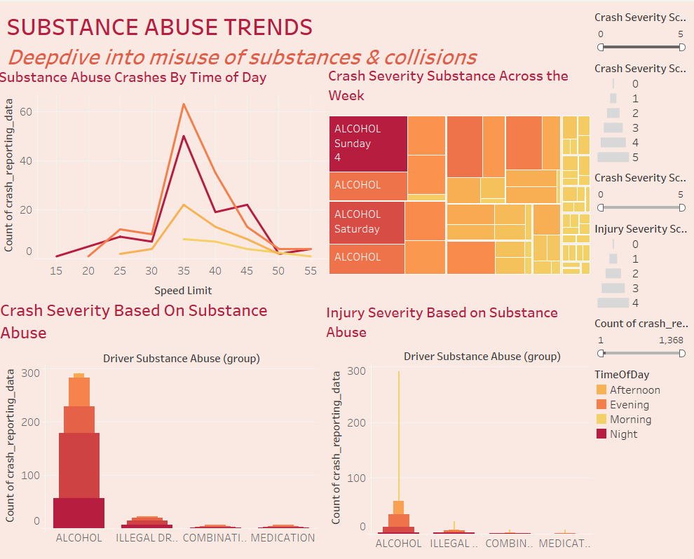
5. Conclusion
Overall Progress of the Project Explained
In Part I, we delved into foundational Tableau visualization techniques, exploring various chart types and their practical applications. The most intriguing and impactful were dual-axis synchronized charts and bar-in-bar charts, which allowed us to effectively present multiple ideas within a single, cohesive visual representation.
In Part II, we delved deeper into connecting data points to craft a compelling narrative that effectively raises questions and delivers meaningful conclusions. The team invested significant effort in mastering calculations, requiring a solid understanding of both Tableau concepts and the storyline we aimed to follow. During this process, we focused on exploring various calculation methods, including percentages, table calculations, and fixed calculations. Recognizing that not all calculations added value to our analysis, we selectively applied those that aligned with our story and offered meaningful insights. The project was divided into two distinct narratives: the first focused on a timeline of collisions, encompassing all time-related analyses such as yearly, monthly, and daily comparisons. The second narrative explored collision hotspots, diving deeper into the factors contributing to higher collision rates in these areas. This structured approach allowed us to provide a comprehensive and insightful analysis.

Major Takeaways:
Our analysis of motor vehicle collision patterns in Montgomery County, Maryland, underscores key areas for strategic focus and intervention. Between 2021 and 2023, a 42.2% reduction in collisions reflects the positive impact of measures implemented under the zero-death vision initiative. These interventions—such as speed limit reductions, improved traffic signals, and traffic-slowing measures—highlight the effectiveness of targeted safety improvements. However, the persistence of collision hotspots, particularly on Georgia Avenue, reveals the need for continued efforts. The lack of adequate traffic signs and road safety infrastructure on this stretch suggests that infrastructure improvements remain critical in reducing risks and ensuring safer travel.
The trend analysis of substance abuse-related collisions provides further insight into driving behaviors. A significant portion of these crashes occurs during weekends, indicating a strong correlation with social activities and impaired driving. This calls for intensified enforcement and awareness campaigns during high-risk periods to mitigate such incidents effectively.
The dashboard visualizations confirm that although overall collision frequency has declined, certain patterns persist. Seasonal fluctuations and hotspot regions like Georgia Avenue necessitate adaptive strategies, including infrastructure enhancements and more widespread traffic control measures.
Evaluation of Goal achievement:
The objective as formulated in the initial part of project including investigating the hotspots and probable reasons behind the increased cases in that area, as well as the giving appropriate recommendations to the authorities that can be helpful, seems to have shown a positive result.
In short, while progress is evident, sustaining and amplifying these positive trends will require a dual approach—targeted infrastructure improvements and behavioral interventions. Strategic investments in high-priority areas and continued public awareness campaigns are critical to achieving long-term traffic safety goals in Montgomery County.
6. Contributions
Team Member | Contributions
Anushka Singh | - Visualizations  - Research
Krishna Sri Sali | - Visualizations  - Documentation  - Presented
Nirvik Thapa | - Research  - Visualizations  - Documentation  - Presentation Creation  - Presented
Rajdeep Kaur Sandhu | - Dataset  - Visualizations  - Documentation  - Presentation Creation  - Presented
Shiva Sivani Behata | - Visualizations  - Documentation  - Presentation Creation  - Presented
Varsha Reddy Dandu | - Visualizations  - Research

7. References:
- Silsüpür, E. (2021). Montgomery County Traffic Collisions (ACRS) Data [Dataset]. Kaggle. https://www.kaggle.com/datasets/emirslspr/montgomery-county-traffic-collisions-acrs-data
- Ku, C.-H. (2021). Basic calculations [35]. DSCI 5360, Data Visualization for Analytics.
- Ku, C.-H. (n.d.). Arrange tables [13, 16]. DSCI 5360 Data Visualization for Analytics.
- Ku, C.-H. (n.d.). Basic charts [44 - 46, 52 - 56]. DSCI 5360 Data Visualization for Analytics.
- Ku, C.-H. (n.d.). Basic visualizations [60 - 62]. DSCI 5360 Data Visualization for Analytics.
- Ku, C.-H. (n.d.). Human cognition: Rules of thumb [64]. DSCI 5360 Data Visualization for Analytics.
- Ku, C.-H. (n.d.). Level calculations [7 - 9]. DSCI 5360 Data Visualization for Analytics.
- Ku, C.-H. (n.d.). Table calculations [7 - 12, 44 - 46]. DSCI 5360 Data Visualization for Analytics.
- Ku, C.-H., & Torres, R. (n.d.). Visualization design [6, 15 - 17, 23]. DSCI 5360 Data Visualization for Analytics.
- Chen, W., Guo, F., & Wang, F. (2015). A survey of traffic data visualization. IEEE Transactions on Intelligent Transportation Systems, 16, 2970–2984. https://doi.org/10.1109/TITS.2015.2436897
- Few, S. (2012). Graph selection matrix. Perceptual Edge. Retrieved from Show Me the Numbers.
- Flerlage, K. (n.d.). Horizontal Sankey template - reduced whitespace. Tableau Public. Retrieved October 29, 2024, from https://public.tableau.com/app/profile/ken.flerlage/viz/HorizontalSankeyTemplate-ReducedWhitespace/Sankey
- OpenAI. (2024). ChatGPT (October 2023 version). https://www.openai.com
- Rolison, J. J. (2020). Identifying the causes of road traffic collisions: Using police officers’ expertise to improve the reporting of contributory factors data. Accident Analysis & Prevention, 135, 105390. https://doi.org/10.1016/j.aap.2019.105390
- Ruan, Z., Miao, Y., Pan, L., Xiang, Y., & Zhang, J. (2018). Big network traffic data visualization. Multimedia Tools and Applications, 77, 11459–11487. https://doi.org/10.1007/s11042-017-5495-y
- Shaffer, J. A. (n.d.). The Shaffer 4 C's of data visualization: "Clean" examples.
- Tableau. (n.d.). Collision. Tableau Exchange. Retrieved October 27, 2024, from https://exchange.tableau.com/products/108?q=COLLISION
- Tableau Tim. (2022, October 11). Tableau basic charts - 14 - introduction to dual axis charts [Video]. YouTube. Retrieved October 27, 2024, from https://www.youtube.com/watch?v=QEptXC972PU&list=PLWPirh4EWFpGXTBu8ldLZGJCUeTMBpJFK&index=14&t=53s
- Tenscope. (n.d.). Data visualization design principles for clarity. Tenscope. https://www.tenscope.com/post/data-visualization-design-principles-for-clarity
- Zero Deaths Maryland. (2024, October 31). Download our Strategic Highway Safety Plan (SHSP). Zero Deaths Maryland & Vision Zero - Maryland Highway Safety Office. https://zerodeathsmd.gov/highway-safety-office/strategic-highway-safety-plan/
- Sheets, C. (2024, August 12). Insurify projects 22% increase in car insurance costs after 15% spike in first half of 2024. Insurify. https://insurify.com/car-insurance/report/
- Dezman, Z., De Andrade, L., Vissoci, J. R., El-Gabri, D., Johnson, A., Hirshon, J. M., & Staton, C. A. (2016). Hotspots and causes of motor vehicle crashes in Baltimore, Maryland: A geospatial analysis of five years of police crash and census data. Injury, 47(11), 2450–2458. https://doi.org/10.1016/j.injury.2016.09.002
- Dwin, H. (2024, April 15). The deadliest highway stretches in Maryland | Cohen & Dwin. Cohen & Dwin, P.A. https://www.law-help.com/blog/the-deadliest-highway-stretches-in-maryland/
- Plotkin, J. (2023, November 21). Maryland's Guide To Common Causes Of Car Accidents | Pinder Plotkin LLC. Pinder Plotkin LLC. https://pinderplotkin.com/common-causes-of-car-accidents/
- Car accident statistics (2024 updated). (2024, December 6). Maryland Personal Injury Lawyers. https://www.millerandzois.com/maryland-injury-victim-help-center/car-accidentstatistics/#:~:text=Car%20Accident%20Fatalities%20in%20Maryland&text=524%20people%20died%20in%20Maryland,894
- Zero Deaths Maryland. (2024b, December 3). Maryland crash and traffic fatalities data. Zero Deaths Maryland & Vision Zero - Maryland Highway Safety Office. https://zerodeathsmd.gov/resources/crashdata/

AI APPENDIX
- OpenAI ChatGPT. (2024). AI-based natural language processing tool (Version 4). OpenAI. https://chat.openai.com

