Exploratory Data Analysis: California Housing Dataset
Rajdeep Kumar

1. Data Familiarization

What does this dataset describe?
The California Housing dataset contains information about California housing districts. It has 20,640 observations and eight input variables: MedInc, HouseAge, AveRooms, AveBedrms, Population, AveOccup, Latitude, and Longitude. The response variable is HouseValue, representing median house value in units of 100,000.
The starter notebook checks missing values, duplicate rows, data types, descriptive statistics, feature distributions, and geographic structure before modeling.

What does the response variable look like?
HouseValue is continuous and its histogram is concentrated toward lower and middle values, with visible right-end concentration/capping. Thus, the response is not perfectly symmetric and the right end matters when considering loss.
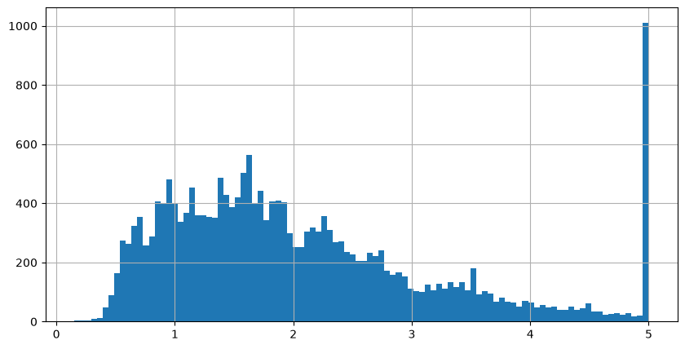
Figure 1. Distribution of the response variable (HouseValue).

Are there visible patterns or surprises?
Yes. Median income is strongly related to house value, and the geographic plot shows clear spatial structure. House values are therefore not randomly distributed across California. Several predictors are also skewed and have different numerical scales, which is important for distance-based methods such as kNN.
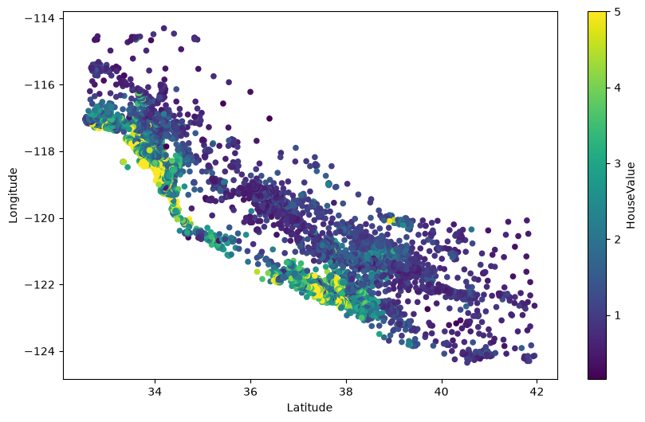
Figure 2. Geographic distribution of observations, with color representing HouseValue.

Basic data checks
The starter notebook reports 20,640 rows and 9 columns before preprocessing. It checks missing values and duplicate rows before modeling; the dataset has no missing values.

2. Two Ways to Draw a Shape Through Data
I compare ordinary least-squares linear regression as the global model with k-nearest-neighbors regression (k=15) as the local model, using each of the eight input variables one at a time.

How does each method see the data?
Linear regression searches for one global linear relationship and uses all observations to determine a single straight-line trend.
kNN instead looks around each prediction point and averages nearby training observations. Its prediction therefore changes according to local density and neighborhood structure.

Where do they agree and differ?
They generally agree on broad trends for strongly related variables, but kNN can follow bends, plateaus, and local changes that a straight line cannot represent. Linear regression is smoother and more constrained; kNN is more flexible and can react strongly to sparse or irregular regions.

Which is more sensitive to local patterns?
kNN is more sensitive to local patterns because each prediction is determined by nearby observations.
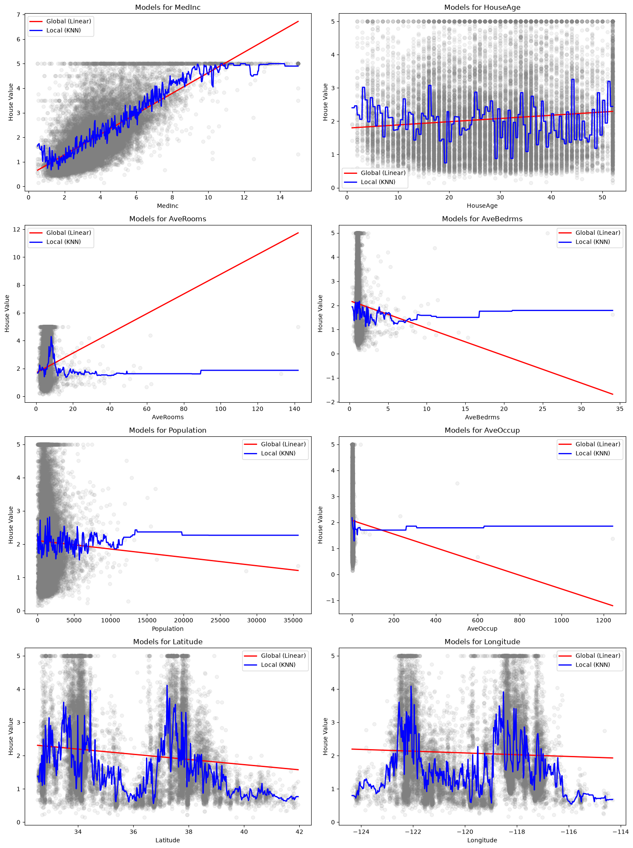
Figure 3. Global linear fits versus local kNN fits across the eight input variables.

3. What Does It Mean to Be Right?
The starter notebook uses MedInc for the loss-function investigation. The reported mean is 3.87 and the median is 3.53. Because the mean is above the median, the distribution is right-skewed.

Mean versus median
The mean is pulled rightward by larger observations, while the median is the middle observation and is less affected by the right tail.
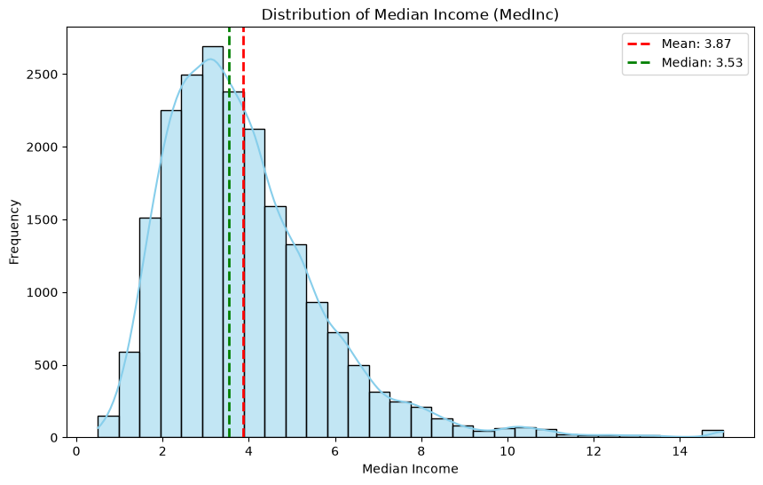

Squared loss versus absolute loss
- Squared loss penalizes an error by its square, so large mistakes receive disproportionately high penalties.
- Absolute loss penalizes errors linearly and is less sensitive to extreme observations.
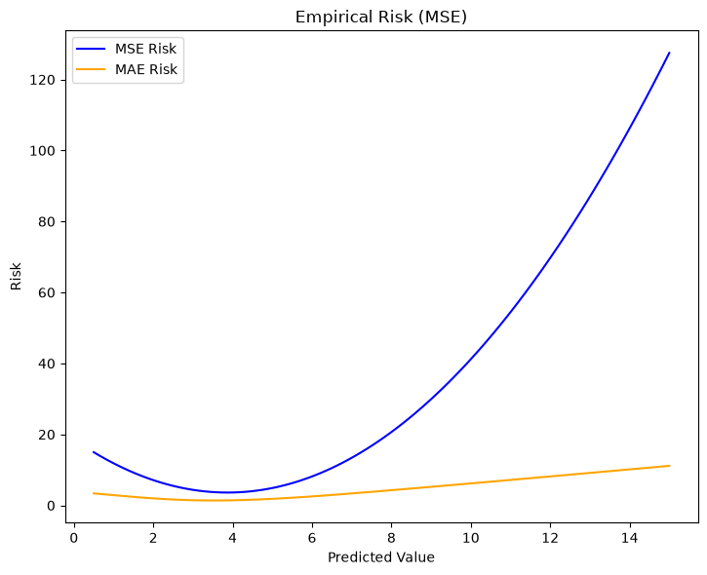
Figure 4. Empirical risk for squared and absolute loss as the proposed prediction changes.

Which prediction does each loss prefer?
Minimizing expected squared loss gives the mean, while minimizing expected absolute loss gives the median. For this subset, squared loss therefore prefers about 3.87, whereas absolute loss prefers about 3.53.

4. When Neighborhoods Stop Being Local
The effective dimension is increased one feature at a time, from one feature to all eight original features. For each dimension, the notebook measures average nearest-neighbor distance and compares kNN and linear-regression mean squared error.

How does nearest-neighbor distance change?
As dimensions are added, observations occupy a larger feature space and points become relatively more isolated. The nearest neighbor therefore becomes less local in the intuitive sense suggested by a two-dimensional plot.

How does prediction error change?
kNN error becomes more sensitive to increasing dimensionality because distance defines its neighborhoods. Linear regression does not depend on nearest-neighbor distance and therefore follows a different error pattern. This explains why local methods that look powerful in low-dimensional plots can become less reliable in higher dimensions.
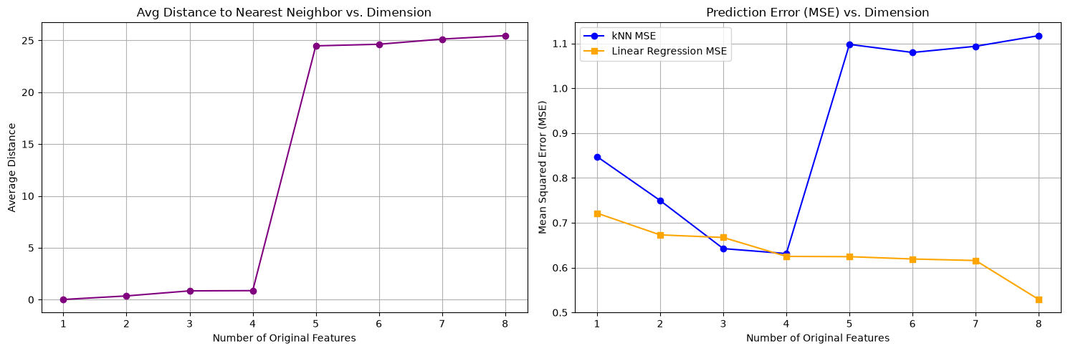
Figure 5. Nearest-neighbor distance and prediction error as the effective dimension increases.

5. Optional: High-Dimensionality and Structure
The notebook also fits ordinary least squares (OLS), Ridge, and Lasso after standardization. Regularization restricts the space of possible coefficient vectors instead of allowing the model to fit completely freely.
Ridge uses an L2 penalty and continuously shrinks coefficients toward zero. Lasso uses an L1 penalty and can shrink some coefficients exactly to zero, producing a sparse model. These structural assumptions can make learning more stable, although the restriction must be appropriate for the data.
Reported test MSEs from the starter notebook:
Model | Test MSE
OLS | 0.556
Ridge (alpha=100) | 0.553
Lasso (alpha=0.1) | 0.680
Ridge is slightly better than OLS in this run, while the selected Lasso setting performs worse. Therefore, structure can stabilize learning, but regularization strength and type matter.
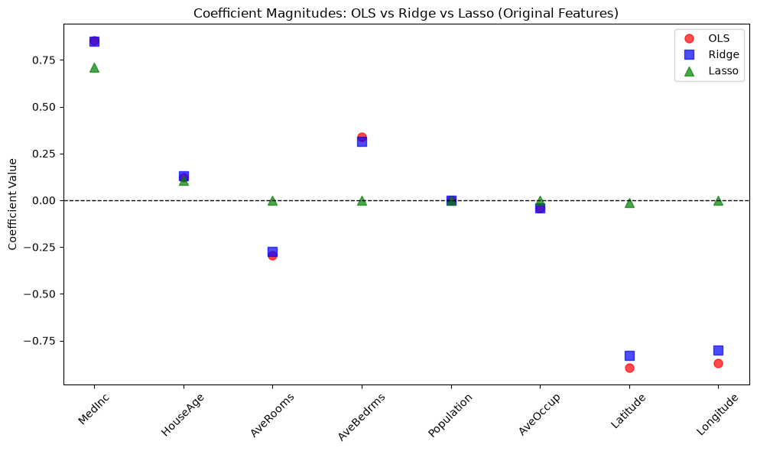
Figure 6. Coefficient comparison for OLS, Ridge, and Lasso.

6. Model Performance in the Starter Notebook
The notebook evaluates several regression models after preprocessing. The held-out test set is the key comparison because training error alone can hide overfitting.
Model | Test MSE | Test MAE | Test R²
Linear Regression | 0.3068 | 0.4194 | 0.6582
Decision Tree | 0.3665 | 0.4071 | 0.5917
k-Nearest Neighbors | 0.2893 | 0.3858 | 0.6777
Random Forest | 0.1686 | 0.2799 | 0.8122
Gradient Boost | 0.2018 | 0.3230 | 0.7751
AdaBoost | 0.4267 | 0.5337 | 0.5246
XGBoost | 0.1507 | 0.2701 | 0.8321
LightGBM | 0.1496 | 0.2711 | 0.8333
CatBoost | 0.1347 | 0.2531 | 0.8499
In the reported run, CatBoost has the lowest test MSE (0.1347) and highest test R² (0.8499) among the listed models. XGBoost and LightGBM are close behind. The decision tree has perfect training performance but weaker test performance, which is a clear sign of overfitting.

7. Your Visualization Story
- First, the data exploration showed that house values have a non-uniform distribution and strong geographic structure.
- Second, the global linear model and local kNN model showed two different notions of similarity: one global trend versus local neighborhoods.
- Third, the loss-function experiment showed that 'best' prediction depends on how error is measured: squared loss targets the mean, while absolute loss targets the median.
- Finally, increasing dimension showed why local intuition breaks down. Nearest neighbors become less local, making distance-based prediction harder, while global and structured approaches are affected differently.
- The overall lesson is that machine learning is not only about fitting equations. It is about choosing a representation of similarity, a loss function, and a model structure that match the geometry of the problem.

8. Conclusion
The California Housing analysis moves from description to increasingly structural questions. The data first reveal distributional and geographic patterns. Global linear regression and local kNN then demonstrate two different ways of seeing those patterns. The mean/median experiment shows that the loss function determines what counts as a good prediction. Finally, the dimensionality experiment explains why local methods can lose their advantage when neighborhoods become less meaningful. The optional regularization comparison reinforces that useful structure can stabilize learning, although overly strong regularization can hurt performance.

