**CODING ASSIGNMENT 1**

**ME 674 SOFT COMPUTING**



# **SUBMITTED BY- RAJESH**

# **214103318**

**MASTER OF TECHNOLOGY**

**FLUID AND THERMAL ENGINEERING**

**INDIAN INSTITUTE OF TECHNOLOGY, GUWAHATI**

**COURSE INSTRUCTOR: PROF.SUKHOMAY PAL**

**REPORT**

**1.Introduction:**

**Problem definition:** Prediction of tensile strength in friction stir welded aluminium alloy using artificial neural network

**Background:**

This paper presents a systematic approach to optimizing friction stir welding process parameters for the aluminium alloy. Friction stir welding (FSW) is solid state joining process widely used for the difficult welding joints of aluminum alloys. Weld quality is predominantly affected by welding input parameters. The welding parameters such as tool shoulder diameter, tool rotational speed, welding speed and axial force play a major role in deciding the joint strength. In present work an attempt has been made to join the aluminium alloy AA8014 by FSW using the conventional milling machine. Friction stir welding have been carried out on the 4 mm thick AA8014 plate. ANN has been developed based on back propagation (BP) of error for prediction of the tensile strength in FSW.

The input parameters of the model consist of tool shoulder diameter, tool rotational speed, welding speed and axial force whereas the output of the model is the tensile strength of joint. Testing of the ANN is carried out using experimental data. The results showed that the outcomes of the ANN are in good agreement with the experimental data; this indicates that the developed neural network can be used as an alternative way for calculating tensile strength for given process parameters.

Input parameters:

|  |  |  |
| --- | --- | --- |
|  | Parameter | Unit |
| 1 | Tool shoulder diameter | Mm |
| 2 | Tool rotational speed | Rpm |
| 3 | Welding speed | Mm/min |
| 4 | Axial force | N |

Output parameters:

|  |  |  |
| --- | --- | --- |
|  | Parameter | Unit |
| 1 | Tensile strength | MPa |

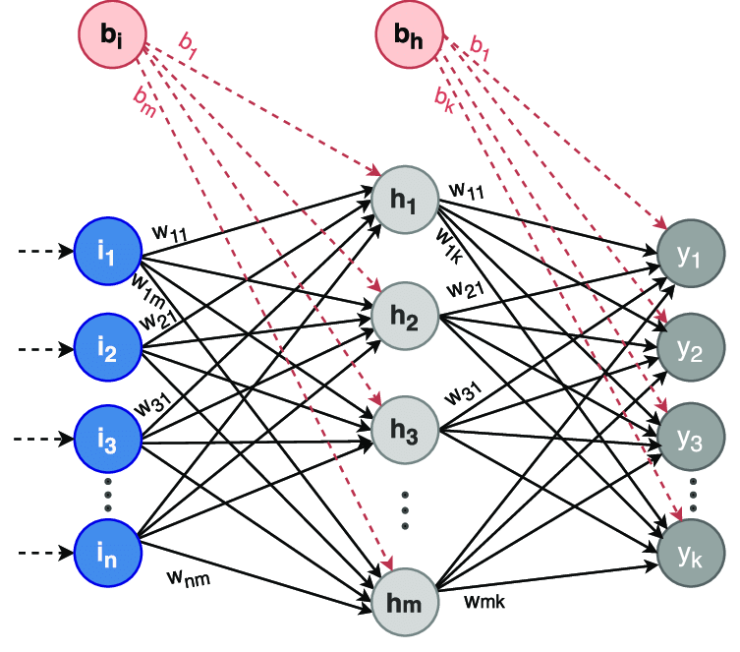

Fig-ANN with frequency output

**DESIGNED ANN NETWORK(METHODOLOGY):**

While calculating the following parameters:

No. of input parameters used= 4

No. of output parameters used= 1

Architecture of the model used:

No of hidden Neurons: 7

Activation function in hidden layer: Log-Sigmoid function

Activation function used in output layer: Log-Sigmoid function

**1.Selection of optimum number of hidden Neurons:**

After checking MSE (mean squared error) values of training set for different values of H (no of single hidden layer neurons -ranging from 1 to 10), the following graph is obtained:

So optimum number of neurons are= 7

**2.Selecting optimum value of learning rate:**

After checking MSE (mean squared error) values of training set for different values of learning value (learning rate-ranging from 0.1 to 0.9), we found that higher range learning value gives fast optimum result.

Therefore, optimum learning rate is 0.9

**3.Results**

Test set MSE =10-3

The MSE value continuously decreases with the number of iterations, but the rate at which it is decreasing slows down.

Final optimum values,

H=7

Learning rate =0.9

4.**Conclusions**

* Higher range for iteration is difficult to handle
* Final W and V are predicted nicely
* For greater accuracy we have to consider higher test sets and higher no. of training patterns.
* Overall, it can be said that using ANN we can very nicely formulate such real-life problems and experiments.