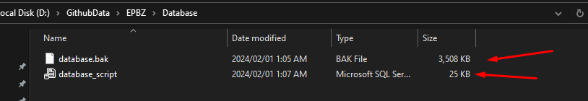  
  
Restore or use script to get database.

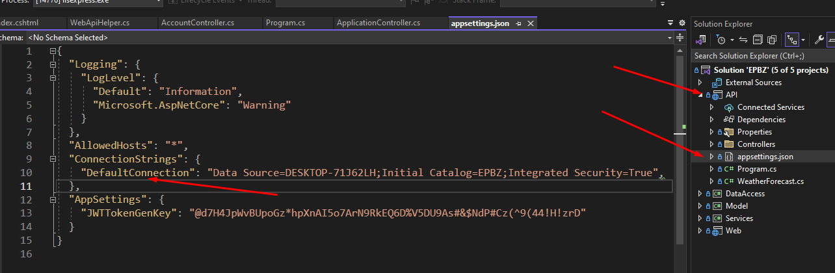  
  
  
Set proper database connection string in api project for database.

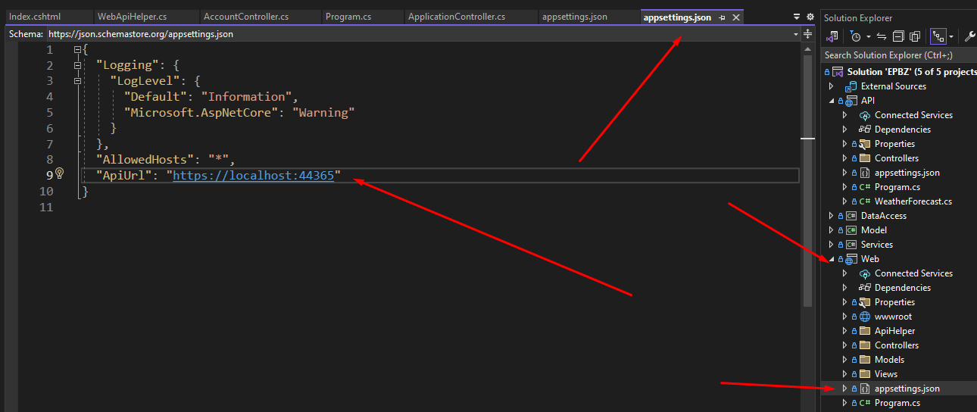  
  
Set proper api url in web application.  
  
  
  
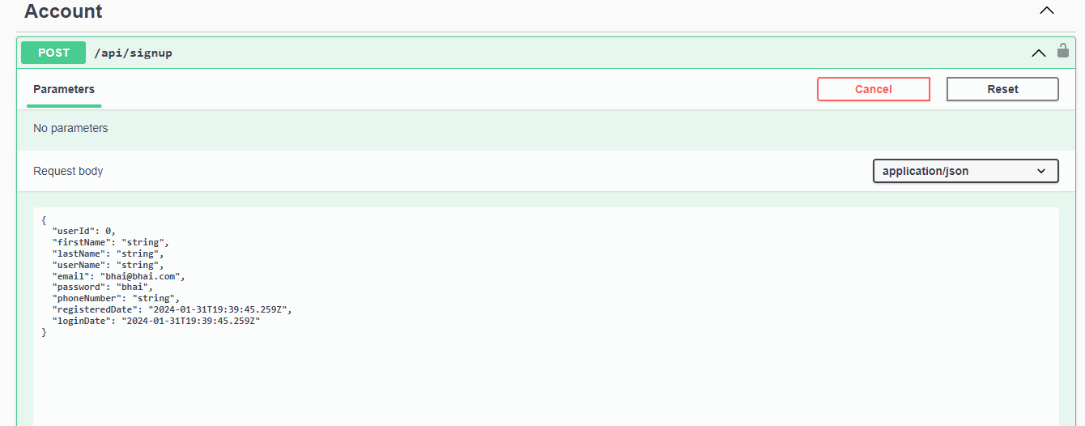  
  
Add above endpoint to add admin user.

Example:  
  
Email => [admin@admin.com](mailto:admin@admin.com)

Password => admin