



PROFESSIONAL

 NI ERSITY

*Cransfornii“np Zi:éucaSon Cransforniinp India*



LOVELY PROFESSIONAL UNIVERSITY

CA 3

School of Hotel Management & Tourism II



De artment of Tourism and Airlines

Name of the faculty member: Ms. Ankita Kaushik

Course Code: SPA 101 Course Name: Basic Spanish Section: VE003

Date of Submission: 13/11/2024 Name: Utkarsh Khandekar Admission no,: 12307976

Page No.

Date

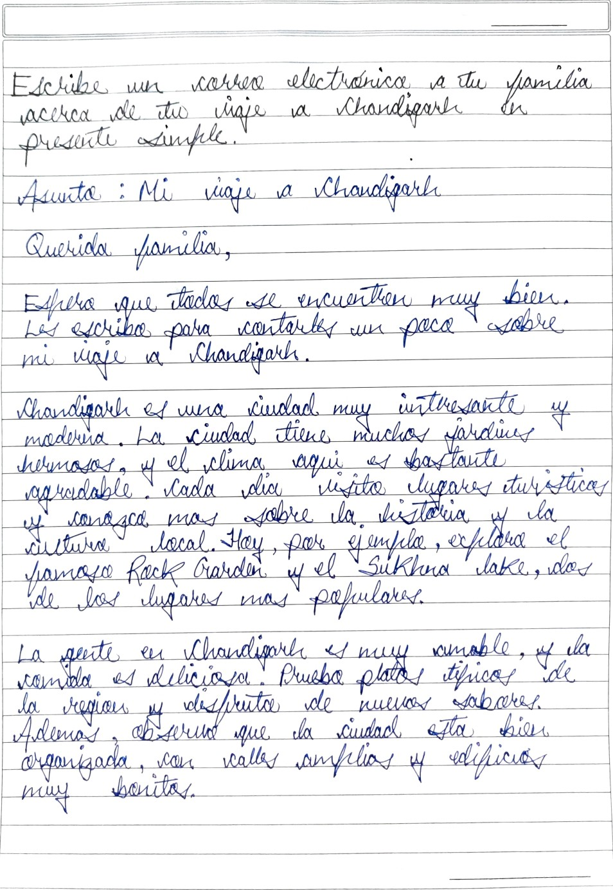

Teacher's Signature :

Pape No.

Date

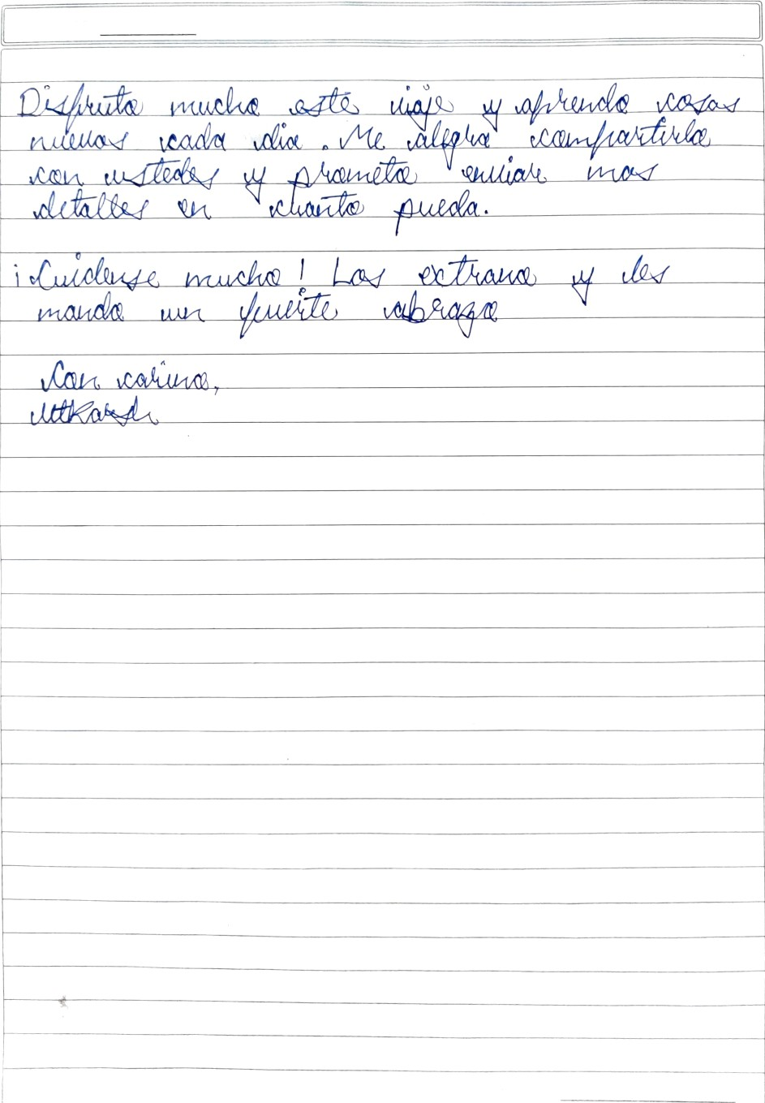

Teacher’s Signature