## ACKNOWLEDGEMENT

Any achievement does not depend solely on the individual effort but on the guidance, encouragement and co-ordination of intellectuals, elders and friends. A number of personalities, in their own capacities have helped us carrying out this mini project work. We would like to take this opportunity to thank them all.

This completion of mini project work brings a sense of satisfaction, but it is never complete without thanking the person responsible for its successful completion.

Firstly ,I would like to thank our Management for all the support. I extend my deep sense of sincere gratitude to Principal **Dr. Mahesha K**,SKIT,

I express my sincere gratitude to **Dr. Shantaram Nayak**, professor and HOD, Department of Computer Science and Engineering, Sri Krishna Institue of Technology, Bangalore, for her valuable suggestion and support.

I extend my special in-depth, sincere gratitude to my guide **Asst. Prof. Aruna R** Assistant Professor, Department of Computer Science and Engineering, Sri Krishna Institute of Technology, Bengaluru, for her constant support and valuable guidance for completion of this project .

I would like to thank all the teaching and non-teaching staff members in my

Department of Computer Science and Engineering, Sri Krishna Institute of Technology, Bengaluru, for their support finally, we thank our parents and friends for their moral support.

**Adarsh raj (1KT21CS004)**

# TABLE OF CONTENTS

ACKNOWLEDEMENT .......................................................................................................... i

TABLE OF CONTENTS ........................................................................................................ ii

LIST OF FIGURES ................................................................................................................. iii

ABSTRACT ............................................................................................................................ iv

### CHAPTER1: INTRODUCTION

1.1. Introduction………………………………………………………………1

1.2. Issues…………………………………………………………………….2

1.3. Project Domains…………………………………………………………2

1.4. Scope…………………………………………………………………..2-3

1.5. Objective of the project………………………………………………….4

1.6. Methodology…………………………………………………………….4

### CHAPTER2: DRONE TECHNOLOGY AND APPLICATIONS

2.1. Drone Technology…………………………………………………...5-11

**CHAPTER3: IMPLEMENTATION**

3.1. Hardware Required………………….……………………………..12-17

**CHAPTER4: CONCLUSION……………………………………………………….**18

**CHAPTER5: COST ESTIMATION…………………………………………….**19**-**20

**CHAPTER6: FUTURE ENHANCEMENT………………………………………...**21

## LISTOFFIGURES

SN FIGURENAME FIGURE NO

1. Drone 1.1
2. Multi Rotor Drone 2.1.1
3. Multi Wings Drone 2.1.2
4. Single Rotor Drone 2.1.3
5. Drone Frame 3.1.1
6. KK Board 3.1.2
7. BLDC Motor 3.1.3
8. ESCs 3.1.4
9. Transmitter-Receiver Set 3.1.5
10. Propellers 3.1.6
11. LiPo Battery 3.1.7.1
12. Li-ion Battery 3.1.7.2

# ABSTRACT

The drone project aims to develop an autonomous quad copter system for various applications, such as surveillance, mapping, and delivery. Incorporating advanced computer vision and machine learning algorithms, the drone will navigate through complex environments, avoiding obstacles, and accurately identifying targets. Its modular design will allow easy customization for specific tasks, ensuring versatility. The project focuses on optimizing flight stability, energy efficiency, and safety, while enabling remote control and real-time data transmission. This innovative drone solution promises to revolutionize industries by offering efficient and reliable aerial capabilities for diverse tasks, ultimately reshaping the way we interact with technology.

**CHAPTER 1**

## INTRODUCTION

### 1.1. Introduction

Drones are basically flying unmanned robot that can be remotely controlled or made to fly autonomously through software-controlled flight plans in their embedded systems, working in conjunction with onboard sensors and GPS as shown in fig.1.1. The drones need to become smart and quick-witted in order to optimize industrial processes, maximize their utility and can be widely established in future factories. This technology offers various applications not only in the field of aerial surveillance and monitoring but also firefighting operations.

While drones continue to get much smaller, more powerful, and have better payload options, one thing that will stay the same is its ability to quickly reach a vantage point where humans cannot easily get access to. This remote controlled or even autonomous flying platforms can be used to make people's jobs easier and more efficient through better information gathering and surveying. Firefighter Drones are sent to fire locations as scouts, using cameras with thermal imaging technology to help first responders in their rescue efforts.

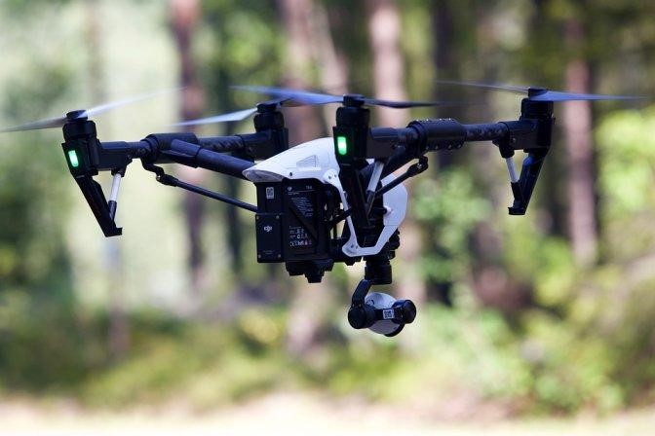

Figure 1.1. Drone

### 1.2. Issues

Issues of drones can be classified in different ways like morally, ethically and legally. In many country's drone is not permitted to fly openly, but in some advance country is now allowing drone for social purposes. Also, there is a build up a decent drone marketplace in Singapore but from ethical point of view it has some conflict using drone. Military drone manufacturers are also looking for an upgrade civilian uses for remote sensing drones to spread their markets and this includes the use of drones for surveillance where it's needed. Drones will no doubt make possible the dramatic change in the surveillance state. With the convergence of other technologies it may even make possible machine recognition of faces, behaviors, and the monitoring of individual conversations.

### 1.3. Project Domain

This project is mainly focused on Public Safety and the goal of this project was the develop a wing equipped with legs to be more valuable and more stability to the design that can sit with different application under one design. Maximize the flight time for drone with low cost and minor changes in design to develop a better usage for those who are using the drone for long time such as monitoring proposes - Understand the design of propeller angels and numbers can create a change in the drone flight efficiency, which can help those are working with the drone to deliver packages or unexpected increase of weight. Improve Sensors selection optimization & Analysis of the performance requirements of Quad copter. Studying the changes in the system and get the best valuable result in improving the design based on the experiment that will implements will help the future researcher or drone manufacturers make their drone project with based data can guide them to make the best design without studying the project from zero and make their testing just for the data.

### 1.4. Scope

1.4.1. Photography and Videography

Drones equipped with high-quality cameras provide stunning aerial views, which have revolutionized photography, filmmaking, and media coverage. They can capture breathtaking landscapes, real estate properties, and events from unique angles.

1.4.2. Surveillance and Security

Drones are employed for surveillance purposes in various settings, including law enforcement, border control, and security monitoring. They can cover large areas quickly and access hard-to-reach locations, providing real-time information to operators.

1.4.3. Search and Rescue

Drones are crucial tools in search and rescue operations, especially in remote or disaster-stricken areas. Equipped with thermal cameras and other sensors, they can locate missing persons and relay vital information to rescue teams.

1.4.4. Environmental Monitoring

Drones are used to monitor environmental conditions such as air and water quality, deforestation, wildlife populations, and natural disasters. They help researchers collect data more efficiently and make informed decisions about conservation efforts.

1.4.5. Infrastructure Inspection

In industries like energy, construction, and transportation, drones are used to inspect and maintain infrastructure such as power lines, pipelines, bridges, and buildings.

They can identify potential issues without putting human inspectors at risk.

1.4.6. Agriculture

Drones are employed in precision agriculture to monitor crops, assess soil conditions, and optimize irrigation and pesticide usage. This enhances crop yields and reduces the environmental impact of farming.

1.4.7. Delivery Services

Some companies are exploring the use of drones for delivering small packages and goods to remote or congested areas. This could potentially revolutionize the logistics industry by enabling faster and more efficient deliveries.

1.4.8. Scientific Research

Drones are increasingly used in scientific research, enabling researchers to study remote and inaccessible areas. They aid in collecting data on wildlife behavior, glacier movements, and volcanic activity, among other things.

### 1.5. Objective of the project

The primary objectives of this drone project are to automate the inspection process of critical infrastructure, such as power transmission lines and communication towers, with the aim of enhancing safety and efficiency. By utilizing advanced sensor technologies and autonomous flight capabilities, the project seeks to reduce human exposure to hazardous environments, minimize downtime for maintenance, and provide real-time, accurate data for proactive decision-making and predictive maintenance strategies. Through the successful implementation of this project, the goal is to optimize resource allocation, mitigate risks associated with manual inspections, and contribute to the overall reliability and longevity of the infrastructure network.

### 1.6. Methodology

The signals will be transmitted from Transmitter and it will be received by the Receiver in the drone. From the receiver the signal goes to the Flight controller where the signal will be processed with accelerometer and gyroscope sensors. The processed signal will be sent to the ESC, which allows the specific amount to the motor based on the signal it receives. The propellers are mechanically coupled to the motors so that they rotate and produce thrust.

**CHAPTER 2**

## DRONE TECHNOLOGY AND APPLICATIONS

### 2.1. Drone Technology

A drone, often known as an Unmanned Aerial Vehicle (UAV), is described as an aircraft controlled without an onboard pilot. They may be either autonomously flown or remotely controlled. Drones have found useful applications in the military. The ability to fly an aircraft without a pilot has been able to improve efficiency and safety in such roles as surveillance and even precision strikes US military drones are around the size of small planes and in some cases are even larger. In recent years, drone technology has expanded to private and public applications, focusing on smaller drones and other scenarios Private and public research laboratories have contributed to this development

Furthermore, the recent miniaturization and cost reduction of electronics has also contributed to the size reduction of drone development. There are two main categories of aerial drones: multi-rotor and fixed wing drones, Multi- rotor drones consist of several two or three blade propellers powered around the center of the drone.

#### 2.1.1. Multi Rotor Drones

Multi-rotor drones are the easiest and cheapest option for getting an ‘eye in the sky.’ They also offer greater control over position and framing, and hence they are perfect for aerial photography and surveillance. They are called multi-rotor because they have more than one motor, more commonly tri copters (3 rotors), quad copters (4 rotors), hexa copters (6 rotors) and octa copters (8 rotors), among others as shown in fig.2.1.1. By far, quad copters are the most popular multi-rotor drones.

**Advantages**

* It provides better control of the aircraft during the flight. Due to its increased maneuverability, it can move up and down on the same vertical line, back to front, side to side and rotate in its own axis.
* It has the ability to fly much more closely to structures and buildings.
* The ability to take multiple payloads per flight increases its operational efficiency and reduces the time taken for inspections.

### Disadvantages

* Multi-rotor drones have limited endurance and speed, making them unsuitable for large scale aerial mapping, long-endurance monitoring and long-distance inspection such as pipelines, roads and power lines.
* They are fundamentally very inefficient and require a lot of energy just to fight gravity and keep them in the air.
* With the current battery technology, they are limited to around 20-30 minutes when carrying a lightweight camera payload. However, heavy-lift multi-rotors are capable of carrying more weight, but in exchange for much shorter flight times.
* Due to the need for fast and high-precision throttle changes to keep them stabilized, it isn’t practical to use a gas engine to power multi-rotors, so they are restricted to electric motors. So until a new power source comes along, we can only expect very small gains in flight time.

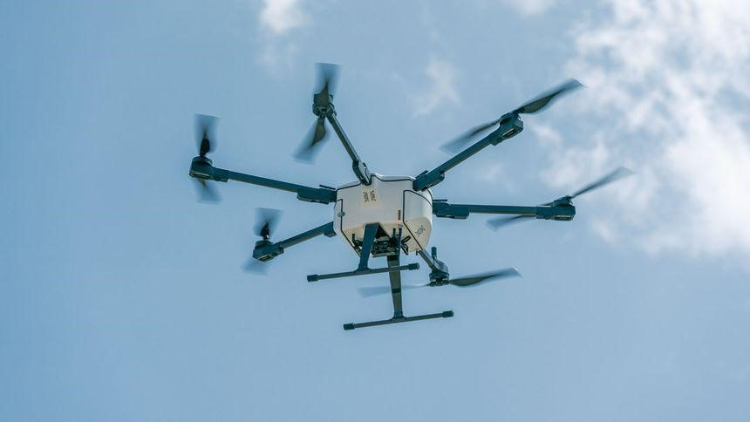

#### Figure 2.1.1. Multi Rotor Drone

**Technical Uses** o Visual inspections Thermal reports o Photography & Videography o 3D scans

#### 2.1.2. Fixed-Wings Drone

A fixed-wing drone has one rigid wing that is designed to look and work like an aero plane as shown in fig.2.1.2, providing the lift rather than vertical lift rotors. Hence, this drone type only needs the energy to move forward and not to hold itself in the air. This makes them energy-efficient.

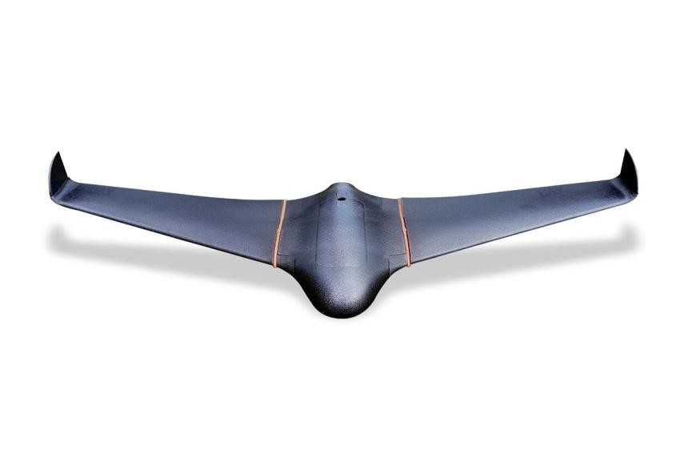

Figure 2.1.2. Fixed-Wings Drone

### Advantages

* Fixed-wing drones cover longer distances, map much larger areas, and loiter for long times monitoring their point of interest. The average flight time is a couple of hours. But with a greater energy density of fuel (gas engine powered), many fixed-wing UAVs can stay aloft for 16 hours or more.
* This drone type can fly at a high altitude, carry more weight and are more forgiving in the air than other drone types.

### Disadvantages

* Fixed-wing drones can be expensive.

Training is usually required to fly fixed-wing drones. The first time you launch a fixed-wing drone, you need to be confident in your abilities to control through the flight and back to a soft landing. A fixed-wing drone is always moving forward, and they move a lot quicker than a multi-rotor, and hence you might not get a chance to put it into a hover. In most cases, a launcher is needed to get a fixedwing drone into the air.

* With fixed-wing, the flight is just the beginning. The hundreds and thousands of captured images have to be processed and stitched together into one big tiled image. There is a lot more to be done after this, including performing data analysis, such as the stockpile volume calculations, tree counts, overlaying other data onto the maps, and so on.

**Technical Uses**

o Aerial Mapping

* Drone Surveying – Forestry/Environmental Drone Surveys, Pipeline UAV

Surveys, UAV Coastal Surveys o Agriculture

o Inspection

o Construction

o Security

**2.1.3. Single Rotor Drone**

Single-rotor drone types are strong and durable. They look similar to actual helicopters in structure and design as shown in figure 2.1.3. A single-rotor has just one rotor, which is like one big spinning wing, plus a tail rotor to control direction and stability.

**Advantages:**

* A single-rotor helicopter has the benefit of much greater efficiency over a multirotor, which increases if the drone is gas-powered for even longer endurance.

A single-rotor helicopter allows for very long blades, which are more like a spinning wing than a propeller, giving great efficiency.

* If you need to hover with a heavy payload (e.g. an aerial LIDAR laser scanner) or have a mixture of hovering with long endurance or fast forward flight, then a single-rotor helicopter is really your best bet.
* They are built to be strong and durable.

**Disadvantages:**

* Single-rotor drone types are complex and expensive.
* They vibrate and aren’t as stable or forgiving in the event of a bad landing.
* They also require a lot of maintenance and care due to their mechanical complexity.
* 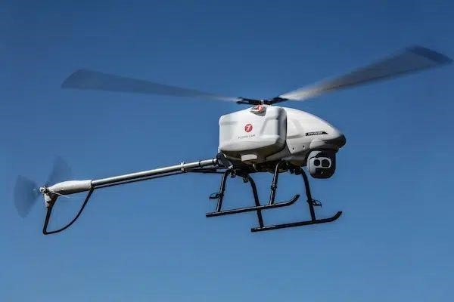The long, heavy spinning blades of a single rotor can be dangerous

Figure 2.1.3. Single Rotor Drone

### 2.2. Applications

#### 2.2.1. Construction and Site Management

Drones monitor construction progress, track material stockpiles, and provide site visualization for project managers and stakeholders.

#### 2.2.2. Emergency Response

Drones assess disaster-affected areas, deliver medical supplies, and provide realtime situational awareness to emergency responders.

#### 2.2.3. Delivery Services

Companies are exploring drone deliveries for small packages and medical supplies in remote or congested areas, potentially transforming logistics and last-mile delivery.

#### 2.2.4. Wildlife Conservation

Drones monitor wildlife behavior, track animal migrations, and combat poaching by providing surveillance over protected areas.

#### 2.2.5. Scientific Research

Drones enable scientists to study remote or inaccessible environments such as polar regions, volcanoes, and ocean ecosystems.

#### 2.2.6. Entertainment and Sports

Drones are used for aerial shows, racing competitions, and capturing dynamic shots during sporting events.

#### 2.2.7. Security and Surveillance

Drones provide surveillance in border control, law enforcement, and private security, enhancing monitoring and response capabilities.

#### 2.2.8. Education and Training

Drones are used in educational settings to teach programming, robotics, and aerospace concepts to students.

**CHAPTER 3**

## IMPLEMENTATION

### 3.1. Hardware Requirement

3.1.1. Frame

The most important part of the drone is its skeleton that holds everything in fact– Frame. the copter has 4 arms. The frame should be light as well as rigid to host a LIPO battery, 4 BLDC motors, 4 ESC, controller. Good to go for a readily available stronger Carbon Fiber material such frame which is easy to assemble as shown in fig.3.1.1. The frame arms are made of ultra strength material to survive any crash. The frame boards are high strength compound PCB frames, which makes wiring of ESCs and battery more safe and easier. Different color codes help know the orientation of the Drone. which we have implemented using the color codes RED and BLACK to indicate forward and backward faces of the drone.

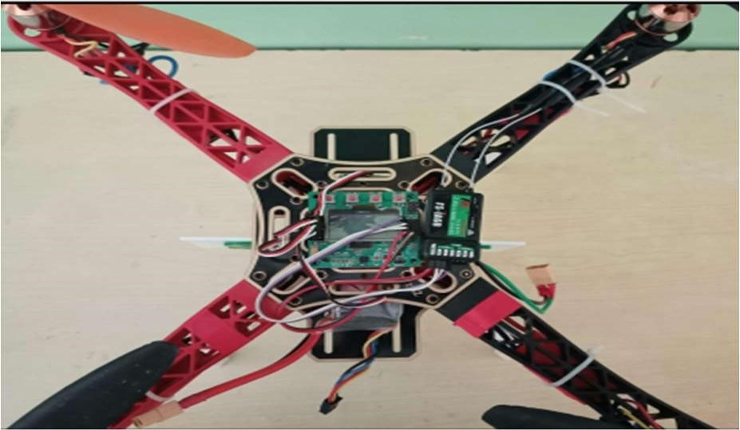

#### Figure 3.1.1.Drone Frame

3.1.2. KK Board

The most common control board widely used is KK control board. The models available are KK2.0, KK2.1.5 & KK2.1 HC. The KK2.1.5 multi-rotor controller manages the flight of multi-rotor Aircraft(Tri copters, Quad copters etc.).Its purpose is to stabilize the aircraft during flight. It is easy for the beginner to start with and has firmware predefined in it. While activating or turning off the board there is beep from the piezo buzzer of KK2.1.5. It has inbuilt gyroscope, 6050MPU, and auto level function. This board has 8 motor outputs, 5 control inputs, an LCD display, polarity protected voltage sensor input, an ISP header, six-axis accelerometers or gyro and a piezo output as shown in fig.3.1.2. The user signals from KK board are processed by ATMEL 664PA IC and then passed to the ESCs for action.

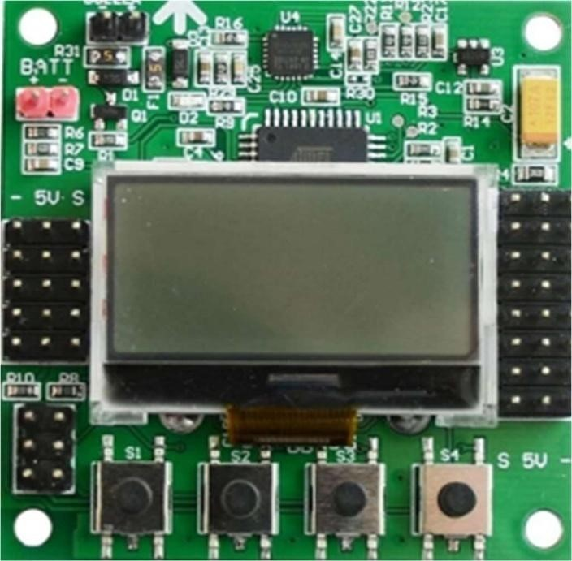

#### Figure 3.1.2. KK Board

3.1.3. BLDC Motor

A BLDC motor, or Brushless DC motor, is an electric motor that operates without the use of brushes and commutators, which are common components in traditional brushed DC motors. BLDC motors are widely used in various applications due to their efficiency, reliability, and performance advantages as shown in fig.3.1.3. Here's a basic overview of how BLDC motors work and some of their characteristics:

Working Principle:

A BLDC motor operates using a permanent magnet rotor and a stator with windings. The stator windings are energized in a specific sequence to create a rotating magnetic field that interacts with the permanent magnets on the rotor. This interaction causes the rotor to rotate, producing mechanical motion.

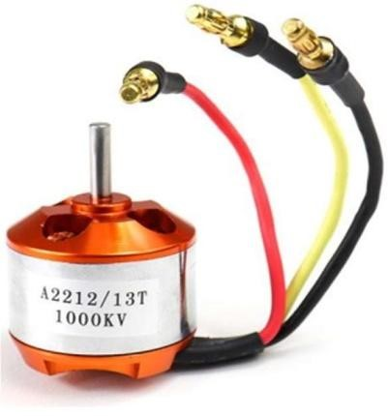

#### Figure 3.1.3.BLDC Motor

3.1.4. ESCs

An Electronic Speed Controller (ESC) is a crucial component in many electric motor systems, including Brushless DC (BLDC) motors. It controls the speed, direction, and sometimes other parameters of the motor by adjusting the voltage and current supplied to it. ESCs are commonly used in various applications such as drones, electric vehicles, remote-controlled vehicles, and robotics. It can be seen in fig.3.1.4.

Functions of an ESC:

* Motor Control: The primary function of an ESC is to control the speed and direction of the motor. It achieves this by regulating the voltage and current that reaches the motor terminals.
* Commutation: In BLDC motors, the ESC performs electronic commutation by switching the stator windings' current in the correct sequence to maintain the motor's rotation.
* Throttle Control: In applications like remote-controlled vehicles and drones, the ESC interprets the throttle input from the user and adjusts the motor speed accordingly.
* Braking: Some ESCs can apply electronic braking to quickly stop or slow down the motor's rotation, which can be useful for certain applications like drones or RC cars.

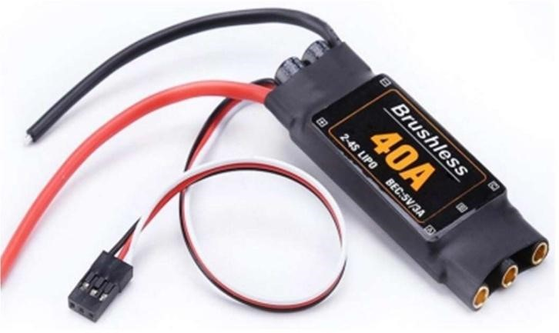

#### Figure 3.1.4.ESCs

3.1.5. Transmitter-Receiver Set

You need a RC Transmitter (2.4 GHz RC radio transmitter) to direct the quad copter direction and position, A 2.4- GHz RC radio receiver on the quad copter receives commands from the RC transmitter on the ground. (One way link). You get a Receiver along with the corresponding Transmitter. The transmitter is the hand-held controller you use to remotely control your craft. The transmitters have two sticks, two trim buttons or a slider per stick, a number of switches, a display, and a power button as shown in fig.3.1.5. Transmitters and receivers need a frequency range to operate and the new frequency range is 2.4 GHz, with digital spectrum modulation 2.4 GHz is the Radio band which needs no license to operate.

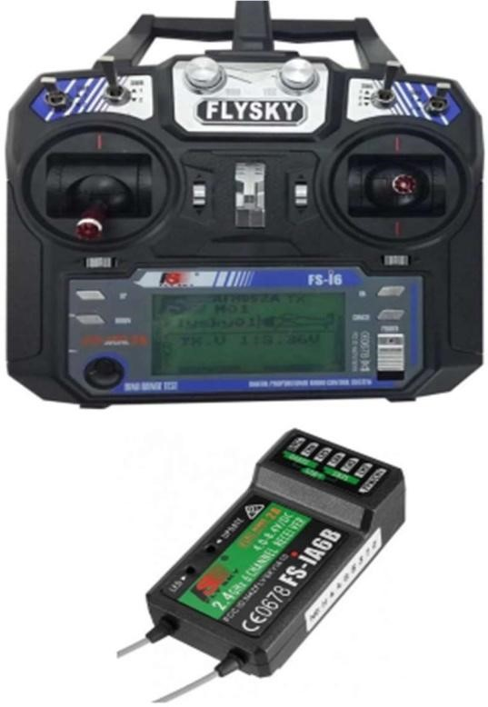

#### Figure 3.1.5. Transmitter-Receiver Set

3.1.6. Propellers

Propellers are aerodynamic devices that convert rotational energy from a motor into thrust, which propels an aircraft, vehicle, or other objects through a fluid medium like air or water. They are commonly used in applications such as airplanes, drones, helicopters, boats, and wind turbines. The design and characteristics of propellers play a significant role in determining the performance, efficiency, and handling of the vehicle or device they are attached to.

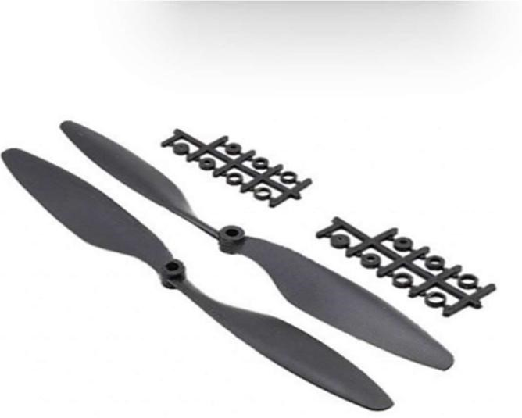

#### Figure 3.1.6. Propellers

3.1.7. Batteries

Batteries are a critical component of drones, providing the necessary power for propulsion, electronics, and various onboard systems. The choice of drone battery has a significant impact on flight time, performance, and safety. There are two types of drone batteries:

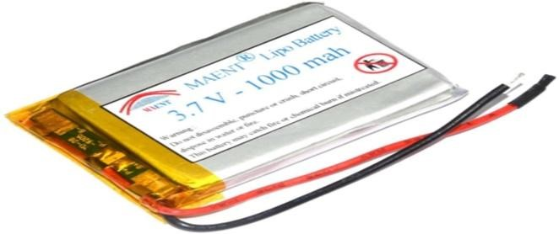o Lithium Polymer (LiPo): LiPo batteries are the most common choice for drones due to their high energy density, lightweight design, and ability to deliver high discharge rates as shown in fig 3.1.7.1. They offer a good balance between power and weight, making them suitable for various drone types.

#### Figure 3.1.7.1. LiPo battery

o Lithium-Ion (Li-ion): Li-ion batteries are similar to LiPo batteries but tend to have a slightly higher energy density as shown in fig.3.1.7.2. They are often used in drones where specific energy capacity is a priority over high discharge rates.

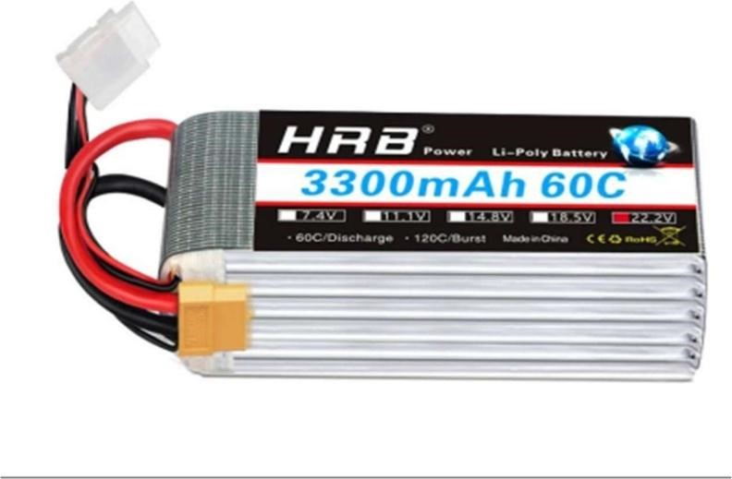

Figure 3.1.7.2. Li-ion Battery

**CHAPTER 4**

## CONCLUSION

Drone technology has rapidly transformed various industries, revolutionizing fields from aerial photography to disaster response. These unmanned aerial vehicles (UAVs) have proven their utility in tasks previously deemed challenging or dangerous. Equipped with advanced sensors and cameras, drones provide invaluable data collection, enabling accurate mapping, surveillance, and environmental monitoring. Their swift deployment during emergencies, such as natural disasters, aids in search and rescue operations, optimizing response efforts. Additionally, drones have streamlined logistics and supply chain management by facilitating remote deliveries to remote or inaccessible areas. However, challenges remain, including regulatory hurdles, privacy concerns, and limited battery life. As technology advances, addressing these issues becomes pivotal to unlock drones' full potential. As we navigate a future influenced by these flying marvels, their continued integration and innovation promise enhanced efficiency, safety, and solutions across diverse sectors.

**CHAPTER 5**

## COST ESTIMATION

The cost of manufacturing a basic drone can vary widely depending on several factors, including the type of drone, its features, quality, and the scale of production. Here's a breakdown of some of the key components that contribute to the cost of manufacturing a basic drone:

**Frame and Structure:**

* The frame is typically made from lightweight materials like plastic, carbon fiber, or aluminum.
* Cost can range from Rs.800 to Rs.8000 or more, depending on the material and quality.

**Propulsion System:**

* Motors and propellers are necessary for drone flight.
* Motors can cost around Rs.400 to Rs.4100 each, and propellers cost around $1 to $5 per set.

**Flight Controller:**

* The flight controller is the brain of the drone, controlling its stability and navigation.
* A basic flight controller might cost Rs.1650 to Rs.8250, while more advanced ones can cost several hundred dollars.

**Electronic Speed Controllers (ESCs):**

* ESCs regulate the speed of the motors.
* Prices vary, with budget options starting at around Rs.400 each and higher-quality versions costing more.

**Battery:**

* Lithium-polymer (LiPo) batteries are common for drones.
* Battery costs can range from Rs.825 to Rs.4100 or more, depending on capacity and quality.

**Remote Controller:**

* Basic remote controllers can start at around Rs.1650 to Rs.4125, while more advanced ones can cost hundreds of dollars.

**Propulsion System:**

* Motors and propellers are necessary for drone flight.
* Motors can cost around Rs.412 to Rs.4126 each, and propellers cost around Rs.82 to Rs.412 per set.

**Sensors and Components:**

* Basic sensors like gyroscopes and accelerometers are necessary for stabilization.
* Costs can vary, but budget options may start at Rs.825, and more advanced sensors can cost more.

**Camera (if applicable):**

* Cameras can range from basic low-cost options to high-definition and specialized cameras.
* Basic cameras might start around Rs.1650, while more advanced options can be several hundred dollars or more.

**CHAPTER 6**

## FUTURE ENHANCEMENT

In the near future, drone technology is poised to undergo transformative implementations across various sectors. These versatile unmanned aerial vehicles will revolutionize industries like e-commerce, where they will enable rapid and efficient delivery of goods, reducing both delivery times and carbon emissions. In agriculture, drones will be equipped with advanced sensors and AI, offering farmers invaluable insights into crop health, optimizing irrigation and pesticide use, thus boosting yields and sustainability. Emergency response will also benefit, as drones equipped with cameras and sensors can swiftly survey disaster-stricken areas, aiding in search and rescue missions. Additionally, drones will play a pivotal role in infrastructure maintenance by autonomously inspecting bridges, power lines, and pipelines, enhancing worker safety. As these aerial technologies become more sophisticated, privacy and regulatory concerns will necessitate careful navigation. Overall, the future implementation of drones holds the potential to reshape industries, enhance efficiency, and contribute to a safer and more connected world.