INTRODUCTION

Overview

It helps schools and educational institutions automate admission processes and manage communication with students and parents

Purpose

Institutions can benefit from CRM higher education technology in a variety of ways :

* A unified view of constituent information.
* An improved student experience.
* Empowered faculty and staff.
* The flexibility needed to pivot quickly.

PROBLEM DEFINITIONS & DESIGNS THINKING

Empathy Map

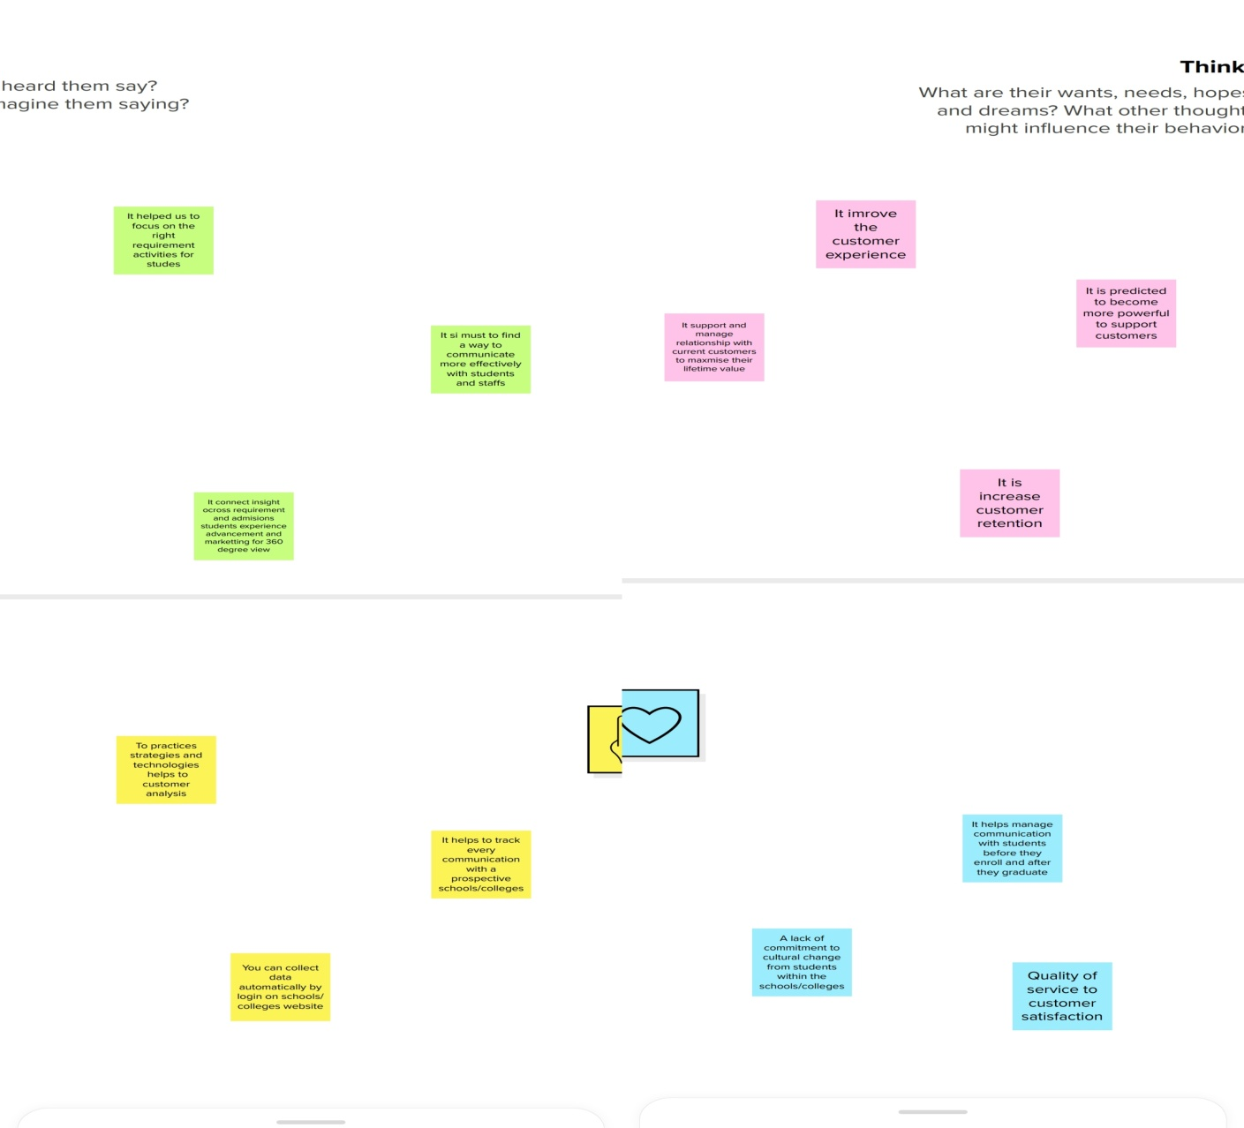

Ideation and Brainstorming map:

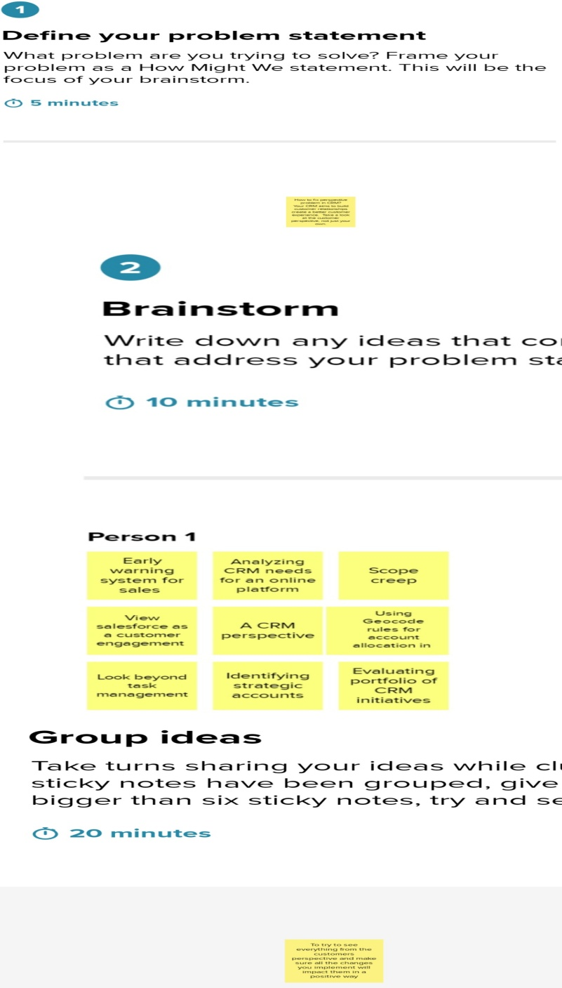

RESULT

Data Model:

|  |  |  |
| --- | --- | --- |
| Object name | Field label | Data type |
| School | School label | High School |
| Student | Student label | Standard |
| Parent | Parent label | Mobile Number |

Activity and Screenshort

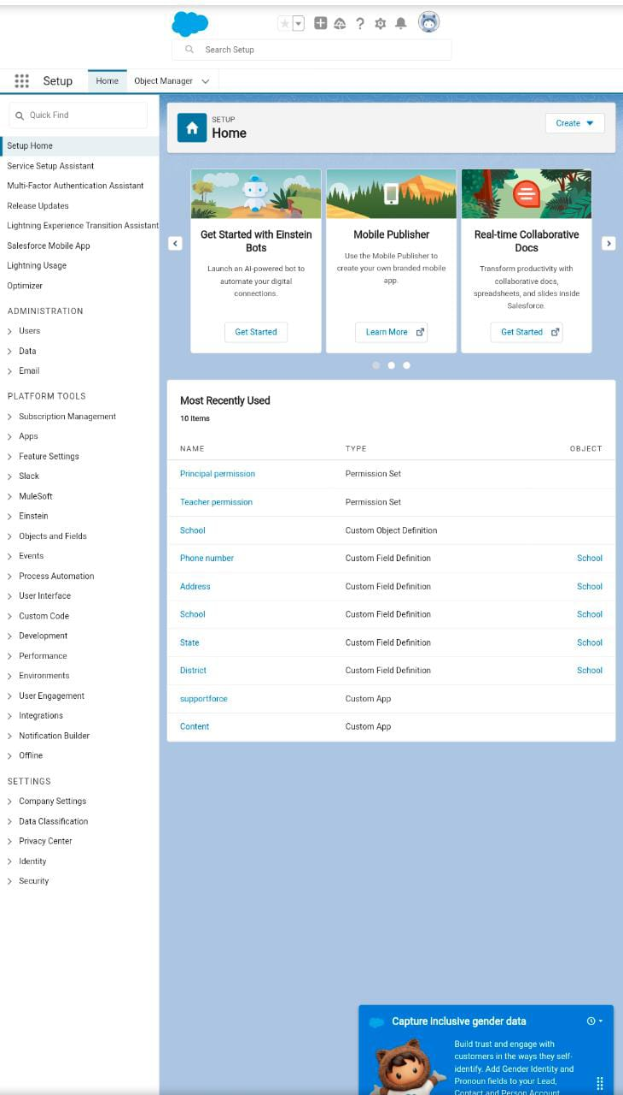

TRAILHEAD PROFILE PUBLIC URL

Team Lead: <https://trailblazer.me/id/mrajeshwari003>

Team Member 1: <https://trailblazer.me/id/mjohncy>

Team Member 2: <https://trailblazer.me/id/rithayapoorni>

Team Member 3: <https://trailblazer.me/id/melakkiya>

ADVANTAGES AND DISADVANTAGES

Advantages:

The main benefits of CRM for higher education:

1. Reduction in the cost of expenses.
2. Improving the quality of service product
3. Improving the organization management process.
4. Increased customer loyalty.
5. History of work with each student.

Disadvantages:

1. Staff over-reliance on CRM may diminish customer loyalty through a bad experience.
2. It may not suit every business.
3. It requires a process-driven sales organization.
4. Security concerns associated with centralized data

APPLICATIONS

A CRM is a system that helps schools manage the entire lifecycle of a potential customer-sometimes also referred to as a lead. With a CRM you can track and store data that’s important to you operations, all in one easy-to-access place.

You can collect data either manually, such as by logging a phone call with a lead, or automatically by integrating an online form on your school website.

CONCULSION

An education CRM software manage all your institutions interactions with prospective and current students. It also supports managing communications with alumni, employees, donors, and other members of the education sector in your institution.

FUTURE SCOPE

* Track the admissions and applications processes and communication with students once they log in.
* Keep track of the courses with the most questions.
* Integrate with other campus programs.
* Maintain the courses details with fee structure.