**Day 10 Assignment**

Write a function to Calculate the total stock value for a given category:

(Stock value=ROUND(SUM(unit_price * units_in_stock)::DECIMAL, 2)

Return data type is DECIMAL(10,2)

CREATE OR REPLACE FUNCTION get_category_stock_value(p_category_id INT)

RETURNS DECIMAL(10,2)

LANGUAGE plpgsql

AS $$

DECLARE

v_total_value DECIMAL(10,2);

BEGIN

SELECT ROUND(SUM(unit_price * units_in_stock)::DECIMAL, 2)

INTO v_total_value

FROM products

WHERE category_id = p_category_id;

RETURN COALESCE(v_total_value, 0.00);

END;

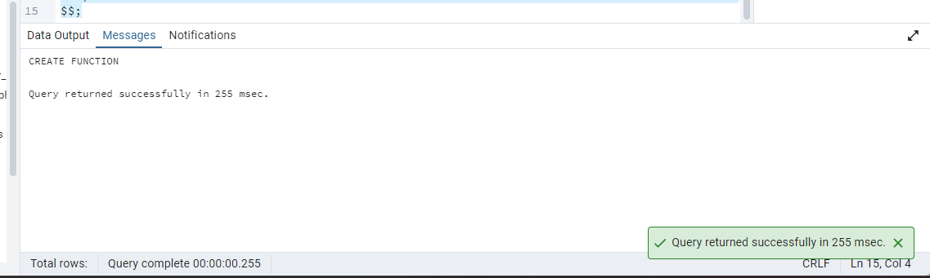

SELECT get_category_stock_value(1);

