1. Write a function to Calculate the total stock value for a given category:

(Stock value=ROUND(SUM(unit_price * units_in_stock)::DECIMAL, 2)

Return data type is DECIMAL(10,2)

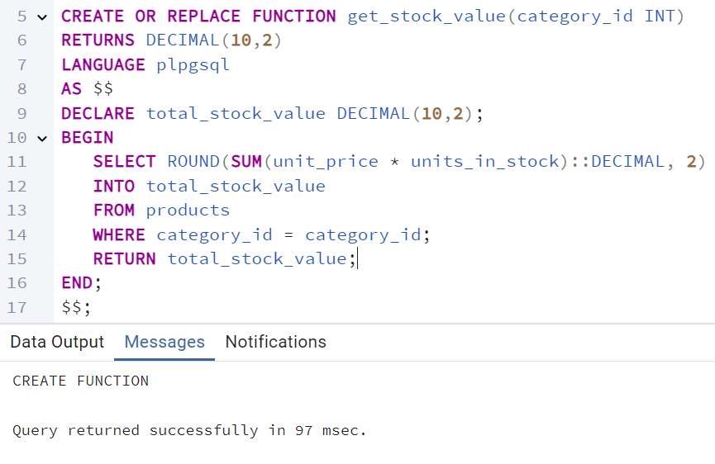

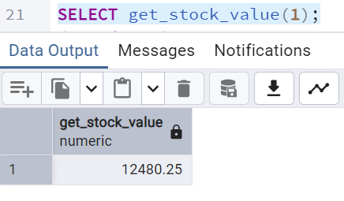

2. Try writing a cursor query which I executed in the training.

