Assignment 10

1.Write a function to calculate the stock value for a given category:(stock value=Round(SUM(unit price * unit in stock)::Decimal,2)Return datatype is Decimal(10,2).

--creating a function

CREATE OR REPLACE FUNCTION get_stock_value_by_category(p_category_id INT)

RETURNS DECIMAL(10,2) AS $$

DECLARE

stock_value DECIMAL(10,2);

BEGIN

SELECT ROUND(SUM(unit_price * units_in_stock)::DECIMAL, 2)

INTO stock_value

FROM products

WHERE category_id = p_category_id;

RETURN COALESCE(stock_value, 0); -- Return 0 if no rows found

END;

$$ LANGUAGE plpgsql;

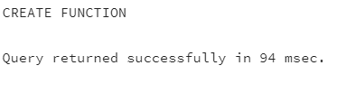

--calling the function

-- This will output the stock value for category with ID =3

SELECT get_stock_value_by_category(3);

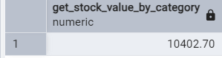

2.Cursor

CREATE OR REPLACE PROCEDURE update_prices_with_cursor()

LANGUAGE plpgsql

As $$

DECLARE

product_cursor CURSOR FOR

SELECT product_id,product_name,unit_price,units_in_stock FROM products WHERE discontinued = 0;

product_record RECORD;

v_new_price Decimal(10,2);

BEGIN

OPEN product_cursor;

LOOP

FETCH product_cursor INTO product_record;

EXIT WHEN NOT FOUND;

v_new_price:=product_record.unit_price*0.95;

UPDATE products

SET unit_price = ROUND(v_new_price,2)

WHERE product_id = product_record.product_id;

RAISE NOTICE 'Updated % price from % of % ',

product_record.product_name,product_record.unit_price,v_new_price;

END LOOP;

CLOSE product_cursor;

END;

$$;

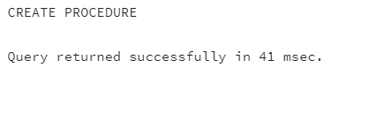

--Calling the Procedure:

CALL update_prices_with_cursor();

