**DAY 10**

1. Write a function to Calculate the total stock value for a given category:

(Stock value=ROUND(SUM(unit_price * units_in_stock)::DECIMAL, 2)

Return data type is DECIMAL(10,2)

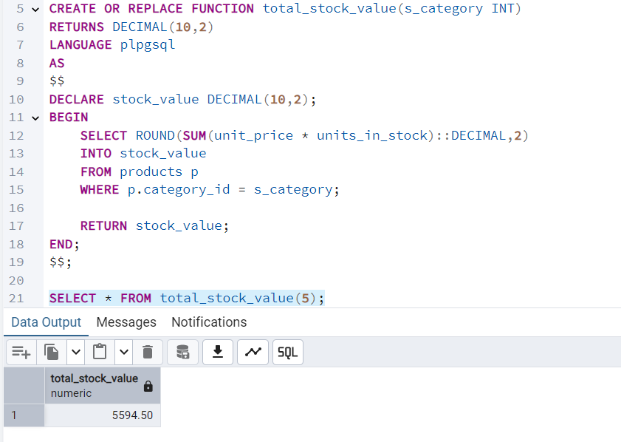

2. Try writing a cursor query which I executed in the training.

CREATE OR REPLACE PROCEDURE update_price_with_cursor()

LANGUAGE plpgsql

AS $$

DECLARE

product_cursor CURSOR FOR

SELECT product_id,product_name,unit_price,units_in_stock

FROM products

WHERE discontinued = 0;

product_record RECORD;

v_new_price DECIMAL(10,2);

BEGIN

--Open the cursor

OPEN product_cursor;

LOOP

--Fetch the next row

FETCH product_cursor INTO product_record;

--Exit when no more rows to fetch

EXIT WHEN NOT FOUND;

--Calculate new price

IF product_record.units_in_stock < 10 THEN

v_new_price := product_record.unit_price*1.1; --increase 10%

ELSE v_new_price := product_record.unit_price*0.95; --decrease 5%

END IF;

--Processing the fetched row: Here updating the products table with new_price

UPDATE products

SET unit_price = ROUND(v_new_price,2)

WHERE product_id = product_record.product_id;

--Log the change

RAISE NOTICE 'Updated % price from % to %',

product_record.product_name,

product_record.unit_price,

v_new_price;

END LOOP;

--Close the CURSOR

CLOSE product_cursor;

END;

$$;

