--1)Alter table

--Add a new column linkedin_profile to employees table to store LinkedIn URLs as varchar.

ALTER TABLE "employees"

ADD COLUMN "linkedin_profile" VARCHAR(255);

SELECT * FROM employees;

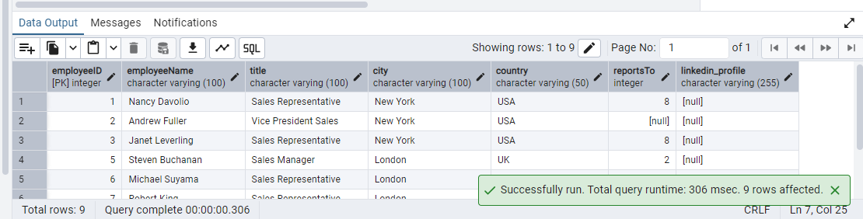

--Change the linkedin_profile column data type from VARCHAR to TEXT.

ALTER TABLE "employees"

ALTER COLUMN "linkedin_profile" TYPE TEXT;

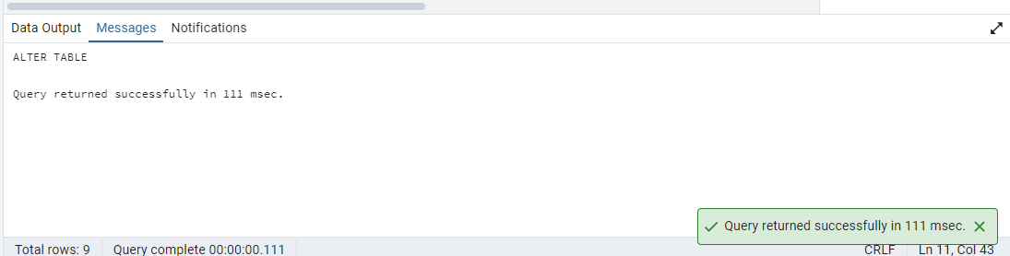

--Adding data in column linked_profile

UPDATE "employees"

SET "linkedin_profile" = 'https://www.linkedin.com/in/nancy-Dav'

WHERE "employeeID" = 1;

UPDATE "employees" SET "linkedin_profile" = 'https://www.linkedin.com/in/Andrew'

WHERE "employeeID" = 2;

UPDATE "employees" SET "linkedin_profile" = 'https://www.linkedin.com/in/Janet'

WHERE "employeeID" = 3;

UPDATE "employees" SET "linkedin_profile" = 'https://www.linkedin.com/in/Margaret'

WHERE "employeeID" = 4;

UPDATE "employees" SET "linkedin_profile" = 'https://www.linkedin.com/in/Steven'

WHERE "employeeID" = 5;

UPDATE "employees" SET "linkedin_profile" = 'https://www.linkedin.com/in/Michael'

WHERE "employeeID" = 6;

UPDATE "employees" SET "linkedin_profile" = 'https://www.linkedin.com/in/Robert'

WHERE "employeeID" = 7;

UPDATE "employees" SET "linkedin_profile" = 'https://www.linkedin.com/in/Laura'

WHERE "employeeID" = 8;

UPDATE "employees" SET "linkedin_profile" = 'https://www.linkedin.com/in/Anne'

WHERE "employeeID" = 9;

OUTPUT

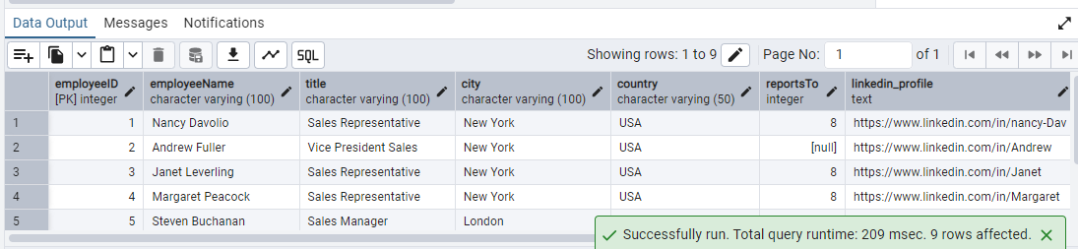

--Add unique, not null constraint to linkedin_profile

ALTER TABLE "employees"

ALTER COLUMN "linkedin_profile" SET NOT NULL;

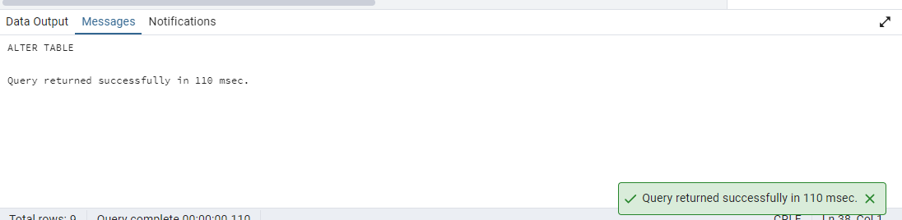

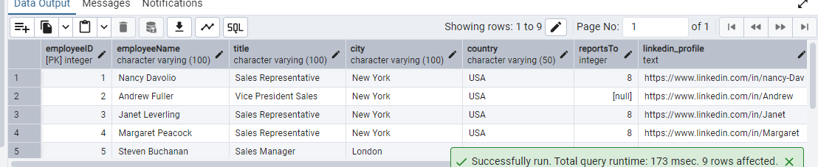

ALTER TABLE "employees"

ADD CONSTRAINT "unique_linkedin_profile" UNIQUE ("linkedin_profile");

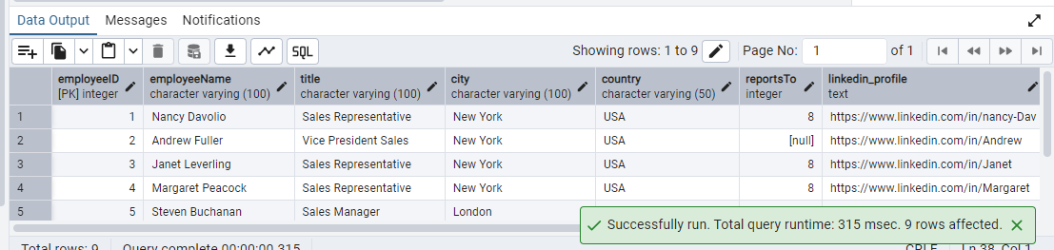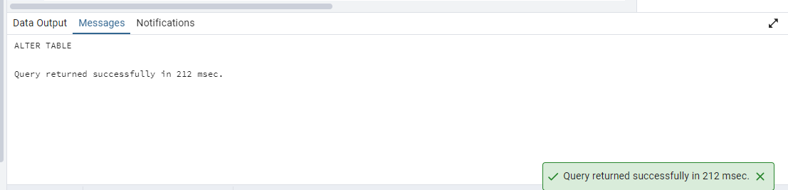

--Drop column linkedin_profile

ALTER TABLE "employees"

DROP COLUMN "linkedin_profile";

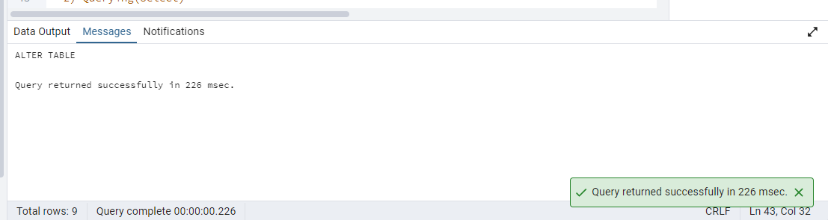

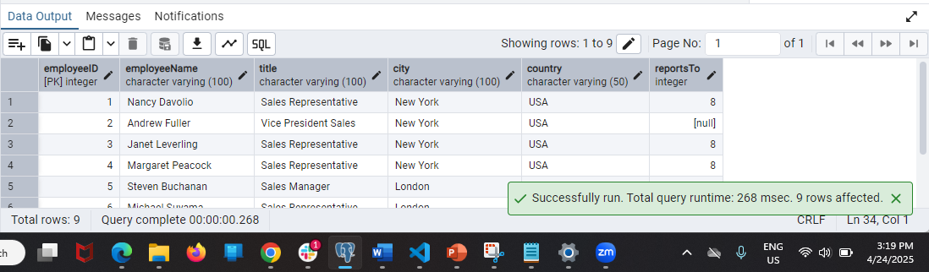

--2) Querying(Select)

-- Retrieve the employee name and title of all employees

select "employeeName","title" from employees;

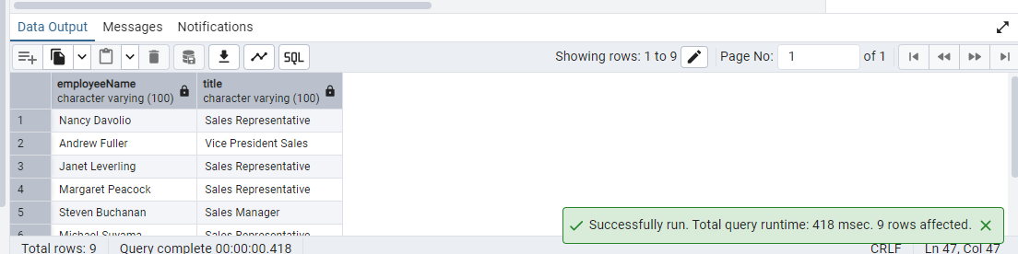

-- Find all unique unit prices of products

SELECT DISTINCT "unitPrice"

FROM "products";

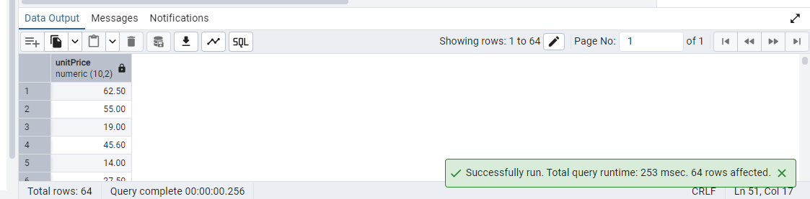

--List all customers sorted by company name in ascending orde

SELECT *from "customers" ORDER BY "companyName" ASC;

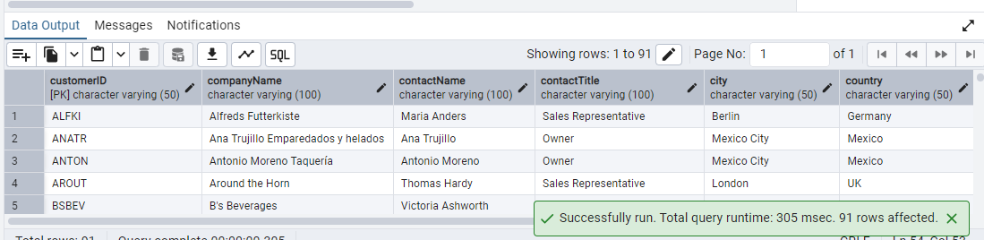

--Display product name and unit price, but rename the unit_price column as price_in_usd

SELECT "productName","unitPrice" AS "price_in_usd"

FROM "products";

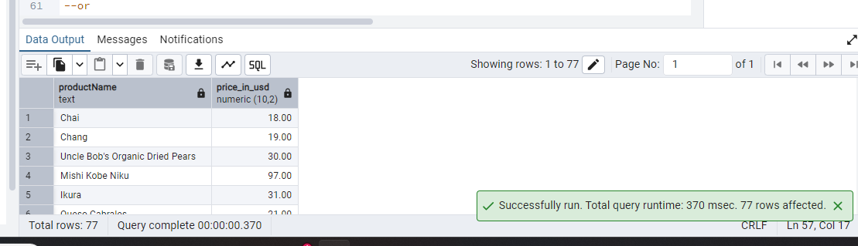

--3)Filtering

--Get all customers from Germany.

SELECT "customerID" FROM "customers" WHERE country='Germany';

--or

SELECT *FROM "customers" WHERE country='Germany';

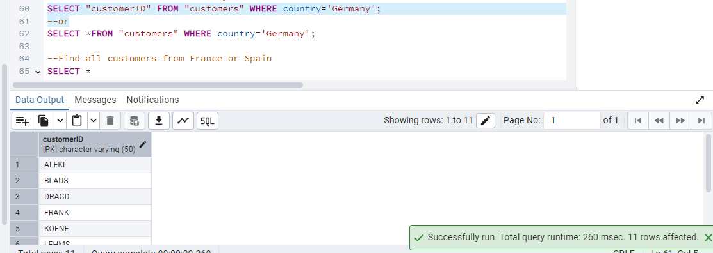

--Find all customers from France or Spain

SELECT *

FROM customers

WHERE country IN ('France', 'Spain');

--or

SELECT "customerID" ,"country" FROM "customers" WHERE country IN ('France', 'Spain');

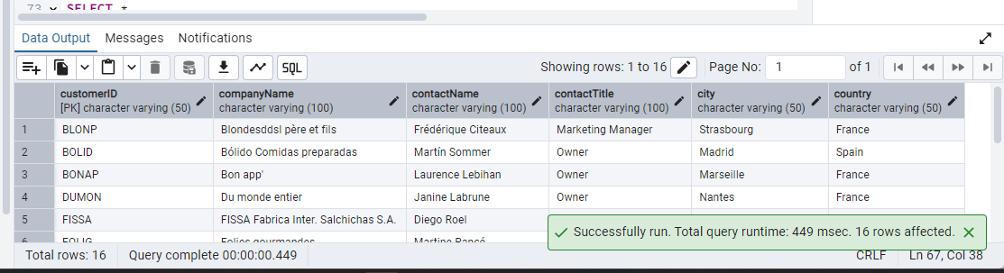

--Retrieve all orders placed in 2014(based on order_date), and either have freight greater than 50 or the shipped date available (i.e., non-NULL) (Hint: EXTRACT(YEAR FROM order_date))

SELECT *FROM "orders";

SELECT *

FROM "orders"

WHERE EXTRACT(YEAR FROM "orderDate") = 2014

AND (freight > 50 OR "shippedDate" IS NOT NULL);

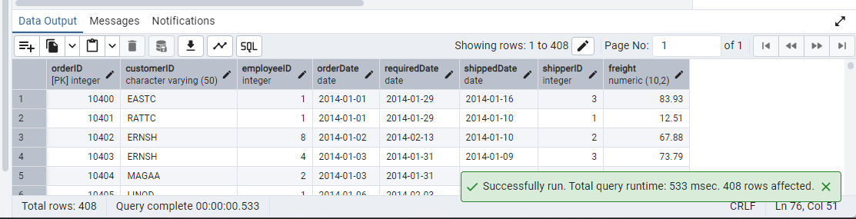

--4)Filtering

--Retrieve the product_id, product_name, and unit_price of products where the unit_price is greater than 15.

SELECT "productID","productName","unitPrice" from "products" WHERE "unitPrice" > 5;

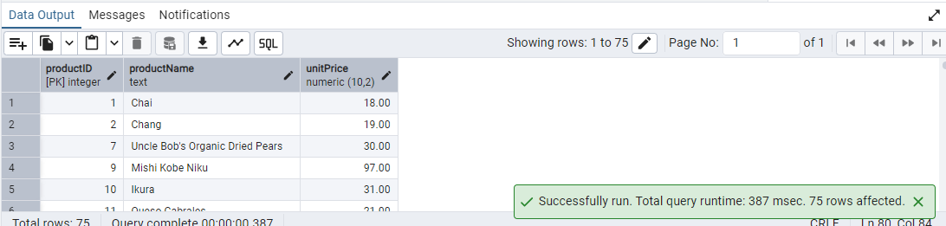

--List all employees who are located in the USA and have the title "Sales Representative".

SELECT "employeeID","employeeName","country","title" FROM employees

WHERE "country"='USA'AND "title"='Sales Representative';

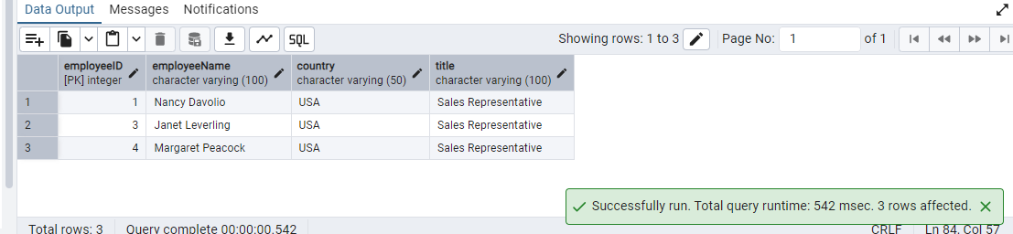

--Retrieve all products that are not discontinued and priced greater than 30.

SELECT *

FROM "products"

WHERE "discontinued"= 'False'

AND "unitPrice" > 30;

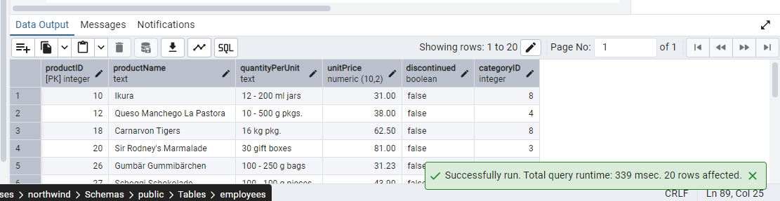

--5)LIMIT/FETCH

-- Retrieve the first 10 orders from the orders table.

SELECT *FROM "orders" LIMIT 10;

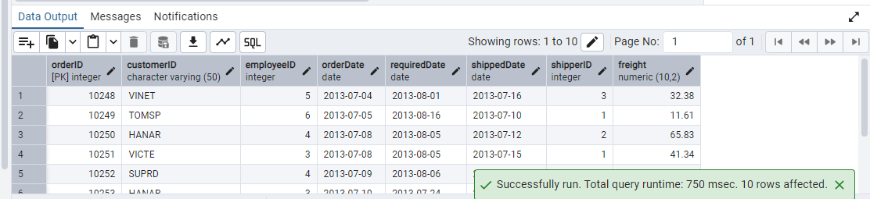

--Retrieve orders starting from the 11th order, fetching 10 rows (i.e., fetch rows 11-20).

SELECT *

FROM "orders"

ORDER BY "orderID"

OFFSET 10

LIMIT 10;

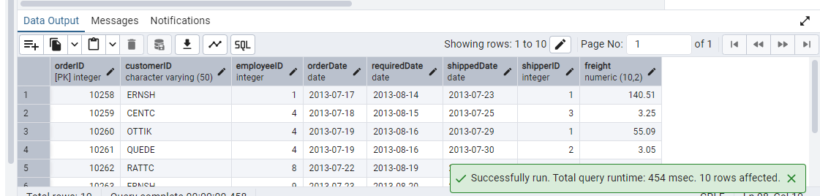

--6)Filtering (IN, BETWEEN)

--List all customers who are either Sales Representative, Owner

SELECT *

FROM "customers"

WHERE "contactTitle" IN ('Sales Representative', 'Owner');

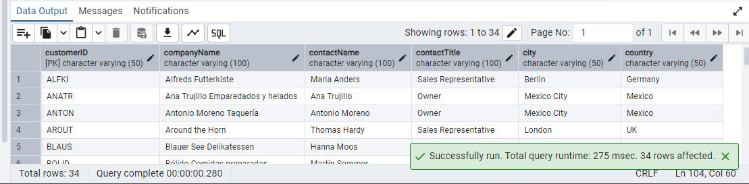

--Retrieve orders placed between January 1, 2013, and December 31, 2013

SELECT *

FROM "orders"

WHERE "orderDate" BETWEEN '2013-01-01' AND '2013-12-31';

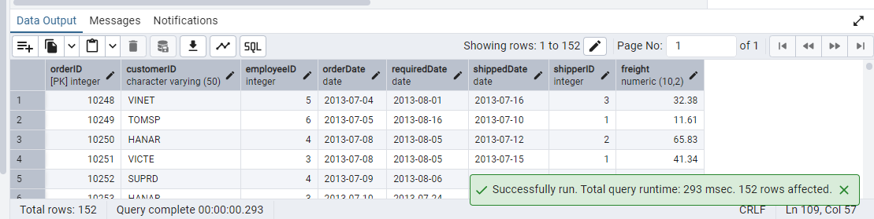

--7) Filtering

--List all products whose category_id is not 1, 2, or 3.

SELECT *FROM "products" WHERE "categoryID" NOT IN(1,2,3);

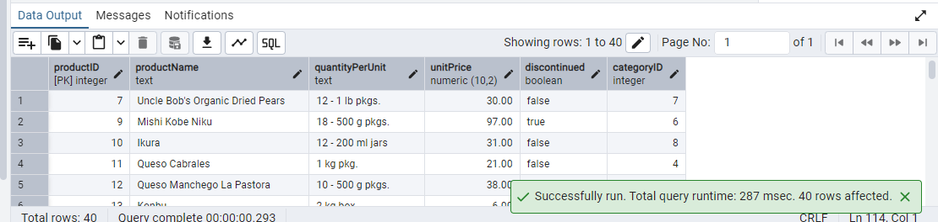

--Find customers whose company name starts with "A".

SELECT *FROM "customers" WHERE "companyName" LIKE 'A%';

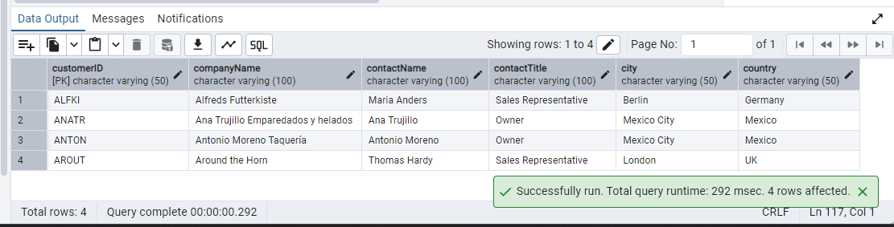

--8)INSERT into orders table:

Task: Add a new order to the orders table with the following details:

Order ID: 11078 Customer ID:

ALFKI Employee ID: 5

Order Date: 2025-04-23 Required Date: 2025-04-30

Shipped Date: 2025-04-25 shipperID:2

freight: 45.50

INSERT INTO "orders" (

"orderID", "customerID", "employeeID","orderDate",

"requiredDate", "shippedDate", "shipperID","freight"

)

VALUES (

11078, 'ALFKI', 5, '2025-04-23',

'2025-04-30', '2025-04-25', 2, 45.50

);

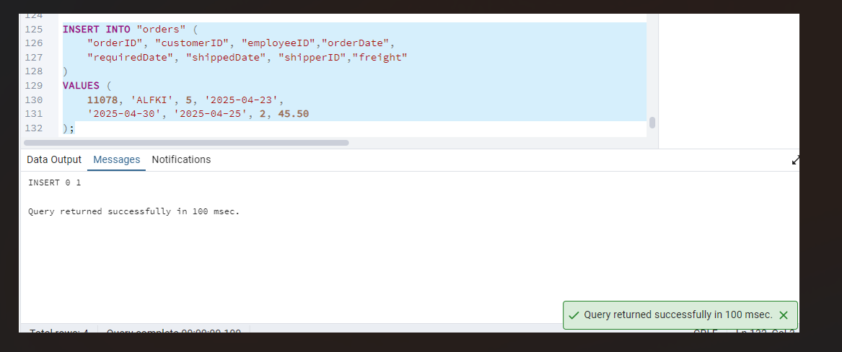

--9)Increase(Update) the unit price of all products in category_id =2 by 10%.

(HINT: unit_price =unit_price * 1.10)

UPDATE "products"

SET "unitPrice" = "unitPrice" * 1.10

WHERE "categoryID" = 2;

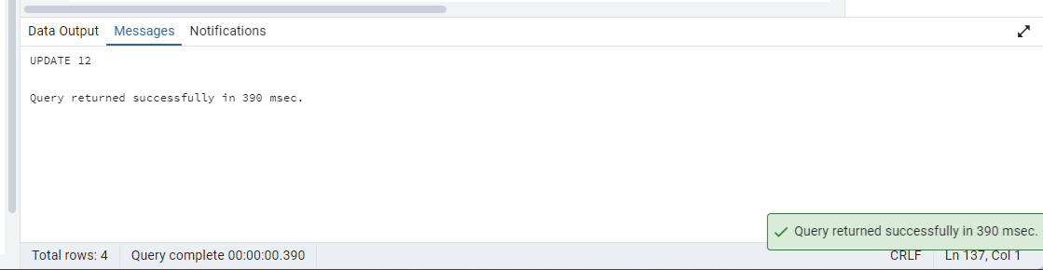

10)

