* Add a new column linkedin_profile to employees table to store LinkedIn URLs as varchar.

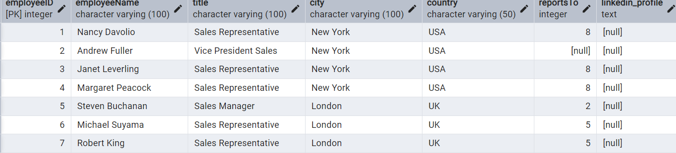

-- Retrieve the first name, last name, and title of all employees

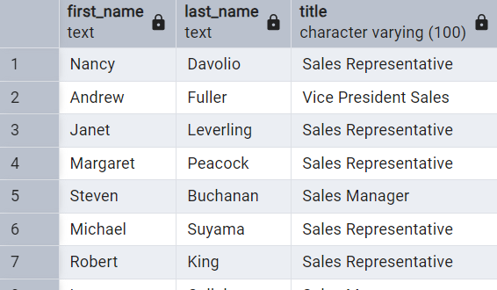

Find all unique unit prices of products

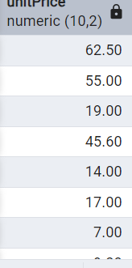

List all customers sorted by company name in ascending order

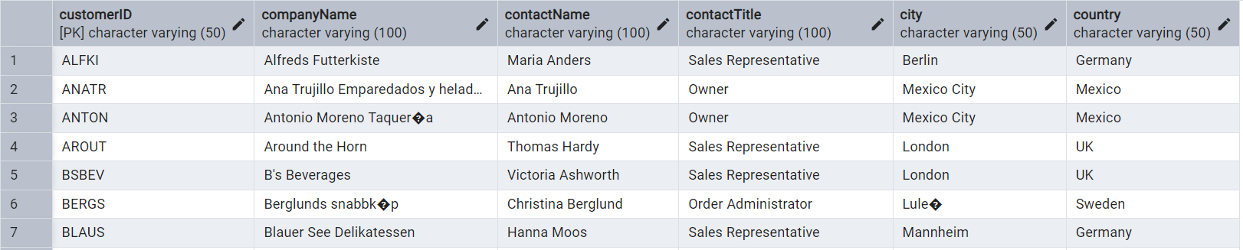

Display product name and unit price, but rename the unit_price column as price_in_usd

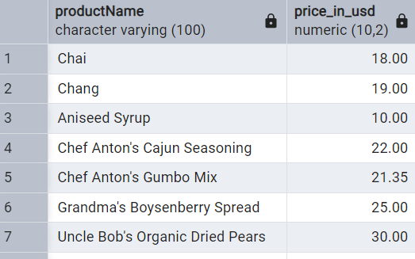

-- Retrieve the employee name and title of all employees

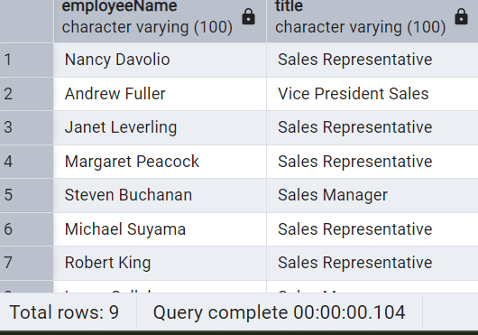

Get all customers from Germany

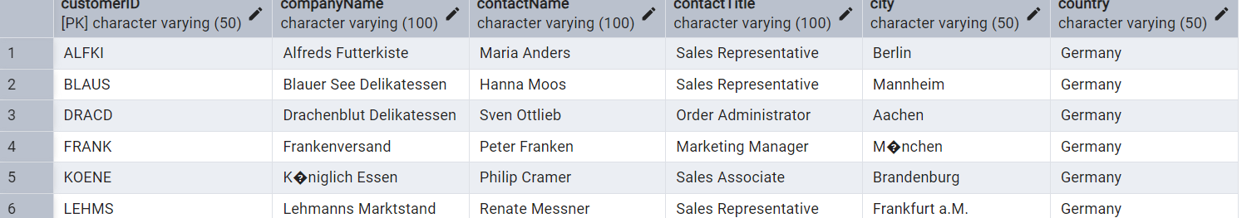

-Find all customers from France or Spain

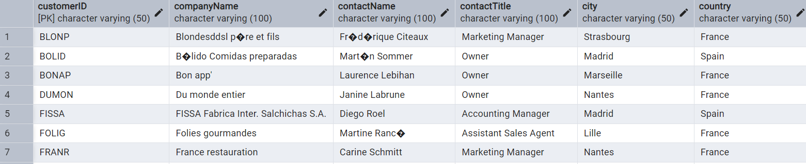

--Retrieve all orders placed in 2014(based on order_date), and either have freight greater than 50 or the shipped date available (i.e., non-NULL)

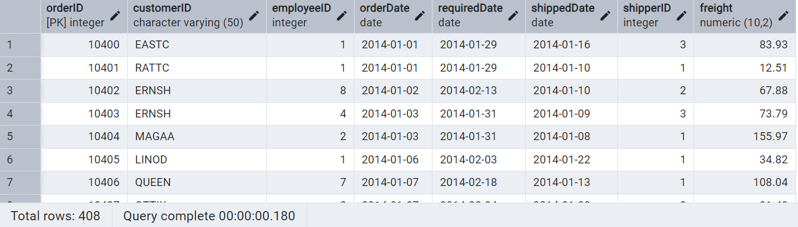

Retrieve the product_id, product_name, and unit_price of products where the unit_price is greater than 15

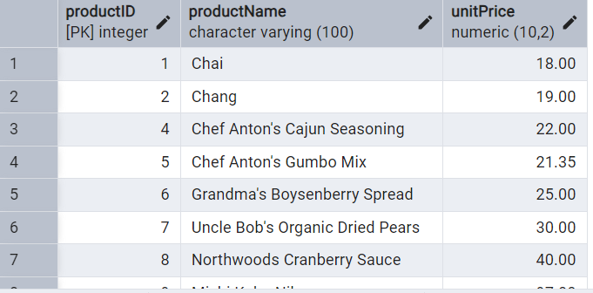

-List all employees who are located in the USA and have the title "Sales Representative

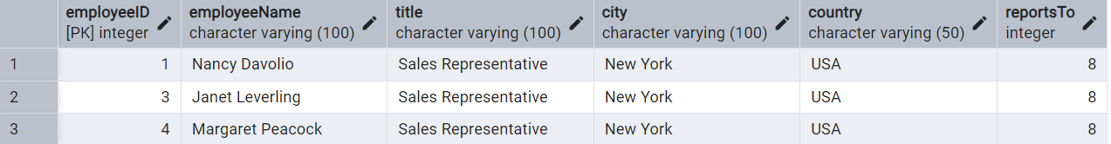

Retrieve all products that are not discontinued and priced greater than 30

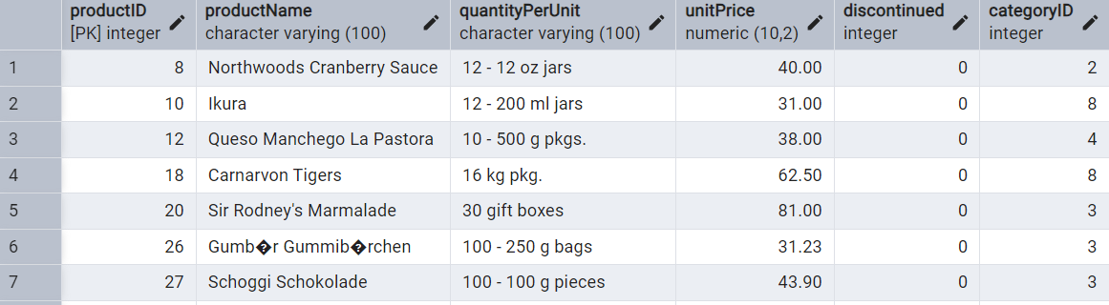

Retrieve the first 10 orders from the orders table

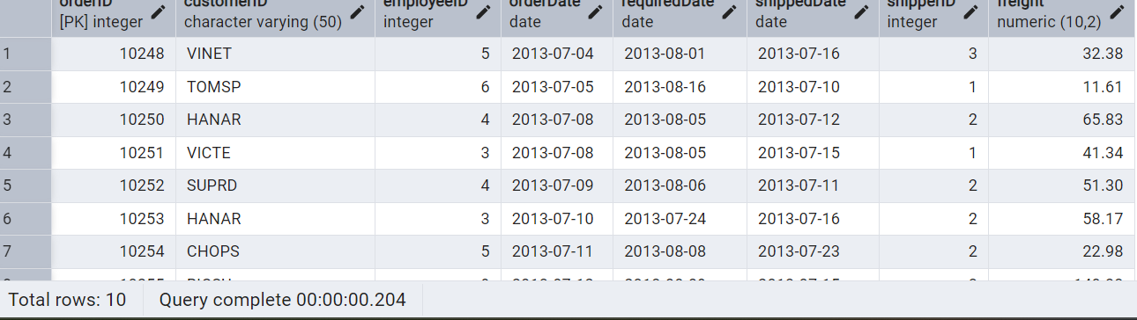

Retrieve orders starting from the 11th order, fetching 10 rows (i.e., fetch rows 11-20)

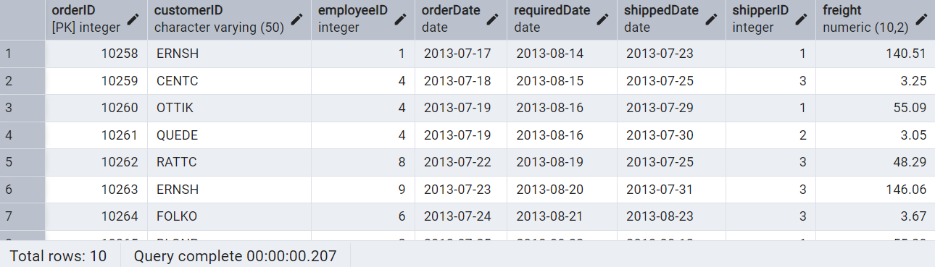

List all customers who are either Sales Representative, Owner

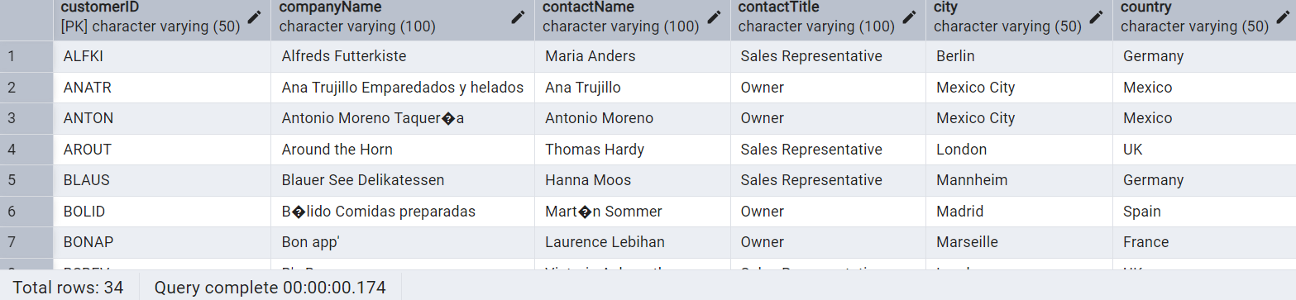

Retrieve orders placed between January 1, 2013, and December 31, 2013

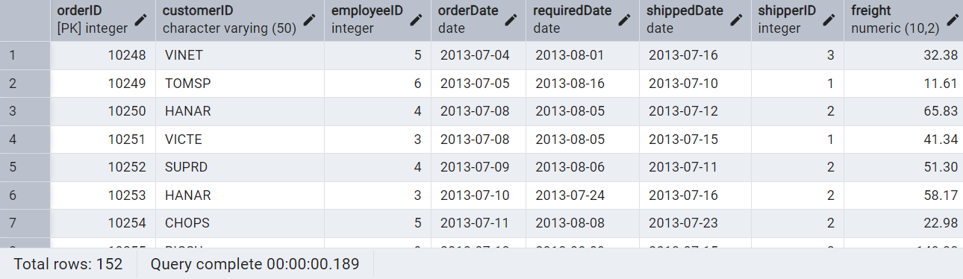

List all products whose category_id is not 1, 2, or 3

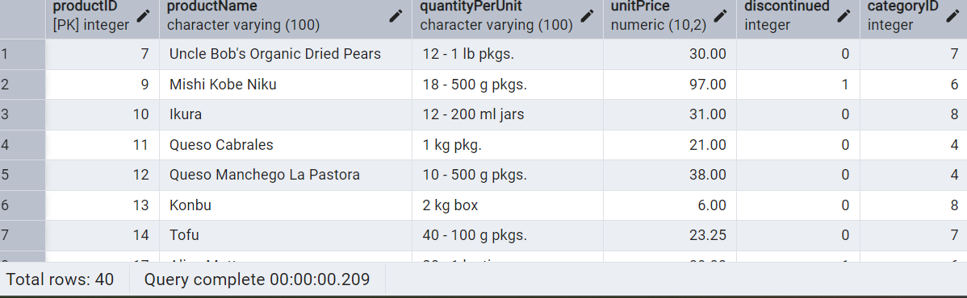

Find customers whose company name starts with "A"

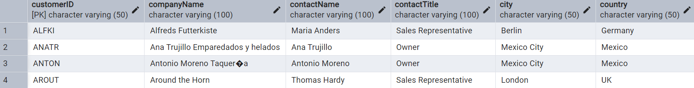

Adding new order in orders table(after new order in entire order table)

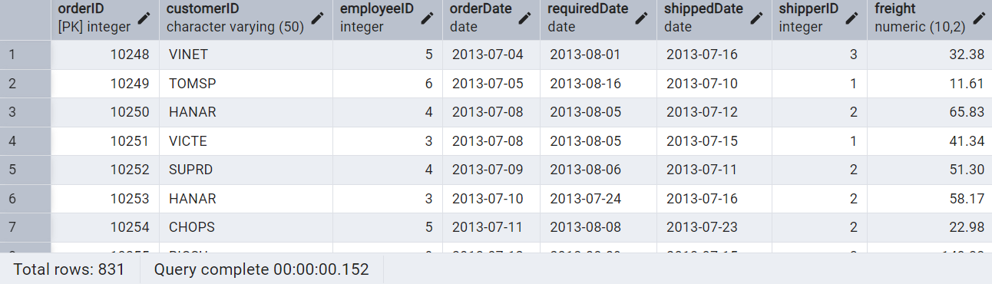

Increase(Update) the unit price of all products in category_id =2 by 10%

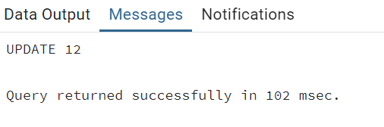

Sample Northwind database

