**Day2**

1)      Alter Table:

* Add a new column linkedin_profile to employees table to store LinkedIn URLs as varchar.

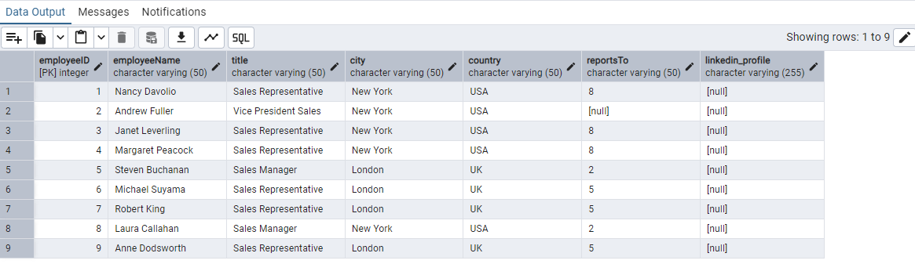

* Change the linkedin_profile column data type from VARCHAR to TEXT.

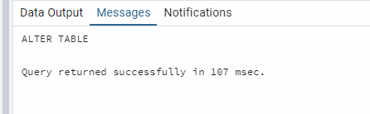

* Add unique, not null constraint to linkedin_profile

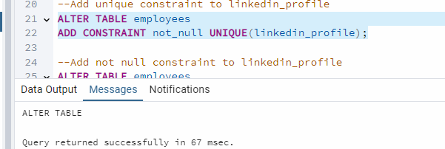

* Drop column linkedin_profile

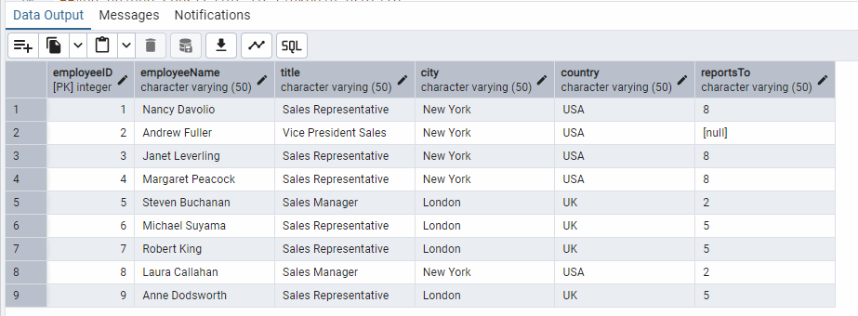

2)      Querying (Select)

* Retrieve the employee name and title of all employees

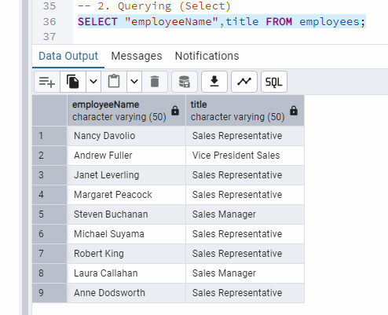

* Find all unique unit prices of products

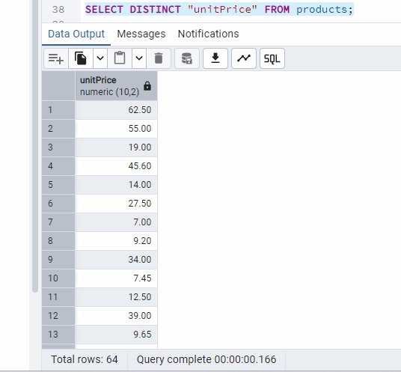

* List all customers sorted by company name in ascending order

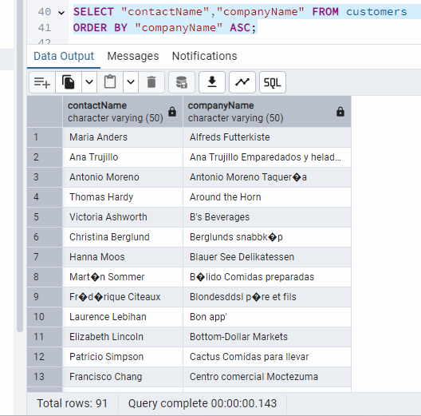

* Display product name and unit price, but rename the unit_price column as price_in_usd

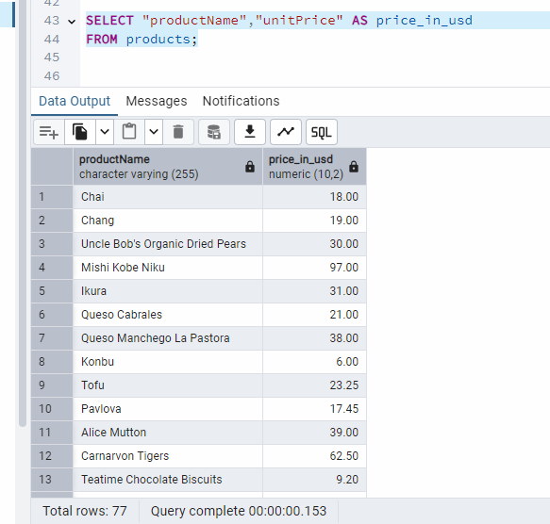

3)      Filtering

* Get all customers from Germany.

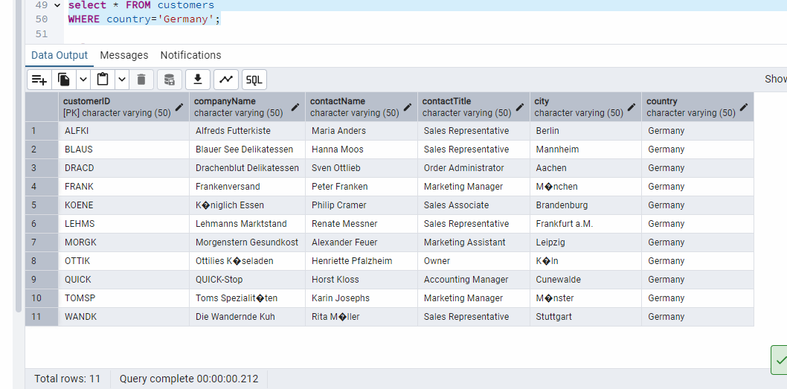

* Find all customers from France or Spain

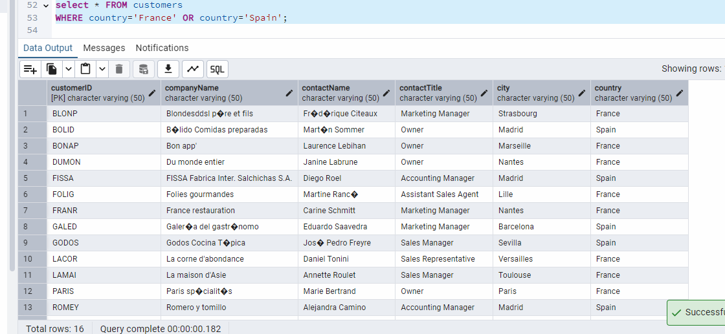

* Retrieve all orders placed in 2014(based on order_date), and either have freight greater than 50 or the shipped date available (i.e., non-NULL)  (Hint: EXTRACT(YEAR FROM order_date))

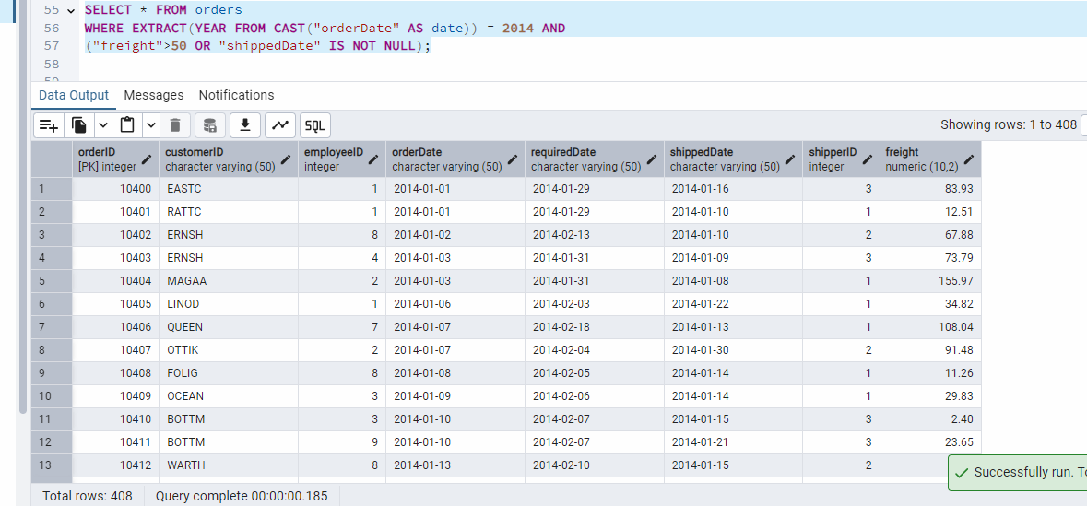

4)      Filtering

* Retrieve the product_id, product_name, and unit_price of products where the unit_price is greater than 15.

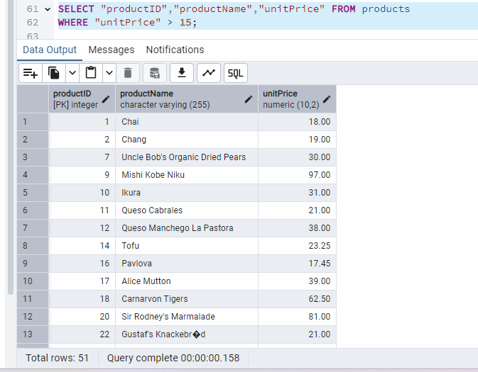

* List all employees who are located in the USA and have the title "Sales Representative".

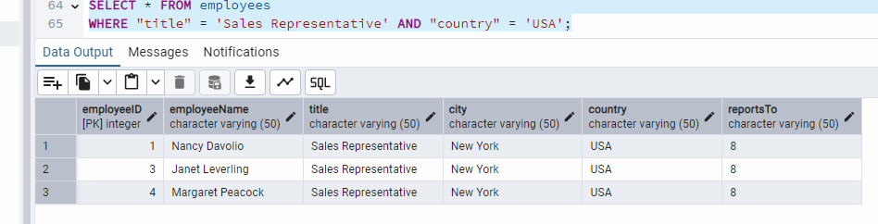

* Retrieve all products that are not discontinued and priced greater than 30.

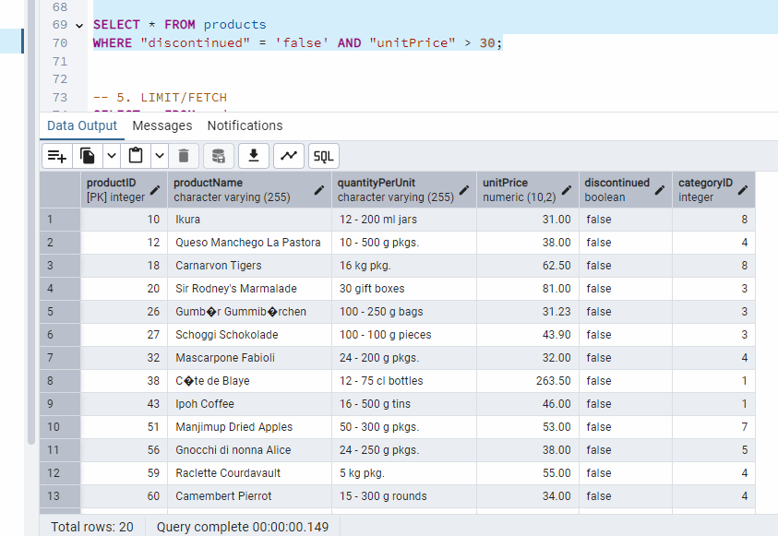

5)      LIMIT/FETCH

* Retrieve the first 10 orders from the orders table.

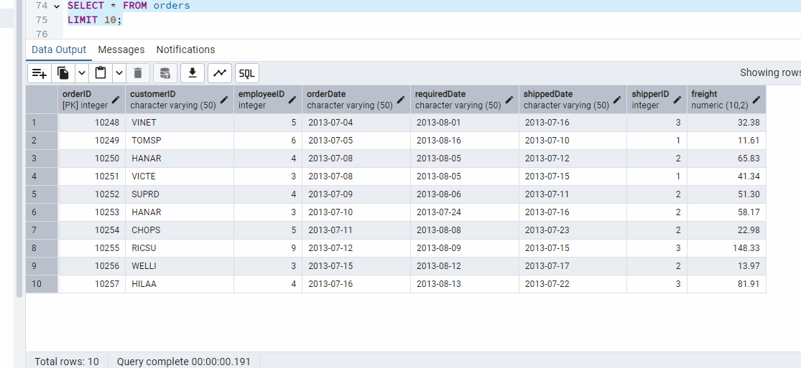

* Retrieve orders starting from the 11th order, fetching 10 rows (i.e., fetch rows 11-20).

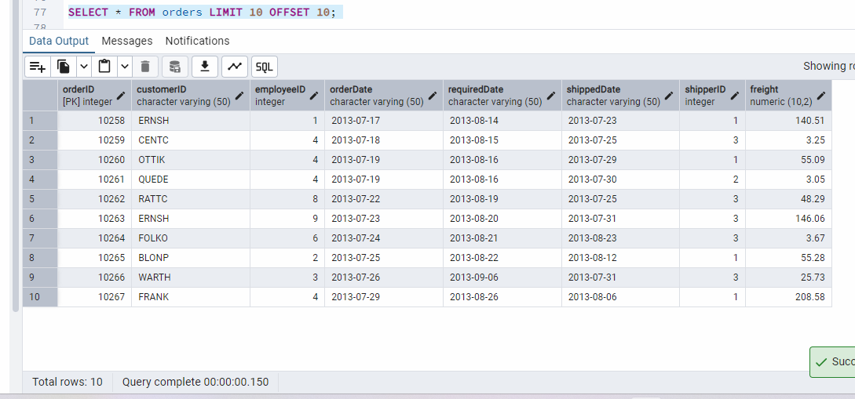

6)      Filtering (IN, BETWEEN)

* List all customers who are either Sales Representative, Owner

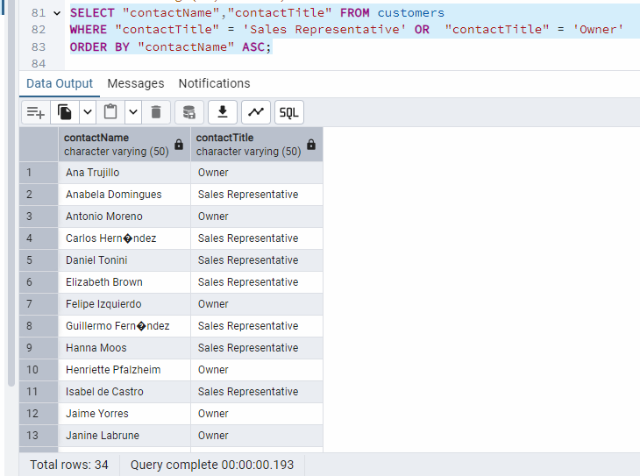

* Retrieve orders placed between January 1, 2013, and December 31, 2013.

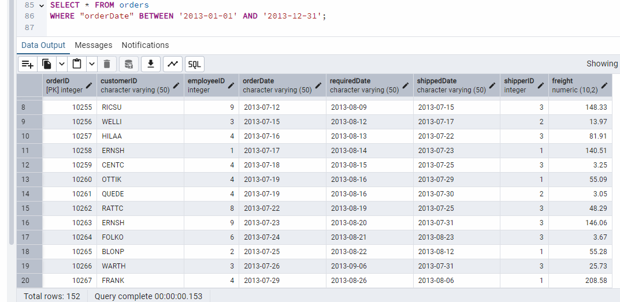

7)      Filtering

* List all products whose category_id is not 1, 2, or 3.

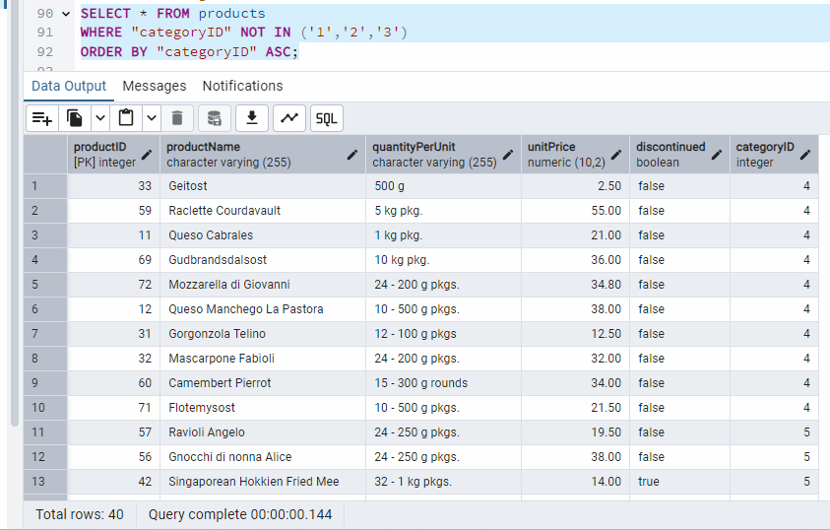

* Find customers whose company name starts with "A".

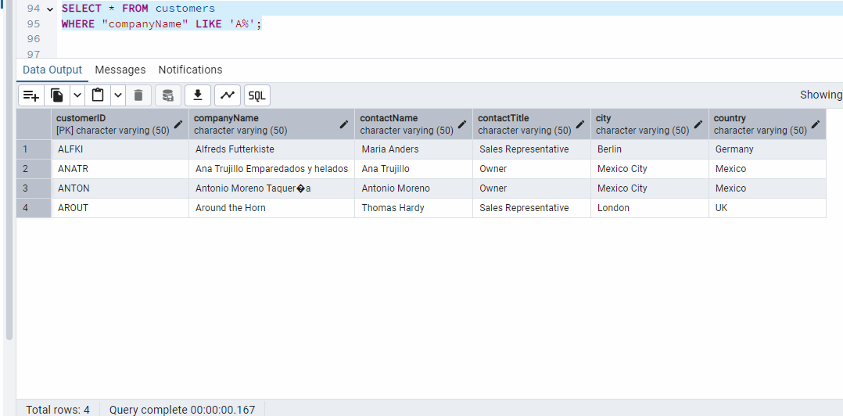

8)       INSERT into orders table:

 Task: Add a new order to the orders table with the following details:

Order ID: 11078

Customer ID: ALFKI

Employee ID: 5

Order Date: 2025-04-23

Required Date: 2025-04-30

Shipped Date: 2025-04-25

shipperID:2

Freight: 45.50

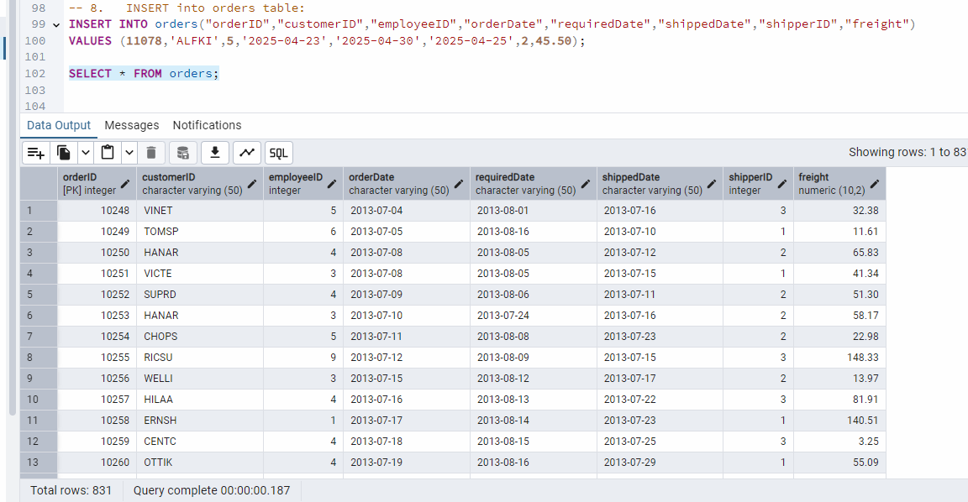

9)      Increase(Update)  the unit price of all products in category_id =2 by 10%.

(HINT: unit_price =unit_price * 1.10)

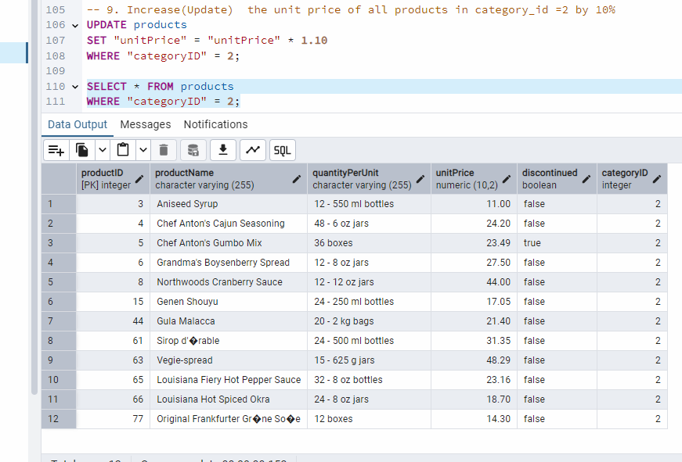

10) Sample Northwind database:

Download

1. Download northwind.sql from below link into your local. Sign in to Git first <https://github.com/pthom/northwind_psql>
2. Manually Create the database using pgAdmin:
   1. Right-click on "Databases" → Create → Database
   2. Give name as ‘northwind’ (all small letters)
   3. Click ‘Save’

Import database:

1. Open pgAdmin and connect to your server
2. Select the database  ‘northwind’
3. Right Click-> Query tool.
4. Click the folder icon to open your northwind.sql file
5. Press F5 or click the Execute button.
6. You will see total 14 tables loaded
7. Databases → your database → Schemas → public → Tables

