**Day 3**

**USE Northwind from Kaggle:**

1) Update the categoryName From “Beverages” to "Drinks" in the categories table.

UPDATE "categories"

SET "categoryName" = 'Drinks'

WHERE "categoryName" = 'Beverages';

SELECT * FROM "categories";

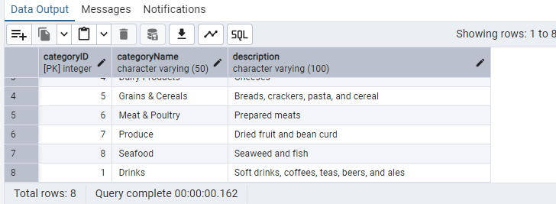

2) Insert into shipper new record (give any values) Delete that new record from shippers table.

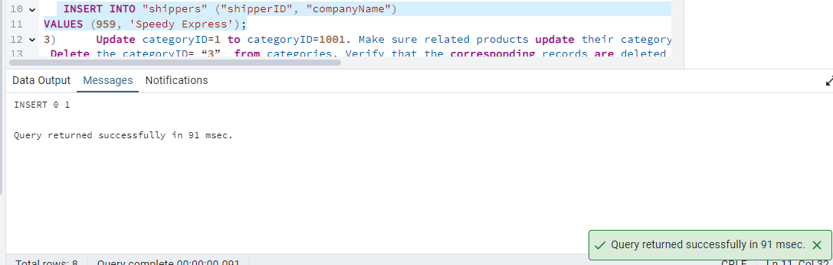

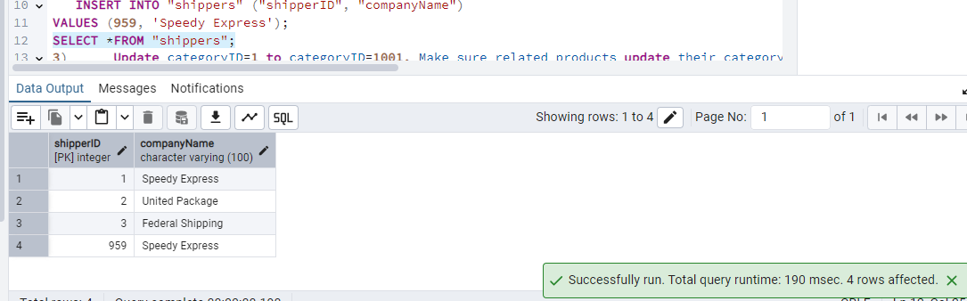

Delete that new record from shippers

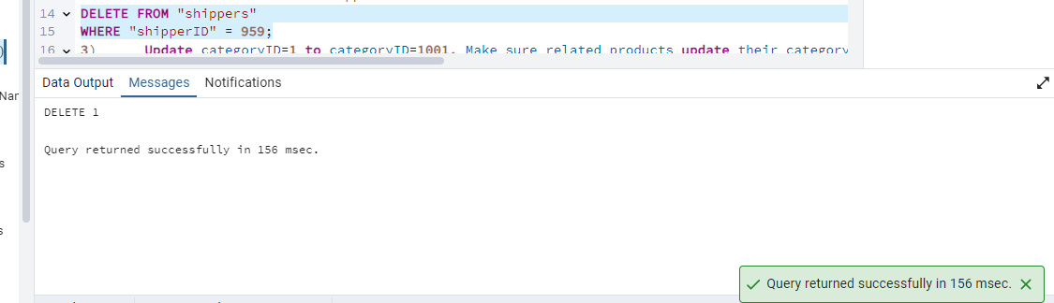

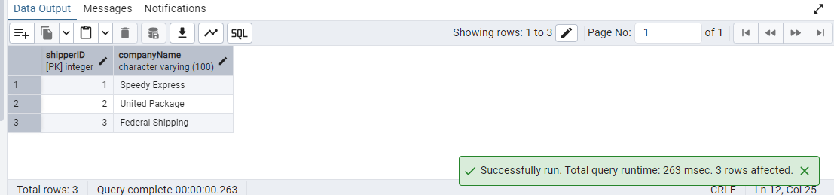

3) Update categoryID=1 to categoryID=1001. Make sure related products update their categoryID too. Display the both category and products table to show the cascade.

Delete the categoryID= “3” from categories. Verify that the corresponding records are deleted automatically from products.

(HINT: Alter the foreign key on products(categoryID) to add ON UPDATE CASCADE, ON DELETE CASCADE)

---- Drop the existing foreign key (replace the constraint name with the actual one)

ALTER TABLE "products"

DROP CONSTRAINT IF EXISTS fk_categoryID;

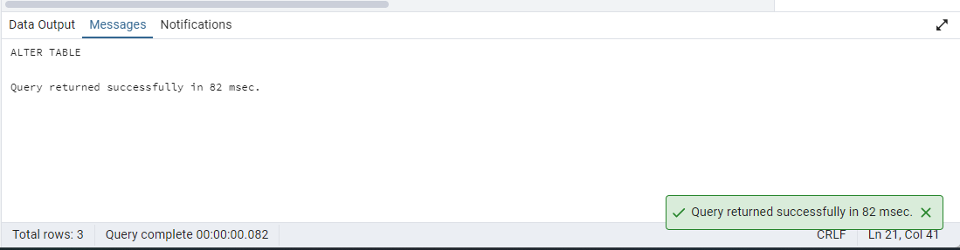

-- Add the new foreign key with cascade behavior

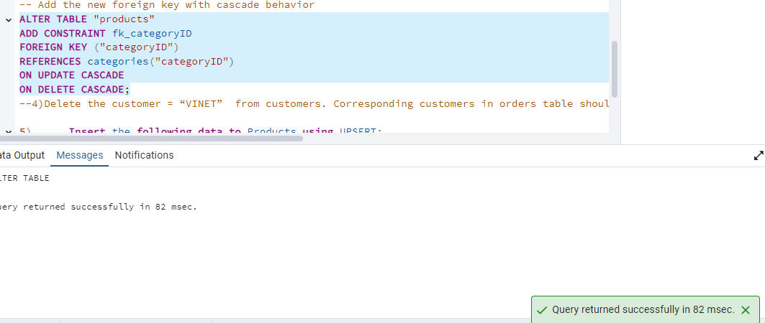

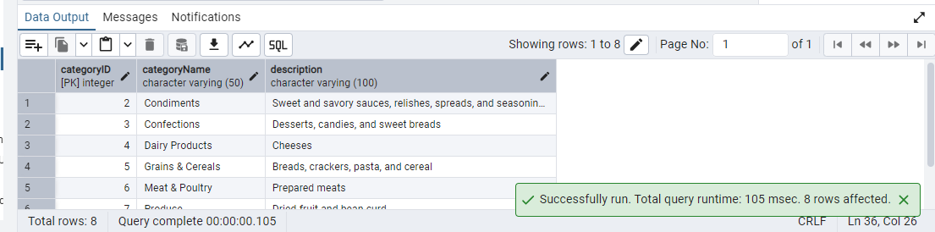

4) Delete the customer = “VINET” from customers. Corresponding customers in orders table should be set to null (HINT: Alter the foreign key on orders(customerID) to use ON DELETE SET NULL)

ALTER TABLE "orders"

DROP CONSTRAINT fk_customerID ;

--Add new FK with ON DELETE SET NULL

ALTER TABLE "orders"

ADD CONSTRAINT "fk_customerID"

FOREIGN KEY ("customerID")

REFERENCES "customers"("customerID")

ON DELETE SET NULL;

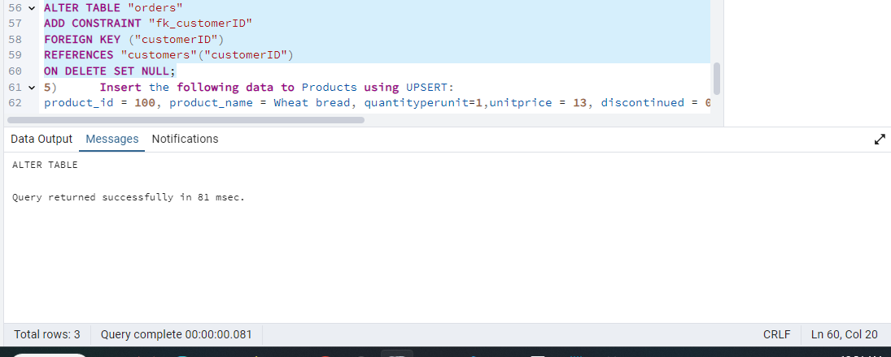

SELECT * FROM orders

WHERE "orderID" IN (10248,10274,10295,10737,10739);

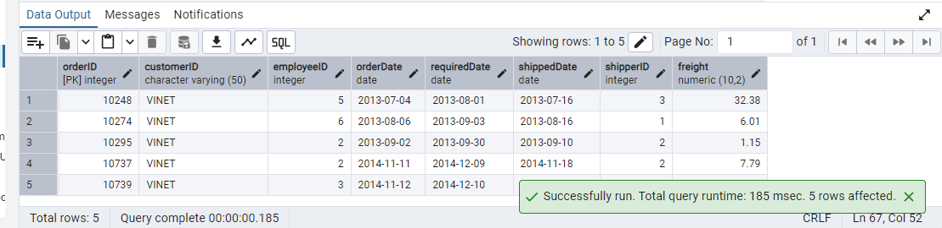

5) Insert the following data to Products using UPSERT:

product_id = 100, product_name = Wheat bread, quantityperunit=1,unitprice = 13, discontinued = 0, categoryID=3

product_id = 101, product_name = White bread, quantityperunit=5 boxes,unitprice = 13, discontinued = 0, categoryID=3

product_id = 100, product_name = Wheat bread, quantityperunit=10 boxes,unitprice = 13, discontinued = 0, categoryID=3

(this should update the quantityperunit for product_id = 100)

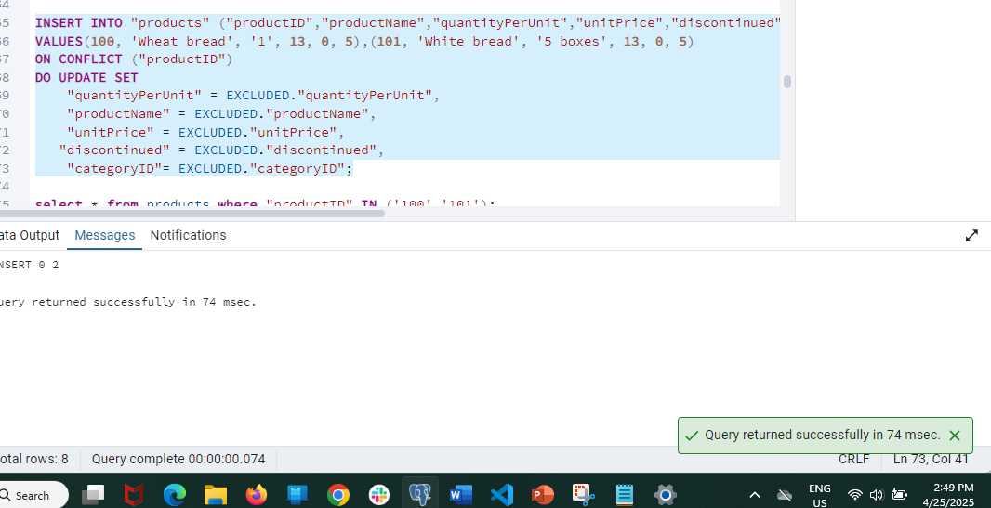

select * from products where "productID" IN ('100','101');

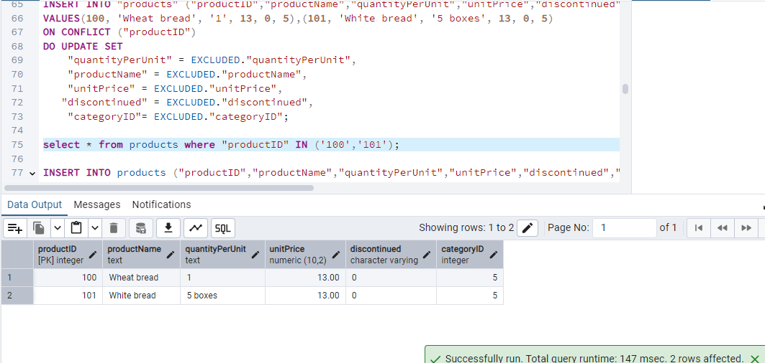

After Assert

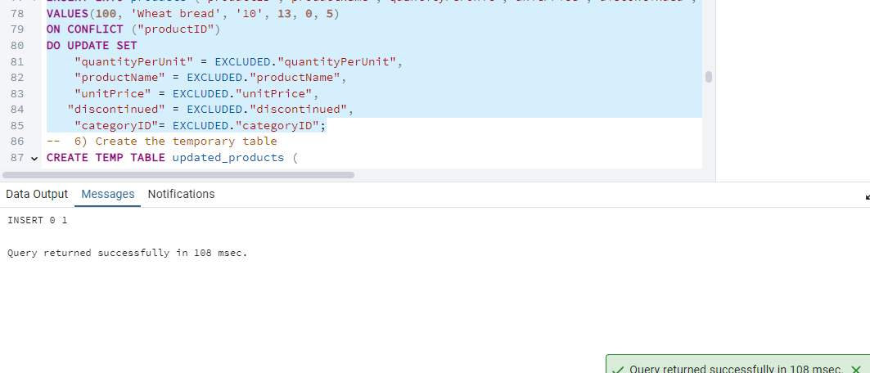

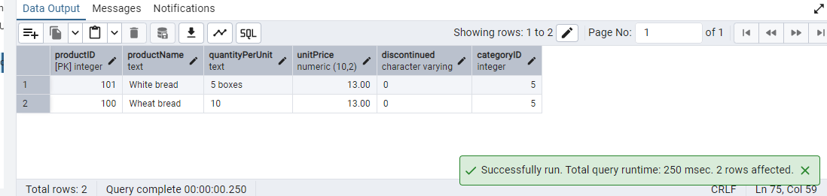

6) Write a **MERGE query**:

Create **temp table with name:**  ‘updated_products’ and insert values as below:

| productID | productName | quantityPerUnit | unitPrice | discontinued | categoryID |
| --- | --- | --- | --- | --- | --- |
| 100 | Wheat bread | 10 | 20 | 1 | 3 |
| 101 | White bread | 5 boxes | 19.99 | 0 | 3 |
| 102 | Midnight Mango Fizz | 24 - 12 oz bottles | 19 | 0 | 1 |
| 103 | Savory Fire Sauce | 12 - 550 ml bottles | 10 | 0 | 2 |

* Update the price and discontinued status for from below table ‘updated_products’ only if there are matching products and updated_products .discontinued =0
* If there are matching products and updated_products .discontinued =1 then delete

* Insert any new products from updated_products that don’t exist in products only if updated_products .discontinued =0.

–Insert the Data

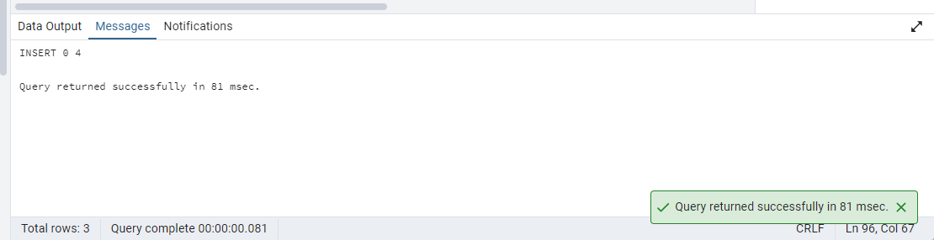

Insert data

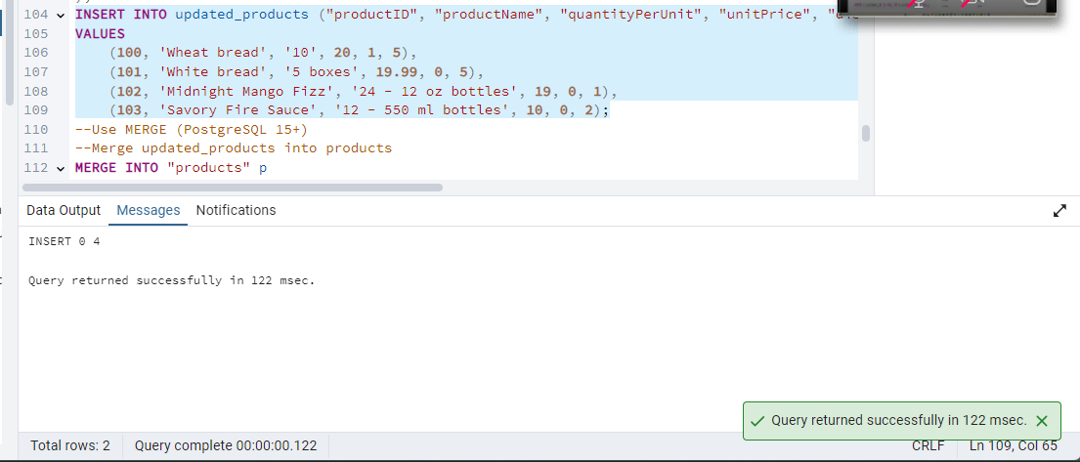

--Merge updated_products into products

MERGE INTO "products" p

USING "updated_products" u

ON p."productID" = u."productID"

-- If matching and discontinued = 0 → UPDATE

WHEN MATCHED AND u."discontinued" = 0 THEN

UPDATE SET

"unitPrice" = u."unitPrice",

"discontinued" =u."discontinued"

-- If matching and discontinued = 1 → DELETE

WHEN MATCHED AND u."discontinued" = 1 THEN

DELETE

-- If not matched and discontinued = 0 → INSERT

WHEN NOT MATCHED AND u."discontinued" = 0 THEN

INSERT ("productID","productName", "quantityPerUnit", "unitPrice", "discontinued", "categoryID")

VALUES (u."productID", u."productName", u."quantityPerUnit", u."unitPrice", u."discontinued", u."categoryID");

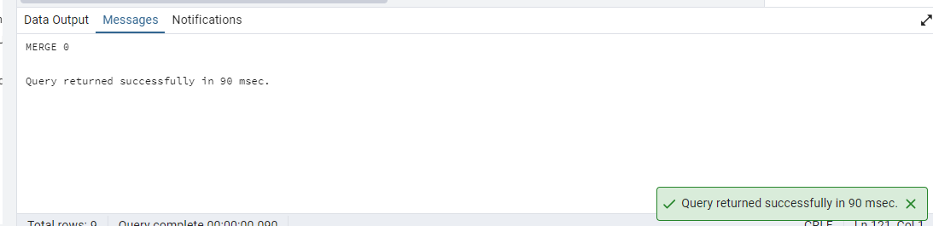

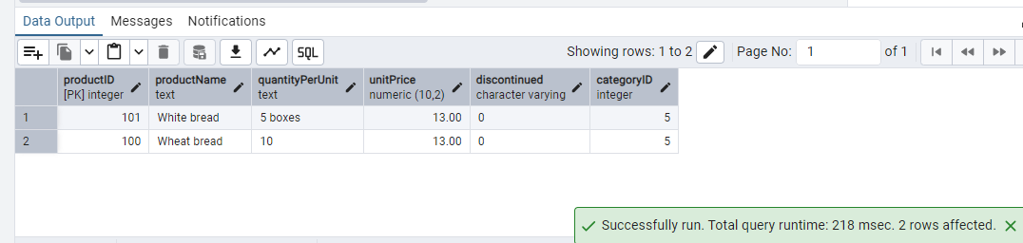

**USE NEW Northwind DB:**

7) List all orders with employee full names. (Inner join)

