1. List all customers and the products they ordered with the order date. (Inner join)

**Tables used:** customers, orders, order_details, products

**Output should have below columns:**

companyname AS customer,

orderid,

productname,

quantity,

orderdate

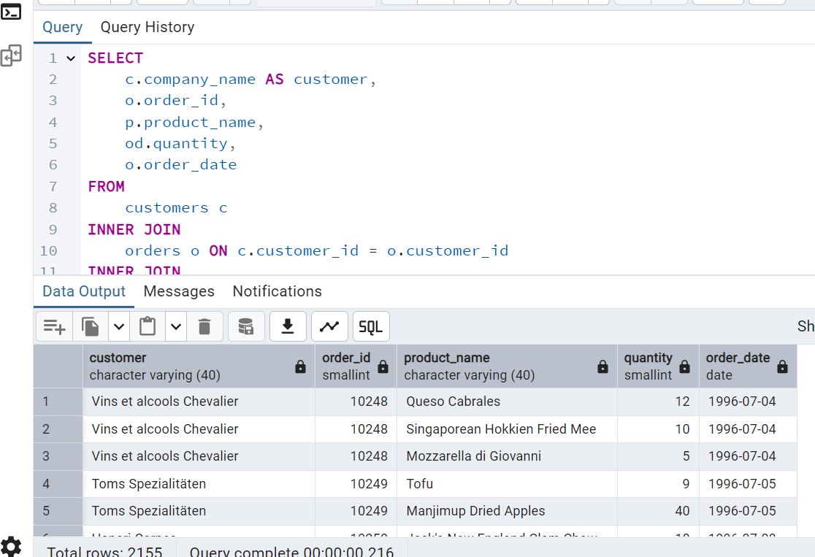

2. Show each order with customer, employee, shipper, and product info — even if some parts are missing. (Left Join)

**Tables used: orders, customers, employees, shippers, order_details, products**

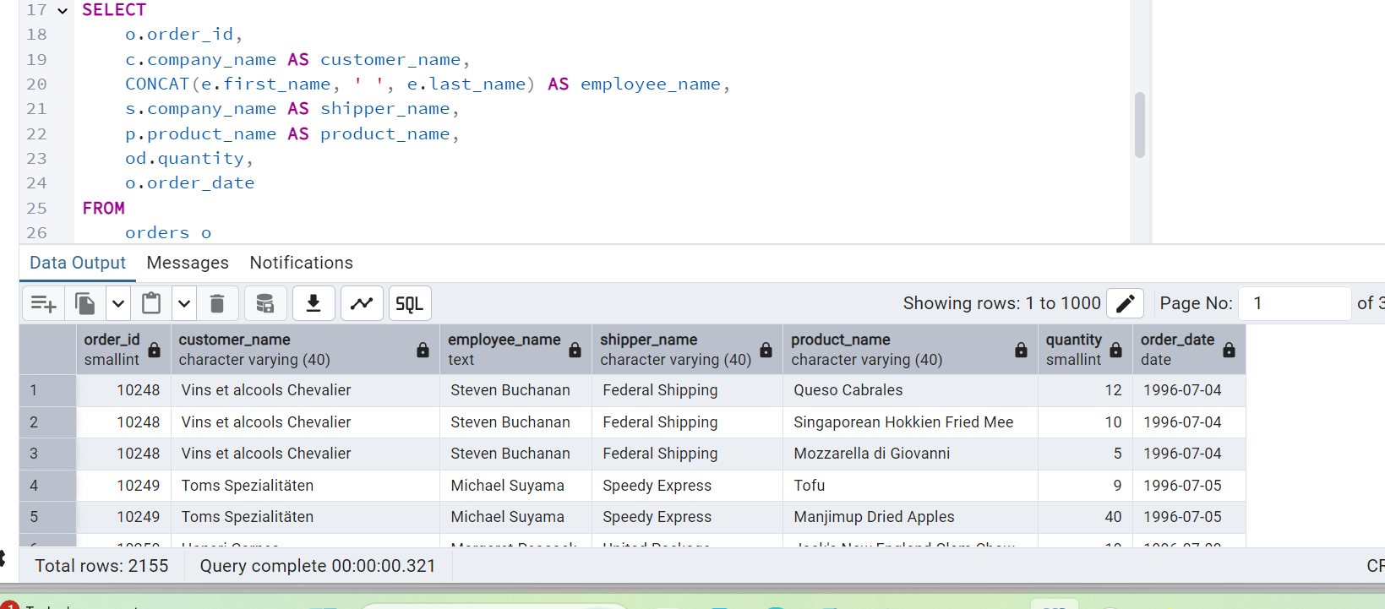

3. Show all order details and products (include all products even if they were never ordered). (Right Join)

**Tables used: order_details, products**

**Output should have below columns:**

orderid,

productid,

quantity,

productname

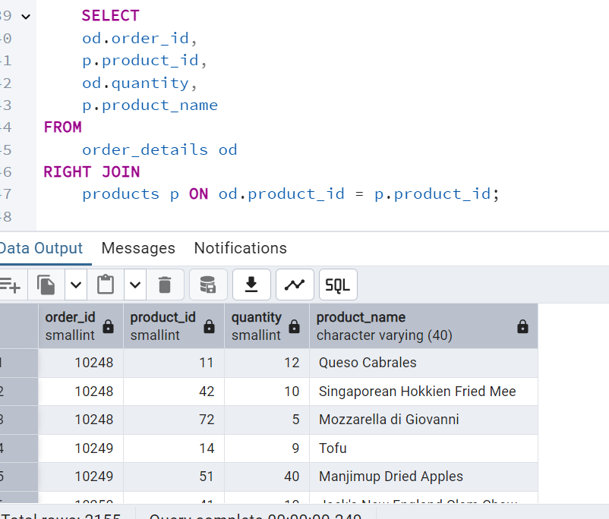

4. List all product categories and their products — including categories that have no products, and products that are not assigned to any category.(Outer Join)

**Tables used: categories, products**

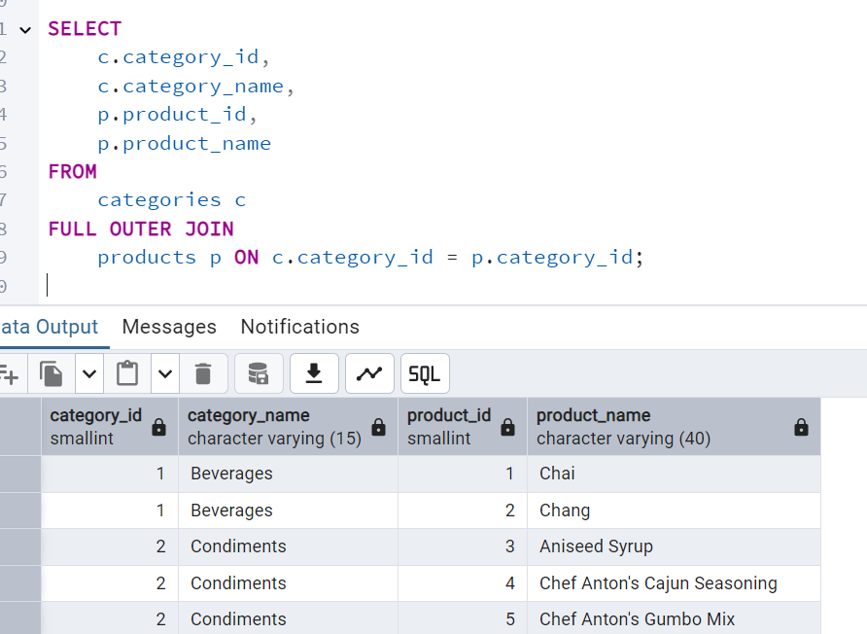

5. Show all possible product and category combinations (Cross join).

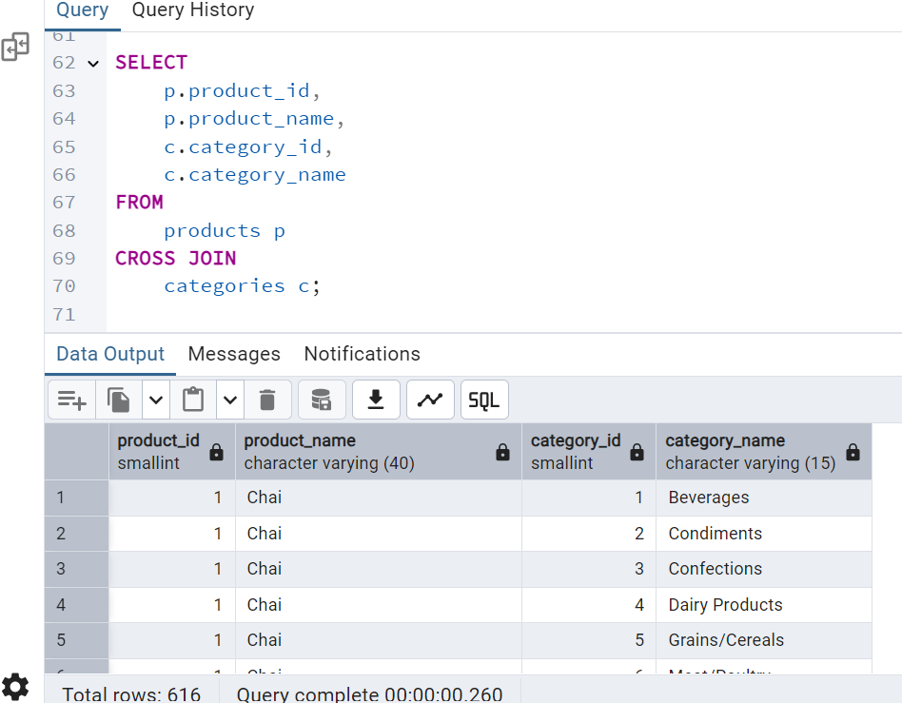

6. Show all employees and their manager(Self join(left join))

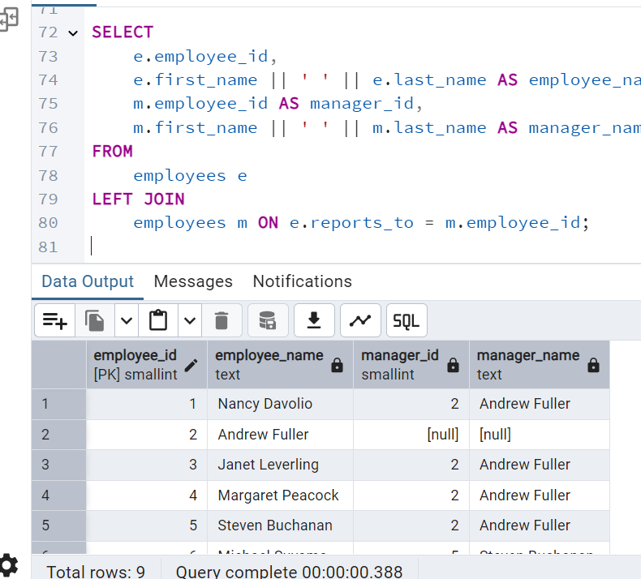

7. List all customers who have not selected a shipping method.

**Tables used:** customers, orders

**(Left Join, WHERE o.shipvia IS NULL)**

