Assignment 5

1.Group by with where-orders by year and quarter.Display order year,quarter,order count,avg frieght for those orders where freight cost>100

SELECT

EXTRACT(year FROM order_date) AS order_year,

EXTRACT(quarter FROM order_date) AS quarter,

COUNT(*) AS order_count,

AVG(freight) AS avg_freight

FROM

orders

WHERE

freight > 100

GROUP BY

order_year,

quarter

ORDER BY

order_year,

quarter;

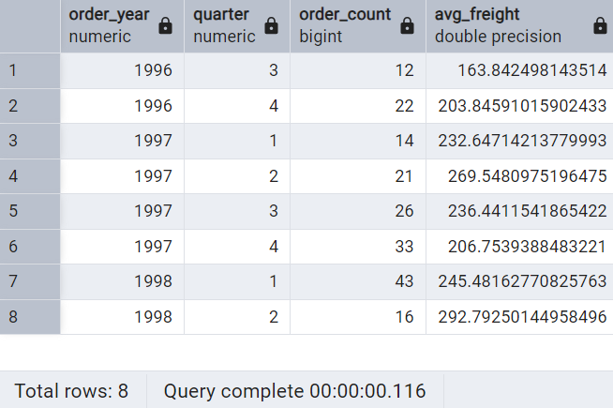

2.Group by with Having -High Volume Ship Regions.Display ship region,no of order in each regions,min and max freight cost.Filter regions where no of orders>=5

SELECT

ship_region,

COUNT(*) AS order_count,

MIN(freight) AS min_freight,

MAX(freight) AS max_freight

FROM

orders

WHERE

ship_region IS NOT NULL

GROUP BY

ship_region

HAVING

COUNT(*) >= 5

ORDER BY

order_count DESC;

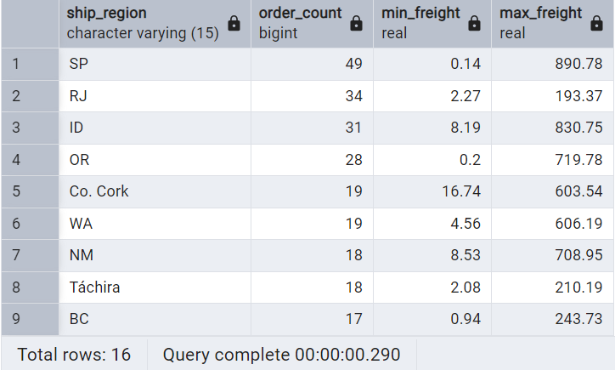

3.Get all title designations across employees and customers(Try UNION & UNION ALL)

--UNION

SELECT title AS designation

FROM employees

UNION

SELECT contact_title AS designation

FROM customers;

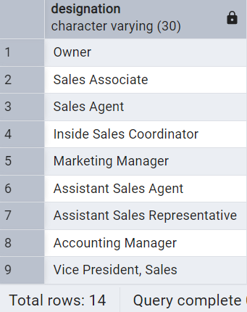

--UNION ALL

SELECT title AS designation

FROM employees

UNION ALL

SELECT contact_title AS designation

FROM customers;

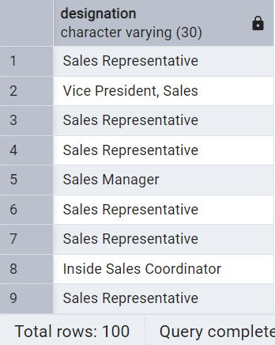

4.Find categories that have both discontinued and in-stock products.Display category_id,instock means unit_in_stock>0,Intersect.

-- Categories with discontinued products

SELECT category_id

FROM products

WHERE discontinued=1

INTERSECT

-- Categories with in-stock products

SELECT category_id

FROM products

WHERE units_in_stock> 0;

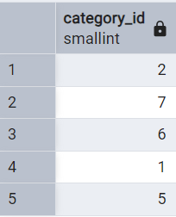

5.Find orders that have no discounted items.Display order_id,EXCEPT.

-- Orders that have any discounted items

SELECT order_id

FROM order_details

WHERE discount > 0

EXCEPT

-- Orders that have only non-discounted items

SELECT order_id

FROM order_details

WHERE discount = 0;

