**Day 6 Assignment**

--1.Categorize products by stock status

--(Display product_name, a new column stock_status whose values are based on below condition

--units_in_stock = 0 is 'Out of Stock' units_in_stock < 20 is 'Low Stock')

SELECT

product_name,

CASE

WHEN units_in_stock = 0 THEN 'Out of Stock'

WHEN units_in_stock < 20 THEN 'Low Stock'

ELSE 'In Stock'

END AS stock_status

FROM products;

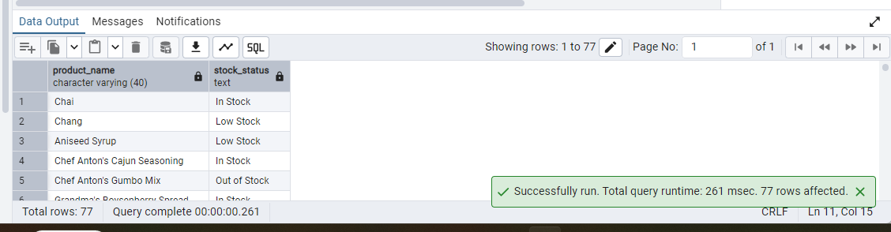

--2. Find All Products in Beverages Category(Subquery, Display product_name,unitprice)

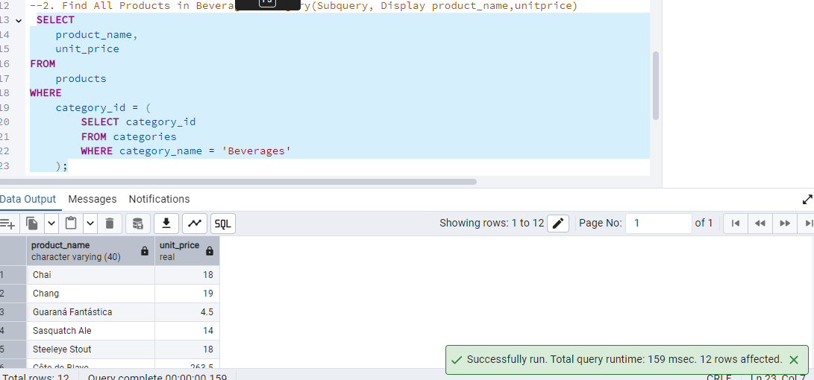

--3.Find Orders by Employee with Most Sales(Display order_id, order_date, freight, employee_id.

--Employee with Most Sales=Get the total no.of of orders for each employee then order by DESC and limit 1. Use Subquery)

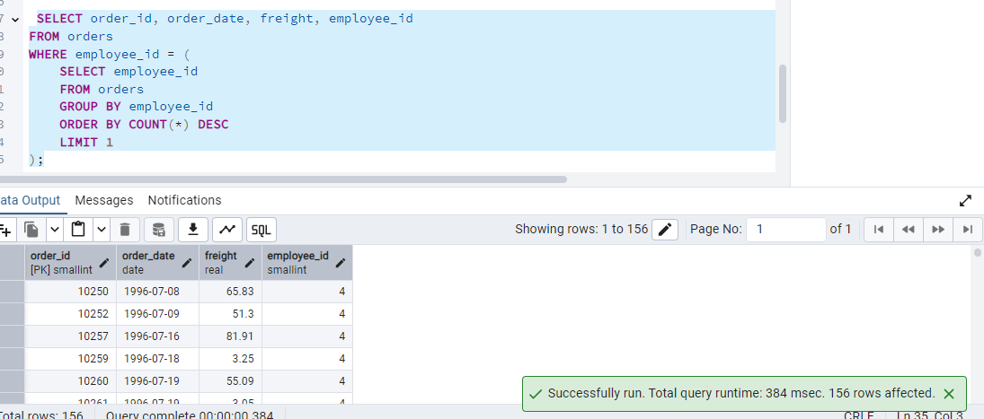

--4.Find orders where for country!= ‘USA’ with freight costs higher than any order from USA. (Subquery, Try with ANY, ALL operators)

Using ANY

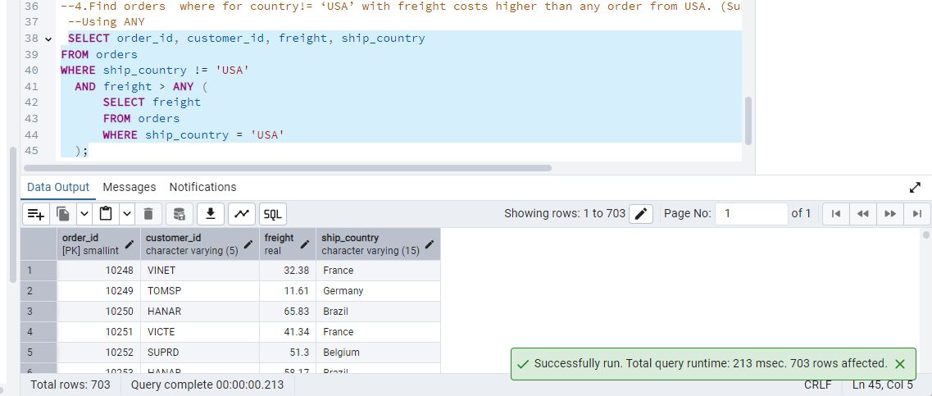

Using ALL

