Assignment 6

1.Categorize products by stock status.(Display product_name, a new column stock_status whose values are based on below conditionunits_in_stock = 0  is 'Out of Stock', units_in_stock < 20  is 'Low Stock')

SELECT

product_name,

CASE

WHEN units_in_stock = 0 THEN 'Out of Stock'

WHEN units_in_stock < 20 THEN 'Low Stock'

ELSE 'In Stock'

END AS stock_status

FROM

products;

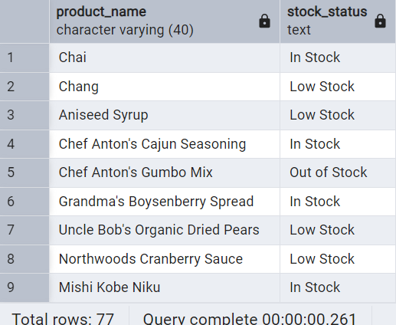

2. Find All Products in Beverages Category(Subquery, Display product_name,unitprice)

SELECT

product_name,

unit_price

FROM

products

WHERE

category_id IN (

SELECT category_id

FROM categories

WHERE category_name = 'Beverages'

);

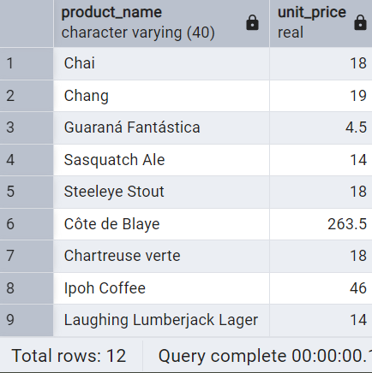

3.Find Orders by Employee with Most Sales.(Display order_id,   order_date,  freight, employee_id.Employee with Most Sales=Get the total no.of of orders for each employee then order by DESC and limit 1. Use Subquery)

SELECT

order_id,

order_date,

freight,

employee_id

FROM

orders

WHERE

employee_id = (

SELECT employee_id

FROM (

SELECT employee_id, COUNT(*) AS total_orders

FROM orders

GROUP BY employee_id

ORDER BY total_orders DESC

LIMIT 1

) AS top_employee

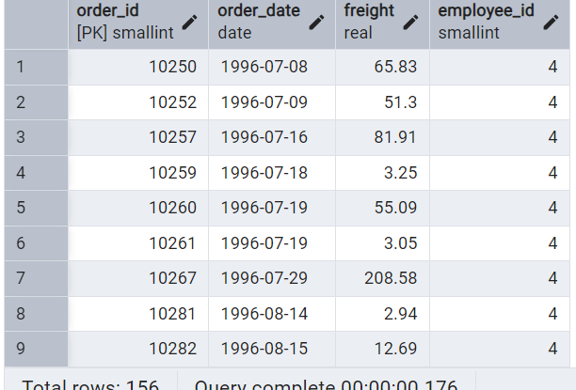);

 4. Find orders  where for country!= ‘USA’ with freight costs higher than any order from USA. (Subquery, Try with ANY, ALL operators)

-- Using Any

SELECT

order_id,

order_date,

freight,

ship_country

FROM

orders

WHERE

ship_country != 'USA'

AND freight > ANY (

SELECT freight

FROM orders

WHERE ship_country = 'USA'

);

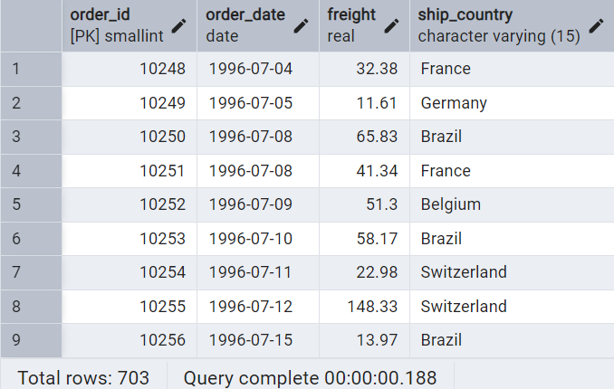

--Using All operators

SELECT

order_id,

order_date,

freight,

ship_country

FROM

orders

WHERE

ship_country != 'USA'

AND freight > ALL (

SELECT freight

FROM orders

WHERE ship_country = 'USA'

);

