Day 7 Assignment

--1.Rank employees by their total sales(Total sales = Total no of orders handled, JOIN employees and orders table)

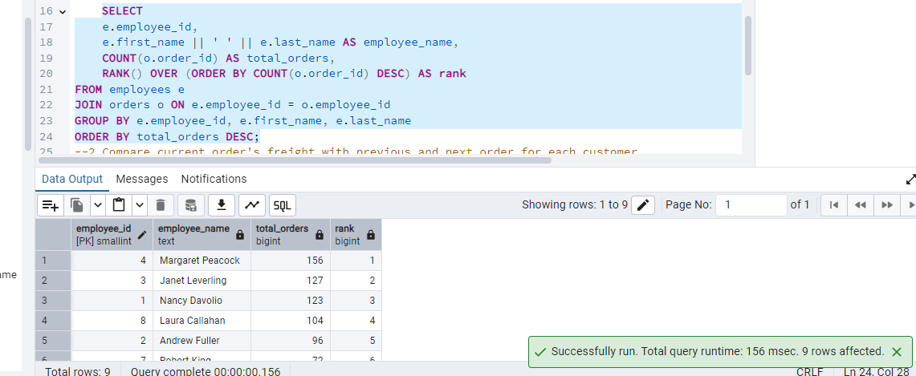

--2.Compare current order's freight with previous and next order for each customer.

--(Display order_id, customer_id, order_date, freight,

--Use lead(freight) and lag(freight).

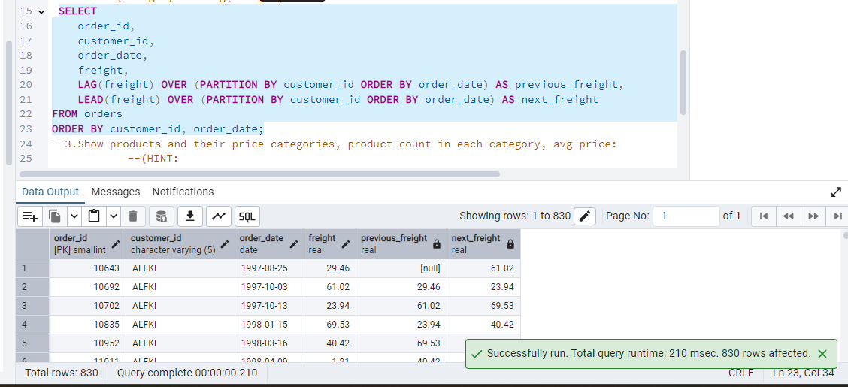

--3.Show products and their price categories, product count in each category, avg price:

--(HINT:

--·Create a CTE which should have price_category definition:

--WHEN unit_price < 20 THEN 'Low Price'

--WHEN unit_price < 50 THEN 'Medium Price'

--ELSE 'High Price'

--·In the main query display: price_category, product_count in each price_category, ROUND(AVG(unit_price)::numeric, 2) as avg_price)

WITH price_categorized AS (

SELECT

product_name,

unit_price,

CASE

WHEN unit_price < 20 THEN 'Low Price'

WHEN unit_price < 50 THEN 'Medium Price'

ELSE 'High Price'

END AS price_category

FROM products

)

SELECT

price_category,

COUNT(*) AS product_count,

ROUND(AVG(unit_price)::numeric, 2) AS avg_price

FROM price_categorized

GROUP BY price_category

ORDER BY price_category;

