1. Rank employees by their total sales

(Total sales = Total no of orders handled, JOIN employees and orders table)

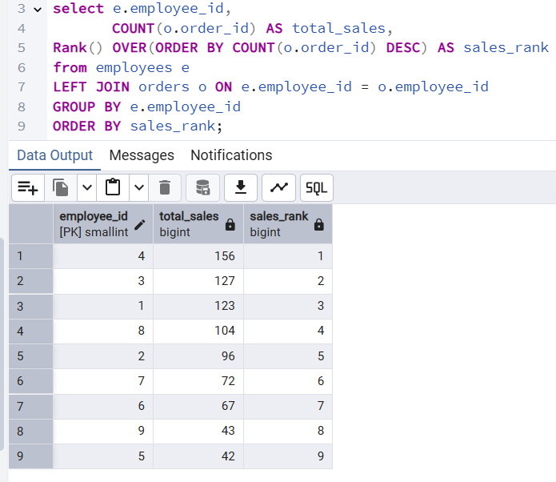

2. Compare current order's freight with previous and next order for each customer.

(Display order_id, customer_id, order_date, freight,

Use lead(freight) and lag(freight).

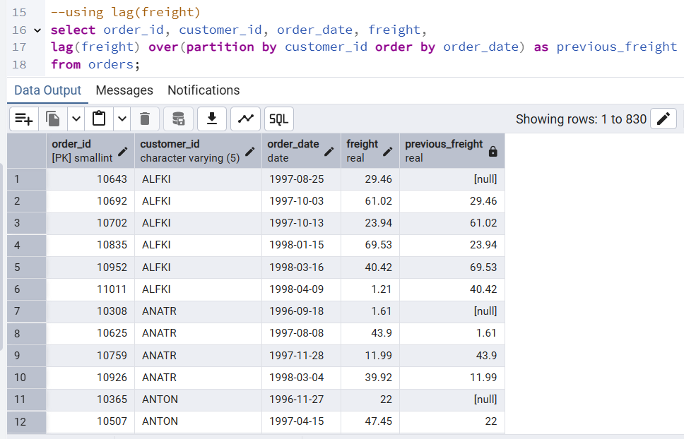

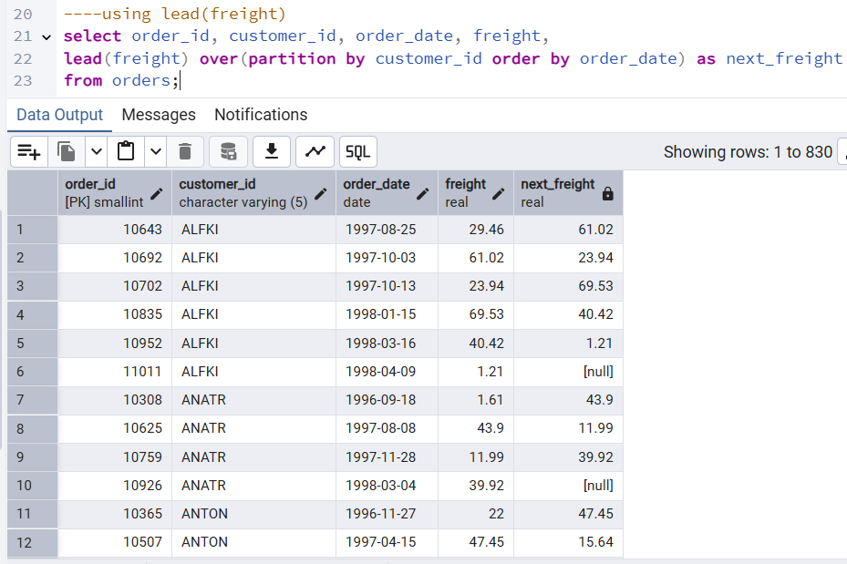

3. Show products and their price categories, product count in each category, avg price:

(HINT:

· Create a CTE which should have price_category definition:

WHEN unit_price < 20 THEN 'Low Price'

WHEN unit_price < 50 THEN 'Medium Price'

ELSE 'High Price'

· In the main query display: price_category, product_count in each price_category, ROUND(AVG(unit_price)::numeric, 2) as avg_price)

