DAY 7

1. Rank employees by their total sales

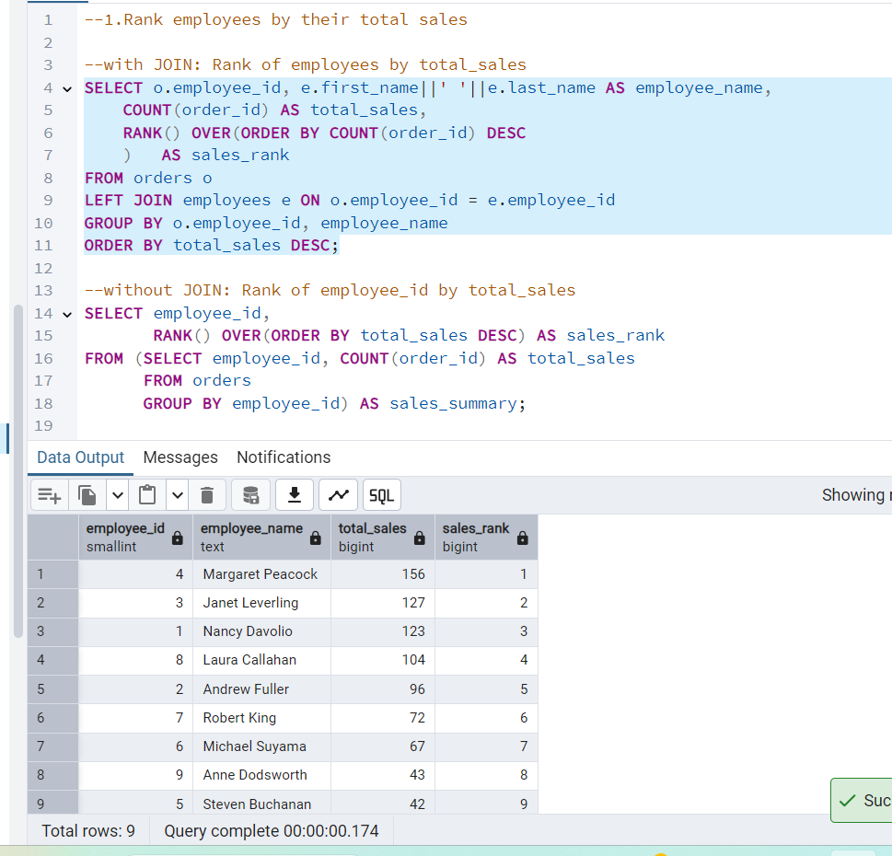

2. Compare current order's freight with previous and next order for each customer.

(Display order_id, customer_id, order_date, freight,

Use lead(freight) and lag(freight)*/

--LAG

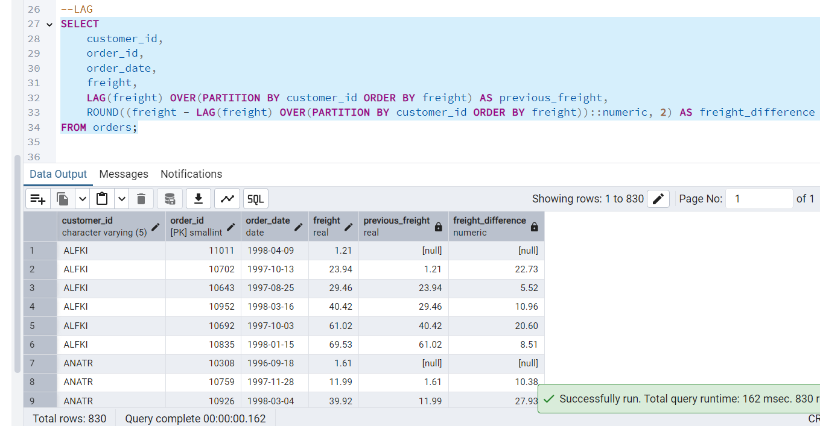

--LEAD

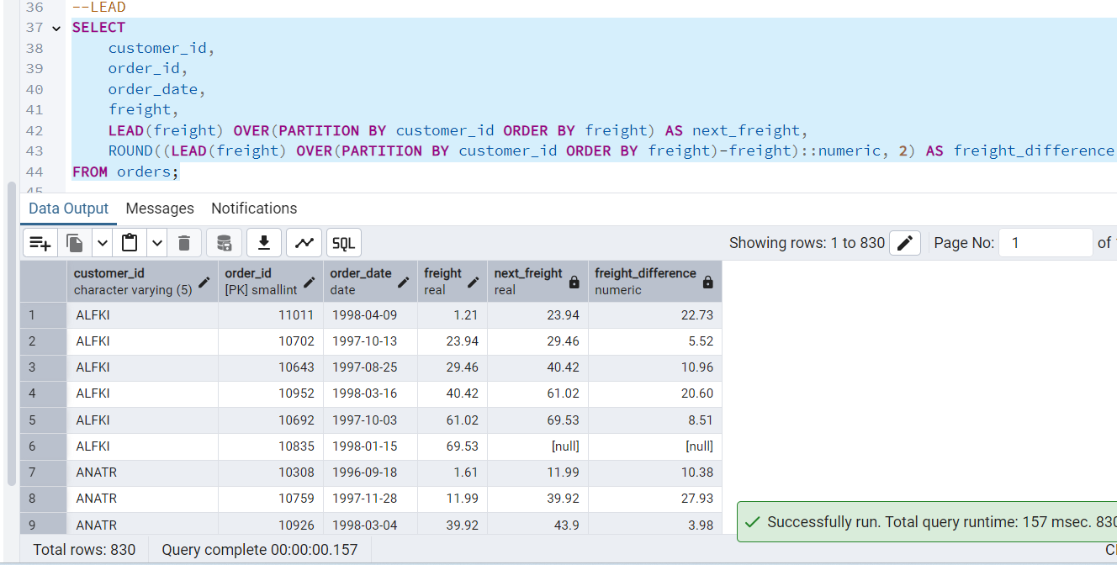

3. Show products and their price categories, product count in each category, avg price

