**Day 8 Assignment**

--1. Create view vw_updatable_products (use same query whatever I used in the training)

--Try updating view with below query and see if the product table also gets updated.

--Update query:

--UPDATE updatable_products SET unit_price = unit_price * 1.1 WHERE units_in_stock < 10;

CREATE OR REPLACE VIEW vw_updatable_products AS

Create the View vw_updatable products

CREATE OR REPLACE VIEW vw_updatable_products AS

SELECT

productid,

productname,

unitprice,

units_in_stock

FROM products;

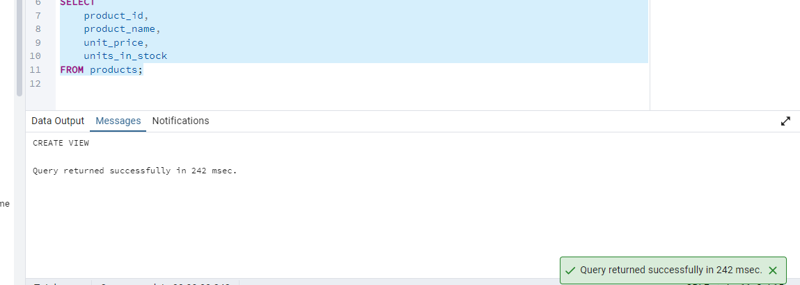

Try to Updating View

UPDATE vw_updatable_products

SET unit_price = unit_price * 1.1

WHERE units_in_stock < 10;

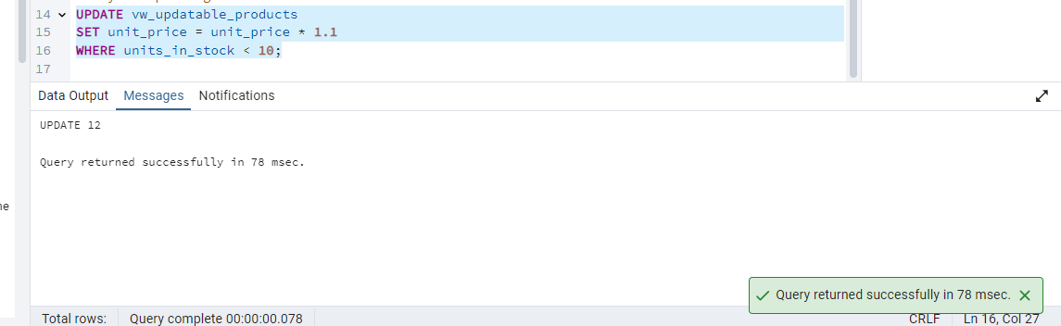

### Verify if the main table(Products) is updated:

SELECT

product_id,

product_name,

unit_price,

units_in_stock

FROM products

WHERE units_in_stock < 10;

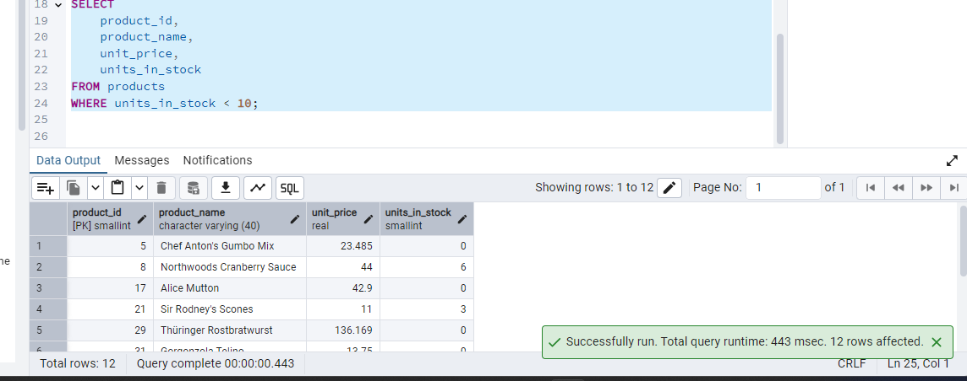

2. Transaction:

–Update the product price for products by 10% in category id=1

–Try COMMIT and ROLLBACK and observe what happens.

BEGIN;

UPDATE products

SET unit_price = unit_price * 1.10

WHERE category_id = 1;

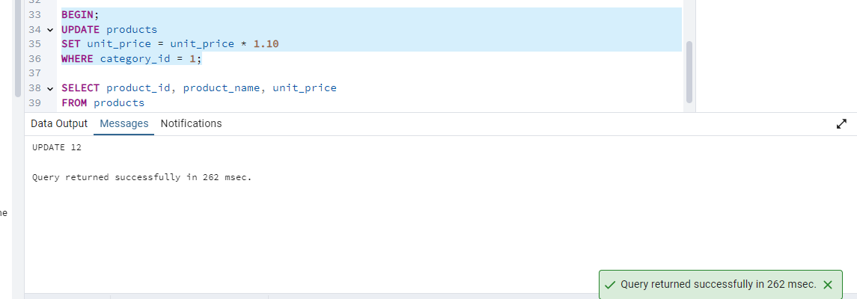

--Check what changed:

SELECT product_id, product_name, unit_price

FROM products

WHERE category_id = 1;

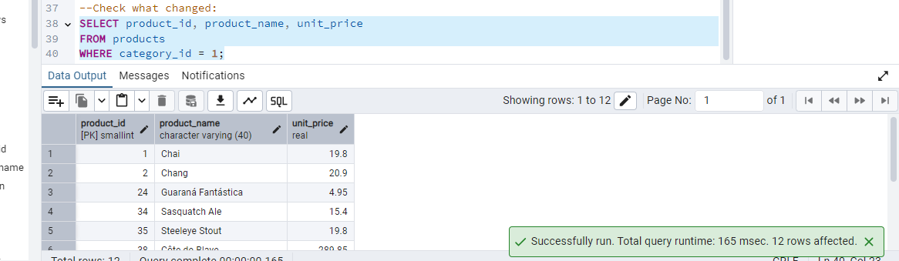

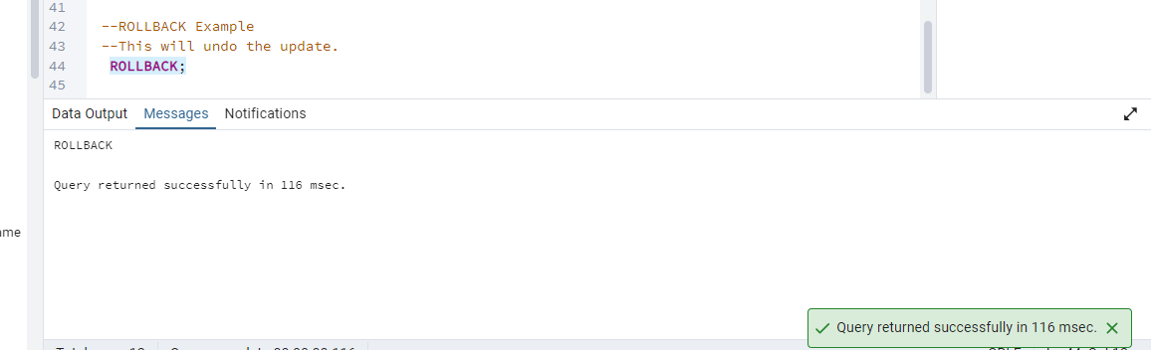

COMMIT

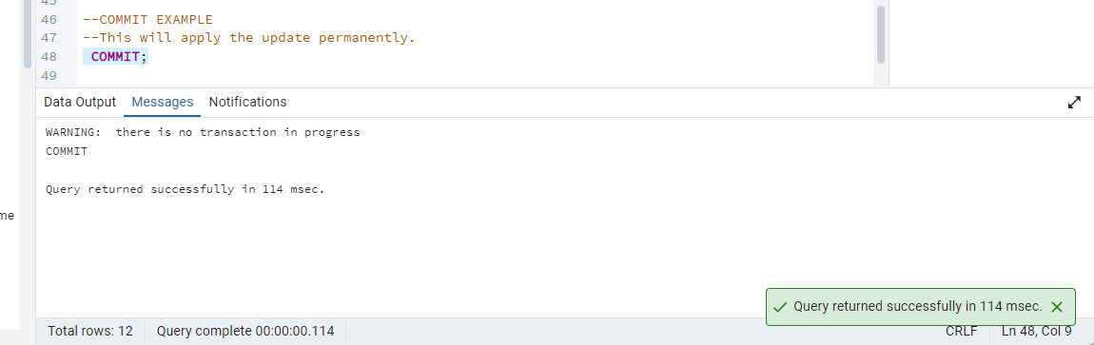

3. Create a regular view which will have below details (Need to do joins):

Employee_id,

Employee_full_name,

Title,

Territory_id,

territory_description,

Region_description

Query:-

CREATE VIEW vw_employee_territory_details AS

SELECT

e.employee_id,

e.first_name || ' ' || e.last_name AS employee_full_name,

e.title,

t.territory_id,

t.territory_description,

r.region_description

FROM employees e

JOIN employee_territories et ON e.employee_id = et.employee_id

JOIN territories t ON et.territory_id = t.territory_id

JOIN region r ON t.region_id = r.region_id;

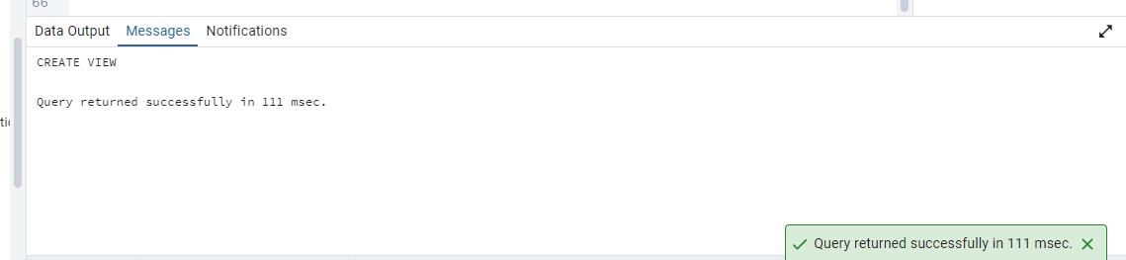

To view Data

SELECT * FROM vw_employee_territory_details;

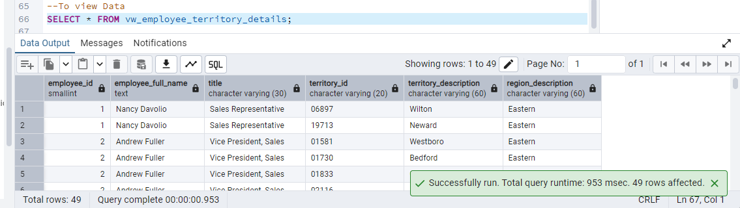

4. Create a recursive CTE based on Employee Hierarchy

Query:

WITH RECURSIVE employee_hierarchy AS (

-- Base case: top-level employees (no manager)

SELECT

employee_id,

first_name || ' ' || last_name AS employee_name,

reports_to AS manager_id,

1 AS level

FROM employees

WHERE reports_to IS NULL

UNION ALL

-- Recursive case: employees who report to others

SELECT

e.employee_id,

e.first_name || ' ' || e.last_name AS employee_name,

e.reports_to AS manager_id,

eh.level + 1

FROM employees e

INNER JOIN employee_hierarchy eh ON e.reports_to = eh.employee_id

)

SELECT * FROM employee_hierarchy

ORDER BY level, manager_id;

