Assignment 8

1.Create view vw_updatable_products (use same query whatever I used in the training).Try updating view with below query and see if the product table also gets updated.Update query:UPDATE updatable_products SET unit_price = unit_price * 1.1 WHERE units_in_stock < 10;

--Create the view

CREATE VIEW vw_updatable_products AS

SELECT product_id, product_name, unit_price, units_in_stock

FROM products;

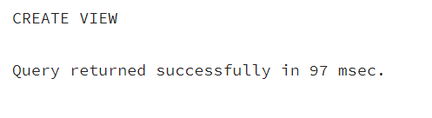

--Update query

UPDATE vw_updatable_products

SET unit_price = unit_price * 1.1

WHERE units_in_stock < 10;

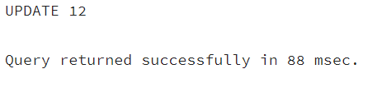

--check if the base table products was updated

SELECT product_id, product_name, unit_price, units_in_stock

FROM products

WHERE units_in_stock < 10;

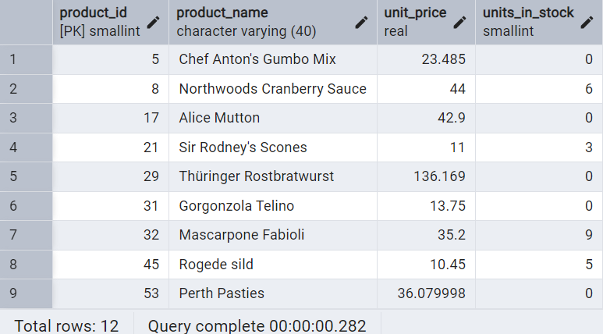

2.Transaction:Update the product price for products by 10% in category id=1.Try COMMIT and ROLLBACK and observe what happens.

--Start the transaction and run the update

BEGIN;

UPDATE products

SET unit_price = unit_price * 1.1

WHERE category_id = 1;

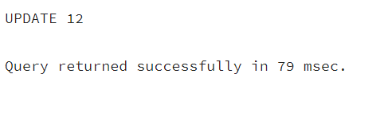

--Preview the changes

SELECT product_id, product_name, unit_price

FROM products

WHERE category_id = 1;

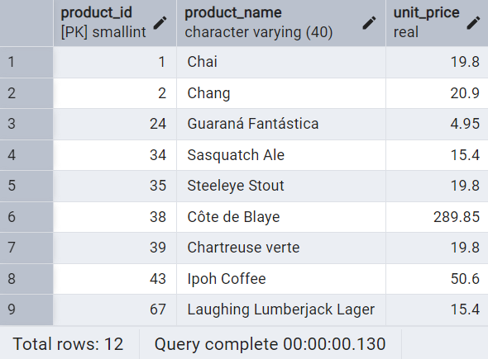

--committing the transaction

COMMIT;

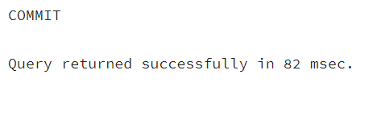

--rollback

ROLLBACK;

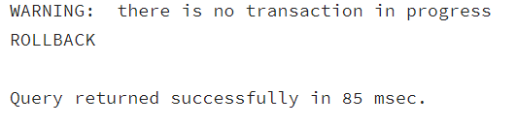

3. Create a regular view which will have below details (Need to do joins):Employee_id,Employee_full_name,Title,Territory_id,territory_description,region_description

CREATE VIEW vw_employee_territories AS

SELECT e.employee_id,

e.first_name || ' ' || e.last_name AS employee_full_name,

e.title,

t.territory_id,

t.territory_description,

r.region_description

FROM employees e

JOIN employee_territories et ON e.employee_id = et.employee_id

JOIN territories t ON et.territory_id = t.territory_id

JOIN region r ON t.region_id = r.region_id;

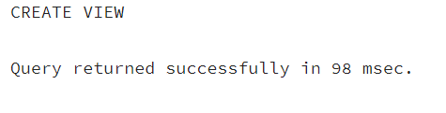

--preview

SELECT * FROM vw_employee_territories;

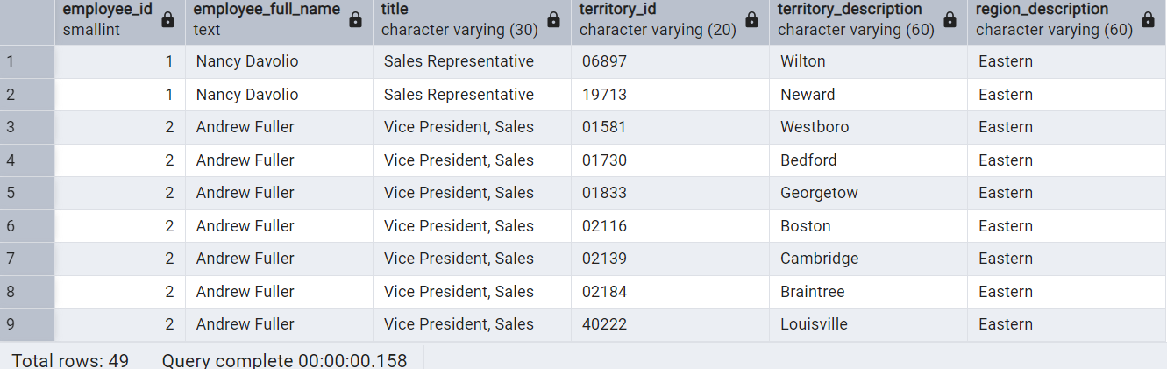

4. Create a recursive CTE based on Employee Hierarchy

WITH RECURSIVE employee_hierarchy AS (

-- Anchor member: top-level employees (no manager)

SELECT

employee_id,

first_name || ' ' || last_name AS employee_name,

reports_to,

1 AS level

FROM employees

WHERE reports_to IS NULL

UNION ALL

-- Recursive member: employees reporting to others

SELECT

e.employee_id,

e.first_name || ' ' || e.last_name,

e.reports_to,

eh.level + 1

FROM employees e

INNER JOIN employee_hierarchy eh ON e.reports_to = eh.employee_id

)

SELECT * FROM employee_hierarchy

ORDER BY level, employee_id;

