**Day 9**

1. Create AFTER UPDATE trigger to track product price changes

· Create product_price_audit table

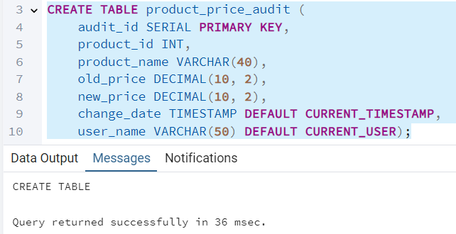

· Create a trigger function with the below logic:

INSERT INTO product_price_audit (product_id, product_name, old_price, new_price)

VALUES (OLD.product_id, OLD.product_name, OLD.unit_price,NEW.unit_price );

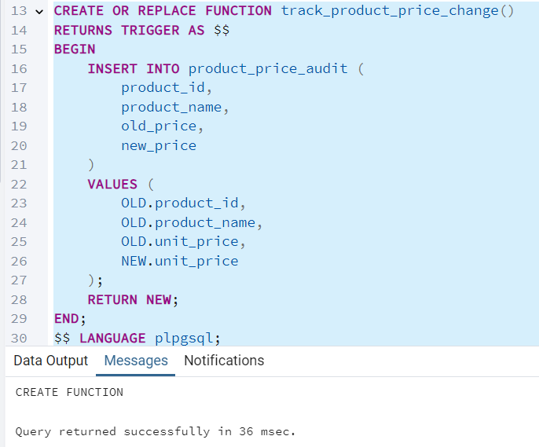

· Create a row level trigger for below event:

AFTER UPDATE OF unit_price ON products

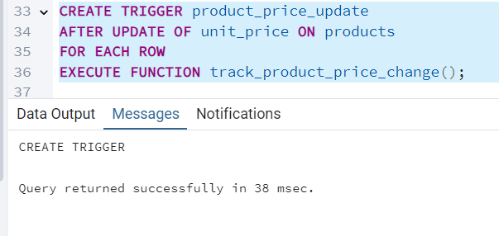

· Test the trigger by updating the product price by 10% to any one product_id.

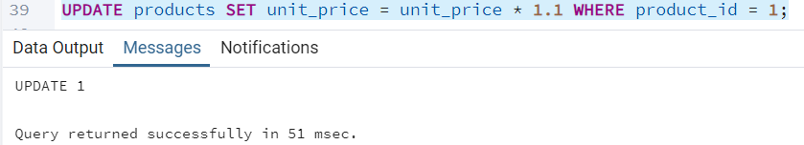

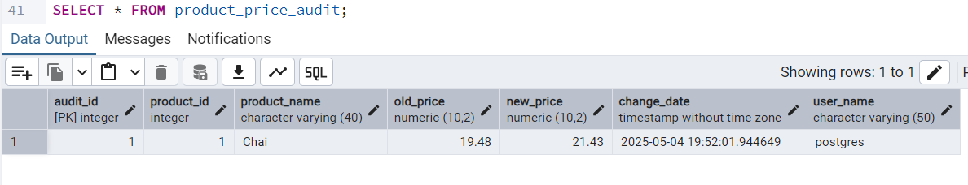

2. Create stored procedure using IN and INOUT parameters to assign tasks to employees

· Parameters:

IN p_employee_id INT,

IN p_task_name VARCHAR(50),

INOUT p_task_count INT DEFAULT 0

