# Abstract

This Project on “Supermarket Management System” is an interface system of the supermarket store .This project was implemented through C programming language using Linked list and aims to create an environment to buy or sell items, and also to add or remove items from the shop and also to modify the rate and quantity of product available in the market. Initially, in the home screen you have option to access the supermarket either as an owner or a customer.

The customer can buy numerous items along with the quantity of items from the items available in the market with certain discount and also return back the unwanted brought products. The owner section can be used to add or remove the products in the store and also to modify the cost of the products and can also view all the available products in the super market along with their rate and available quantity.

The advantage of the Supermarket Management System is that information can be available easily. The project was successful in achieving this objective, resulting in a fully functional implementation of the Supermarket Management System. Using Supermarket Management System, User can easily find the list of the products and easily buy the products.

# Acknowledgement

The successful completion of any project would be incomplete without mentioning the people who made it possible. I take a privilege to express a few words of gratitude and respect to all those who had helped in the completion of this project.

Firstly, I would like to thank the NCCS college for giving me this golden opportunity to work on this project which would be fruitful for me in the upcoming days. I would also like to express my sincere thanks to **Mr. Dinesh Khadka**, our esteemed lecturer, and **Mr.Yachu Shakya,** our dedicated lab teacher, for their invaluable guidance and expertise.

I would also like to express my hearty thanks to all my friends who had helped me in the completion of this project and also for their support and suggestions in the project. Without the guidance and help of my friends, the completion of this project would not have been possible.

Rajib Duwal

**National College of Computer Studies**

Bsc Csit 3rd SEM

Contents

Abstract i

Acknowledgement ii

Introduction 1

1.1 Introduction to project 1

1.2 Problem Statement 1

1.3 Objective 1

Implementation 2

2.1 Tools Used 2

2.2 Implementation detail of module 2

Code 3

Conclusion 8

Reference 9

# Introduction

## 1.1 Introduction to project

Super Market is required for the purpose of buying and selling of items and various services. Nowadays, a shop that can be accessed from anywhere especially in a digital form is highly prevalent in the age of internet.

A Supermarket Management system is an interactive program that can simulate a real life supermarket environment for a user. In a Supermarket, a customer buys items and also return unwanted bought items and the owner is responsible for managing and overseeing all the details and content within a supermarket. These all real life aspects of a supermarket are included in a program to form a Supermarket Management System in a digitalized form. Supermarket Management System is a desktop application that keeps track of all the transactions.The purpose of this project is planning to build a supermarket which is easier to use, more convenient to order the product for customer and better to manage the product information for the administrator. This project is created using linked list in C language.

## 1.2 Problem Statement

A physical supermarket can only be accessed by physically being present in the supermarket. On top of that, Supermarket are limited and are only located in limited locations as well. Locating and purchasing items can also be more time consuming when done physically. Sometimes, the items might not be available too. A digital Supermarket Management System can be used to address all the problems that may arise from the traditional shops. Through the use of Supermarket Management system, it solves the main problem of the traditional shops related with physical presence. . It displays a list of all the items available in the shop and user can purchase items as needed. An owner can easily modify the rate of products and product ID and also easily know the available quantity of the products.

## 1.3 Objective

The objective of Supermarket Management System is that it allows to create a simple supermarket interface for owner and customer to simulate a supermarket environment.It allows to display available items in the store along with their price and quantity and allows to add, remove or modify the products.

# Implementation

## 2.1 Tools Used

**Dev C++:** This project utilizes the C programming Language as its primary tool to implement the Supermarket Management System. C language was chosen for its versatility and its wide chosen support. Additionally the project uses DEV C++ to write, debug and manage the code efficiently.

## 2.2 Implementation detail of module

Below are some of the implementation details for the module within Supermarket Management System. Here is a branch description of the key procedures/functions used in the code:

1. **Void beg and Void end (Linked list, int ID, char proname[], double Preprice, int quantity):**This method is responsible for inserting the product ID, product name, product price and the quantity of the products. It also adds the new product in the store. This function is used to enter items at beginning of the store and continuously add the other items.
2. **Void delpro and void modify (Linked list):** These two functions are used to delete the items from the store or modify the product ID, name or cost of the product.
3. **Display (Linked list):** This method prints the entire items available in the store along with their quantity and cost in the linked list order. It iterates through the each list and display each entry details(product ID, name, quantity, cost).
4. **Buy (Linked List):** This method is used to buy any products in the store. This method easily helps to buy required quantity of the items easily and even easily provide the bills of the items bought. This method firstly checks whether required product is in required quantity or not.
5. **Back (Linked List):** This method is used to return back the bought product again to the supermarket.

# Code

# 

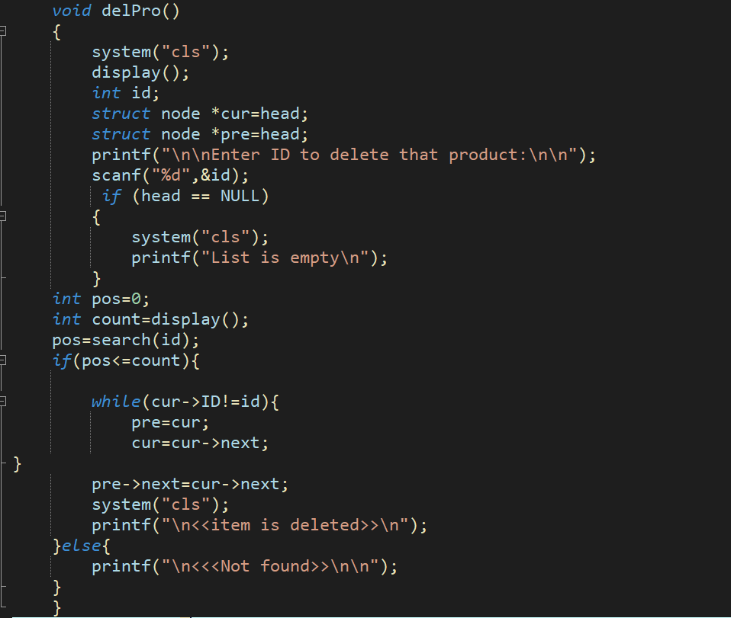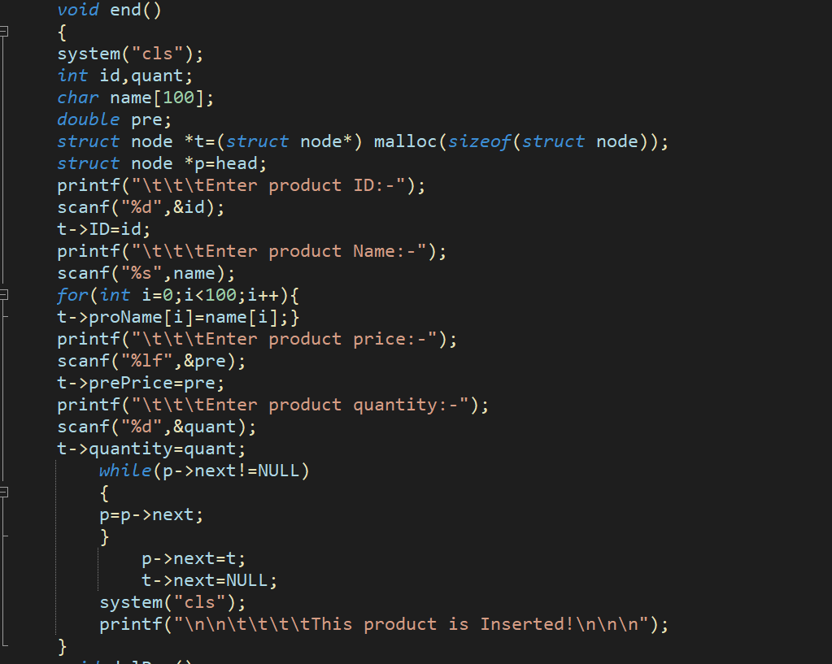

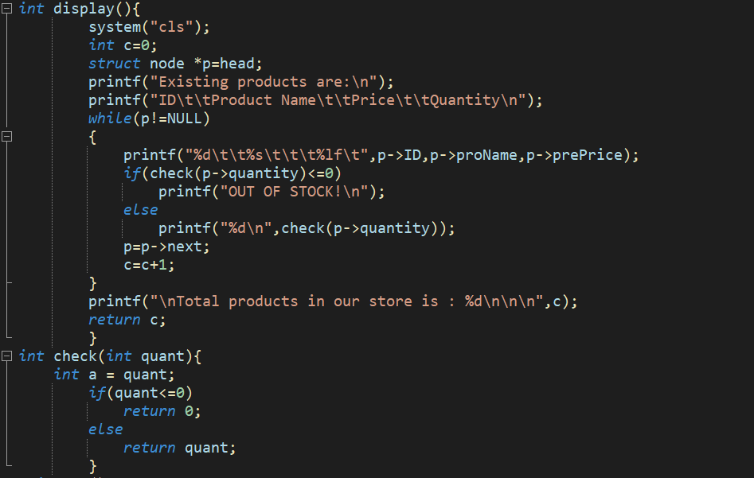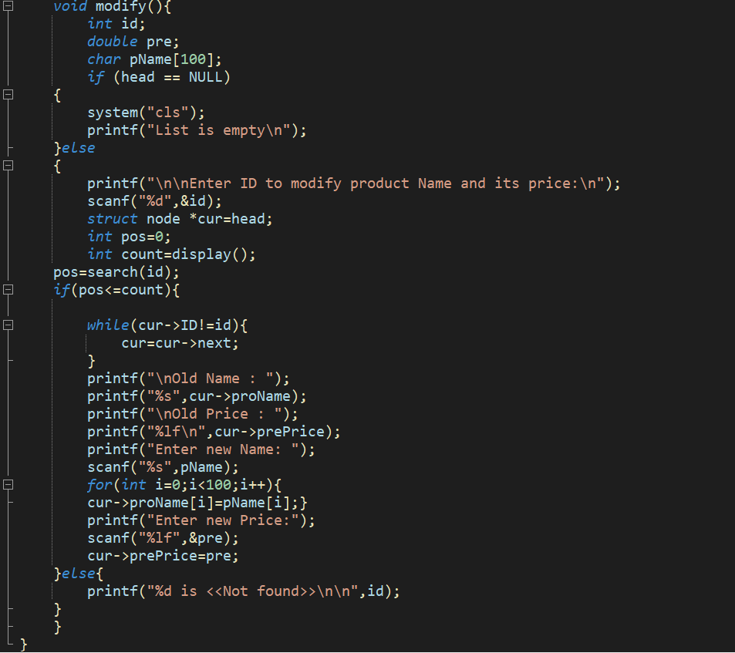

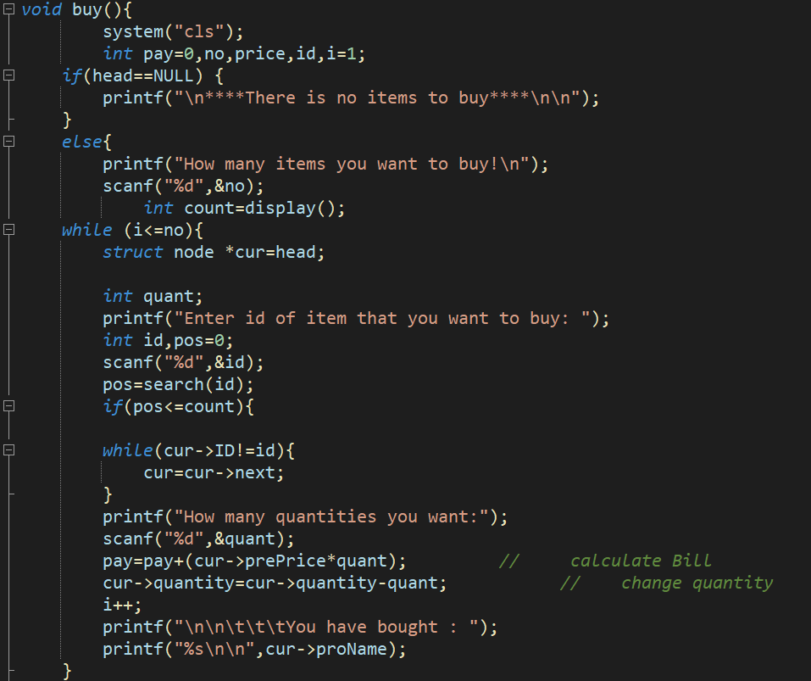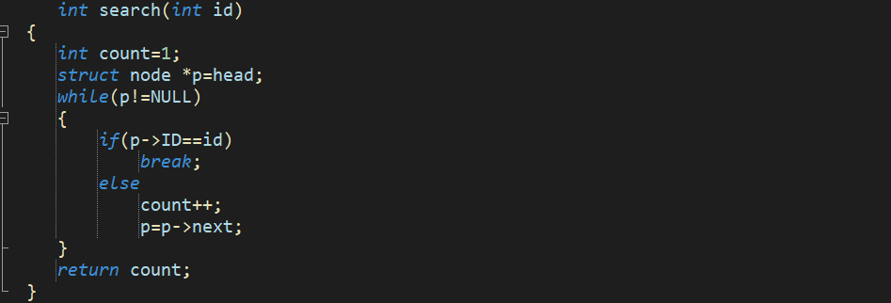

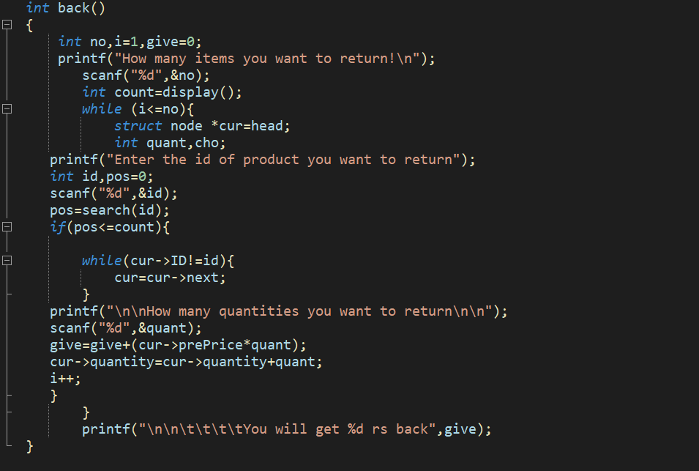

# Conclusion

Supermarket Management System program was successfully created using DSA in C language and its features. The program can simulate a supermarket environment and can host purchasing of items and generation of bill for the customer along with admin functions like adding or removing items and viewing all the items available in the store.

In conclusion, Supermarket Management System is a fun and simple project that can be used to practice programming skills in C using Linked list. Overall, this project provides a good introduction to Data structure and algorithms and programming concepts. Through this project, I learned the importance of planning, organization, and attention to detail in software development. At the completion of this project we are able to add, search and delete items and hence the proposal is completed successfully.

# Reference

* <https://stackoverflow.com/questions/61687163/supermarket-simulation-in-c>
* <https://www.slideshare.net/wethecodershelp/supermarket-management-system>
* [https://www.scribd.com/doc/140997151/Supermarket-Management-System-Project-Report#](https://www.scribd.com/doc/140997151/Supermarket-Management-System-Project-Report)