The State Pattern allows an object to alter its behavior when its internal state changes. The object will appear to change its class.

UML class diagram

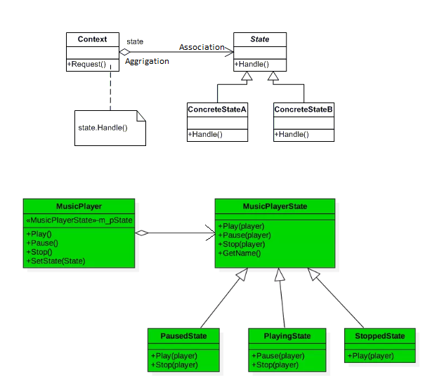

Participants

The classes and objects participating in this pattern are:

* **Context**  **(Account)**
  + defines the interface of interest to clients
  + Maintains an instance of a Concrete State subclass that defines the current state.
* **State**  **(State)**
  + defines an interface for encapsulating the behavior associated with a particular state of the Context.
* **Concrete State**  **(RedState, SilverState, GoldState)**
  + each subclass implements a behavior associated with a state of Context

Discussion about relationships: MusicPlayer & MusicPlayerState

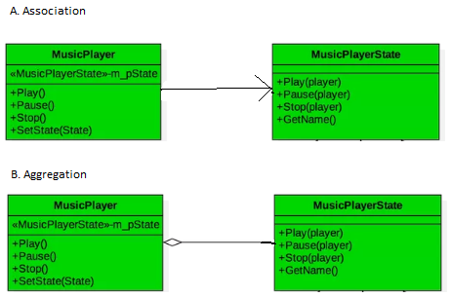

We often confuse with both relationship, which one is correct, let’s see one by one. Find the below code.

class MusicPlayerState;

class MusicPlayer {

public:

MusicPlayer();

virtual ~MusicPlayer();

void Play();

void Pause();

void Stop();

void SetState(MusicPlayerState *state);

private:

MusicPlayerState * m_pState;

};

class MusicPlayerState {

public:

MusicPlayerState(std::string name);

virtual ~MusicPlayerState();

virtual void Play(MusicPlayer * player);

virtual void Pause(MusicPlayer * player);

virtual void Stop(MusicPlayer * player);

std::string GetName();

private:

std::string m_name;

};

Association:

* MusicPlayer has MusicPlayerState, which is not created inside MusicPlayer class,

So both are independent.

* Recall this statement “*The lifetime of the instances of the two classes is independent of each other and there is no ownership between two classes called* ***Association***”.

Aggregation:

* Aggregation is a variant of the ***has A*** association relationship or we can say it is more specific then association. And it has logical ownership associated between two classes.

***Purely based on my observation:***

Now it seems like both relationship are correct. Here aggregation is more precise relation then association, because Music player has logical ownership on MusicPlayerState.