Name: Rajeev Nakka
Roll No: 23PA1A12E1
Salesforce Developer Bridge Program
Day 2 Documentation
Task 1: Apex Collections
I practiced List, Set and Map in Execute Anonymous using my Vehicle__c custom object.
1. List<String> — loop and print in uppercase
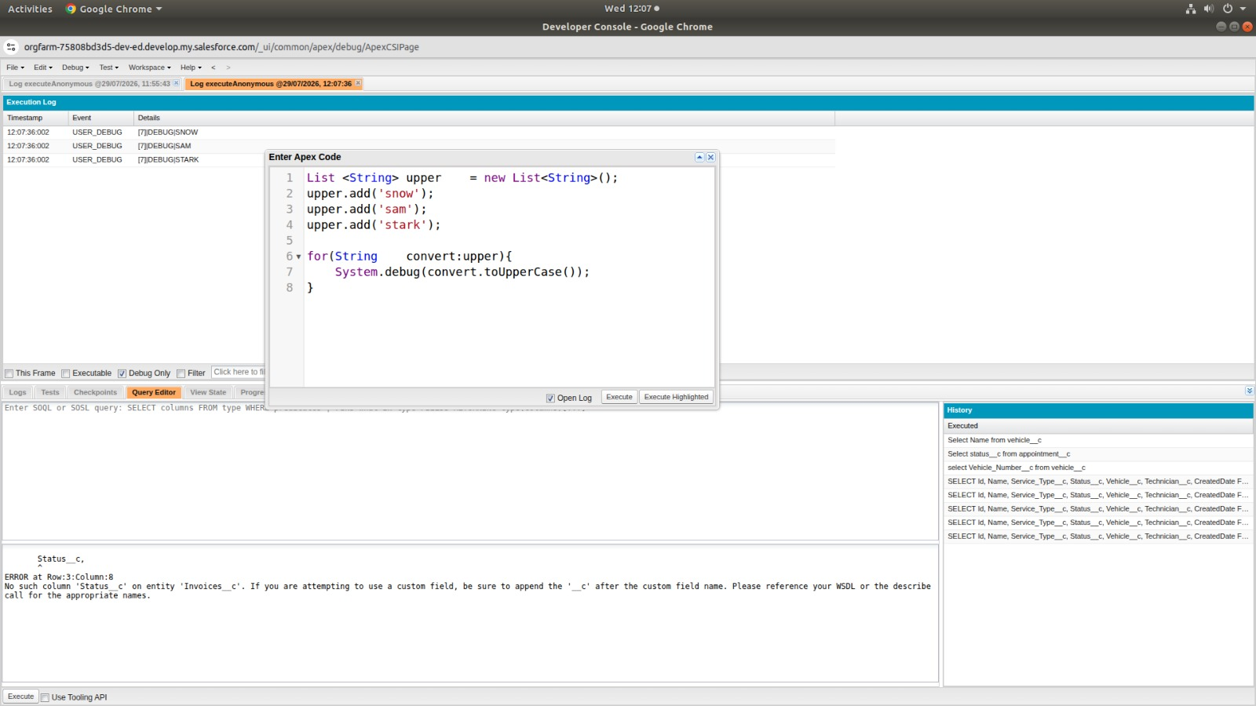
2. Set<Id> from a SOQL query — no duplicates, print size
Queried Id from Vehicle__c, added each Id to a Set, and printed the size to confirm no duplicates.
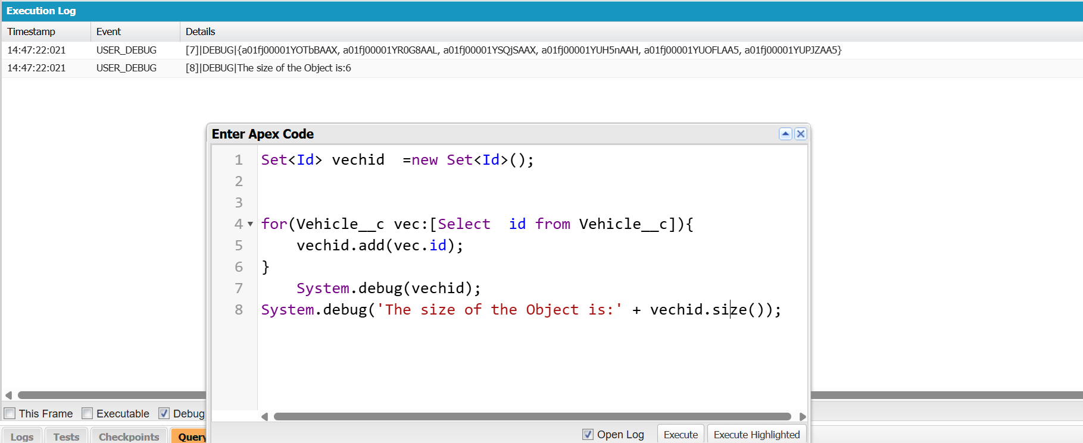
3. Map<Id, Vehicle__c> from a SOQL query — look up a field value
Built a Map keyed by Id from Vehicle__c records and looped through the map values to print Customer_Name__c for each record.
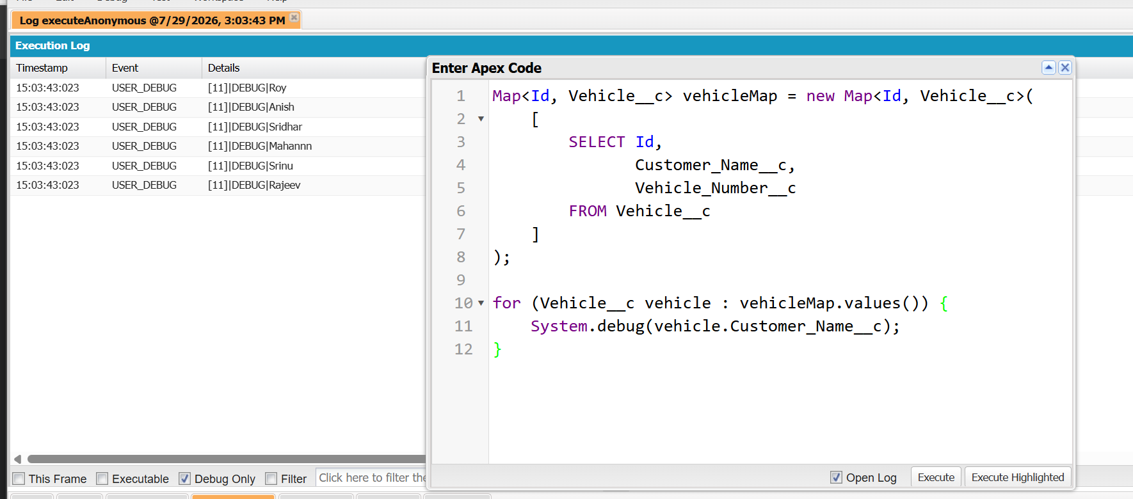
Task 2: Governor Limits & Bulkification
I bulk-inserted 200 Vehicle__c records to generate enough data to actually hit a governor limit.
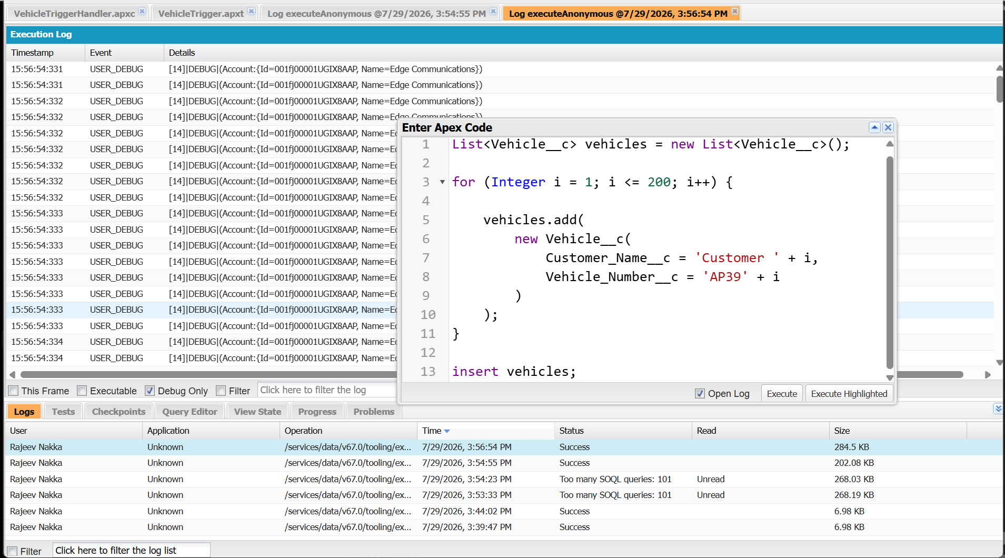
Bad trigger — SOQL inside the for loop
I wrote VehicleTriggerHandler with a SOQL query inside the loop. Running it against 200 records threw "Too many SOQL queries: 101", confirming the governor limit failure.
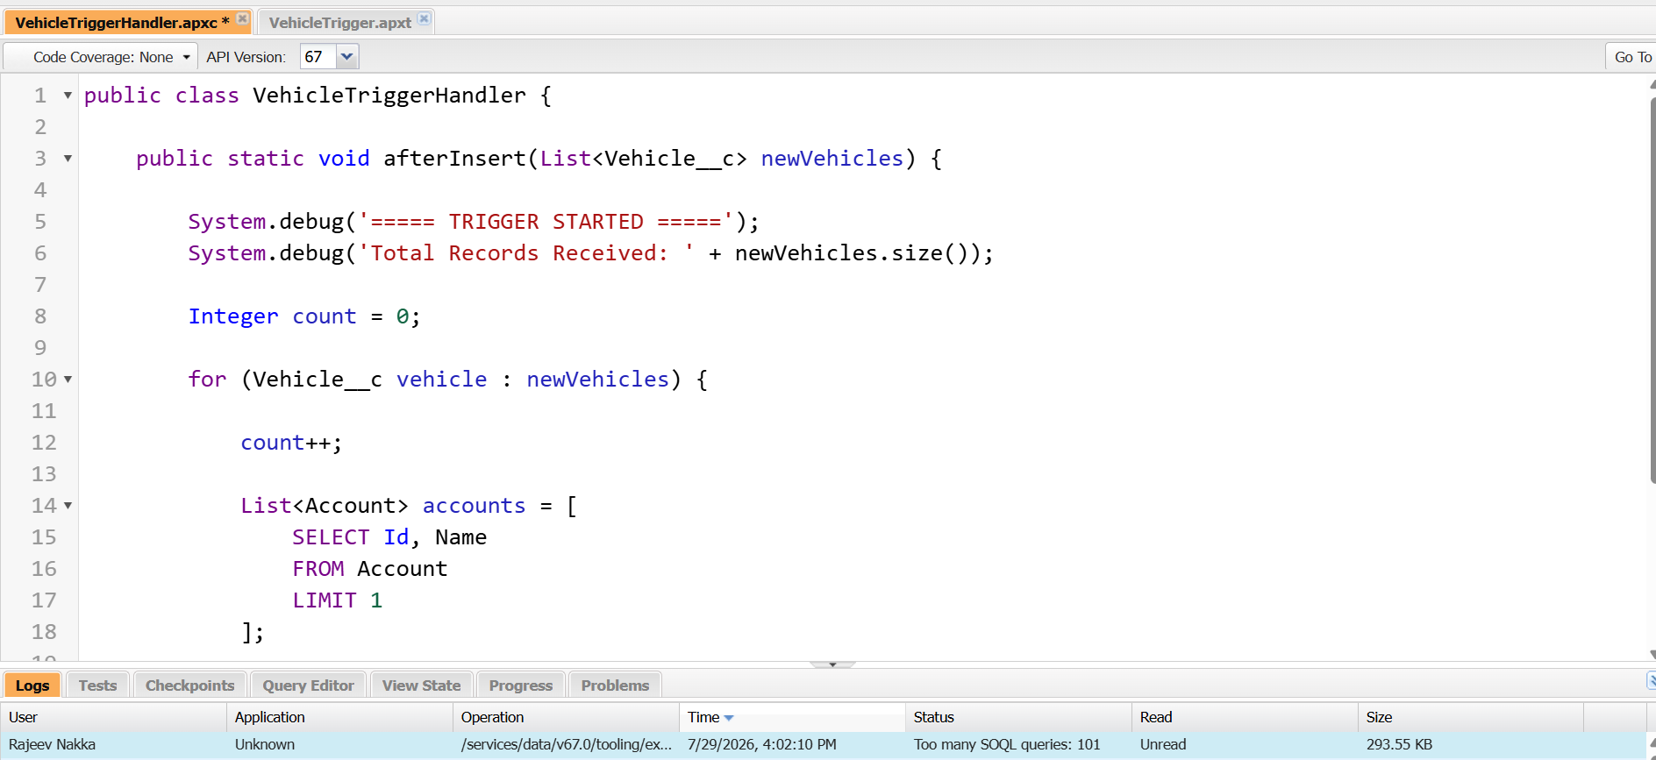
Fixed trigger — bulkified version
I moved the SOQL query outside the loop. Re-running with 200 records processed every record successfully with no governor limit error.
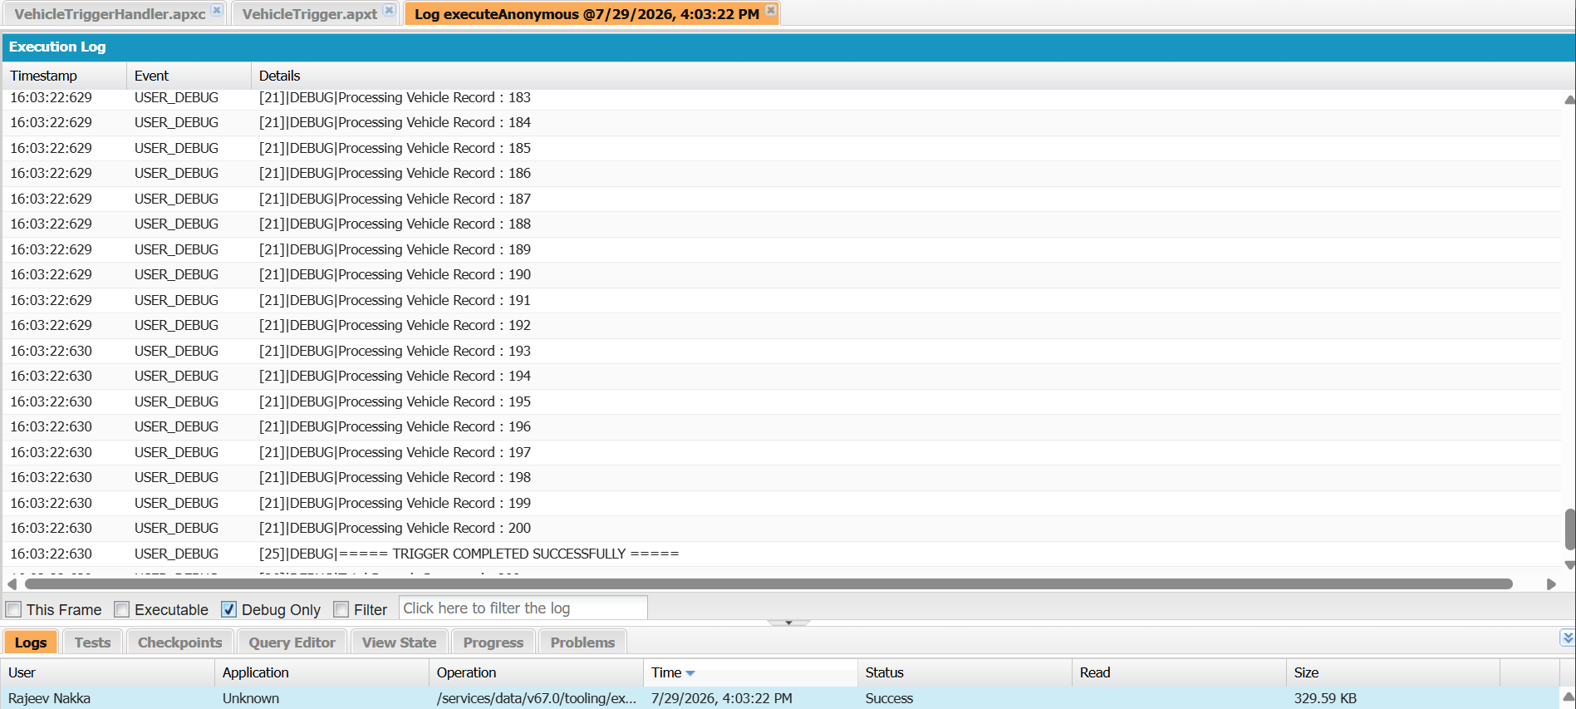
Task 3: Asynchronous Apex
@future method
VehicleFutureHandler.updateVehicle runs as a future method, queries the Vehicle record and updates it. The log confirms "FUTURE METHOD STARTED" and "FUTURE METHOD ENDED", showing it ran asynchronously.
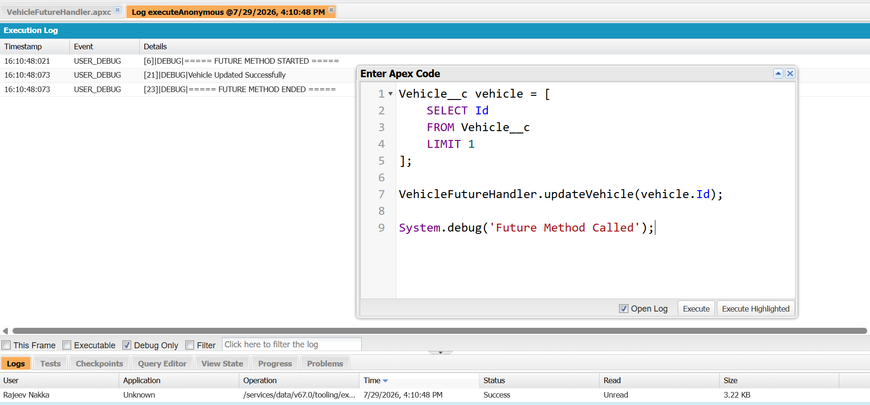
Queueable Apex
I also implemented VehicleQueueableHandler using System.enqueueJob to compare it with the future method. The log shows "QUEUEABLE JOB STARTED" and "QUEUEABLE JOB COMPLETED".
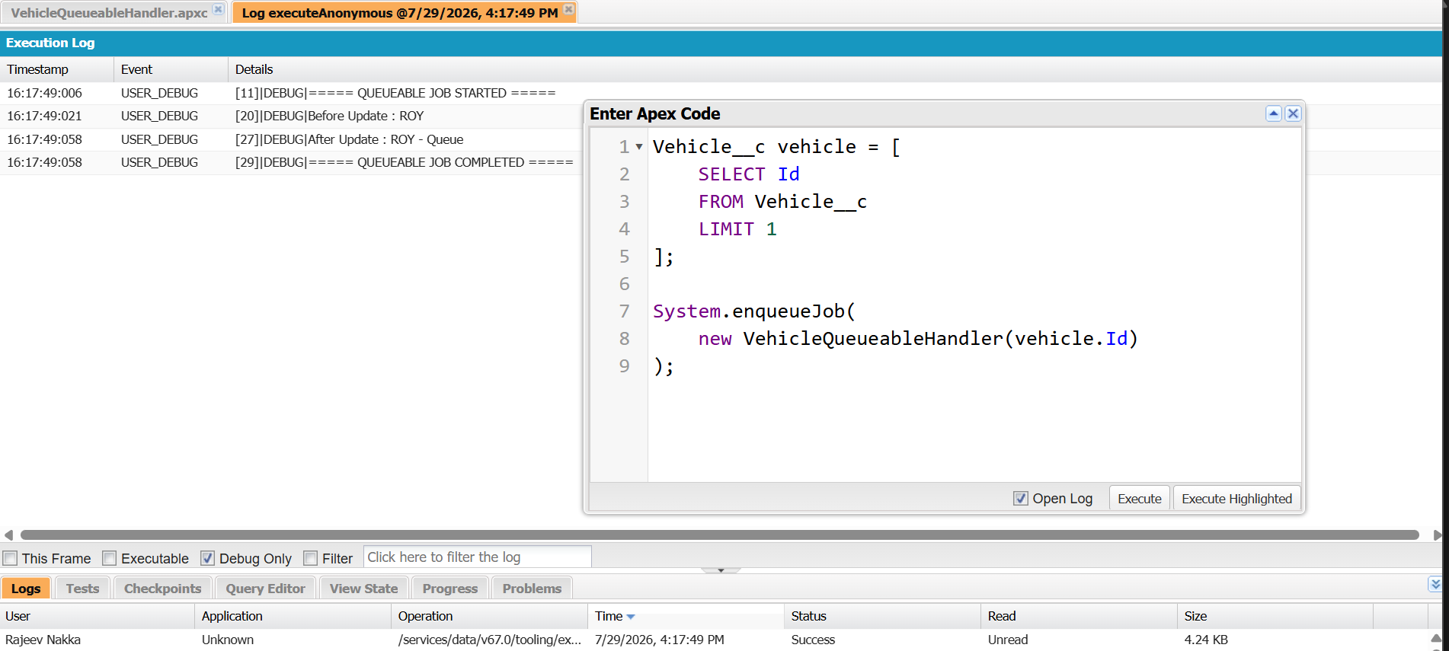
Batch Apex
To answer why Batch Apex is needed over a normal trigger, I ran VehicleBatchHandler with Database.executeBatch, which confirmed 50 records processed in the batch.
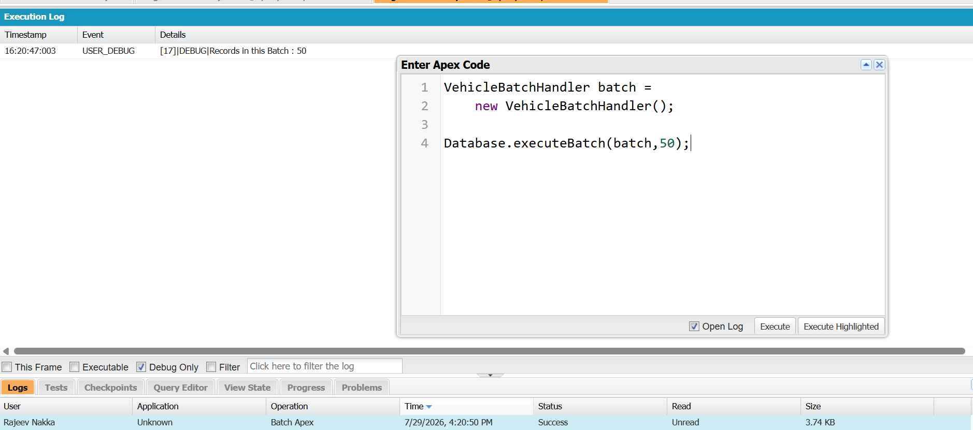
Written answers
Future method vs Queueable Apex: A future method only takes primitive parameters and cannot be chained or monitored easily, while Queueable Apex accepts non-primitive types (like sObjects), can be chained to another job, and its Id can be tracked via System.enqueueJob's return value.
Why Batch Apex instead of a normal trigger: Batch Apex is needed when processing very large numbers of records (more than what fits in a single transaction's governor limits), since it splits the records into manageable chunks (scopes) and processes each chunk in its own transaction.
Task 4: LWC — Component Communication
I built a parent and child LWC pair on the Vehicle__c object. The parent passes the Vehicle record Id to the child via a public @api property, and the child displays the Customer Name and Vehicle Number. The child also fires a custom event back to the parent when the "Notify Parent" button is clicked.
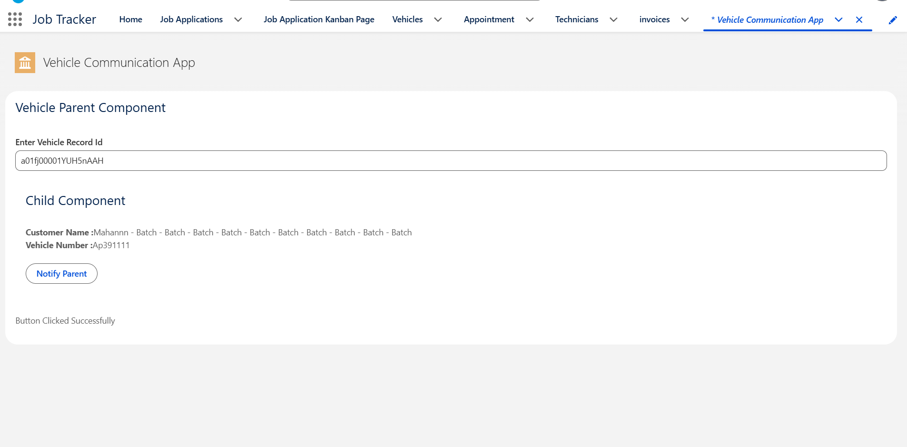
Below is the parent component after processing multiple Vehicle records (via the batch/queueable jobs), showing the list of Vehicle records with their Customer Name and Vehicle Number.
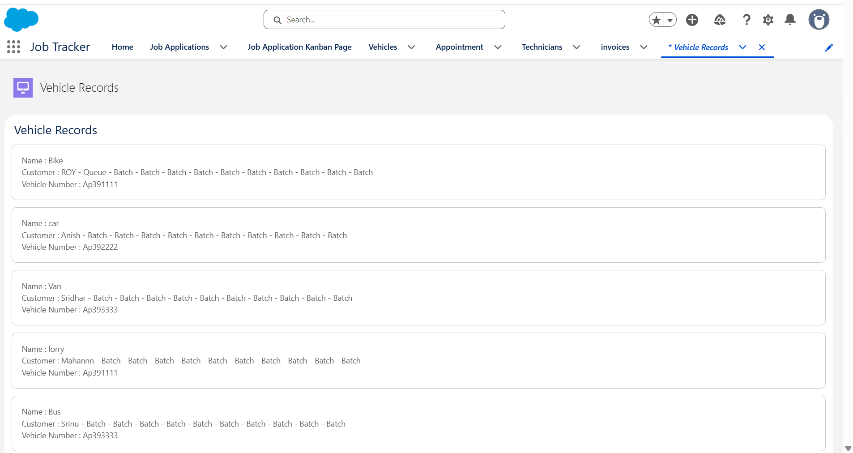
Summary
Today I learned how to use List, Set and Map collections with SOQL, how to deliberately break a trigger with SOQL inside a loop and then fix it by bulkifying, the difference between Future methods, Queueable Apex and Batch Apex, and how to pass data between parent and child LWCs in both directions.

