**Welcome to day2 of Compute and Network Services!!**

**Lex Link:**

https://lex.infosysapps.com/en/app/toc/lex_19685426003365850000/overview

**Attendance Link:**

http://iscls4apps/ITMS/Learning/Index

**Agenda:**

* EC2 --> pricing models, custom AMI
* Load balancers

**EC2 pricing models:**

* On demand instances: pay as you go, no long-term commitments, workloads which do not want interruptions
* Reserved instances: 1 year / 3 years commitment, discount on the price
* EC2 instance --> t2.micro --> 1yr
* Spot instances: unused Ec2 capacity, 90% discount
* current spot price
* max price
* Use case example: Batch jobs

**User data:**

* custom scripts to perform some activities
* to install web servers, software
* user data --> executed only once --> instance is launched
* Ec2 instance --> connected to Linux machine --> installed an apache web server
* Ec2 instance --> user data script
* EC2 instance --> start --> execute user data --> apache web server is installed --> stopped --> start --> user data will not be executed

**Sample user data:**

#!/bin/bash

# Use this for your user data (script from top to bottom)

# install httpd (Linux 2 version)

yum update -y

yum install -y httpd

systemctl start httpd

systemctl enable httpd

echo "<h1>Hello World from $(hostname -f) </h1>" > /var/www/html/index.html

**Elastic IP**

* Ec2 instance --> 11.22.33.44 (public IP) --> stopped --> started --> will change
* Before stopping: http://13.232.177.171/
* After stopping: 3.110.115.191
* Want a static IP?? --> Elastic IP
* Request for elastic IP --> associate with an instance

**Load balancers:**

* to distribute the traffic evenly across the endpoints
* regular health checks
* single point of DNS
* Managed service -- scalability

Load balancers reference: https://www.nginx.com/resources/glossary/load-balancing/

4 different types:

* Classic load balancer: previous gen
* Application LB - HTTP and HTTPS, layer7
* Network LB - TCP, UDP, layer 4
* Gateway LB - virtual firewall, third-party virtual appliances, layer 3

Endpoints:

* Instances
* IP addresses
* Lambda function
* ALB

Health checks:

* Healthy threshold
* Unhealthy threshold

Security group of instances:

* EC2 instances --> sec grp --> allow HTTP from anywhere????

HTTP only from Load balancer?

Public vs Private IP:

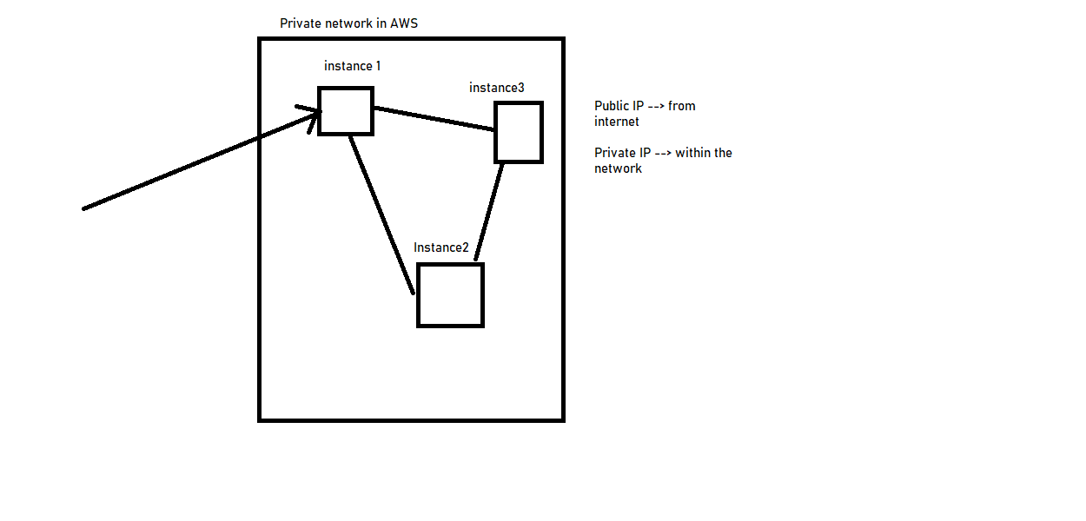

Load balancer:

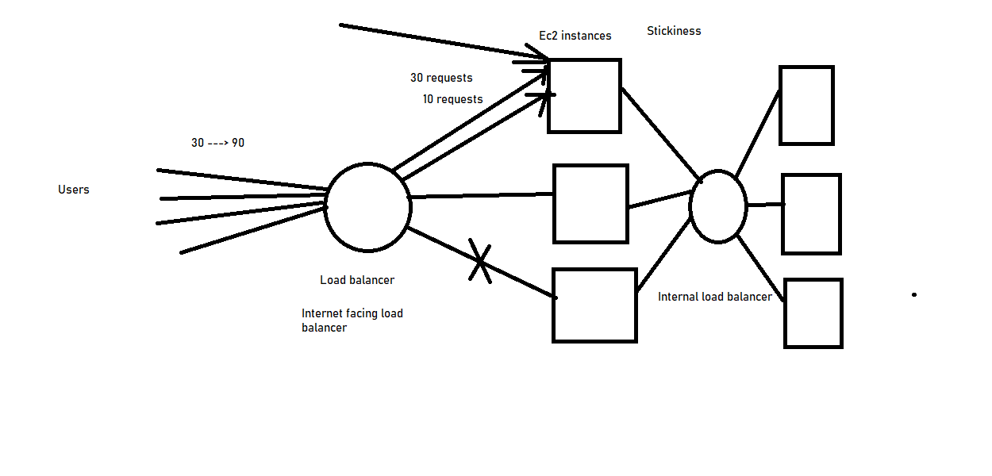

Understanding EC2:

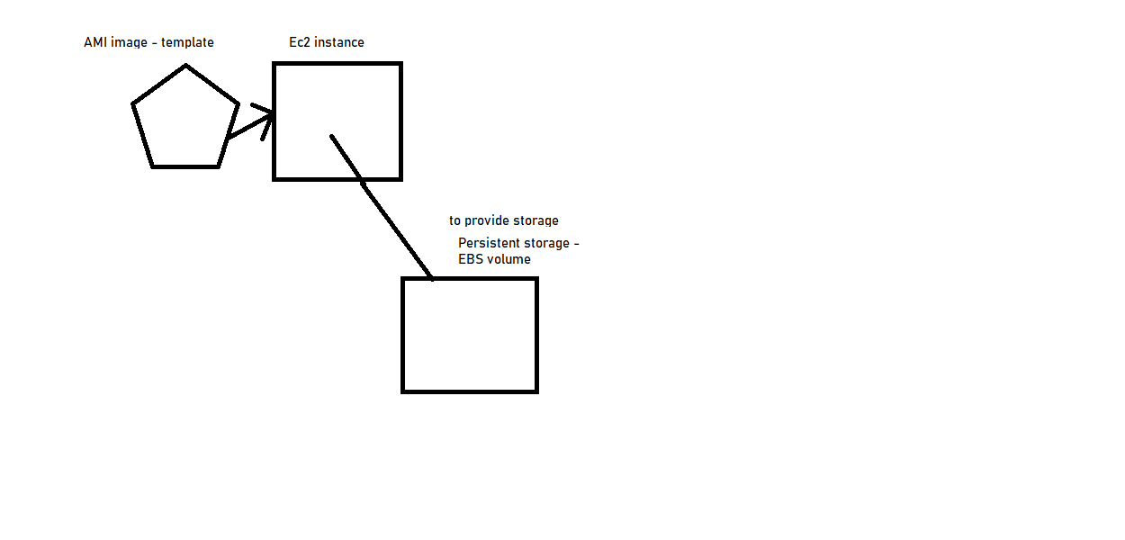

Additional Links:

<https://docs.aws.amazon.com/AWSEC2/latest/UserGuide/user-data.html>

<https://docs.aws.amazon.com/AWSEC2/latest/UserGuide/ec2-security-groups.html>

<https://docs.aws.amazon.com/AWSEC2/latest/UserGuide/ec2-key-pairs.html>

<https://docs.aws.amazon.com/AWSEC2/latest/UserGuide/AMIs.html>

<https://docs.aws.amazon.com/AWSEC2/latest/UserGuide/instance-purchasing-options.html>

<https://docs.aws.amazon.com/AWSEC2/latest/UserGuide/ebs-volumes.html>

<https://aws.amazon.com/ec2/pricing/reserved-instances/pricing/>

<https://aws.amazon.com/ec2/pricing/on-demand/>

<https://aws.amazon.com/ec2/spot/pricing/>