We are currently storing battery images in our Azure Storage under base folders like so
We’ll be uploading the battery images under each of the respective device folder.
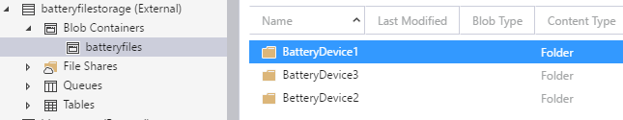

DESIRED: So the need is that I want my Logic App Blob Storage Trigger to fire regardless of which folder the image is uploaded to.
However, this does not work. The trigger does not fire
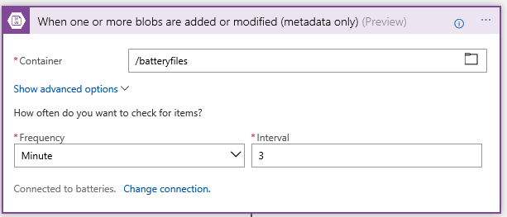

The trigger will only fire when we specify the sub container (folder) name like so.
The problem with this is that we’ll have many Battery Device folders and we to avoid creating duplicate Logic Apps for each folder
