Google Cloud Platform
Notes on GCP and it’s services
Rajeev Suravajhula
Infosys Limited
Contents
Essentials of Cloud Computing 3
Cloud Deployment Models 3
Cloud Service Models 3
Serverless Services 4
Major Cloud Service providers 5
Virtualization 5
Types of Virtualization 6
Benefits of Virtualized Structure 6
Containers 6
Benefits of Containers 6
Containers and Virtual Machines 7
Containerization using Docker 7
Cloud Native Application Development 8
Cloud Migration 9
Phases of Migration 9
Assessment 10
Migration Strategies 10
Migration 11
Cloud Security 11
Cloud Security 12
Cloud Security Features 12
Best Practices 13
Latest Trends in Cloud 14
Multi Cloud 14
Poly Cloud 14
GCP SERVICES OVERVIEW 15
GCE Google Compute Engine(GCE) 15
Creating VM 15
Region and zone 17
Hardware configuration 17
Boot Disk 18
Networking 20
SSH Keys 21
View and Launch Instance 21
Access Instance via SSH 22
Deploy Web Application 23
Other Compute Services 24
Google Cloud App Engine 24
Google Cloud Kubernetes Engine 24
Cloud Run 25
Google Cloud Functions 25
Google Cloud Anthos 25
Google Cloud VPC 26
Hybrid Connectivity 29
Network Service Tiers 30
Google Cloud Armor 30
Google Network Intelligence Center 31

Essentials of Cloud Computing

Cloud Deployment Models
Cloud services can be deployed over the internet, based on workload patterns and security there are 4 models those are:
- Public Cloud – Infrastructure is owned by service provider (unlimited resources, maintenance is owned by service provider) – suitable for spikey workload, dev/test and short-term analytics
- Private Loud – solely for an enterprise (sensitive workload where security is paramount, costly)
- Community Cloud – with common concerns, typically outside of org (Common goal)
- Hybrid Cloud – combination of one or more models (both public and private cloud, data exchange between public and private cloud, control over sensitive assets, flexibility, cloud bursting)

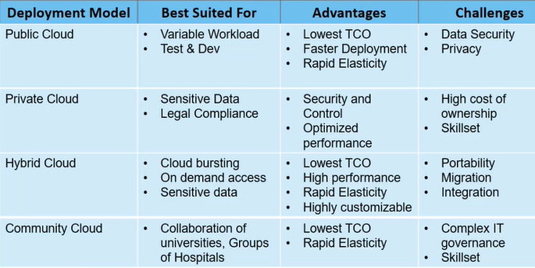

Cloud Service Models
There are 3 types of models on basis of control over infrastructure, those are:
- SaaS
  - Readily available software apps
  - Accessed through web browser
  - No visibility over backend infra structure
  - Billed based on subscription
Ex: MS Office 365, Microsoft Teams, Google Apps, Slack Channel

- PaaS
  - Runtime, Platform and tools by cloud service provider
  - No management effort
  - Less control over infrastructure
  - Control over application code
Ex: App Cloud from salesforce.com
Google App Engine (GAE) from GCP
OpenShift from RedHat
Oracle Cloud Platform from Oracle
- IaaS
  - Compute, Storage and Network resources
  - Control over OS and Cloud storage devices
  - Configure development environment remotely
Ex: EC2 from AWS
VM from Azure
Google Compute Engine from GCP

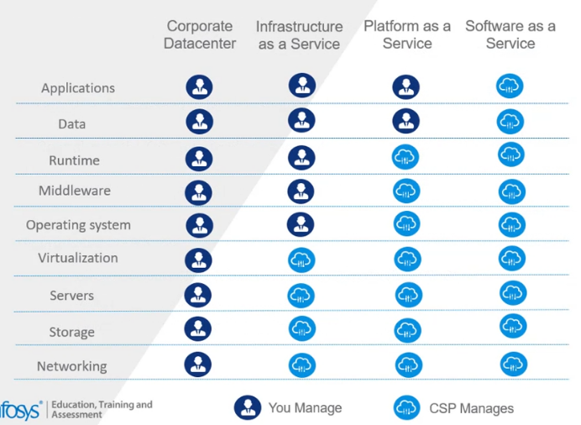

Serverless Services
- No Infrastructure management, i.e., Capacity management and patching OS is done by cloud service provider
- It reduces TCO (Total Cost of Ownership)
- Highly available and fault tolerant
- Also known as Function as a Service
It only executed when request till then it will be inactive, and charges are for the execution time only.
Serverless services is automatic scaling

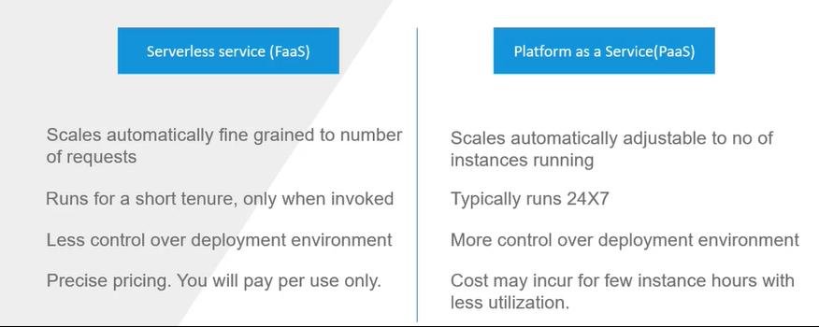

Major Cloud Service providers

AWS – Azure -- GCP
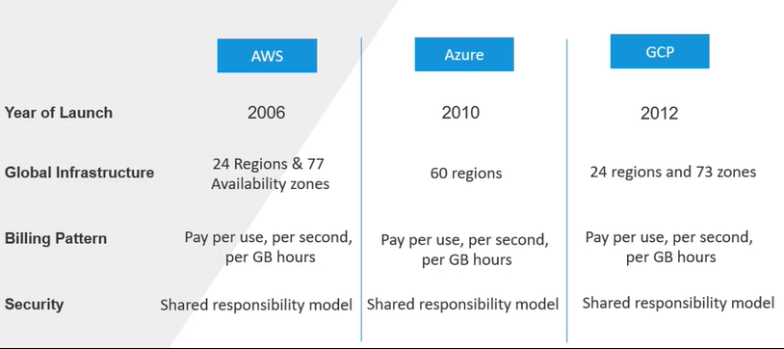

Virtualization
- Allows you to run application on fewer physical servers
- Reduces TCO by utilizing full capacity of resources
- Isolates workloads hosted on physical infrastructure
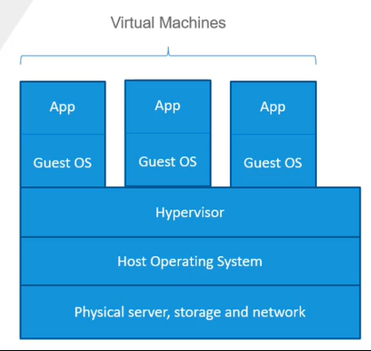
- VM are created from Physical Infrastructure, each VM has a guest OS on it
- Hypervisor manages the resources for VM
- Each VM is an isolated environment

Types of Virtualization
Classified into two based on whether presence or absence of OS layer on the physical host., they are
- Type 1 or Bare Metal Virtualization
  - Does not have an OS on the host for high performance and low latency
  - Ex: Microsoft Hyper-V
- Type 2 or Hosted Virtualization
  - Runs on top of a OS layer, good for admin tasks for a VM.
  - Ex: Oracle VM VirtualBox, VMWare Workstation

Benefits of Virtualized Structure
- Cost Saving
- Agility
- Reduced Downtime

Containers
- Lightweight run time environment for app deployment.
- Bundles all the required dependency
- Use components of host kernel in order to provide deployment environment for the apps to run

Benefits of Containers
- Rapid Scalability as boot up time is milli seconds
- Each container does not have a OS, so it uses less resources.
- Highly portable, can run on any infrastructure.
- Greater efficiency as few resources are needed to spin up Container

Containers and Virtual Machines
Each container run a single process, so workload is highly isolated, and each container gets it network stack where as in VM, multiple apps can be hosted and isolation is achieved through instance level firewall.
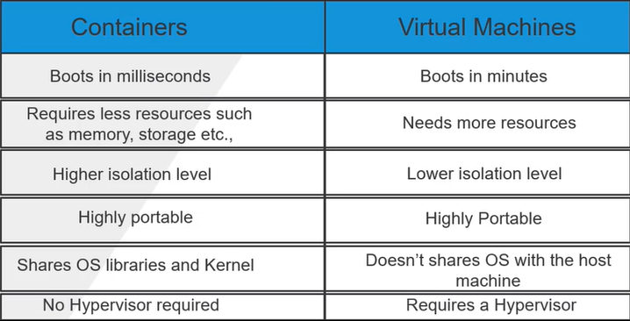

Containerization using Docker
- Open source Docker Engine (provides container run time to deploy applications)
- Provides both windows and Linux based containers can be created using docker
- Docker container bundles all the dependencies the apps require to execute, due to which the packaged application can tun anywhere consistently
- Containerization using Docker can be done using Docker CLI, API
- We can build custom docker Image using docker container registry and use it to spin up the containers
- Docker fie a set of commands to install packages to build custom image

Container Orchestration
- It automates deployment, scaling and networking of containers and other management activities.
- Continues integration and Deployment requires updates to source code will be deployed automatically, hence automatic provisioning of containers facilitates deployment in CI/CD pipelines
- It makes sure that faulty containers are replaced, so high availability is ensured
- It also manages load balancing and routing of the traffic to the application containers
- Enables secure interaction among different containers
- Ex: Docker Swarm, Kubernetes, Apache Mesos, Amazon EKS and GKE

Cloud Native Application Development
Developing refactoring and deploying by leveraging cloud services
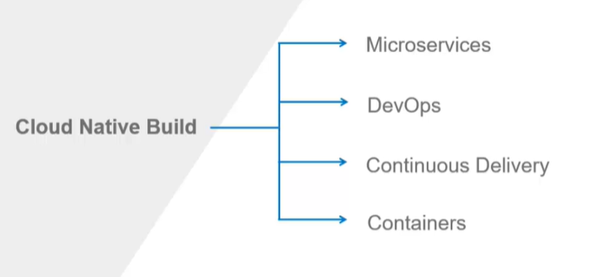

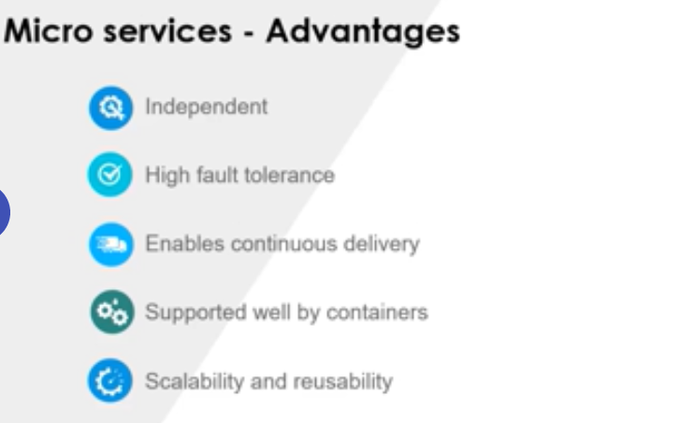

Cloud Migration

Phases of Migration
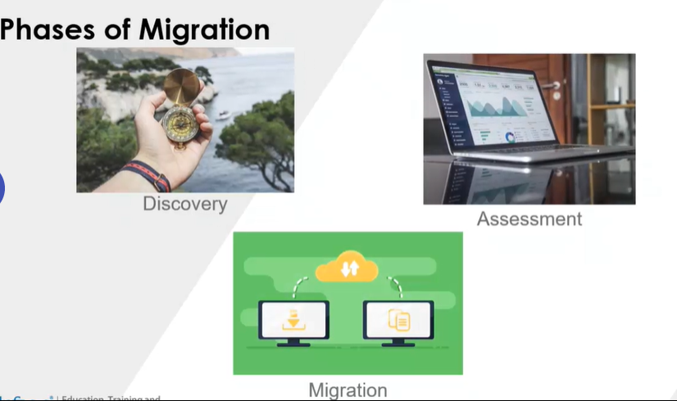

Assessment
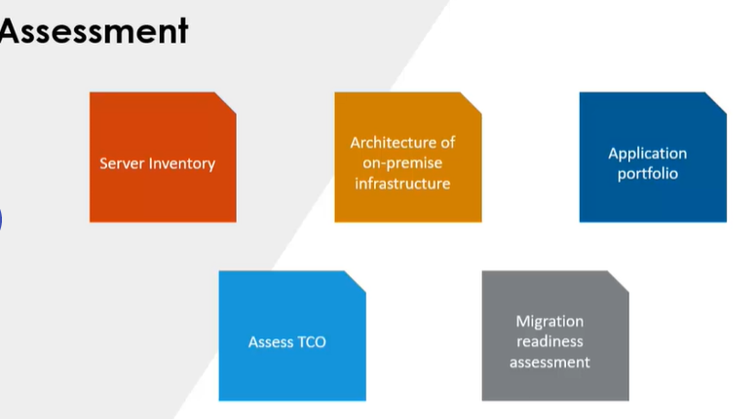

Migration Strategies
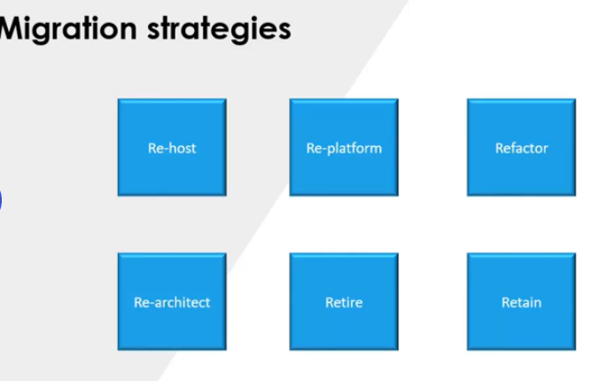

Migration
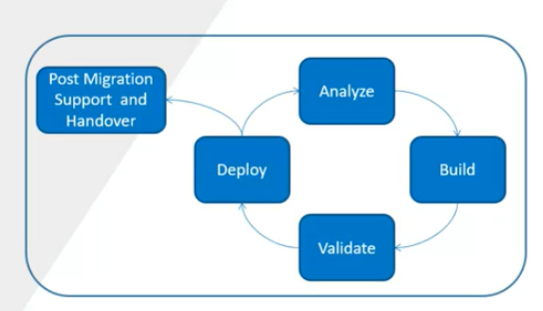

Cloud Security

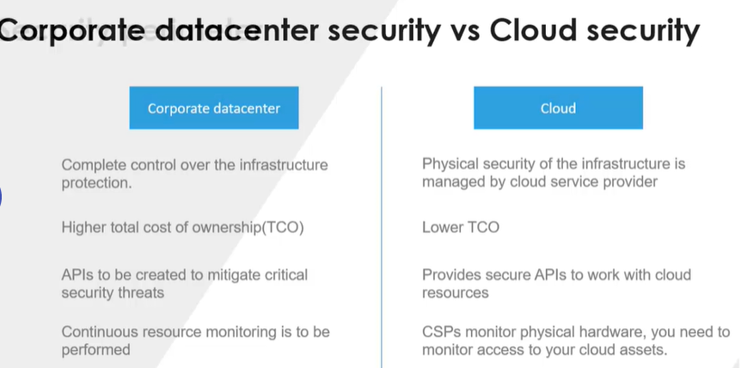

Cloud Security
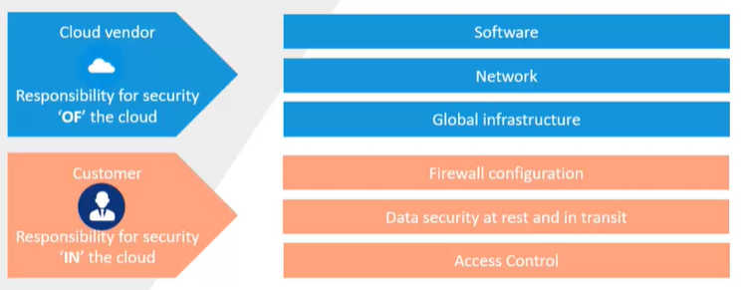

Cloud Security Features
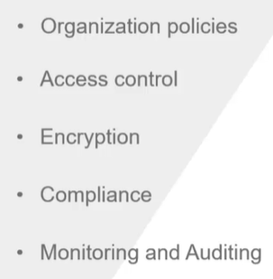

Best Practices
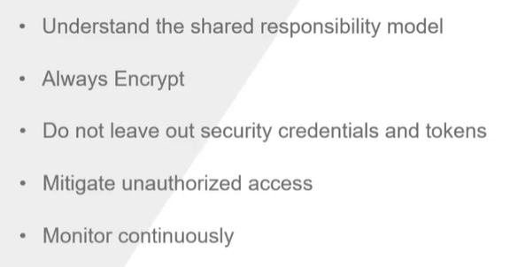

Latest Trends in Cloud

Multi Cloud

Poly Cloud
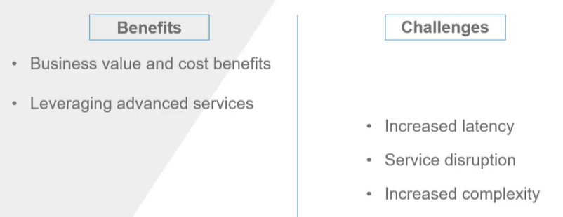

GCP SERVICES OVERVIEW

GCE Google Compute Engine(GCE)
- Google Compute Engine (GCE) is a web service used to create configurable virtual machines(VM) hosted on Google's infrastructure which provides flexible and re-sizable compute capacity as a service.
- Allows to create and manage VM by GCP console, Gcloud and REST API
- Allows you to launch a VM with operating systems like Windows and Linux
- Provide options to manage a VM
- Provide options to create desired number of VMs from predefined/custom created templates named images (Public/Private)

Creating VM
- Using GCE (Google Compute Engine), virtual machines can be created and configured as per business need. It is highly scalable and reliable service which minimizes the infrastructure cost
- Virtual machines created using GCE service are commonly known as instances.
- Just like customizing and configuring a physical machine, you can configure instances according to the business requirement.
- You configure an instance based on:
  - Zone, operating system and application software
  - Processor, memory and storage
  - Network and security
- To create a VM
  - Google Compute Engine VM instances create name the instance under boot disk change OS check Allow HTTP traffic under Firewall
- To check the status of VM go to VM instance tab and you will be able to see your VM Instance in running condition.
- To connect to the IP, click on SSH under connect column, it will open a new window, we can use to execute shell commands etc.
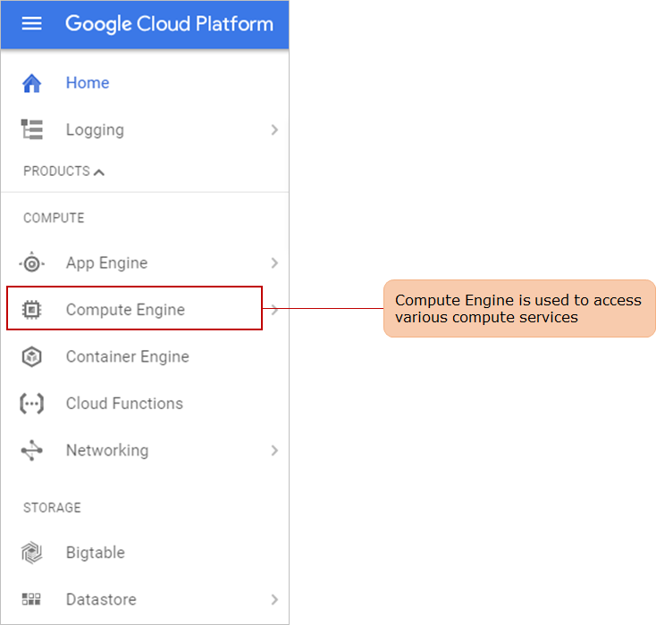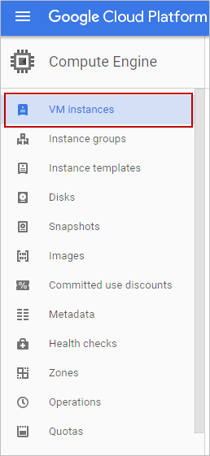
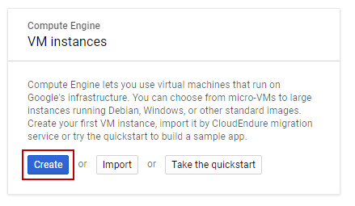
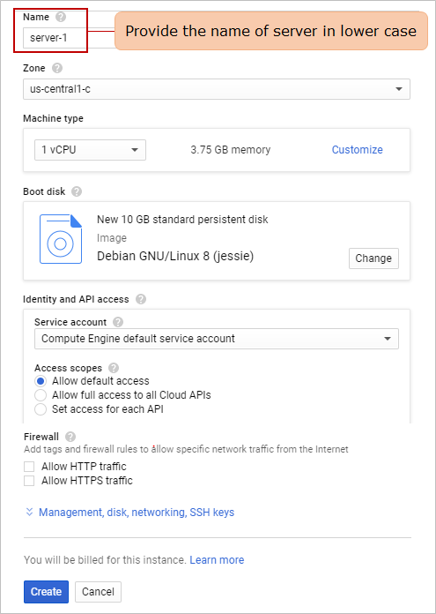

Region and zone
- Region: It is a collection separate geographic area which has multiple isolated locations called zones.
Regions are entirely independent from another region, and the traffic between regions transfers over the public internet.

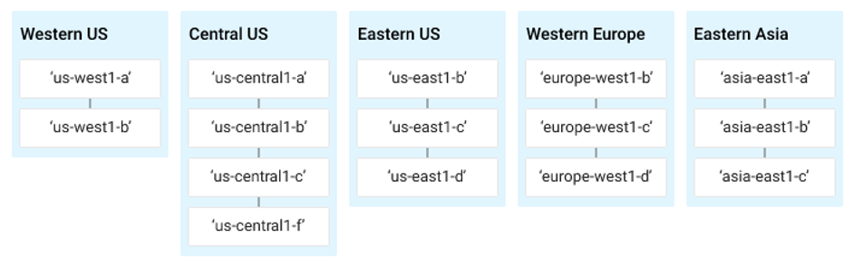

Hardware configuration
Machine types are categorized according to:

- Configurations: of storage, CPU, memory, network capacity, clock speed etc.
- Families: Grouping of instance types based on the nature of data center workload e.g: f1, g1, n1, small, medium, large etc. Under which it is then categorized into:
  - Standard machine type
  - High memory machine type
  - High-CPU machine type
  - Shared-core machine type
- The starting level instance is f1.micro which has bursting capabilities to use additional physical resources. It has 1 vCPU (virtual CPU), 0.60 GiB memory, and storage of up to 3PD (Persistent disk).
- If you must perform some basic operations, then a standard machine type can be selected.
- In case of big and critical operations, you might need some high processing and storage capacity

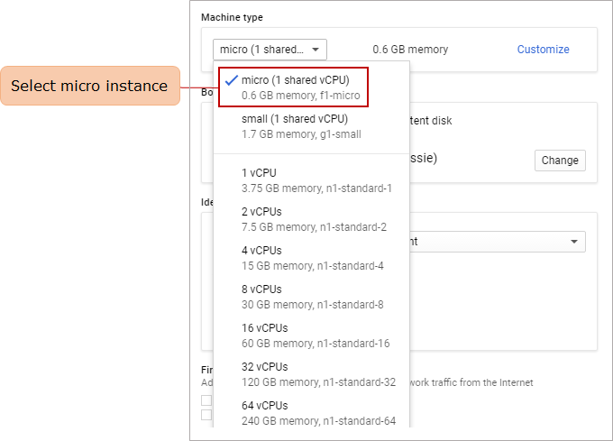

Boot Disk
To create a root persistent disk for instances, GCE uses images which are of two kinds
- Public image: These are the default images accessed by all projects which are provided by Google, third-party vendors and open-source community. OS and application images are public images.
- Custom image: User can create the image of existing root persistence disk. It can be used to create instance only in that specific project.
Expand "Management, disk, networking, SSH keys" for additional configuration as shown below

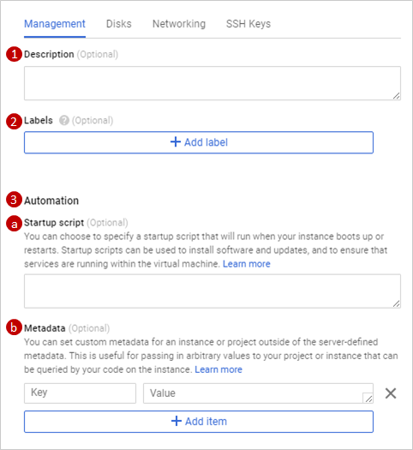

Description
- Describe your instances that can be documented. Description can be related to application on top of which the instances are built on.

Label
- It is the key value pair which can be used to group the instance based on staging, deployment and development separately.

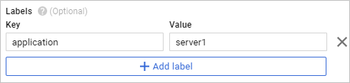

Automation

Provide the configuration scripts in Automation: Start up section.
- We have added the script in "Startup Script" to configure apache server in instance as shown below

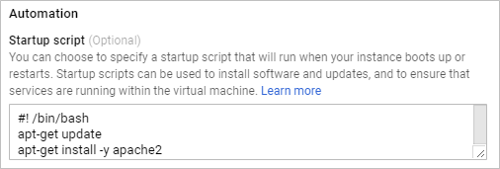

Metadata
- These are the unique information of an instance ex: External IP address, which exist in key: value pair. Metadata can be used in startup and shutdown script and are stored in metadata server that can queried within the instance. Google set default metadata entries, however in below screenshot we have set user defined metadata.

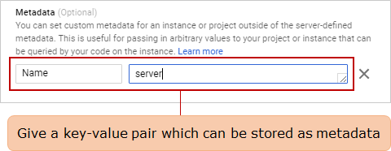

Disk
- As the boot disk is attached to the instance, if you wish GCP to delete the disk once instance is deleted you can check the option as shown below.

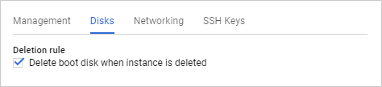

Networking

Network
- The network traffic that instance can access. GCP sets a default network.

Subnetwork
- An IPv4 address is assigned to the instance from subnetwork's range using which they can communicate with another instance. We will study in detail about subnetwork in subsequent modules.

Network tags
- Adding tag to the network is useful as the same tag can be used to applying firewall rules. We have added "server-1" for the tag value as shown below
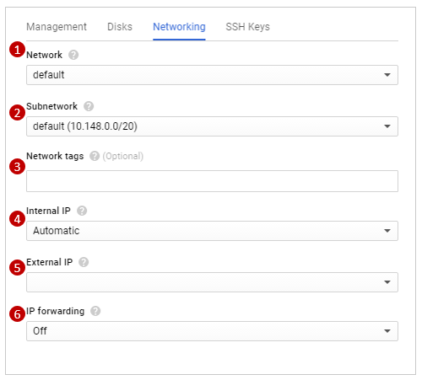
*********************************************************************
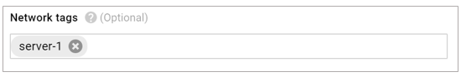

Internal IP
- Internal IP is automatically generated and assigned to an instance when created. It is unique to a virtual private network (VPN). VPN will be discussed in next section.

External IP
External IPs are used to communicate with internet or services in other network. It is of two types:
- Static external IP: It is assigned to the project and remain attached to the stopped instance as well until released
- Ephemeral external IP: It remain attached to VM until it is stopped or restarted

IP forwarding
- It lets the instance to route the packets. You can set it on to enable forwarding.

SSH Keys
GCP creates a default key-pair for the instance, however if you wish to generate and apply for instance you can define it here. We will proceed with default key-pair.

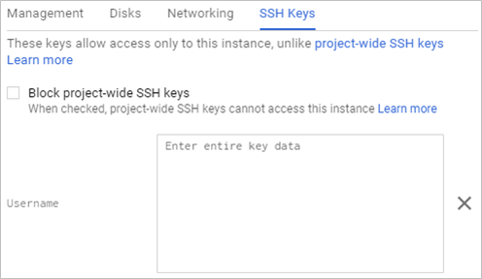

View and Launch Instance
Once instance is created you can see the green check which proves that the instance is created successfully.

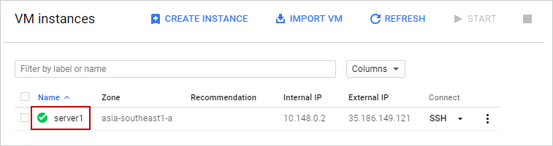

CPU Utilization
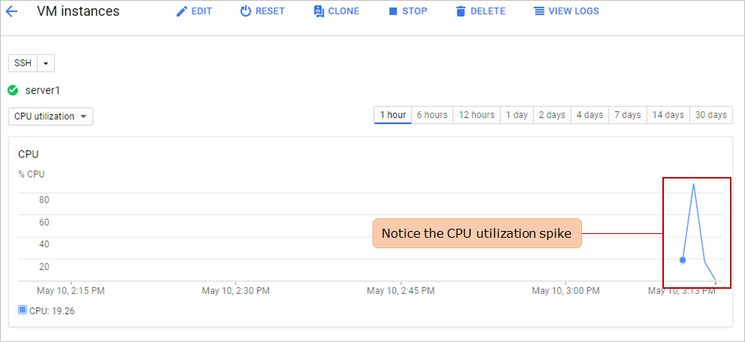

Access Instance via SSH
To access the instance, click the SSH in VM instance page and choose the appropriate option as shown below

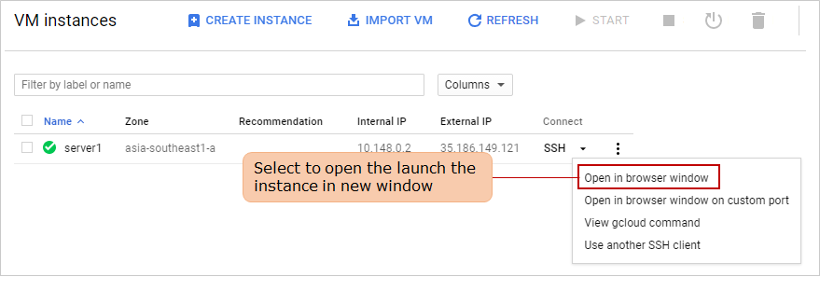
You will see below screen once you SSH which proves healthy instance is created that can be accessible

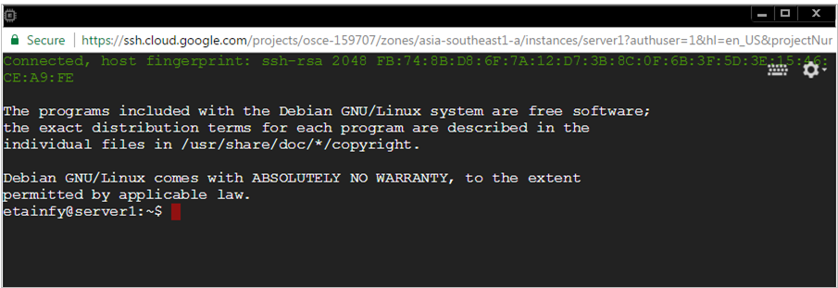

Deploy Web Application
Deploying an application in the instance requires utilities like application server, deployment platform, database support and few other configuration changes. An Apache server is already running in the instance that we have created. You will now deploy a simple PHP application on the server.

Sudo and install application
- Once you have logged into the instance using SSH, switch user as shown below and execute the below set of commands.
Below commands will switch user to root, update current configuration, install php and MySQL on VM.
sudo su -
apt-get update
apt-get install php5
apt-get install mysql-server php5-mysql php-pear

Test the Apache and PHP
Get the external IP address and paste in browser to verify Apache using below format
http://[INSTANCE_EXTERNAL_IP_ADDRESS]

Create and deploy a PHP application on the server
/var/www/html is the document root directory of Apache server where all applications are stored and executed

cd /var/www/html
vi Welcome.php

write your code in Welcome.php and execute it

Test the application in the browser
Call the script from your web browser to test the application

Other Compute Services

Google Cloud App Engine
Managed application platform that support any language, framework or library, infrastructure provided by google and code is taken care by developers
Languages supported by GCP, if you want any other language or library you can use custom container (Docker)
- Node.js
- Java
- Python
- .NET
- Ruby
- Go
- PHP

To deploy any application in the cloud run the following command

gcloud app deploy

App engine will take care of uploading the code and running it in the google infrastructure.

When you are ready to push the updates to your application, GAE makes it easy. You can run multiple versions of your application at the same time and can even split the traffic between different versions of your app making it simple for performing rollouts or a/b testing.

If your application starts to grow, your app engine will automatically scale it for you and app engine automatically balances instances across multiple availability zones, making sure your app is up and running.

If your app traffic is slowing down, GAE will automatically scale down the resources.

GAE integrates with google stack driver diagnostics, monitor, logging.

Google Cloud Kubernetes Engine
- It is used to orchestrate docker containers.
- It lets user to scale their cluster at any scale, use integrated developer tools and get multi cluster support.
- The operational overhead is resolved by making use of auto repair and auto upgrade options from GKE.
- The vulnerability scanning of container images and encryption of Data are provided by default.
- The operations can be streamlines with release pipeline channels.

Features of Kubernetes Engine
- Automatically scales based on the load
- Integrated with a private registry of GCP
- Can easily monitor and generate logs for the cluster setup
- Auto recovery options are provided to process nodes from failure

Containers allows apps to be broken down into smaller independent pieces that can be deployed or managed dynamically.

Containerization also allows a separation of apps from infrastructure, and as they are very lightweight individual services they can be called when they are needed and are available almost immediately.

Kubernetes is a production ready open source platform and provides a container specific management environment
Kubernetes allows you to interact with container cluster to deploy and manage your apps, perform admin tasks and set policies and monitor health of your deployed workloads.

Cloud Run
- Cloud Run is a fully managed compute platform that automatically scales your stateless containers.
- Serverless agility to containerized apps, you can you cloud run to deploy any stateless http container. This will automatically scale up or down based on incoming traffic.
- It is billed down to nearest 100ms, it is built with K native. You can use it with Kubernetes engine in cluster.
- It is serverless i.e. it abstracts away all infrastructure management, so users can focus on what matters most—building great applications.
- Users can run their containers in fully managed Cloud Run or on Anthos, which supports both Google Cloud as well as on‐premises environments.
- As Cloud Run is built upon an open standard, K Native, it enables the portability of your applications.

Features of Cloud Run
- Supports languages such as Go, Python, Java, C#, PHP, Ruby, Node.js, Shell, and others
- Abstract away all infrastructure management for a simple developer experience
- Users pay only when their code is running

Google Cloud Functions
- it is Google Cloud’s event-driven serverless compute platform.
- It enables users to run their code locally or in the cloud without having to provision servers.
- Since Cloud Functions scales up or down, you pay only for compute resources you use.
- Moreover, users can easily create end-to-end complex development scenarios by connecting with existing Google Cloud or third-party services.

To create a cloud function, follow the below steps
- Login into GCP console, which have billing enabled project
- Go to menu and click on APIs & Services and it will redirect to another page
- Click on Enable API and Services
- Search for API “Cloud Functions API “and enable it for the project and do the same for “Cloud Build API “
- Go to menu and click on Cloud Functions and click on create function

Features of Cloud Functions
- No need to provision, manage, or upgrade servers
- Scales automatically based on the load
- Provides support for different languages
- Integrated monitoring, logging, and distributed tracing
- Provides built-in security at role and per function level based on the principle of least privilege
- Key networking capabilities for hybrid and multi-cloud scenarios

Google Cloud Anthos
- Anthos is an open hybrid and multi-cloud application platform that enables you to modernize your existing applications, build new ones, and run them anywhere in a secure manner
- Built on open source technologies pioneered by Google—including Kubernetes, Istio, and Knative—Anthos enables consistency between on-premises and cloud environments and helps accelerate application development

Network Services

Google Cloud VPC
Using Google VPN (Virtual Private Network) you will be able to establish a fine-grained access and permission control over project resources in GCP. One can use VPN to securely connect to the services running in multiple projects without exposing to public.

VPC (Virtual Private Cloud)
- VPC is an isolated private network within the Google cloud that provides network functionality for GCP resources.
- VPCs are configured under regions. By default, every project starts with a VPC created by GCP termed as default VPC. Users can define their own VPCs within regions based on the business requirement.
- VPC network within GCP are further divided into subnetworks and referred as subnets. Subnets are also defined as IP address ranges in CIDR notation and will be contained within a single region.
- We can isolate portion of network or a subnet by using firewall rules.
- It is a managed networking service for GCP resources, GCP use VPC to network with each other
- Create virtual topology which can be expanded to multiple regions
- It works independent of the internet; the communication happens over google back bone network
- Supports hybrid cloud environments where n/w can be established between on premise and GC through VPN and it will let you configure your IP and subnets across any regions

VPN (Virtual Private Network)
- VPN enables you to define a customizable network between on-premise and VPC. It is completely under the control of the organization that manages the VPN.
- To ensure contents is delivered with lowest latency, GCP uses software-defined networking and distributed systems technology to deliver the services. With Google Cloud Virtual Network, you can securely connect your existing network to your GCP network. It supports only IPsec gateway-to-gateway connection.
- Let us further explore the VPN components by designing a simple VPN.

For the resources within GCP to be useful, VPN should allow the resources to connect with internet. There are few configuration entries which helps a resource within VPN to communicate with internet and within the VPN as discussed below:
- Cloud VPN gateway- It is the virtual component of VPN managed by GCP which allows communication between resources inside VPN and internet.
- Peer VPN gateway- It is the gateway running in peer device to which connection needs to be established from cloud VPN. It refers to the other side of connection that can be a physical device running on your premises.
- Shared secret- IKE (Internet key exchange) is the protocol used to establish a shared secret used for VPN connection setup between two different network or regions. This shared secret allows connection to your network. Cloud VPN supports Internet Key Version [ IKEv1 and IKEv2] using a shared secret.

Below specifications are required to use VPN
- A peer VPN gateway in other side of tunnel
- Peer VPN gateway must have a static external IP address (IP address assigned to a project)
- Non conflicting CIDR ranges on both networks
- A shared secret must be provided to peer VPN gateway

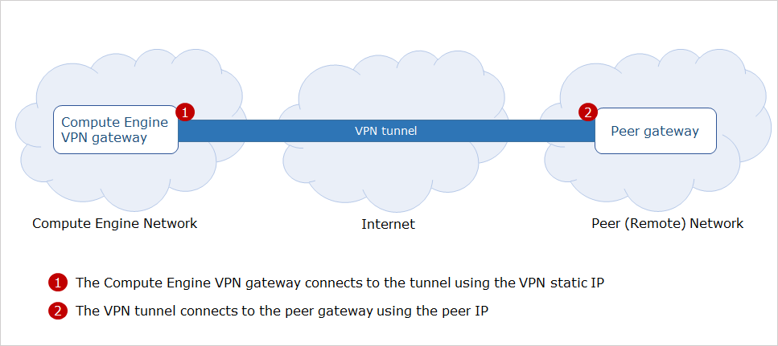

Configuring a VPN
- Define a dedicated network by providing IP address range
- Establish a dedicated VPN connection
- Explore the components created as part of VPN configuration
- Verify the VPN connection
To configure 1:1 connection between networks create two projects and establish a VPN connection.

- VPN gateway: It is the virtual gateway running in GCP. By attaching this, resources in VPC can get access to the network.
- Tunnel: It is the interconnection of networks between VPCs and there can be 1:1, 1:n, n:n and n:1 connectivity. Tunnel can be established by sharing the remote network configuration details.

Create VPN tunnel
- Remote peer IP address Set “Remote IP address” to be the “IP address” you reserved for project. Here we provide the remote IP address reserved in project.
- To establish a VPN tunnel with peer VPN gateway Google uses IKEv1 and IKEv2 for IPsec connectivity. We choose IKEv2 as the key exchange.
- IKE preshared key Choose a shared secret which is very sensitive as it allows access to your network. It can be any random string.
- Provide the remote network IP created for project
- Provide the local network IP created for project

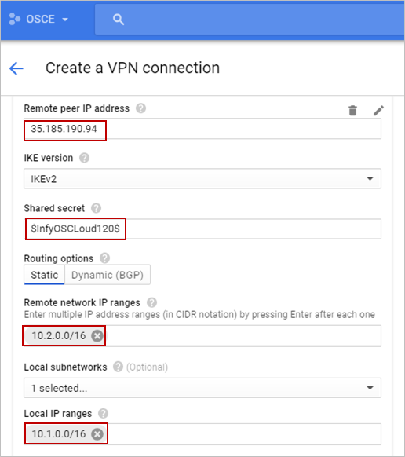
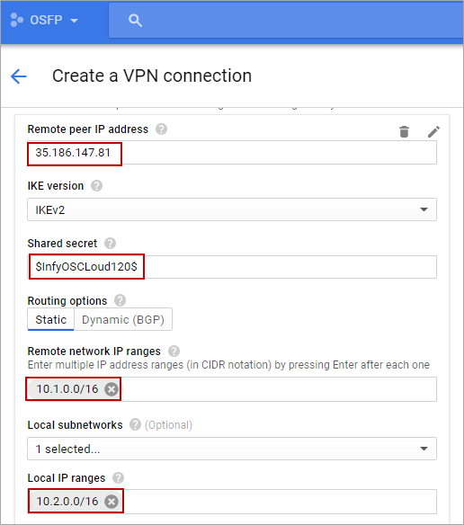

After short wait you can see you have setup a success configuration. The green checkmark for both VPN indicates that:

Verifying VPN Connection
To verify the connection below sets of steps will be performed:
- Add firewall rules to the network created to allow SSH and ICMP traffic for enabling ping
- Create instances under that network and firewall
- SSH into the instances created in two different project and ping to verify the same

Add Firewall rules
- Firewall rules are added to dedicated network created for projects. Navigate to GCP console and select the network you created under Networking tab. Edit the network and add two new firewalls to it.
- We will add two protocols tcp: 22 for SSH and icmp to allow our instances to 'talk'.

Add SSH protocol
- Add SSH protocol to enable connectivity for the instance inside VPC. Select the network as osce-network created to which firewall rule will be applied. Fill the details keeping rest fields as default values as shown below.

Hybrid Connectivity
- Google Hybrid Connectivity lets you to connect your on-premises infrastructure with GCP.
- In order to provide the user who has a business requirement to establish a private and dedicated high performance connection, Hybrid connectivity plays a role.

You can implement the hybrid connectivity using the below three GCP products:
- Cloud interconnect: Connects your on-premise with GCP with 10 Gbps or 100 Gbps physical pipe
- Cloud VPN: Connects your on-premises/ public cloud network securely over the internet via IPsec VPN and requires a bandwidth up-to 3 Gbps
- Peering: Lets you connect to GCP either through direct mode or through carrier peering mode, through which you can access GCP. This will save the egress cloud spent
- The performance is provided at a best scale

Features of Hybrid connectivity
- It ensures the uptime of your business
- It lets you bring google cloud to your premise irrespective of where you are across the globe
- You can scale your environment effortlessly based on the demand
- You can access the internal private IP addresses directly from your premises with peering

Network Service Tiers
Network Service Tiers empowers customers to optimize their cloud network for performance or price.
GCP provides the below two tiers under this service.

Premium Tier
Premium Tier delivers GCP traffic over Google’s well-provisioned, low latency, highly reliable global network.
This network consists of an extensive global private fiber network with over 100 points of presence (POPs) across the globe. By this measure, Google’s network is the largest of any public cloud provider.

- It gives users exceptional high performing network experience by using Google’s global network.
- High performance routing
- Network services such as Cloud Load Balancing are global (single VIP for backends in multiple regions)
- High performance and reliability, Low latency, Global SLA

It is preferred when performance, reliability, global footprint and user experience are your main considerations.

Standard Tier
Our new Standard Tier delivers GCP traffic over a transit ISP's network with the latency and reliability typical of transit ISPs, and with a network quality comparable to that of other public clouds, at a lower price than GCP's Premium Tier.

- We also provide only regional network services in Standard tier, such as the new regional Cloud Load Balancing service.
- This tier enables customers to get control over network costs, while still delivering performance comparable with other cloud providers.
- Lower performance network
- Network services such as Cloud Load Balancing are regional (one VIP per region)
- Performance and availability comparable to other public cloud providers (lower than premium), no Global SLA
- Cost is your main consideration, and you’re willing to trade-off some network performance

Google Cloud Armor
You can protect your network and infrastructure from all type of attacks, monitor security
To enable google cloud armor, follow the below steps:
- Go to Network Security cloud armor create policy give a name to the policyselect default rule action go to add more rules click on Add rule give description
- There are two type of modes (basic (IP addresses/Ranges only and advanced)
- You can put up to 10 IP addresses or ranges per rule. Use a comma to separate IP address/ranges.
- To only review the rule click on enable preview only
- Priority is evaluated from 0 (highest) to 2,147,483,647 (lowest)
- Apply policy to Targets: Targets are Google Cloud Platform resources that you want to control access to. You can only use non-CDN HTTP(S) load balancer backend services as targets.
- You need to have predefined load balanced target
- Cloud Armor Adaptive Protection helps protect backend services from Layer 7 DDoS attacks by learning normal traffic patterns, detecting and alerting on potential attacks, and providing Cloud Armor WAF rules to mitigate them.
- To verify the process worked or not access the backend, navigate to Stack Driver Logs

Google Cloud Armor delivers defense at scale against infrastructure and application distributed denial of service (DDoS) attacks by using Google's global infrastructure and security systems.

Features of Cloud Armor
- Pre-defined rules to protect against the web’s most common attacks: out-of-the-box rules from the Mod Security Core Rule Set to defend against cross-site scripting (XSS) and SQL injection defense
- Rich Rules Language: Create rules using any combination of L3–L7 parameters and geolocation to protect your deployment with a flexible rule’s language. Also use predefined rules to defend against cross-site scripting (XSS) and SQL injection defense
- Visibility and monitoring: Easily monitor all the metrics associated with your security policies in the Cloud Monitoring dashboard. You can also view suspicious application traffic patterns from Cloud Armor directly in the Security Command Center dashboard, now in beta
- Logging: Get visibility into Cloud Armor decisions as well as the implicated policies and rules on a per-request basis via Cloud Logging
- Preview mode: Deploy Cloud Armor rules in preview mode to understand service access patterns, rule accuracy, and impact on production traffic before enabling active enforcement in your policies and to ensure safe operation of your applications
- IP-based and geo-based access control: Filter your incoming traffic based on IPv4 and IPv6 addresses or CIDRs. Identify and enforce access control based on geographic location of incoming traffic

SSL Policies
- SSL policies give you the ability to control the features of SSL that your SSL proxy or HTTPS load balancer negotiates with clients. In this document, the term "SSL" refers to both the SSL and TLS protocols.
- By default, HTTPS load balancing and SSL proxy load balancing use a set of SSL features that provides good security and wide compatibility.
- However, some applications require more control over which SSL versions and ciphers are used for their HTTPS or SSL connections. You can define SSL policies to control the features of SSL that your load balancer negotiates with clients.

Google Network Intelligence Center

Google Network Intelligence Center provides a single console for managing Google Cloud network visibility, monitoring and troubleshooting.

Network Intelligence Center modules
Network Topology: It helps you to monitor your Virtual Private Cloud networks and their associated metrics.
Connectivity tests: It aids you to test network connectivity to and from your network.

Network Topology
- Network Topology lays out information in a graph format, where the nodes and lines represent entities and connections in your network
- No additional configurations or agents are required to use Network Topology
- Network Topology can also help you analyze the performance of your network
- A Network Topology graph shows your resources and traffic as entities and connections

Connectivity tests

Connectivity Tests is a static configuration analyzer and diagnostics tool that enables you to check connectivity in the following ways:
- Between source and destination endpoints in your Virtual Private Cloud (VPC) network
- From your VPC network to and from the internet
- From your VPC network to and from your on-premises network

Connectivity Tests can help you troubleshoot the following network connectivity issues due to misconfiguration:
- Inconsistent configurations that are unintended
- Obsolete configurations due to network configuration changes or migrations
- Configuration errors for a variety of network services and functions

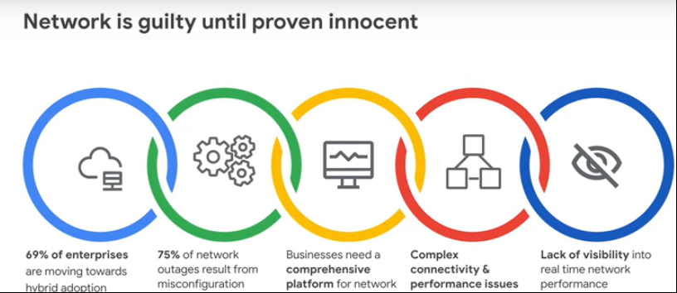

Other key network services from GCP

DNS
- Cloud DNS is a managed domain naming system (DNS) service by GCP. It is simple, scalable and reliable Cloud DNS
- It resolves domain names into IP addresses
- You can easily manage millions of DNS zones and records using Cloud DNS

Load balancing
- Load balancing helps you to quickly scale applications based on-demand to make a highly available environment
- It can span one or multiple regions
- Cloud Load Balancing can put resources behind a single anycast IP, scale resources with autoscaling and integrates with Cloud CDN

CDN
- Cloud CDN caches the content fro websites and applications and will distribute it via edge cache locations
- This offers lowers network latency, offloads origins, and reduces serving costs
- CDN can be easily enabled in a single checkbox after configuring load balancer

NAT
- NAT stands for Network Address Translation.
- It helps in securing your resources by not letting the connection to your private instances from outside resources directly.
- It enables you to get connected to the instances without the public IP address while allowing the internet to flow efficiently.

Telemetry
- Telemetry helps in securing your cloud resources in-depth.
- It collects the traffic and access patterns to prevent operational risks that may happen.
- It provides both network and security operations.

Virtual private network - Exercise - Viewer Page | Lex (infosysapps.com)

Storage Services

Google Cloud Storage

GCP's Cloud storage service can efficiently store and retrieve data in real time using the object storage service. Various storage classes are available to store data based on their frequency of access.

Different applications and workloads require different storage and database solutions. Scenarios range from streaming songs on mobile, downloading songs locally to storing backups. GCP offers full suite of industry-leading storage services that meet your needs for structured or unstructured, transactional or relational data. All these are price performant solutions.

Below table provides a comparative use case for different scenarios. Refer to Cloud storage option which suits best for Projects requirement to store images, audios, videos etc in a cost-efficient manner with high reliability.

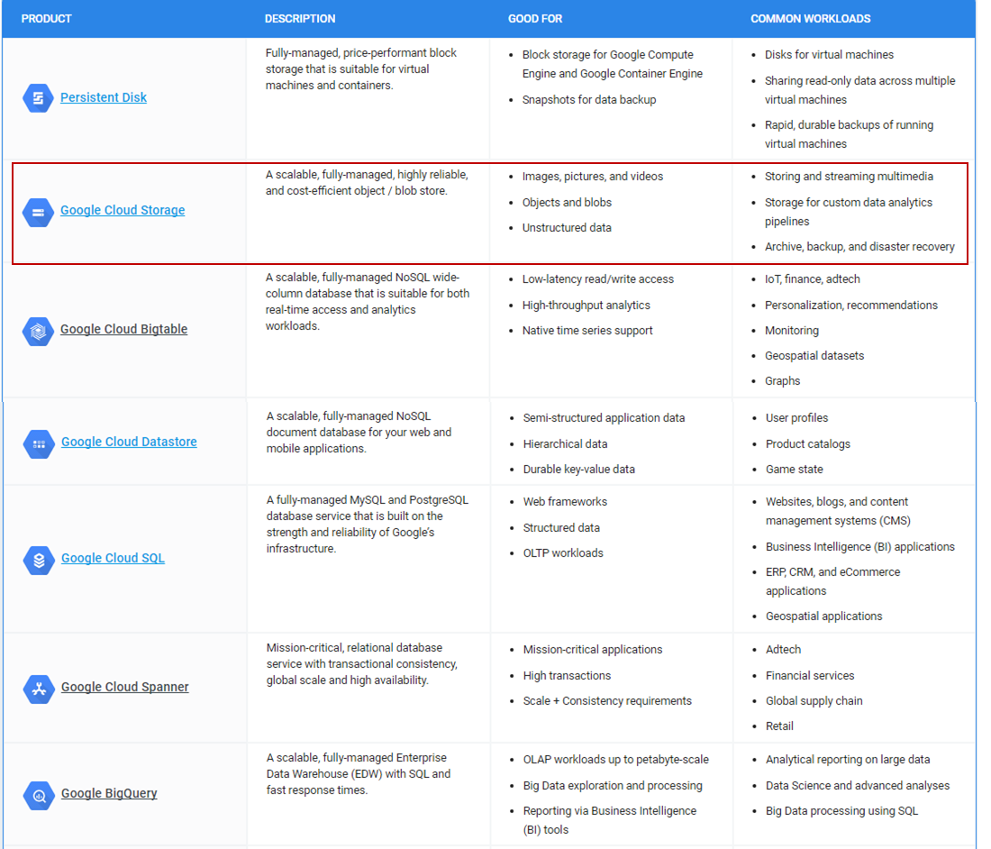
Cloud Storage is scalable object storage service best suited for any kind of unstructured data. It is secure and highly available. A cost-efficient storage for all kinds of workloads. It offers 4 different storage classes for different use cases such as high throughput streaming, batch data/ songs trend analysis or backup and disaster recovery.
Below is a table describing different storage classes and its use cases

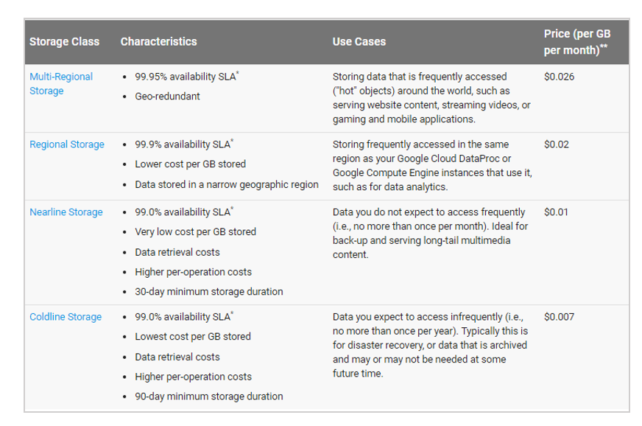

Create a Bucket
- Select the project in which storage must be created. Browse to storage option from products and service list. Select storage
- Select create a bucket. Bucket is a container to hold unstructured data in cloud storage. This can be used to serve static data directly or store data as a repository.
- Name your bucket.
- Bucket names are unique across universal namespace of cloud storage. Naming conventions:
  - A bucket name can contain lowercase alphanumeric characters, hyphens, and underscores.
  - It can contain dots (.) if it forms a valid domain name with a top-level domain (such as .com).
  - Bucket names must start and end with an alphanumeric character

Upload Objects
Once the bucket is created, click on bucket name which further connects us to upload objects. Objects are granular level of data files. Files can be of any size, any type which goes into storage.
- Click on create folder and create folders based on the need
- Click on upload files and upload them
- Upload status is also shown during the process. All files uploaded by default will not be accessible to public.

Granting Permissions
- To access the objects from browser, every object must be shared publicly. There will be a URL generated for public access which can be clicked or shared with customers.
- Edit permissions or metadata as required, also permissions can be edited for every file. Few more operations like copy, move, rename a file can be done based on user's need.
- Access file on browser

Data Transfer and More operations
Data transfer service from GCP is used to transfer your data securely and quickly to google cloud.
You can transfer data either from your on-premise environment to GCP cloud or from an another CSP to GCP cloud.
Based on the amount of data and the internet speed, you can opt for one or more data transfer service from below.
- Online transfer
- Using transfer service
- Using transfer appliance
- Through Big Query Data Transfer Service

Organization leverage cloud services to migrate data center to cloud, to backup and archive data, to decommission on-premises tape storage, to analyze data using big query, to improve the performance of application by reducing latency, etc.,

Features of Data transfer
- It is simple to configure because of its easy to use user interface
- It is a reliable service as it ensures your content is transferred correctly
- Scheduling of data transfer jobs are made easy
- It is highly scalable, as the transfer appliance can capture up to petabyte of data
- Encryption of data is made thus ensuring security

Use Cloud Storage from GCP to establish a low-cost storage infrastructure with access control
Using Cloud Storage service, Projects can configure unlimited storage capacity which supports key-value based object storage with access control

Google Cloud Storage is unified object storage for developers and enterprises, from live data serving to data analytics/ML to data archiving. It offers a simple web service interface to store and retrieve any amount of data, at anytime from anywhere on the web. It is cloud storage for all critical data.

Though storage is a global service, buckets can be created within regions that you choose. This helps in optimizing latency, minimize cost and address regulatory requirements.

Few features of storage buckets are listed below:
- You can control who has access to storage buckets and to what level
- Google storage encrypts your data in server side before it is written or stored
- By enable versioning, an archived version of object is created each time object is overwritten or deleted
- You can manage the lifecycle of object by specifying rules to it
- You can import online data into cloud storage, you can also transfer data within cloud storage buckets

To provide the granular access permission to buckets and objects on specific user(s), Cloud storage provides various options:
- Identity and Access Management (IAM) permissions: grant bulk access to bucket's object
- Access Control Lists (ACLs): grant fine-grained control over objects
- Signed URLs (query string authentication): grant time-limited access to bucket and objects
- Signed Policy Document: to specify upload characteristics to a bucket
As per Project’s requirement, ACLs will be used to manage access permission to specific user on specific objects.

Access Control List
IAM permission is used to give bulk access to your project and bucket but not fine-grained control over individual objects. It is recommended for controlling access to your resources. ACLs are best fit to customize objects within buckets by granting read or write access to users.

In Cloud Storage ACLs are used to define user access level to objects and buckets. Bucket and object ACLs are independent of each other, which means that the ACLs on a bucket does not affect the ACLs on objects. ACLs has entries, which gives specific users to perform specific action. It consists of:
- Permissions
- Scopes
Permission describes the actions to be performed on an object/bucket.
Scopes referred as grantee, allows the user or group to perform specified actions.

ACLs are categorized to two types:
- Default: bucket created with default ACL has predefined project private ACL applied to it which gives additional permission to project team members
- Predefined: also called as 'canned' ACL used to apply many entries to a specific bucket or object

Create and Manage ACL
Highlights:
- Use ACLs to define access to your buckets and objects
- Bucket ACLs are copied to object ACLs by default. Setting ACLs is required if existing permissions needs to be modified.

Navigate to Storage and select bucket to get the URL of specific object of which ACLs are to be defined as per Project's requirement.
Navigate to object whose ACLs you want to modify.

Useful Links
Using Network Topology
Running connectivity tests
Codelab to Setup Network and HTTP Load Balancers
Codelab on Networking
Setting Up Cloud CDN
Protect Your Network with Cloud NAT

