Explore Core Data Concepts 2
How is data defined, stored, and accessed in cloud computing? 2
What is an analytical system? 2
• Data Ingestion: 2
• Data Transformation/Data Processing: 2
• Data Querying: 3
• Data Visualization: 3
Identify types of data and data storage 3
Describe transactional workloads: 3
• Atomicity 3
• Consistency 3
• Isolation 3
• Durability 3
Describe analytical workloads 4
Explore Relational Data in Azure 8

Explore Core Data Concepts

How is data defined, stored, and accessed in cloud computing?

You can provision other services as well in Azure. For example, if you want to store unstructured data such as video or audio files, you can use Azure Blob storage (Blob is an acronym for Binary Large Object). If you want to store semi-structured data such as documents, you can use a service such as Azure Cosmos DB.

After your service is provisioned, the service needs to be configured so that users can be given access to the data. You can typically define several levels of access.
- Read-only access means the users can read data but can't modify any existing data or create new data.
- Read/write access gives users the ability to view and modify existing data.
- Owner privilege gives full access to the data including managing the security like adding new users and removing access to existing users.

What is an analytical system?
In contrast to systems designed to support OLTP, an analytical system is designed to support business users who need to query data and gain a big picture view of the information held in a database.

Analytical systems are concerned with capturing raw data using it to generate insights. An organization can use these insights to make business decisions. For example, detailed insights for a manufacturing company might indicate trends enabling them to determine which product lines to focus on, for profitability.

Most analytical data processing systems need to perform similar tasks: data ingestion, data transformation, data querying, and data visualization. The image below illustrates the components in a typical data processing system.

- Data Ingestion: Data ingestion is the process of capturing the raw data. This data could be taken from control devices measuring environmental information such as temperature and pressure, point-of-sale devices recording the items purchased by a customer in a supermarket, financial data recording the movement of money between bank accounts, and weather data from weather stations. Some of this data might come from a separate OLTP system. To process and analyze this data, you must first store the data in a repository of some sort. The repository could be a file store, a document database, or even a relational database.
- Data Transformation/Data Processing: The raw data might not be in a format that is suitable for querying. The data might contain anomalies that should be filtered out, or it may require transforming in some way. For example, dates or addresses might need to be converted into a standard format. After data is ingested into a data repository, you may want to do some cleaning operations and remove any questionable or invalid data, or perform some aggregations such as calculating profit, margin, and other Key Performance Indicators (KPIs). KPIs are how businesses are measured for growth and performance.
- Data Querying: After data is ingested and transformed, you can query the data to analyze it. You may be looking for trends or attempting to determine the cause of problems in your systems. Many database management systems provide tools to enable you to perform ad-hoc queries against your data and generate regular reports.
- Data Visualization: Data represented in tables such as rows and columns, or as documents, aren't always intuitive. Visualizing the data can often be useful as a tool for examining data. You can generate charts such as bar charts, line charts, plot results on geographical maps, pie charts, or illustrate how data changes over time. Microsoft offers visualization tools like Power BI to provide rich graphical representation of your data.

Identify types of data and data storage

You can categorize data in many ways, depending not only on how it's structured, but also on how the data is used. In this unit, you'll learn about the characteristics of different types of data.

Relational databases provide probably the most well-understood model for holding data. The simple structure of tables and columns makes them easy to use.

Non-relational databases enable you to store data in a format that more closely matches the original structure.

Describe transactional workloads:
A transaction is a sequence of operations that are atomic. This means that either all operations in the sequence must be completed successfully, or if something goes wrong, all operations run so far in the sequence must be undone.

A transactional database must adhere to the ACID (Atomicity, Consistency, Isolation, Durability) properties to ensure that the database remains consistent while processing transactions.
- Atomicity guarantees that each transaction is treated as a single unit, which either succeeds completely, or fails completely. If any of the statements constituting a transaction fails to complete, the entire transaction fails, and the database is left unchanged. An atomic system must guarantee atomicity in each situation, including power failures, errors, and crashes.
- Consistency ensures that a transaction can only take the data in the database from one valid state to another. A consistent database should never lose or create data in a manner that can't be accounted for. In the bank transfer example described earlier, if you add funds to an account, there must be a corresponding deduction of funds somewhere, or a record that describes where the funds have come from if they have been received externally. You can't suddenly create (or lose) money.
- Isolation ensures that concurrent execution of transactions leaves the database in the same state that would have been obtained if the transactions were executed sequentially. A concurrent process can't see the data in an inconsistent state (for example, the funds have been deducted from one account, but not yet credited to another.)
- Durability guarantees that once a transaction has been committed, it will remain committed even if there's a system failure such as a power outage or crash.
Database systems that process transactional workloads are inherently complex. They need to manage concurrent users possibly attempting to access and modify the same data at the same time, processing the transactions in isolation while keeping the database consistent and recoverable. Many systems implement relational consistency and isolation by applying locks to data when it is updated.

Transactional information, however, is an integral part of analytical information. If you don't have good records of daily sales, you can't compile a useful report to identify trends. That’s why efficient handling of transactional information is very important.

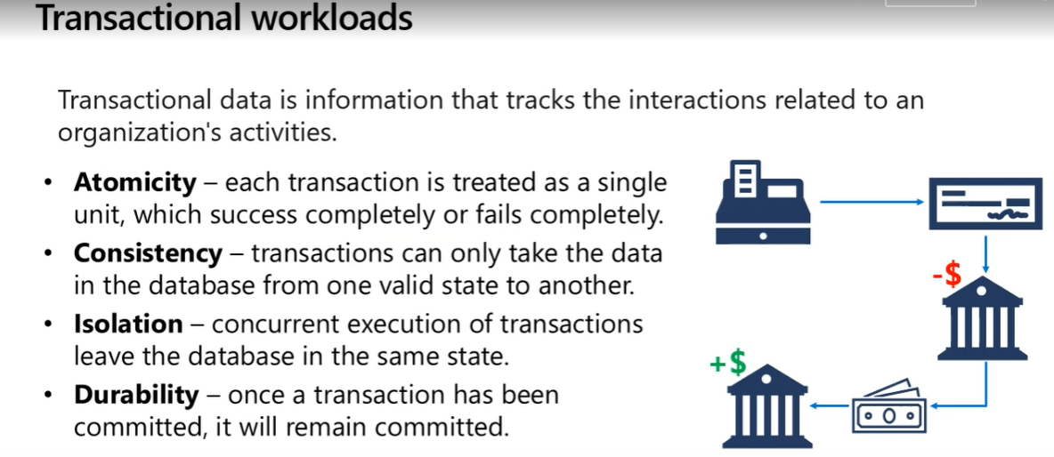

Describe analytical workloads

Analytical workloads are typically read-only systems that store vast volumes of historical data or business metrics, such as sales performance and inventory levels. Analytical workloads are used for data analysis and decision making.

Analytics can be based on a snapshot of the data at a given point in time, or a series of snapshots.

Analytical workloads are summaries, trends, and other kinds of “Business information.”

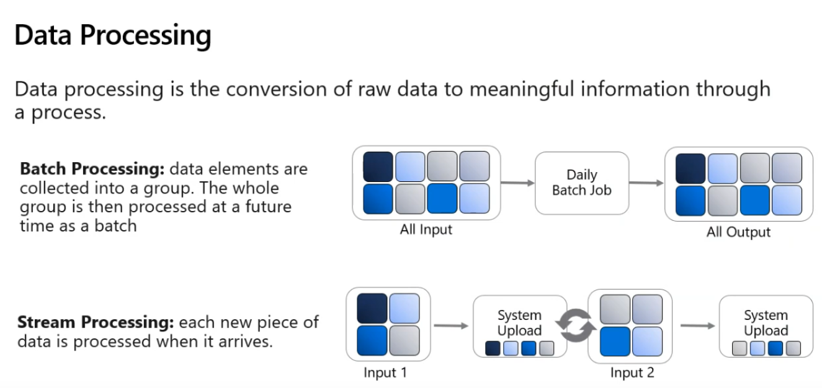

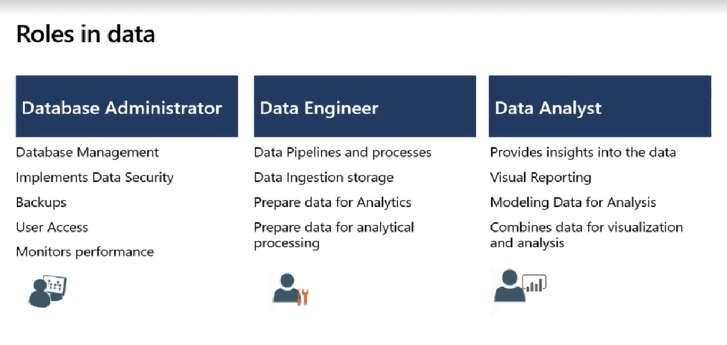

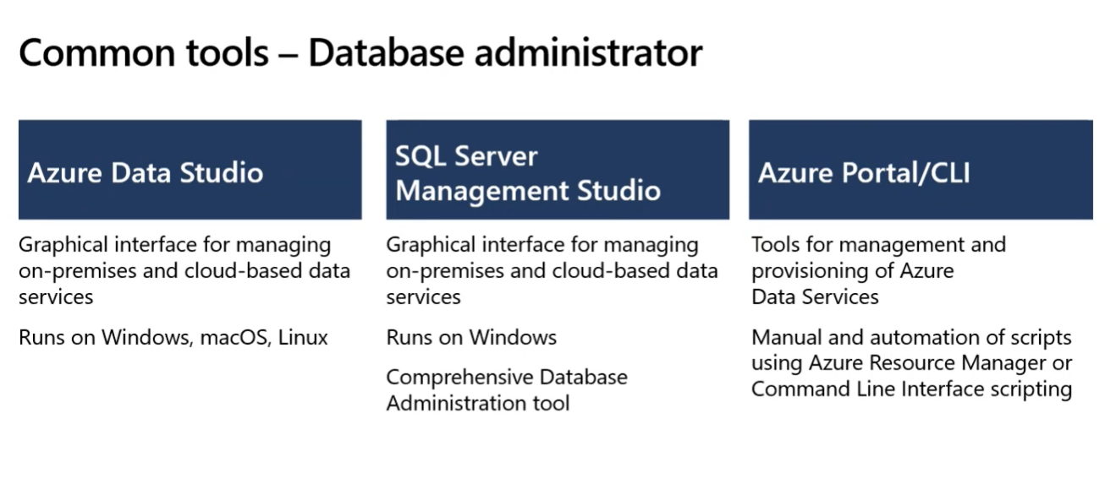
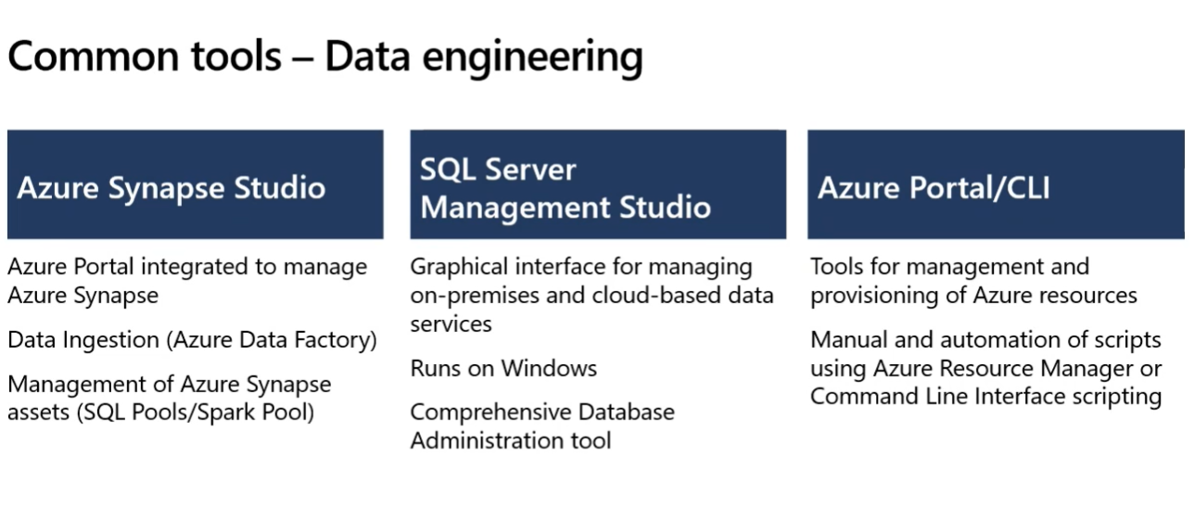
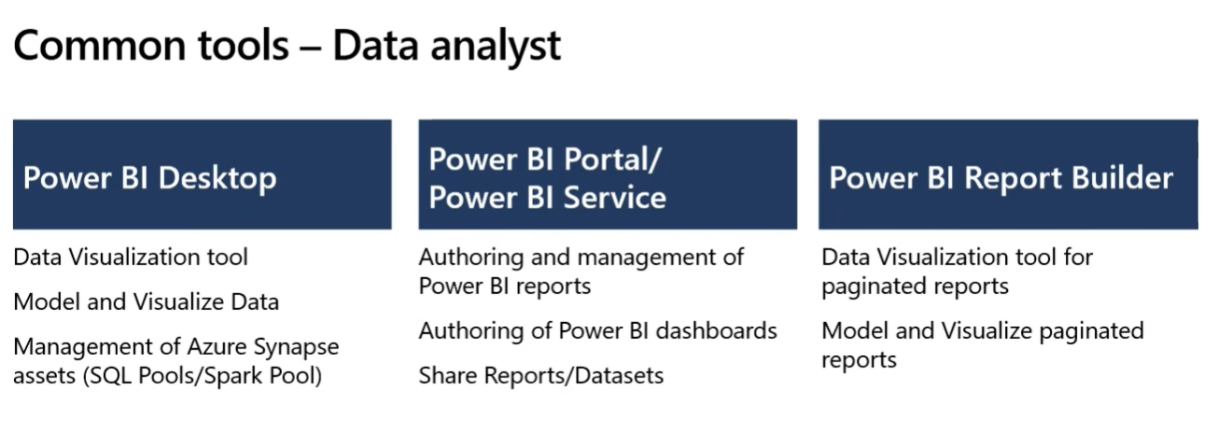

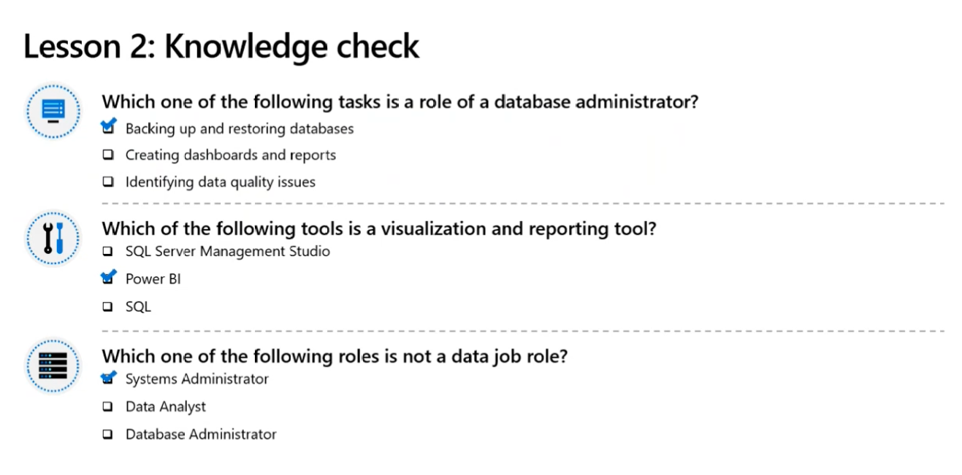

Explore Relational Data in Azure

