To verify Java installation, Open command prompt and type “java -version”, it should show the following output Otherwise install Open JDK 11.0.1 from Software house

Update/set Java Home and path variables like below in command prompt (for me java installed in D drive):
set JAVA_HOME = D:\Java\jdk-11.0.1
set PATH = %PATH%; D:\Java\jdk-11.0.1\bin

OR

Using Environment variable:

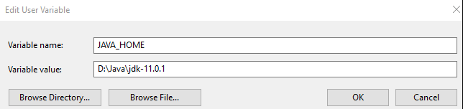

Download spark from Downloads | Apache Spark and extract it.
- Choose spark release as 3.0.2 (if JDK 11 is installed) or 2.4.8 (if you have JDK 8 installed in your machine)
- Choose package type as “pre-built for Apache Hadoop 2.7”
Download Anaconda3-5.3.0-Windows-x86_64.exe from Index of / (anaconda.com) Or install python3.7 from software house
Update/set the variables using command prompt using below commands
set SPARK_HOME = D:\spark\spark-3.1.2-bin-hadoop2.7
set HADOOP_HOME = D:\spark\spark-3.1.2-bin-hadoop2.7
set PATH=%PATH%; D:\spark\spark-3.1.2-bin-hadoop2.7\bin
set PYSPARK_DRIVER_PYTHON=jupyter
set PYSPARK_DRIVER_PYTHON_OPTS=notebook
set PYTHON_HOME = C:\Users\rajeev.suravajhula\AppData\Local\Continuum\anaconda3

set PYSPARK_PYTHON = C:\Users\rajeev.suravajhula\AppData\Local\Continuum\anaconda3\python.exe

Please verify the following path exist (where anaconda installed) in your environment variable “PATH”
C:\Users\rajeev.suravajhula\AppData\Local\Continuum\anaconda3
C:\Users\rajeev.suravajhula\AppData\Local\Continuum\anaconda3\Library\mingw-w64\bin
C:\Users\rajeev.suravajhula\AppData\Local\Continuum\anaconda3\Library\usr\bin
C:\Users\rajeev.suravajhula\AppData\Local\Continuum\anaconda3\Library\bin
C:\Users\rajeev.suravajhula\AppData\Local\Continuum\anaconda3\Scripts
C:\Users\rajeev.suravajhula\AppData\Local\Continuum\anaconda3\python.exe

Add %JAVA_HOME%\bin as well

Download winutils.exe from the following location and place it in %SPARK_HOME%\bin folder (for me it will be D:\spark\spark-3.1.2-bin-hadoop2.7\bin)
winutils/winutils.exe at master · steveloughran/winutils · GitHub

open a new command prompt and execute command pyspark to launch pyspark shell, it will open jupyter notebook, like belwo

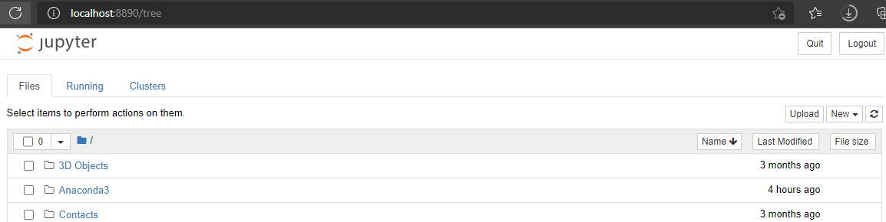

Click on new and then select python3 it will open a jupyter notebook where we can practice spark.

