

**Robotic Process Automation**

Calculator Automation

Development Specifications Document – (DSD)

Contents

1. Document Overview 4

2. Automated Master Project details 4

3. Runtime Guide 5

3.1 Runtime diagram [Architectural structure of the Master Project] 5

3.2 List of packages 5

3.3 Master Project Runtime details 6

4. Project details 6

4.1 Project Name: 7

5. Other Details 8

5.1 Future improvements: 8

5.2 Debugging tips: 8

5.3 Other Remarks: 8

6. Post UAT specifications 8

7. Glossary 9

Document History

|  |  |  |  |  |  |  |
| --- | --- | --- | --- | --- | --- | --- |
| Date | Version | Role | Name | Organization  Department | Function | Comments |
| 12-04-2022 | 1.0 | AUTHOR | *Rajeev* | *Finance* | *Senior Developer* |  |

Version Control

|  |  |  |  |  |  |  |
| --- | --- | --- | --- | --- | --- | --- |
| Date | Version | Role | Name | Organization  Department | Function | Comments |
| 12-04-2022 | 1.0 | Author | A |  | Developer |  |
| 12-04-2022 | 1.0 | Peer Reviewer | B |  | Developer |  |
| 12-04-2022 | 1.0 | Reviewer | C |  | Developer |  |
| 13-04-2022 | 1.0 | Approver | D |  | Project Lead |  |

## Document Overview

The Development Specifications Document (DSD) is created for every business process that is automated using the RPA technology. The DSD document needs to be reviewed and updated for every change requested and applied to the automation process. This document will provide a technical snapshot and must always reflect the latest design and key features of the automated workflow.

The document naming convention will follow the naming convention and the version of the automated process. This can be “business process name version” or it can be defined, case by case, as part of the larger RPA project design.

This document is filled in by the RPA Solution Architect and RPA Developer who automates the business process and reviewed by the RPA Solution Architect prior to handover to RPA Operations.

The purpose of the document is to record the outcome specific to the automated master project and its subcomponents: projects, workflows, sequences etc.

This document is meant for the RPA COE, IT Support and RPA supervisor to help by providing a snapshot of the automated process details and components. It can as well serve developers to have a quick glance at the setup, before diving into the code, to troubleshoot or update changes.

## Automated Master Project details

Details filled in by the developer reflect the actual information for the master project released for production.

|  |  |  |
| --- | --- | --- |
| # | Item | Details  (Fill in with free text. If not applicable, mark the field as “n/a. No empty fields.) |
| **1** | **Master project name and version** | CalculatorAutomation_1.0 |
| **2** | **Robot type**  **(specify if the process was automated for FOR or BOR or mix)** | Front Office Robot(FOR) |
| **3** | **Is Orchestrator used?** (Yes/ No) | YES |
| **4** | **Scalable?** (Yes/ No)  (can the process be run by multiple robots in parallel) | YES |

## Runtime Guide

### Runtime diagram [Architectural structure of the Master Project]

Display the interaction between components (package / robots, Orchestrator queues, and running

order).

*Add diagram below:*

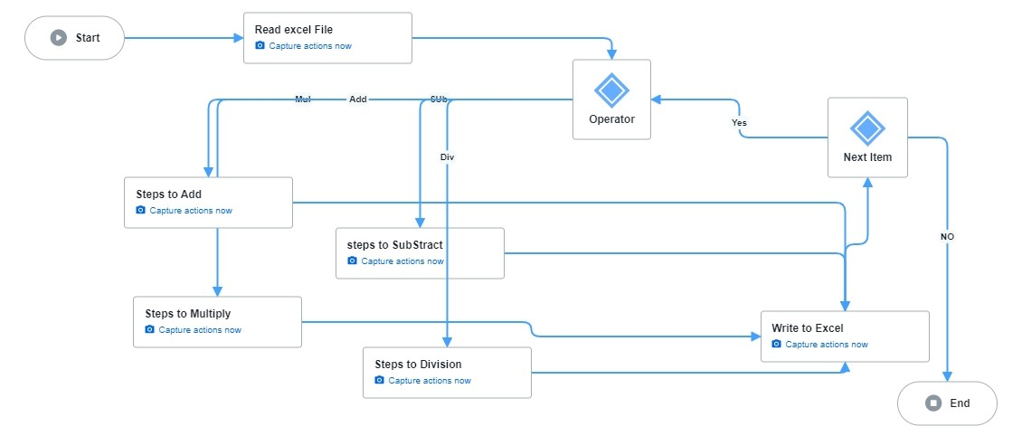

### List of packages

Include **the list of packages and the high level description** for each of them, to explain each one`s purpose :

|  |  |  |
| --- | --- | --- |
| # | Package name | High Level description |
| 1 | CalculatorAutomation_1.0.nupkg | 1.Reads the excel file from Input Folder  2.process the data based on the request  3.send the result file to recipient mail |
| 2 |  |  |

*\*Add more rows to the table to include all the project names and version. No fields should be left empty. Use “n/a” for the items that don`t apply to your project.*

### Master Project Runtime details

Details of the automated process:

|  |  |  |
| --- | --- | --- |
| # | Item | Details  (Fill in with free text. If the section does not apply to your automation, mark the field as “n/a”. No empty fields. ) |
| **1** | **Production environment details** | Runs Everyday |
| **2** | **Prerequisites to run** | Having Excel on the Machine |
| **3** | **Input Data** | Excel file |
| **4** | **Expected Output (output data)** | Excel |
| **5** | **How to start the automated process?** | From the Orchestrator |
| **6** | **Resuming the process from a particular step** | NO |
| **7** | **Reporting**  (queues reporting, Kibana or another platform) | Orchestrator logs and Jobs Dashboard |
| **8** | **Manual Error Handling**  (roll back or manually complete failed transactions). Procedures to reset the item. Ex “set status as investigating” | In case of error the process can be restart |
| **7 a. How to resume the process in case of error** |  |
| **7 b. How to manually fix transactions with error** |  |
| **9** | **Use of Orchestrator** | yes |
| **Password policies**  (specific compliance requests?) |  |
| **Stored Credentials:**  (Never hardcode credentials in the workflow) |  |
| **List of Asset Names:**  (Follow naming convention ProcessName_AssetName) |  |
| **List of Queues Names**  (Follow naming convention ProcessName_QueueName) |  |
| **Schedule details:** | Daily,8:00 am IST |
| **10** | **Multiple resolutions supported**  (in case of image automation/ Citrix) | N/a |
| **Recommended resolution** | N/a |

## Project details

In this section describe all the projects that compose the automated process.

For each project, describe the workflow(s) in the logical order that they are called in.

If the workflow is a flowchart, also include the exported image from Studio.

**If the automated process is composed of multiple projects, copy paste and fill in the table below for each project with its specific details *(Sections 4.1 ; Section 4.2 etc)***

### Project Name: {Calculator}

*Add to the title of this section the actual project name of the automated process.*

|  |  |  |
| --- | --- | --- |
| # | Item name | Details  (Fill in with free text. If not applicable, mark the field as “n/a. No empty fields.) |
| **1** | **Environment used for development**  (name, location, configuration details etc) | UiPath Studio |
| **2** | **Environment prerequisites**  (OS details, libraries, required apps) | Windows10 , Excel |
| **3** | **Logging level** | Info |
| **4** | **Details about automation** (if the apps were automated using UI Automation, Image & Text) | Calculator Automation |
| **5** | **In case of FOR, can the user operate the computer while the robot is running?** | YES |
| **6** | **Repository for project**  (where the developed project is stored) | https://github.com/RajeevEngile/Documentation-Process.git |
| **7** | **List of reused components** | Send Email |
| **8** | **Custom logs defined in the workflows**  **(**where Throw Activity was used or custom log message was defined**)** | 1.Corrupted File  2.Source Missing |
| **9** | **Frequent errors found in the development phase** |  |
| **10** | **Workarounds used in the automation phase** |  |
| **11** | **Configuration method**  (assets, excel file, Json file) |  |
| **12** | **Configuration details**  (path for input files, configuration Orchestrator assets used) |  |
| **13** | **Workflow File Export List**  (Use this [TOOL](https://drive.google.com/open?id=0B_Ti7JQEeRYvS3ktRHJiUzhJa0U)) |  |

#### Workflow(s) specific to {Project name}

*Add to the title of this section the actual project name to which the workflows are specific to. The name should normally coincide with the Project name mentioned at Section 4.1*

Define below all the workflow files ( xaml files) used in the project, with the Input and Output data.

|  |  |  |  |  |
| --- | --- | --- | --- | --- |
| # | Workflow file name | Description | Input Argument | Output Argument |
| 1 | Main | Invoke Other workFlows | Excel | Excel |
| 2 |  |  |  |  |
| 3 |  |  |  |  |
| 4 |  |  |  |  |
| 5 |  |  |  |  |
| 6 |  |  |  |  |
| 7 |  |  |  |  |
| 8 |  |  |  |  |
| 9 |  |  |  |  |
| 10 |  |  |  |  |

*\*Add more rows to the table to include all the workflow file names. No fields should be left empty. Use “n/a” for the items that don`t apply to your project.*

*If the workflow is a flowchart, also include below the exported image from Studio.

**Start the list with the one that will run by default when the package is executed.

## Other Details

### Future improvements:

### Debugging tips:

### Other Remarks:

## Post UAT specifications

**Average duration per transaction**: (varies depending on the Test environment) :

**Recommended number of robots for the specified volumes**:

**Specified schedule**:

## Glossary

**Master project** - the overall output of the development, containing one or multiple projects that together cover the scope of the robotic process automation.

**Project** - an UiPath Studio project containing one or multiple workflow files. A project can be converted to a package and run independently, covering a particular scope within the master project. The project is used when defining the development and support phase of the automation.

**Package** - the output of compiling a project. A package can be deployed on the robot machine and be executed by the robot service. Only one package can be executed at a given time by a robot. The package is used when defining the running phase of the automation

**Workflow** - a component of the package, the workflow encapsulates a part of the project logic. The workflow can be of type: sequence, flowchart or state machine. a workflow is saved as an .xaml file inside the project folder. A workflow file can be invoked from another workflow and by default there is an initial workflow file that will run when executing the package.

**Activity** - an action that the robot executes.

**Sequence** - a workflow where activities are executed one after another, in a sequential order

**Flowchart** - a workflow where activities are connected by arrows and the logic of the workflow can be easily followed in a visual manner. The flowchart can also be exported as an image from UiPath studio

**State machine** - a more advanced way of organizing a workflow, similar to a flowchart.

**BOR** - Back office robot

**FOR** – Front office robot

**Orchestrator** – Enterprise architecture server platform supporting: release management, centralized logging, reporting, auditing and monitoring tools, remote control, centralized scheduling, queue/robot workload management, assets management.