

**TRIPLOCK**

**SUBJECT: INT-402(project)**

**SUBMITTED BY:**

**MARUMUDI RAJEEV (RKE178B40)**

**MALLAMPATI NUTAN KUMAR REDDY (RKE178B28)**

**ADAPA MIDHUN (RKE178B30)**

**BATTULA GANESH SAI PAVAN (RKE178B26)**

**SUBMITTED TO:**

**Ms. ANKITA WADHAWAN (UID: 23891)**

**CONTENTS**

* INTRODUCTION
* BRIEF DESCRIPTION ABOUT PROJECT
* EVERY WEBFORM DESCRIPTION
* FUNCTIONAL REQUIREMENTS
* CONCLUSION

**INTRODUCTION**

.NET is a developer platform made up of tools, programming languages, and libraries for building many different types of applications. ASP.NET extends the .NET developer platform with tools and libraries specifically for building web apps. ASP.NET supports industry standard authentication protocols. Built-in features help protect your apps against cross-site scripting (XSS) and cross-site request forgery (CSRF). ASP.NET provides a built-in user database with support for multi-factor authentication and external authentication with Google, Twitter, and more.

So, we as a group of four members, made a web application named “TripLock”. TripLock is a travel and tourism based web application and it’s features are discussed in the coming sections. This project is done in MicroSoft Visual Studio 2012.

**BRIEF DESCRIPTION**

Making of TripLock is divided into 4 parts. They are: 1) Master Page

2) Webforms

3) C#

4) Database

Here Master Page is the main page and all the design part which is set to be constant is designed in the master page with HTML and CSS being used. Webforms are derived from the master page and design is made using the inbuilt tools in the Visual Studio 2012. C# code is used for linking the webforms and giving functionality to the tools and properties used in the design phase. Database used in this project is MySQL and it is used for user authentication during Sign Up and Login. This is the basic description of the project. We’ll see step by step description now.

**STEP BY STEP DESCRIPTION**

The webforms present in TripLock are Home.aspx, Places.aspx, PlanVacation.aspx, Hotels.aspx, Login.aspx, Signup.aspx, Contact.aspx and Billing.aspx and Travel.master which is a Master Page.

**Home.aspx:**

Home.aspx is linked with master page and it is very normally designed. This page is done using basic visual studio design.

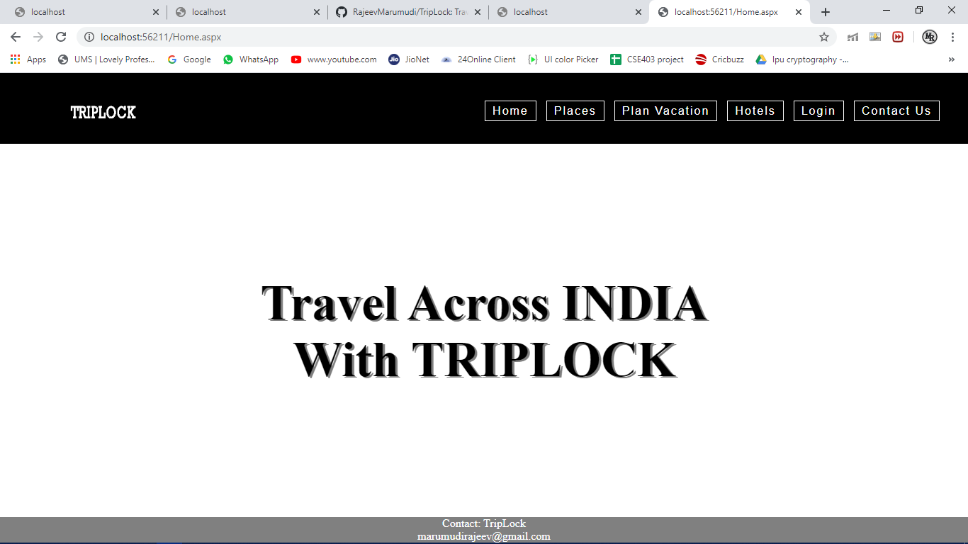

Fig 1. Home.aspx

**Places.aspx:**

Places.aspx is also linked with master page and it comprises of tourist places and packages in it. This page is done using basic visual studio design and functioned using C#.

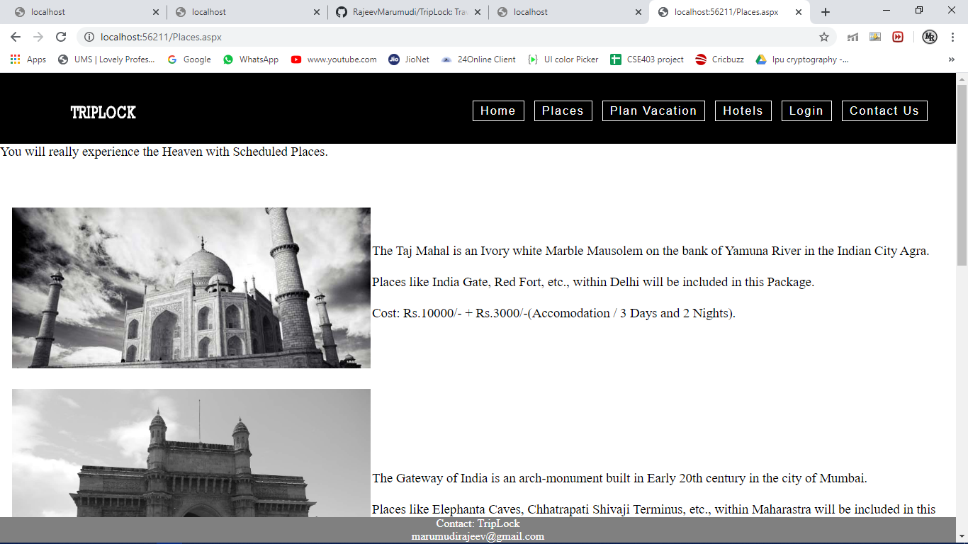

Fig 2. Places.aspx

**Hotels.aspx:**

Places.aspx is also linked with master page and it comprises of Hotels and packages in it. This page is done using basic visual studio design and functioned using C#.

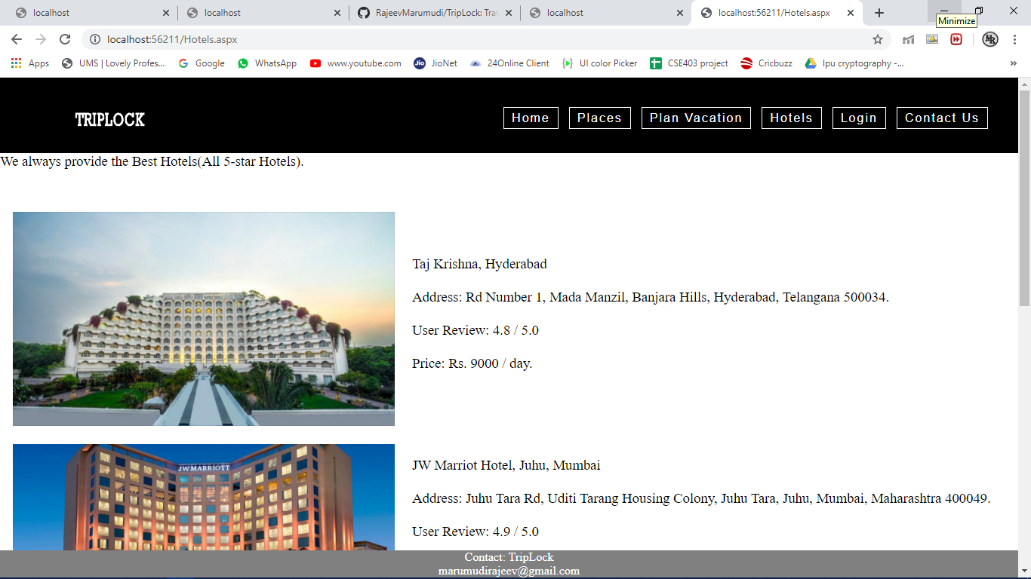

Fig 3. Hotels.aspx

**PlanVacation.aspx:**

Plan.aspx comprises of planning a vacation and it is directed to Billing.aspx. This page is done using basic visual studio design and functioned using C#.

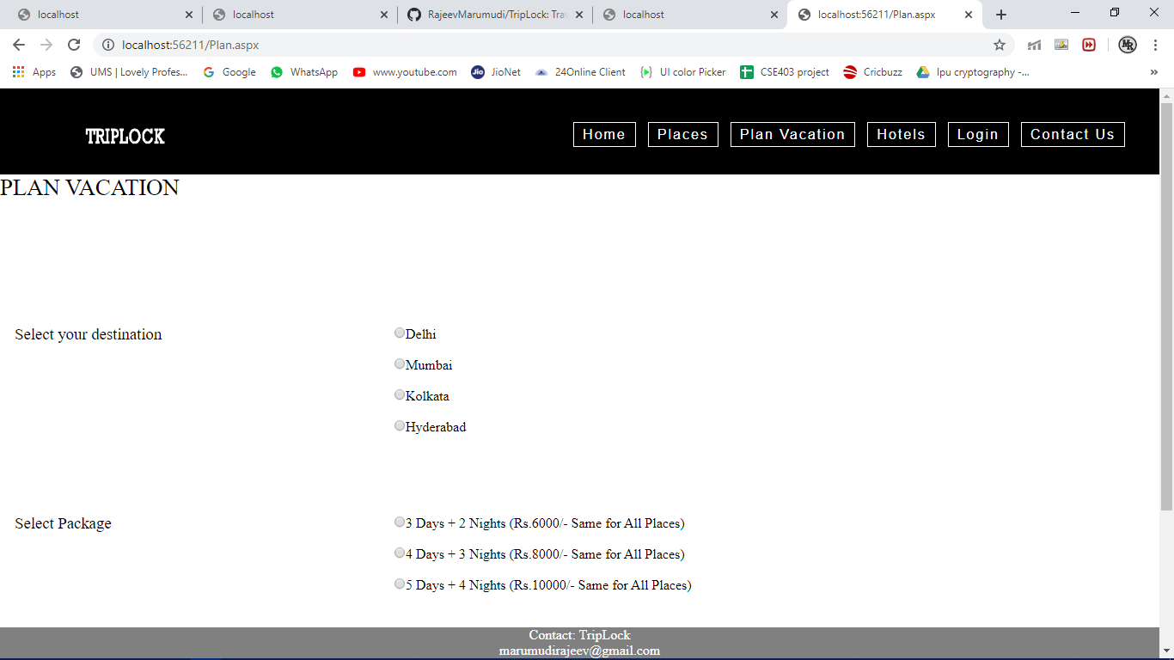

Fig 4. PlanVacation.aspx

**Login.aspx:**

Login.aspx comprises of email and password with two text boxes and Database DB.mdf with table UserInfo used to authenticate the user’s credentials.

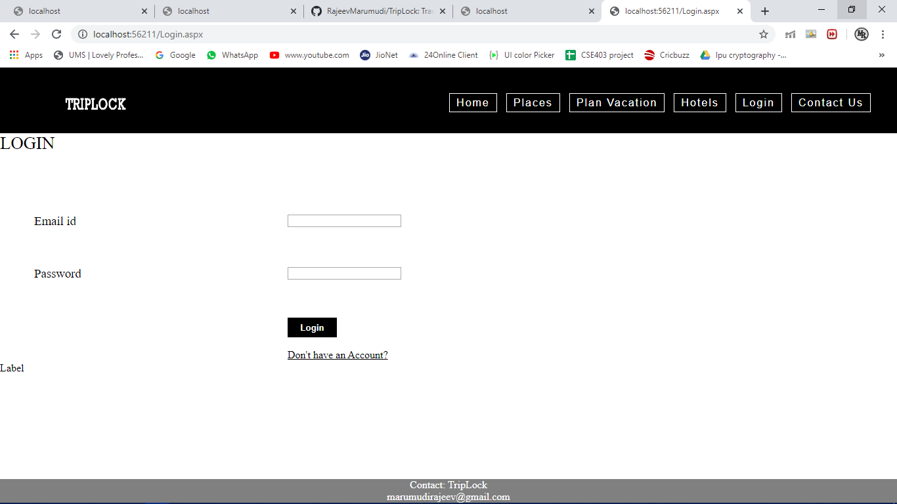

Fig 5. Login.aspx

**SignUp.aspx:**

SignUp.aspx comprises of full name, email, phone number, password with two text boxes and Database DB.mdf with table UserInfo to insert the data which is used to authenticate the user’s credentials.

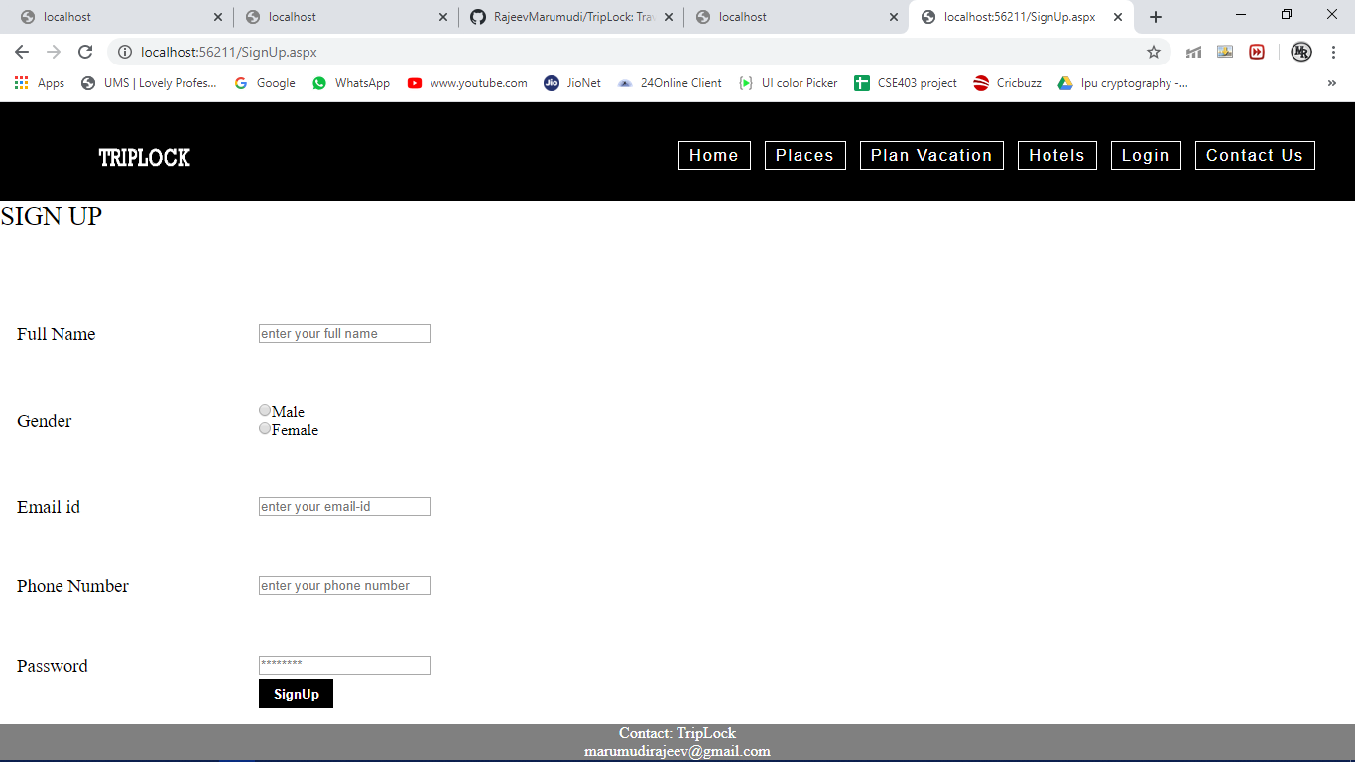

Fig 6. SignUp.aspx

**Contact.aspx:**

Contact.aspx is provided with developers contact information.

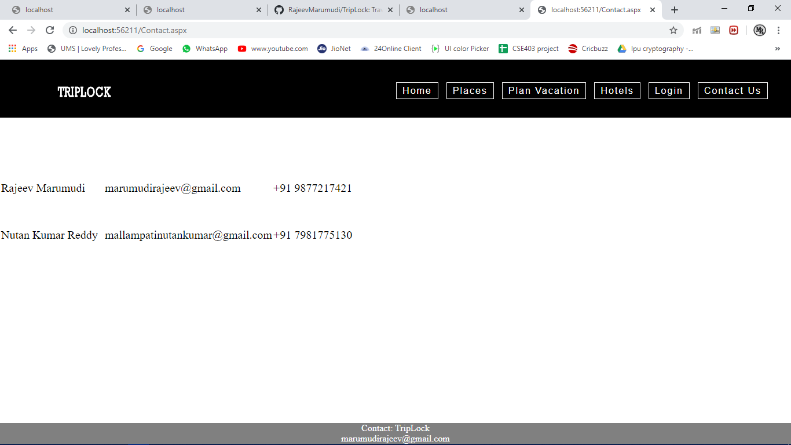

Fig 7. Contact.aspx

This is all about the Step by Step Development of the project.

**FUNCTIONAL REQUIREMENTS**

* Microsoft Visual Studio 2012
* Database(MySQL)
* HTML(Master Page)
* CSS(Master Page)
* Visual Studio Asp.Net ToolBox

**CONCLUSION**

As we come to conclusion, we come to know that Asp.Net and Microsoft Visual Studio are user friendly and we can develop user friendly web applications. When it comes to TripLock, this is also user friendly and there are many areas of improvement needed to make TripLock a compatible application.