Full deep learning CNN
https://medium.com/thedeephub/convolutional-neural-networks-a-comprehensive-guide-5cc0b5eae175
https://www.analyticsvidhya.com/blog/2018/12/guide-convolutional-neural-network-cnn/
https://medium.com/@alejandro.itoaramendia/convolutional-neural-networks-cnns-a-complete-guide-a803534a1930

Table of contents
- What are Convolutional Neural Networks?
- Convolutional layers
- Channels
- Stride
- Padding
- Pooling Layers
- Flattening layers
- Activation functions in CNNs

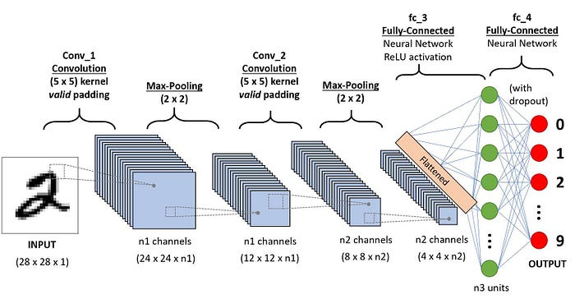
Introduction
Convolution neural networks are fundamental for image analysis.
They are crucial for interpreting visual data, whether it’s for image classification, object detection or even medical image analysis.
Following a unique architectural design, CNNs are a special type of neural network composed of three primary layers: the convolutional layer, the pooling layer and the fully connected layer.
- Convolutional layer: Using filters or kernels, this layer finds local patterns and features from the input image.
- Pooling layer: This layer downsamples the spatial dimensions of the input, reducing the network’s computational complexity and increasing its ability to recognise patterns regardless of scale and position.
- Fully Connected layer: This layer integrates previously extracted features into a traditional neural network, in efforts to learn global relationships and generate task-specific outputs.
By implementing multiple convolutional and pooling layers, the network is able to learn deeper and more abstract features in regards to the input image. Following these layers with a fully connected layer, the network is able to learn global dependencies, as well as complex patterns through non-linear activation functions.

Convolutional Neural Networks (ConvNets or CNNs) are a category of Neural Networks that have proven very effective in areas such as image recognition and classification. ConvNets have been successful in identifying faces, objects and traffic signs apart from powering vision in robots and self driving cars.
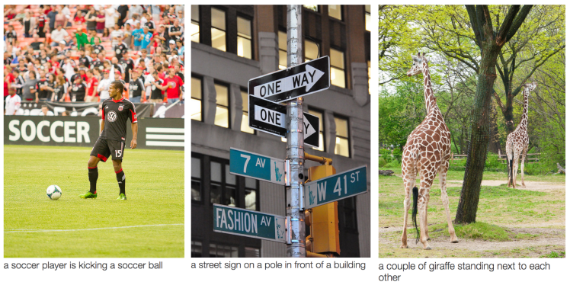
Figure 1: Source [1]
In Figure 1 above, a ConvNet is able to recognize scenes and the system is able to suggest relevant captions (“a soccer player is kicking a soccer ball”) while Figure 2 shows an example of ConvNets being used for recognizing everyday objects, humans and animals. Lately, ConvNets have been effective in several Natural Language Processing tasks (such as sentence classification) as well.
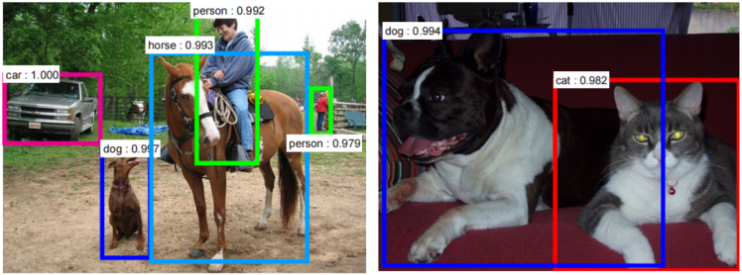
Figure 2: Source [2]
ConvNets, therefore, are an important tool for most machine learning practitioners today. However, understanding ConvNets and learning to use them for the first time can sometimes be an intimidating experience. The primary purpose of this blog post is to develop an understanding of how Convolutional Neural Networks work on images.
An Image is a matrix of pixel values
Essentially, every image can be represented as a matrix of pixel values.

Channel is a conventional term used to refer to a certain component of an image. An image from a standard digital camera will have three channels – red, green and blue – you can imagine those as three 2d-matrices stacked over each other (one for each color), each having pixel values in the range 0 to 255.
A grayscale image, on the other hand, has just one channel. For the purpose of this post, we will only consider grayscale images, so we will have a single 2d matrix representing an image. The value of each pixel in the matrix will range from 0 to 255 – zero indicating black and 255 indicating white.
Convolutional Neural Networks, commonly referred to as CNNs are a specialized type of neural network designed to process and classify images.
If you are new to this field you might be thinking how is it possible to classify an image?
Well… images are also numbers!
Digital images are essentially grids of tiny units called pixels. Each pixel represents the smallest unit of an image and holds information about the color and intensity at that particular point.
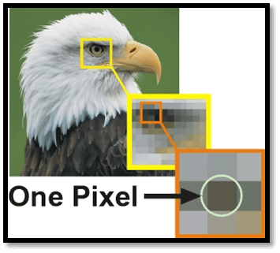
Typically, each pixel is composed of three values corresponding to the red, green, and blue (RGB) color channels. These values determine the color and intensity of that pixel.
You can use the following tool to understand better how the RGB vector is formed:
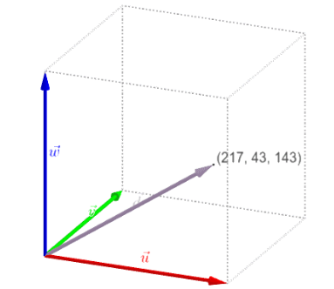
In contrast, in a grayscale image, each pixel carries a single value that represents the intensity of light at that point.
Usually ranging from black (0) to white (255).
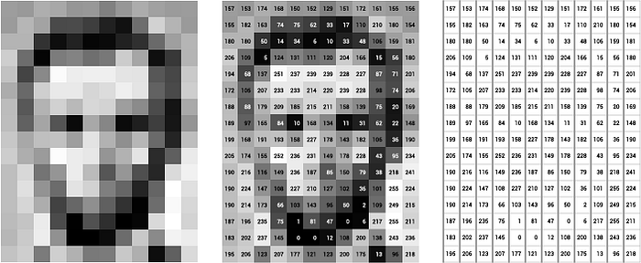

Computer Vision
Some of the computer vision problems which we will be solving in this article are:
- Image classification
- Object detection
- Neural style transfer
One major problem with computer vision problems is that the input data can get really big. Suppose an image is of the size 68 X 68 X 3. The input feature dimension then becomes 12,288. This will be even bigger if we have larger images (say, of size 720 X 720 X 3). Now, if we pass such a big input to a neural network, the number of parameters will swell up to a HUGE number (depending on the number of hidden layers and hidden units). This will result in more computational and memory requirements – not something most of us can deal with.
Edge Detection Example
In the previous article, we saw that the early layers of a Convolutional neural networks detect edges from an image. Deeper layers might be able to detect the cause of the objects and even more deeper layers might detect the cause of complete objects (like a person’s face).
In this section, we will focus on how the edges can be detected from an image. Suppose we are given the below image:

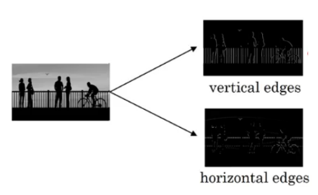
Vertical and Horizontal Edges
As you can see, there are many vertical and horizontal edges in the image. The first thing to do is to detect these edges:
But how do we detect these edges? To illustrate this, let’s take a 6 X 6 grayscale image (i.e. only one channel):
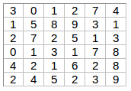
Next, we convolve this 6 X 6 matrix with a 3 X 3 filter:
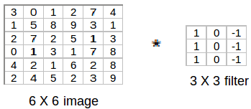
After the convolution, we will get a 4 X 4 image. The first element of the 4 X 4 matrix will be calculated as:
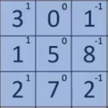
So, we take the first 3 X 3 matrix from the 6 X 6 image and multiply it with the filter. Now, the first element of the 4 X 4 output will be the sum of the element-wise product of these values, i.e. 3*1 + 0 + 1*-1 + 1*1 + 5*0 + 8*-1 + 2*1 + 7*0 + 2*-1 = -5. To calculate the second element of the 4 X 4 output, we will shift our filter one step towards the right and again get the sum of the element-wise product:
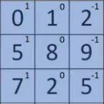
Similarly, we will convolve over the entire image and get a 4 X 4 output:
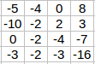
So, convolving a 6 X 6 input with a 3 X 3 filter gave us an output of 4 X 4. Consider one more example:
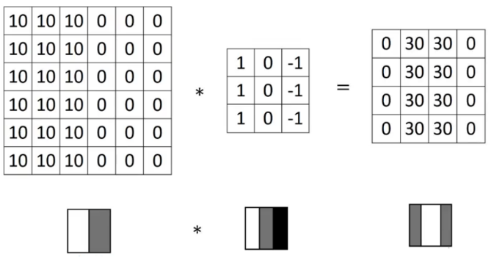
Note: Higher pixel values represent the brighter portion of the image and the lower pixel values represent the darker portions. This is how we can detect a vertical edge in an image.
More Edge Detection
The type of filter that we choose helps to detect the vertical or horizontal edges. We can use the following filters to detect different edges:
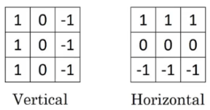
Some of the commonly used filters are:
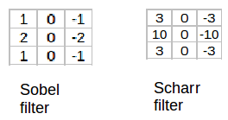
The Sobel filter puts a little bit more weight on the central pixels. Instead of using these filters, we can create our own as well and treat them as a parameter which the model will learn using backpropagation.

How do CNNs work?
To understand how a CNN functions let´s recap some of the basic concepts about Neural Networks.
(If you are reading this post I am assuming that you are familiar with basic neural networks. If that´s not the case I strongly recommend you to read this article).
1.- Neurons: The most basic unit in a neural network. They are composed of a sum of linear functions and a non-linear function known as the activation function is applied to them.
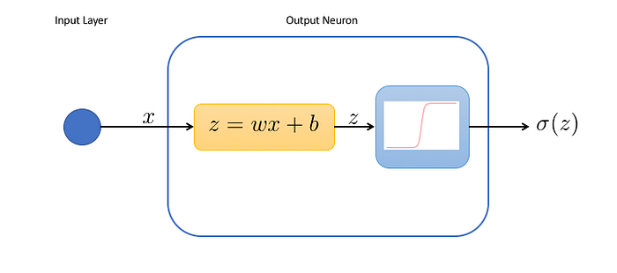
Neuron representation | Source
2.- Input layer: Each neuron in the input layer corresponds to one of the input features.
For instance, in an image classification task where the input is a 28 x 28-pixel image, the input layer would have 784 neurons (one for each pixel).
3.- Hidden Layer: The layers between the input and the output layer. Each neuron in this layer is summed by the result of the neurons in the previous layers and multiplied by a non-linear function.
4.- Output Layer: The number of neurons in the output layer corresponds to the number of output classes (In case we are facing a regression problem the output layer will only have one neuron).
For example, in a classification task with digits from 0 to 9, the output layer would have 10 neurons.


Once a prediction is made, a loss is calculated and the network enters a self-improvement iterative process through which the weights are adjusted with backpropagation to reduce this error.
Now we are ready to understand convolutional neural networks!
The first question we should ask ourselves:
- What makes a CNN different from a basic neural network?
Convolutional layers
They are the fundamental building blocks of CNNs. These layers perform a critical mathematical operation known as convolution.
This process entails the application of specialized filters known as kernels, that traverse through the input image to learn complex visual patterns.
As summarised earlier, the convolutional layer uses a kernel or filter (they are the same thing) to find and extract local features of an image. In modern CNNs, it is common to use multiple convolutional layers with distinct filters in order to capture a wider range of features and patterns.
above we learned about important parts of convolutional layer now let's build a convolutional layer structure
Let’s understand the architecture of CNN by creating one simple model:
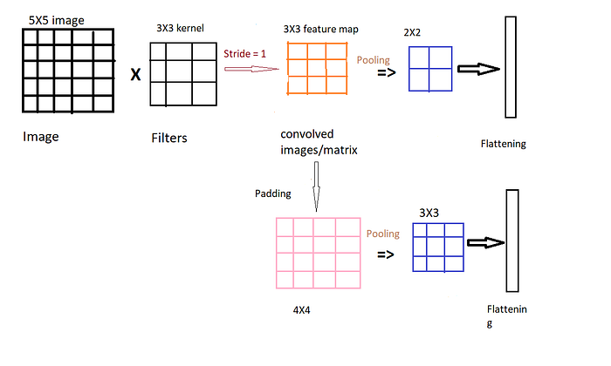
Structure of single Convolutional Layer without padding and with padding.
here let's say the image size is 5X5 when applied kernel of size 3X3 and stride is 1 the learnable kernel extracts features and outputs 3X3 convolved matrix or feature map.2X2 Pooling with stride =1 is applied on top of the convolved matrix and the metric values are flattened to a single vector called flatten layer.
in the above structure, I am applying padding on convolved images or feature maps know the feature map size is 4X4 and after padding applying pooling with stride =1 and flattening values using flatten layer
Why pooling, Padding is needed?
as we took stride =1, there will be overlap in the extraction of feature which results in more data which are correlated so, by applying pooling we can reduce the size of data without losing important features.in our example, we are reducing the 3X3 convolved matrix into 2X2 data by applying pooling with stride = 1.if we increase stride value we can reduce the size of data to small

Kernels/Filter
A filter is a small-sized matrix used to extract features from an image. It is applied on the input matrix through a convolution operation, specifically, dot product. In other words, the filter matrix is multiplied element-wise with the corresponding input values and then summed together into one value.
This filter is then slid across the input image until the whole input image has been convoluted. Bare in mind that since most images are composed of RGB channels, the same filter would be applied onto all three channels. The outputs of each of these channels would be summed to make a single feature map.
This information can be difficult to comprehend with just words, so please take a minute to absorb all this information using the animation below.
Press enter or click to view image in full size

A convolutional layer demonstrating a filter of stride one sliding across the input image and creating a feature map through corresponding dot product operations.
Note: To prevent confusion, please be aware that the blue filter applies a dot product on all three RGB channels, not just the blue channel and sums their results into one output value on the blue feature map. This is then repeated with the green and red filters, producing three output feature maps. To simplify calculations, pixel values of 0 were assigned to both the green and red channel.
After understanding this, it’s now time to ask, how exactly do filters learn features?
Let’s look and at a simple example for intuition purposes.
Press enter or click to view image in full size
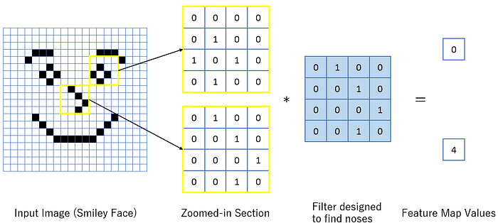
Two sections of a smiley face image being filtered with the corresponding output values shown.
The input image is a smiley face composed of white and black pixels taking values of 0 and 1, respectively. The pixel values of the zoomed-in image can be seen in the yellow boxes.
Additionally, the filter in this example was designed specifically to find noses within an image. Please bear in mind that in reality, the values of the filter matrix are not a hyperparameter, but in fact learnt during training and can take any value, negative or positive.
The filter is then applied onto the zoomed-in pixel maps with their dot product representing the values of the feature map. The reasoning behind naming the output, feature map, is that the feature map effectively portrays the distribution of a particular feature.
In our example, the yellow matrix representing the smiley face’s nose aligns perfectly with our nose finding filter, therefore, producing a high feature map value of 4. On the other hand, the yellow matrix representing the smiley face’s eye, unsurprisingly, does not align with the filter and as a result, produces a dot product of 0. Using this, the model learns that a nose is most likely located at the grid position which produced the value of 4, rather than 0.
Now, this was only the first convolution layer. The output feature map is then further fed as inputs into the next convolution layer. As you indulge into deeper layers, more abstract and complex features can be learnt, many of which, are undetectable to the human eye.
Now that you have learnt how filters function, it is time to learn how they move across an image.

They are essentially small matrices of numbers. These filters move across the image performing element-wise multiplication with the part of the image they cover, extracting features such as edges, textures, and shapes.

In the figure above, visualize the input as an image transformed into pixels.
We multiply each term of the image by a 3 × 3 matrix (this shape can vary) and pass it into an output matrix.
There are various methods to decide the digits inside the kernel. This will depend on the effect you want to achieve such as detecting edges, blurring, sharpening…
But what are we doing exactly?
Let´s take a deeper look at it.
Convolution Operation
The convolution operation involves multiplying the kernel values by the original pixel values of the image and then summing up the results.
This is a basic example with a 2 × 2 kernel:
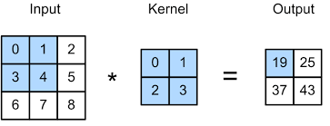
We start in the left corner of the input:
- (0 × 0) + (1 × 1) + (3 × 2) + (4 × 3) = 19
Then we slice one pixel to the right and perform the same operation:
- (1 × 0) + (2 × 1) + (4 × 2) + (5 × 3 ) = 25
After we completed the first row we move one pixel down and start again from the left:
- (3 × 0) + (4 × 1) + (6 × 2) + (7 × 3) = 37
Finally, we again slice one pixel to the right:
- (4 × 0) + (5 × 1) + (7 × 2) + (8 × 3) = 43
The output matrix of this process is known as the Feature map.
Perfect, now we understand how this operation works! But…
Why is it so useful? We are just multiplying and adding pixels, how can we extract image features doing this?
For now, I won´t be diving deeper into the convolution operation because I don´t consider it to be pivotal for understanding Conv. nets in the beginning.
However, if you are very curious I will leave you what I believe to be the best public answer to that question:
That´s it, you´ve understood the most fundamental concept behind CNNs, Convolutional Layers!
At this point, you may be having a bunch of doubts (at least I had them).
I mean, we understand how a convolution works, but:
- Kernels always traverse through the image matrix one pixel at a time?
- What happens with the pixels in the corners, we are only passing over them one time, what if they have an important feature?
- And what about RGB images? We stated that they are represented in 3 dimensions, how does the kernel traverse over them?
These are a lot of questions but don´t worry, all of them have an easy answer.
We’ll start by understanding three essential components inside convolutional layers:
- Channels
- Stride
- Padding
1.- Channels
As I explained before, digital images are often composed of three channels (RGB) which are represented in three different matrices.
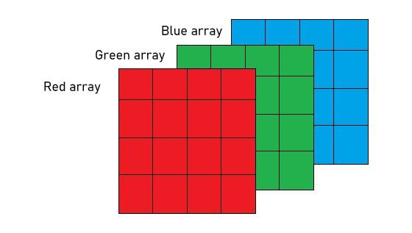
RGB decomposed image | Source
For an RGB image, there are typically separate kernels for each color channel because different features might be more visible or relevant in one channel compared to the others.

Convolution operation in Red, Green, and Blue channels | Source
- Depth of the layer
The ‘depth’ of a layer refers to the number of kernels it contains. Each filter produces a separate feature map, and the collection of these feature maps forms the complete output of the layer.
The output normally has multiple channels, where each channel is a feature map corresponding to a particular kernel.
In the case of RGB, we typically use one channel for each of the 3 matrices, but we can add as many as we want.
For example, let´s say that you have a gray-scale image of a cat, you could create a channel specialized in detecting the ears and another in the mouth.
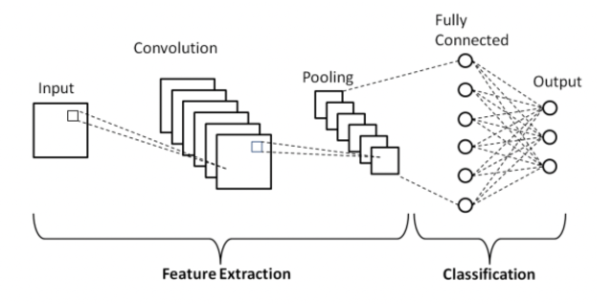
CNN representation | Source
This image illustrates the concept quite well, think of each layer in the convolution as a feature map with a different kernel (don´t worry about the pooling part for now, we`ll break it down in a minute).
☣️ BE CAREFUL with misunderstanding the channels in the convolution layer with the color channels in the image. That was a representative example to understand the concept but you can add as many channels as you want.
Each channel will detect a different feature in the image based on the values you assign to its kernel.
2.- Stride

Suppose we choose a stride of 2. So, while convoluting through the image, we will take two steps – both in the horizontal and vertical directions separately. The dimensions for stride s will be:
- Input: n X n
- Padding: p
- Stride: s
- Filter size: f X f
- Output: [(n+2p-f)/s+1] X [(n+2p-f)/s+1]
Stride helps to reduce the size of the image, a particularly useful feature.
In the convolution layer, the term stride refers to the speed in which a filter translates across an image. A stride of 1 would mean that the filter travels one pixel at at time and with a stride of 2, two pixels at a time etc.
Simple as that.
Press enter or click to view image in full size
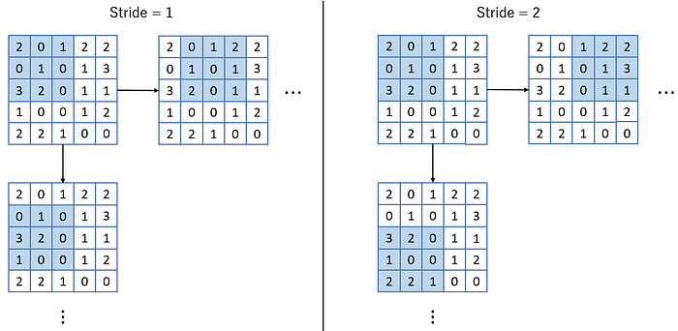
A 3x3 filter of stride 1 (left) and of stride 2 (right) applied on a 5x5 input matrix.
Why does this matter?
Well, take a look at the stride = 1 image, the feature map will clearly be a 3x3 matrix. Now look at stride = 2, the feature map is clearly a 2x2 image.
Therefore, higher stride values are often used for dimension reduction, thus lowering computational complexity. However, be weary that if you assign too high of a stride value, the network may lose vital information.
Consequently, have you noticed anything interesting about feature maps?
They are always of smaller size than the input matrix. This leads us onto the next section, padding.

We have discussed that in a convolution a kernel moves through the pixels of an image, but we haven´t talked about the different ways in which it can do it.
Stride refers to the number of pixels by which a kernel moves across the input image.
The example we saw before had a stride of 1, but this can change.
Let´s see a visual representation:
- Stride = 1

Hyperparameters of a Convolutional Layer | Source
- Stride = 2
Press enter or click to view image in full size

Hyperparameters of a Convolutional Layer | Source
A stride of 2 not only changes the way the convolution iterates over the input size but also the output by making it smaller (2 × 2).
Taking this into account we can conclude that:
A larger stride will produce smaller output dimensions (as it covers the input image faster), whereas a smaller stride results in a larger output dimension.
But why would we want to change the stride?
Increasing the stride will allow the filter to cover a larger area of the input image, which can be useful for capturing more global features.
In contrast, lowering the stride will capture finer and more local details.
In addition, increasing the stride will control overfitting and reduce computational efficiency as it will reduce the spatial dimensions of the feature map.
3.- Padding

We have seen that convolving an input of 6 X 6 dimension with a 3 X 3 filter results in 4 X 4 output. We can generalize it and say that if the input is n X n and the filter size is f X f, then the output size will be (n-f+1) X (n-f+1):
- Input: n X n
- Filter size: f X f
- Output: (n-f+1) X (n-f+1)
There are primarily two disadvantages here:
- Every time we apply a convolutional operation, the size of the image shrinks
- Pixels present in the corner of the image are used only a few number of times during convolution as compared to the central pixels. Hence, we do not focus too much on the corners since that can lead to information loss
To overcome these issues, we can pad the image with an additional border, i.e., we add one pixel all around the edges. This means that the input will be an 8 X 8 matrix (instead of a 6 X 6 matrix). Applying convolution of 3 X 3 on it will result in a 6 X 6 matrix which is the original shape of the image. This is where padding comes to the fore:
- Input: n X n
- Padding: p
- Filter size: f X f
- Output: (n+2p-f+1) X (n+2p-f+1)
There are two common choices for padding:
- Valid: It means no padding. If we are using valid padding, the output will be (n-f+1) X (n-f+1)
- Same: Here, we apply padding so that the output size is the same as the input size, i.e.,
n+2p-f+1 = n
So, p = (f-1)/2
We now know how to use padded convolution. This way we don’t lose a lot of information and the image does not shrink either. Next, we will look at how to implement strided convolutions.

When applying a filter over an input matrix, which pixels experience the least filtering?
Evidently, the borders, with corners undergoing the least filtering (filtered only once).
This fact poses an issue. While central pixels are involved in numerous convolutions, the borders are not. This is called the border effect, which essentially is a loss of information at the borders since they contribute less towards the output feature map.
How do we fix this? PADDING.
Press enter or click to view image in full size
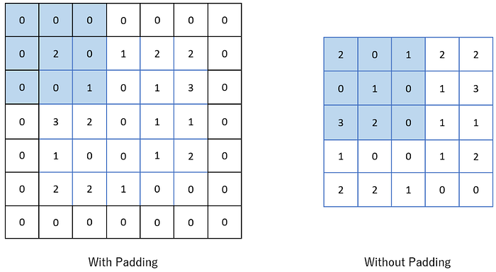
An input image with one layer of zero padding (left) and the same input image with no padding (right). These are the states of the images during the first filter convolution.
Paddings are additional layers, usually 0s, which are added around the outsides of an input image, mitigating border effect and also increasing the spatial dimensions of the resulting feature map.

Padding refers to the addition of extra pixels around the edge of the input image.
When you focus on the pixels in the image’s edges, you’ll notice that we traverse them fewer times compared to those positioned in the center.
The purpose of padding is to adjust the spatial size of the output of a convolutional operation and to preserve spatial information at the borders.
Let´s see another example with the CNN explainer
- Padding = 0 (focus on the edges and count how many times the kernel is passing through them)

Hyperparameters of a Convolutional Layer | Source
- Padding = 1

Hyperparameters of a Convolutional Layer | Source
Now we are passing more times through the pixels in the edges and getting more information about them.
In which cases do you want to apply padding?
Mainly when the edges of the image contain useful information that you want to capture.
You can increase the padding up to the kernel size you are using.
And how does it affect the output field?
Padding increases the size of the output feature map. If you increase the padding while keeping the kernel size and stride constant, the convolution operation has more “room” to take place, resulting in a larger output.
The output size of a convolutional layer can be calculated using the following formula:
Where
- “2 × Padding” accounts for padding applied to both the left and right sides (or top and bottom sides) of the input.
- “+ 1” accounts for the initial position of the filter, which starts at the beginning of the padded input.
☣️ This is a visual explanation of Padding but at a practical level, it doesn´t have to be always the same on all sides of the image.
The padding dimensions can be asymmetric or even have a custom padding design.
If you have reached this point now you can officially say that you know how Convolutional Layers work!
Nevertheless, this is not the end of the journey…
There is a common misconception among beginners that Conv. layers are Convolutional Neural Networks.
Well, convolutional layers are an essential component, but as its name indicates, they are a LAYER inside CNNs.
We have comprehended the most important part of CNNs, but there are still two other special types of layers that we have to understand:
- Pooling Layers
- Flattening Layers
Pooling Layers
Following the convolution layer is the pooling layer. Besides downsampling, this layer also provides additional advantages.
Just like the convolution layer, the pooling layer involves using a filter that slides over the input (feature map) and then extracts a single output value.
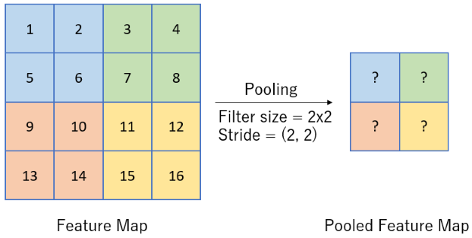
An illustration of pooling using a 2x2 pooling filter with a stride of 2, both vertically and horizontally. Each colour represents a pooled region, note that pooling windows can overlap, for example, if stride = (1, 1).
The main objectives of pooling are:
- Spatial dimension reduction: Pooling extracts only one value from the filtered area, therefore, reducing the matrix size and also the network’s computational complexity.
- Feature generalisation: Small changes and shifts in the input will likely not affect the pooled feature map. This allows the network to be invariant to small variations.
- Increased receptive field: By pooling over a particular window of neighbouring pixels, the network is able to capture patterns from a larger area and increase its receptive field.
Generally, two types of pooling are used, max pooling and average pooling, however, take note that other variations do still exist. Each of these pooling techniques serve different purposes and will be discussed below.

Before explaining how these layers work it´s crucial to have this clear:
Although Convolutional Layers can decrease the output size, their principal objective is not DIMENSIONALITY REDUCTION.
The main objective of Convolutional Layers is FEATURE EXTRACTION.
In fact, in most cases we are not reducing the dimensions of our data because we are creating new channels that weren´t there before, so even if our feature map dimensions are smaller, we have more of them.
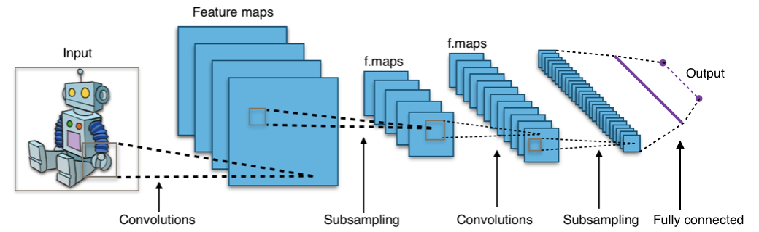
Convolutional neural network representation | Source
Take a look at this example, here we might be reducing a bit our feature map in each Convolutional Layer but we are creating much more channels.

Max Pooling
During max pooling, the most dominant feature (maximum value) within each pooling window is selected as the output value. Let’s take a look at how max pooling is applied on the earlier displayed feature map.
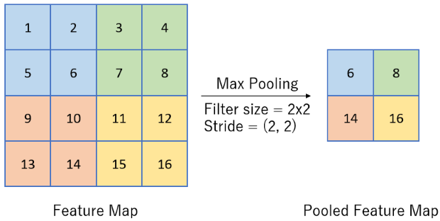
A max pooling operation.
Why perform max pooling?
By retaining the most dominant features in each local region, the network is able to ignore potential noise and focus on the most important features. In addition, by max pooling, the network also becomes less sensitive to small translations or shifts in the input.
Average Pooling
Similarly, during average pooling, the average value of each pooling window is used as the corresponding output value. The application of average pooling on the previous feature map can be seen below.
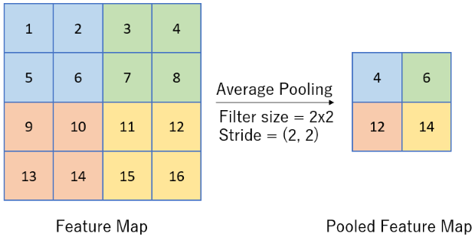
An average pooling operation.
Why perform average pooling?
By computing the average value within each local region, a smoothing effect occurs and as a result reduces noise. Furthermore, just like in max pooling, the network becomes less sensitive to variations and shifts within the input data, making the model further robust.
Fully Connected Layer
The next and final layer in a convolutional network is the fully connected (FC) layer, also known as the dense layer. This layer follows a traditional neural network structure and aims to aggregate all the extracted features from previous layers so that a better understanding of global relationships is learnt. This particular layer is crucial for tasks such as image classification.
Take this feature map for instance.
Press enter or click to view image in full size
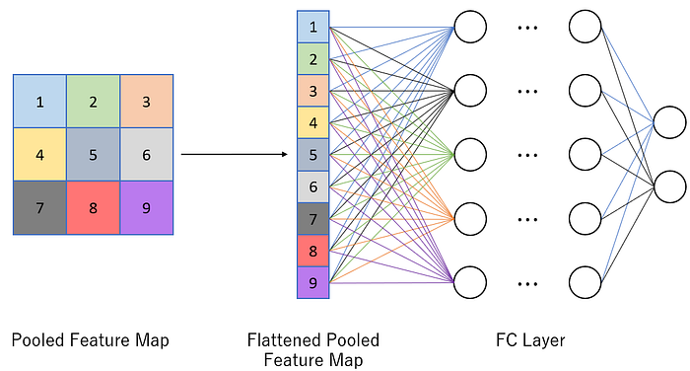
A pooled feature map being flattened and inputted into a fully connected (FC) network layer.
Each value of the pooled feature map represents a different set of features, while some overlap may be present, many values will have been derived from different parts of the image, take feature 1 and 9 for example.
Next, the pooled feature map is flattened. This transforms the matrix into a column vector so that it is able to be fed into the fully connected network.
Inside the fully connected network, each layer connects all its nodes to each and every node in the next layer, hence the name ‘fully connected’. This is a critical characteristic of the fully connected layer.
This is because, by having all extracted features contribute to every individual node, the network is able to combine data and generate further relationships between them as well as capture global context and patterns.
Along with the use of non-linear activation functions such as ReLU at each node within the fully connected layer, the network is able to learn complex non-linear relationships between different features, something that wasn’t possible in previous layers.
The importance of FC layers can be seen in image classification. For instance, when feeding the FC layer’s outputs through a softmax function, a probability distribution corresponding to the possible classes can be outputted.

Convolutions Over Volume
Suppose, instead of a 2-D image, we have a 3-D input image of shape 6 X 6 X 3. How will we apply convolution on this image? We will use a 3 X 3 X 3 filter instead of a 3 X 3 filter. Let’s look at an example:
- Input: 6 X 6 X 3
- Filter: 3 X 3 X 3
The dimensions above represent the height, width and channels in the input and filter. Keep in mind that the number of channels in the input and filter should be same. This will result in an output of 4 X 4. Let’s understand it visually:
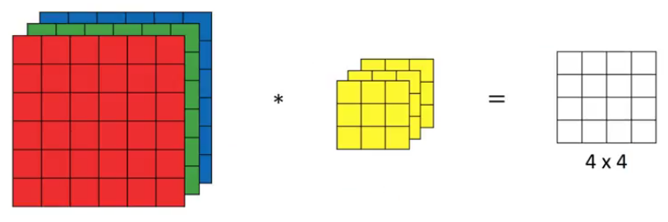
Since there are three channels in the input, the filter will consequently also have three channels. After convolution, the output shape is a 4 X 4 matrix. So, the first element of the output is the sum of the element-wise product of the first 27 values from the input (9 values from each channel) and the 27 values from the filter. After that we convolve over the entire image.
Multiple Filters Edges
Instead of using just a single filter, we can use multiple filters as well. How do we do that? Let’s say the first filter will detect vertical edges and the second filter will detect horizontal edges from the image. If we use multiple filters, the output dimension will change. So, instead of having a 4 X 4 output as in the above example, we would have a 4 X 4 X 2 output (if we have used 2 filters):
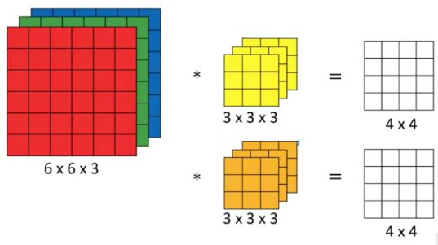
Generalized dimensions can be given as:
- Input: n X n X n_{c}
- Filter: f X f X n_{c}
- Padding: p
- Stride: s
- Output: [(n+2p-f)/s+1] X [(n+2p-f)/s+1] X n_{c}’
Here, n_{c} is the number of channels in the input and filter, while n_{c}’ is the number of filters.

What about the subsampling layers?
Those are pooling layers and its main objective is indeed dimensionality reduction!
How Pooling Layers Work
Imagine you have a large image and want to make it smaller but keep all the important features like edges and colors.
The pooling layer operates independently on every depth slice of the input. It resizes it spatially, using the Max or Average of the values in a window slid over the input data.
Press enter or click to view image in full size

In this example, we have reduced the feature map from (4 × 4) to (2 × 2).

The pooling layer replaces the output of the network at certain locations by deriving a summary statistic of the nearby outputs. This helps in reducing the spatial size of the representation, which decreases the required amount of computation and weights. The pooling operation is processed on every slice of the representation individually.
There are several pooling functions such as the average of the rectangular neighborhood, L2 norm of the rectangular neighborhood, and a weighted average based on the distance from the central pixel. However, the most popular process is max pooling, which reports the maximum output from the neighborhood.
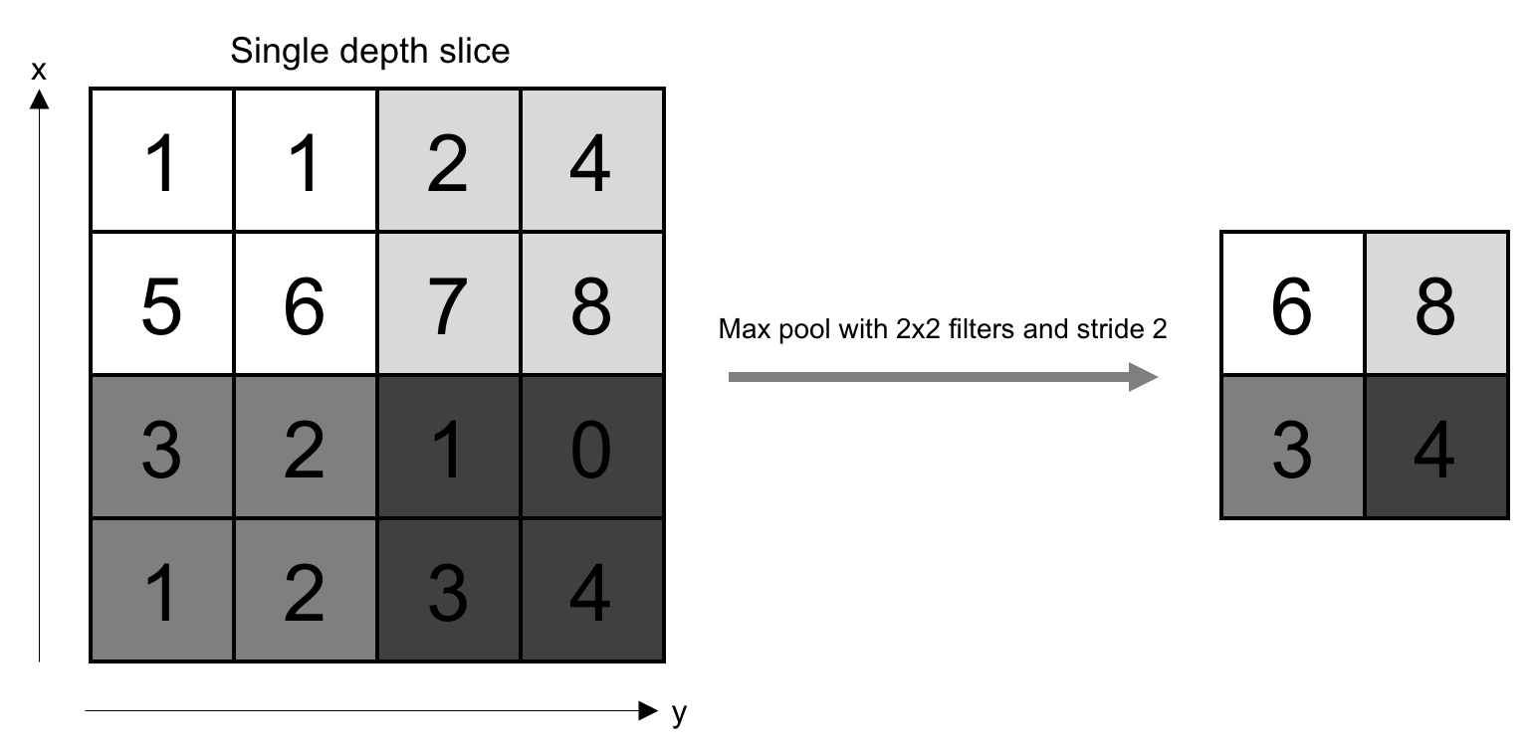
If we have an activation map of size W x W x D, a pooling kernel of spatial size F, and stride S, then the size of output volume can be determined by the following formula:
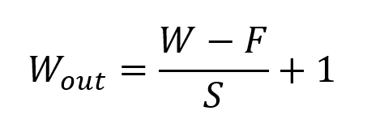Formula for Padding Layer
This will yield an output volume of size Wout x Wout x D.
In all cases, pooling provides some translation invariance which means that an object would be recognizable regardless of where it appears on the frame.

What is the difference between pooling and the convolution operation?
In pooling, we are not applying any kernel to the input data, we are just simplifying the information with a math operation (Max or Avg).
What about the channels, pooling also reduces the number of channels?
You must understand this:
Pooling layers DO NOT REDUCE THE NUMBER OF CHANNELS.
Each pooling operation IS APPLIED INDEPENDENTLY TO EACH CHANNEL of the input data.
Let´s see another example, channels can be a bit complex to visualize at first and I want to ensure that you understand correctly how they work.
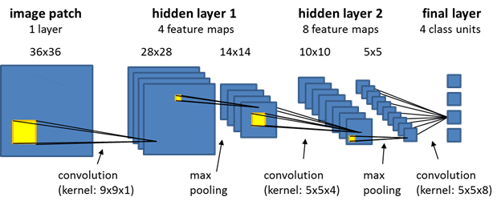

This is a good representation, here you can see how each pooling layer is reducing the dimensions of the spatial space but it's not reducing the number of channels.
The number of channels is not reduced until the end of the architecture.
With Convolutional and Pooling layers we CAN´T reduce the number of channels, just add more to the existing ones.
So why and how do we combine all these channels?
After convolutional and pooling layers have extracted relevant features from the input image we have to turn this high-dimensional feature map into a format suitable for feeding into fully connected layers.
Here´s where flattening layers come into action!
Flattening layers
Imagine you have a grid of data (like pixels in a feature map), and you want to line up all of these grid points in a single, long line.
That’s what flattening does. It takes the entire feature map and reorganizes it into a single, long vector.
Press enter or click to view image in full size
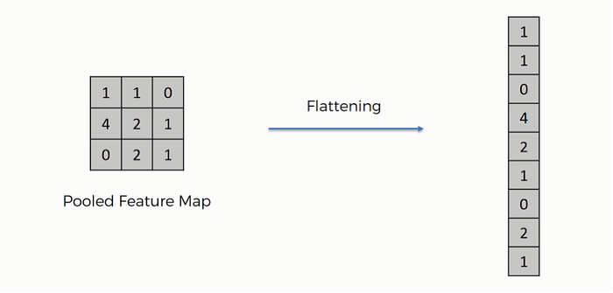
Flattening concept | Source
☣️ Although flattening changes the shape of the data, it does not make any changes to the actual information.
- Why do we need flattening layers?
Integration of features
By flattening the feature maps into a vector, the network can integrate the spatially distributed features extracted for tasks such as classification.
Compatibility with Dense Layers
Fully connected layers (dense layers) are designed to operate on 1-dimensional data, hence, flattening is a necessary step to transition from the multidimensional tensors produced by convolutional layers to the format required for dense layers.
This leads us to our next question:
Why do we need Dense Layers in CNNs?
While convolutional layers are good at detecting features in input data, dense layers are essential for integrating these features into predictions.
For example, if we design a convolutional neural network for facial recognition, early layers might detect edges and textures, while dense layers might interpret these to recognize specific facial features.
Without dense layers, CNNs would not be able to perform the high-level tasks that are often required, such as classifying images, detecting objects, or making predictions based on visual inputs.
CNN recap
Up to this point, we have revised the whole CNN structure:
- Convolutional Layers
- Pooling layers
- Flattening layers
- Dense layers
With the fundamental concepts of channels, stride, and pooling.
We could say that we have joined all the pieces of the puzzle!
Or maybe not… what about activation functions and backpropagation?
Backpropagation functions similarly in feed-forward neural networks but with some special adjustments. I won´t focus much on its technical details.
You can check out this very interesting article to know more about it!

Convolutions and Backpropagations
Ever since AlexNet won the ImageNet competition in 2012, Convolutional Neural Networks (CNNs) have become ubiquitous…
pavisj.medium.com

If you know nothing about Backpropagation you can start by taking a look at my publication:

Backpropagation
From Mystery to Mastery: Decoding the engine behind Neural Networks.
medium.com

However, I will certainly take a look at activation functions.
Activation functions in Convolutional Neural Networks
As you may know activation functions are indispensable, otherwise, we would be creating a very large linear model.
As in simple neural networks, we also need these non-linear terms in ConvNets. However, not all the layers we have seen have an activation function.
Let's use an image as a reference to visualize this. Now you should understand the representation without any problem! Just one little thing…
The first two pooling layers are not shown in this diagram, this is another way of visualizing CNNs, it doesn´t mean that they are not there, just imagine a filter between each layer that makes them smaller.
Press enter or click to view image in full size
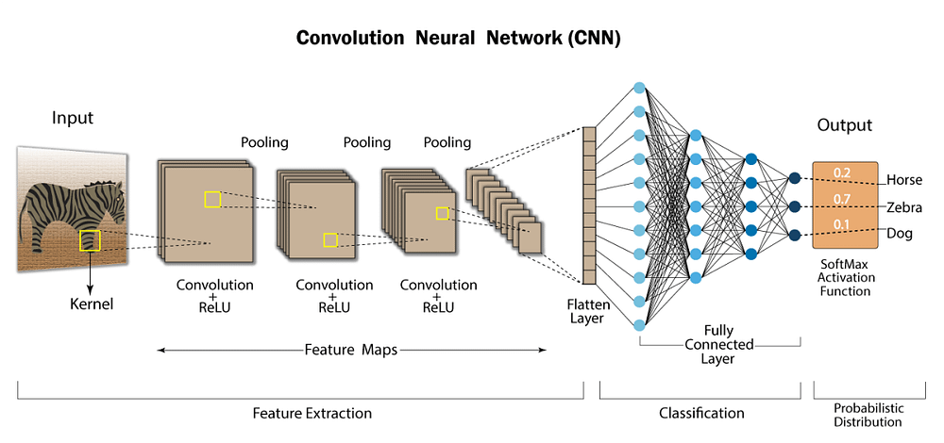
Complete CNN representation | Source
In the feature extraction part, the activations will be in the convolutional layers. The process is quite straightforward, after each convolution operation you multiply the result by an activation function.
Press enter or click to view image in full size
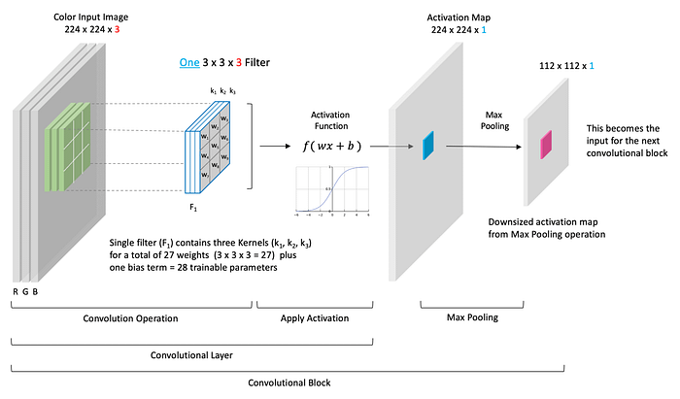
Convolutional layer structure | Source
The pooling and flattening layers DON´T have an activation function.
As we explained before the main function of pooling layers is dimensionality reduction and the main purpose of flattening layers is restructuring the data into a 1D vector.
We don´t need to include non-linearities for doing that. Nevertheless, we do need activation functions for extracting complex features (we won´t be able to capture relevant characteristics of an image with only a linear function).
In the classification part, all the fully connected layers and the output layer will have an activation function, as in simple neural nets.
Here we also need an activation function because we are using the features extracted to make a classification or a prediction, and the algorithm has to learn complex interactions (as a simple neural network would do).
Activations — Convolutional and dense layers
ReLU: is the most common activation function. It outputs the input directly if it is positive, otherwise, it outputs zero. It has the benefit of reducing training time and mitigating the vanishing gradient problem.
Leaky ReLU: A variation of ReLU that allows a small, non-zero gradient when the unit is inactive, which can help prevent dead neurons during training.

Activation functions: ReLU vs. Leaky ReLU
It’s never too late to board the ‘Learning and discussing the insights’ train, and here are my two cents on my recent…
medium.com

Activations — Output layer
Sigmoid: Produces an output in the range (0, 1). It’s not commonly used in hidden layers anymore due to the vanishing gradient problem, but it’s still used for binary classification in the output layer.
Tanh (Hyperbolic Tangent): Output values in the range (-1, 1). It is similar to the sigmoid but can provide better training performance for some problems due to its output range.

Activation Functions in Neural Networks
Sigmoid, tanh, Softmax, ReLU, Leaky ReLU EXPLAINED !!!
towardsdatascience.com

11. CNN Architectures
Convolutional Neural Networks have been around since the early 1990s.
- LeNet (the 1990s)
- AlexNet (2012)
- ZF Net (2013)
- GoogLeNet (2014)
- VGGNet (2014)
- ResNets (2015)
- DenseNet (August 2016)
Bonus References for those who complete this article:-
if your beginner and want to understand CNN visually please visit this site CNN Explainer
Once you are familiar with CNN basic architecture you can visit TensorSpace Playground.

