Neural Networks

What is a Neural Network?
A neural network is a computational model inspired by the structure and functioning of the human brain. It consists of interconnected nodes, called neurons, organized in layers. Information is processed through these layers, with each neuron receiving inputs, applying a mathematical operation to them, and producing an output. Through a process called training, neural networks can learn to recognize patterns and relationships in data, making them powerful tools for tasks like image and speech recognition, natural language processing, and more.
Learn More: An Introductory Guide to Deep Learning and Neural Networks
How Do Neural Networks Work?
Here’s a simplified explanation of how neural networks work:
Architecture Layers
- Input Layer: This layer receives the initial data or features that the neural network will process. Each neuron in the input layer represents a feature of the input data.
- Hidden Layers: These layers perform computations on the input data. Each neuron in a hidden layer takes input from the neurons in the previous layer, applies a mathematical function (called an activation function), and passes the result to the neurons in the next layer.
- Output Layer: The final layer of the neural network produces the model’s output. The number of neurons in this layer depends on the type of problem the neural network is solving. For example, in a binary classification problem (where the output is either yes or no), there would be one neuron in the output layer.
Connections
In a typical dense network, each neuron in a layer is connected to every neuron in the adjacent layers. The neural network actively adjusts the weights associated with these connections during training to optimize its performance.
Activation Function
As mentioned earlier, each neuron applies an activation function, based on which the calculations are done. This function introduces non-linearity into the network, allowing it to learn complex patterns in the data.
Training
Neural networks learn from data through a process called training. During training, the network is fed with input data along with the correct outputs (labels). It adjusts the weights of connections between neurons in order to minimize the difference between its predicted outputs and the true outputs. This process typically involves an optimization algorithm like gradient descent.
Prediction
Once trained, the neural network can make predictions on new, unseen data by passing it through the network and obtaining the output from the final layer.
In essence, a neural network learns to recognize patterns in data by adjusting its internal parameters (weights) based on examples provided during training, allowing it to generalize and make predictions on new data.
Learn More: A Comprehensive Guide on Neural Networks

Different Types of Neural Networks in Deep Learning
This article focuses on three important types of neural networks that form the basis for most pre-trained models in deep learning:
- Single Layer Perceptron
- Multilayer Perceptrons (MLPs)
- Feedforward Neural Networks (FNNs)
- Artificial Neural Network (ANN)
- Recurrent Neural Network (RNN)
- Long Short-Term Memory (LSTM) Networks
- Transformer Networks
- Convolution Neural Network (CNN)
- Deconvolutional Neural Networks
- Autoencoders
- Generative Adversarial Networks (GANs)
- Radial Basis Function (RBF) Neural Network

Let’s discuss each neural network in detail.
1. Single Layer Perceptron
The perceptron is a fundamental type of neural network used for binary classification tasks. It consists of a single layer of artificial neurons (also known as perceptrons) that take input values, apply weights, and generate an output. A single perceptron (or neuron) can be imagined as a logistic regression. It performs a weighted sum of inputs, adds a bias, and passes the result through an activation function – just like logistic regression. When using a sigmoid activation, its output is a probability between 0 and 1, mimicking the behavior of logistic regression.
The perceptron is typically used for linearly separable data, where it learns to classify inputs into two categories based on a decision boundary. It finds applications in pattern recognition, image classification, and linear regression. However, the perceptron has limitations in handling complex data that is not linearly separable.
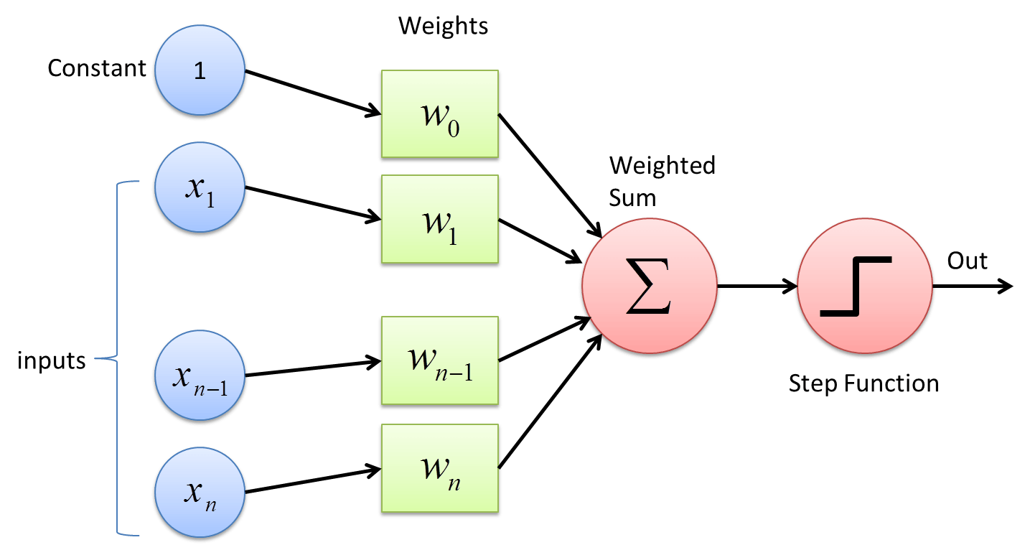
Learn More: Perceptron: Building Block of Artificial Neural Network
Applications of Perceptron
- Image classification: Perceptrons classify images containing specific objects. They achieve this by performing binary classification tasks.
- Linear regression: Perceptrons can predict continuous outputs based on input features. This makes them useful for solving linear regression problems.
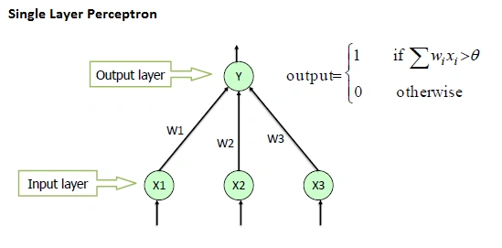
Challenges with Perceptron
- Limited to linear separability: Perceptrons struggle with handling data that is not linearly separable, as they can only learn linear decision boundaries.
- Lack of depth: Perceptrons are a single layer and cannot learn complex hierarchical representations.

2. Multilayer Perceptrons (MLPs)
An MLP is a class of feedforward artificial neural network. It consists of at least three layers of nodes: an input layer, one or more hidden layers, and an output layer. Except for the input nodes, each node is a neuron that uses a nonlinear activation function.​
Applications of MLPs
- Classification Tasks: MLPs are widely used for classification problems, such as handwriting recognition and speech recognition.​
- Regression Analysis: They are also applied in regression problems where the relationship between input and output is complex.​
Challenges with MLPs
- Computational Complexity: Training MLPs can be computationally intensive, especially with large datasets.​
- Overfitting: They are prone to overfitting, particularly when the network is too complex relative to the amount of training data.​
Now, let us see how to overcome the limitations of MLP using two different architectures – Recurrent Neural Networks (RNN) and Convolution Neural Networks (CNN).
Learn More: A Simple overview of Multilayer Perceptron (MLP)
3. Feedforward Neural Networks (FNNs)
Feedforward Neural Network is the simplest type of ANN architecture. In this network, the information moves in only one direction – forward. As seen in the above image, it moves from the input nodes, through the hidden nodes (if any), and to the output nodes. There are no cycles or loops in the network.​
Applications of FNNs
- Pattern Recognition: Used in applications like optical character recognition and facial recognition.​
- Function Approximation: FNNs can approximate complex functions and are used in various predictive modeling tasks.​
Challenges with FNNs
- Inability to Handle Temporal Data: FNNs are not ideal for tasks involving sequential data, as they lack memory of previous inputs.​
- Fixed Input Size: They require a fixed-size input, making them less flexible for varying input lengths.​
4. Artificial Neural Network (ANN)
Artificial Neural Network, or ANN, is a group of multiple perceptrons/neurons at each layer. It consists of 3 layers – Input, Hidden and Output. The input layer accepts the inputs, the hidden layer processes the inputs, and the output layer produces the result. Essentially, each layer tries to learn certain weights.
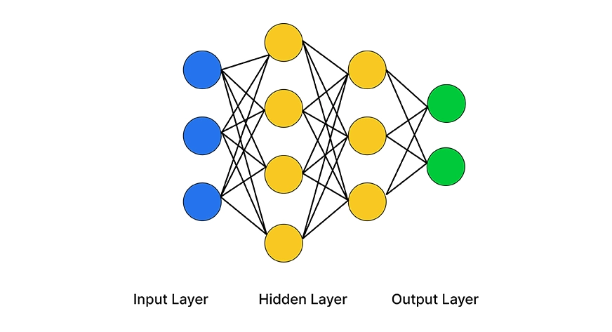
ANN can be used to solve problems related to tabular data, images, and textual data.
Learn More: Artificial Neural Networks – Better Understanding
Activation Functions in ANNs
Artificial Neural Network is capable of learning any nonlinear function. Hence, these networks are popularly known as Universal Function Approximators. ANNs have the capacity to learn weights that map any input to the output.
One of the main reasons behind universal approximation is the activation function. Activation functions introduce nonlinear properties to the network. This helps the network learn any complex relationship between input and output.
As you can see here, the output at each neuron is the activation of a weighted sum of inputs. But wait – what happens if there is no activation function? The network only learns the linear function and can never learn complex relationships. That’s why an activation function is the powerhouse of an ANN!
Advantages of Artificial Neural Network (ANN)
- Nonlinear Modeling & Adaptability: ANNs can learn complex, nonlinear relationships and adapt to changing input data, making them effective in dynamic real-world scenarios.
- Automatic Feature Extraction & Generalization: ANNs reduce the need for manual feature engineering by learning relevant patterns directly from raw data and generalizing well to unseen inputs.
- Fault Tolerance & Parallel Processing: Their distributed structure allows ANNs to continue functioning even with partial failure, and they support efficient parallel computation for faster processing.
Challenges with Artificial Neural Network (ANN)
While solving an image classification problem using ANN, the first step is to convert a 2-dimensional image into a 1-dimensional vector prior to training the model. This has two drawbacks:
- The number of trainable parameters increases drastically with an increase in the size of the image.
- ANN loses the spatial features of an image. Spatial features refer to the arrangement of the pixels in an image. I will touch upon this in detail in the following sections.
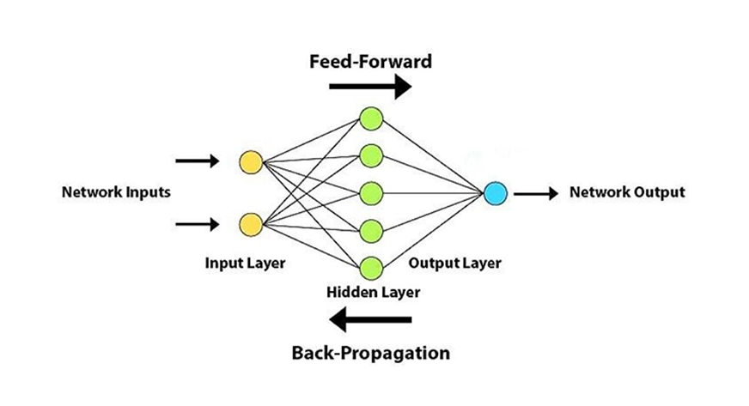
Yet another challenge occurs in the case of backward propagation. If there is a very deep neural network (network with a large number of hidden layers), the gradient vanishes or explodes as it propagates backward which leads to vanishing and exploding gradient.
- ANN cannot capture sequential information in the input data which is required for dealing with sequence data.
5. Recurrent Neural Network (RNN)
Let us first try to understand the difference between an RNN and an ANN from the architecture perspective. Simply put, a looping constraint on the hidden layer of an ANN turns it into an RNN.
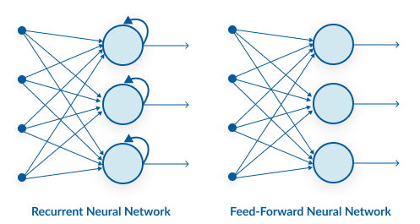
As you can see here, RNN has a recurrent connection on the hidden state. This looping constraint ensures that sequential information is captured in the input data.
Learn More: Fundamentals of Deep Learning – Introduction to Recurrent Neural Networks
We can use recurrent neural networks to solve the problems related to: time series data, textual content, and audio data.
Parameter Sharing in RNNs
As you can see in the image below, the output (o1, o2, o3, o4) at each time step depends not only on the current word but also on the previous words. RNNs share the parameters across different time steps. This is popularly known as Parameter Sharing. This results in fewer parameters to train and decreases the computational cost.
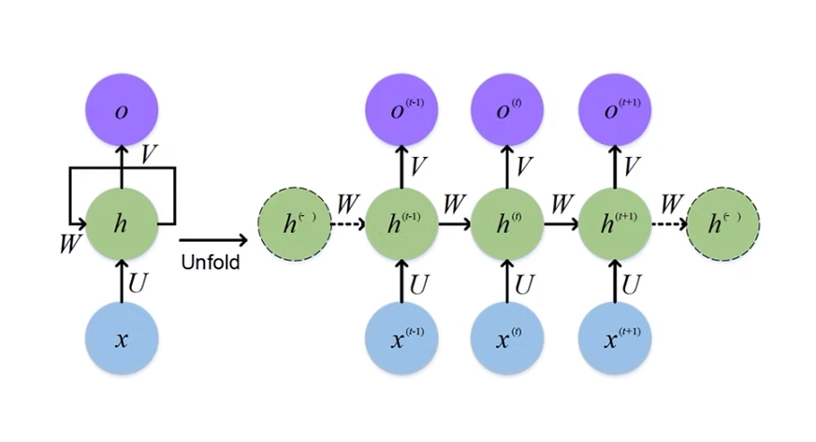
As shown in the above figure, 3 weight matrices – U, W, V, are the weight matrices that are shared across all the time steps.
Advantages of Recurrent Neural Network (RNN)
- Sequential Data Handling: RNNs are specifically designed to process and learn from sequential data, making them ideal for tasks like time series forecasting, language modeling, and speech recognition.
- Context Preservation with Memory: By maintaining internal states, RNNs can retain information from previous inputs, enabling context-aware predictions in sequences.
- Parameter Sharing Across Time Steps: RNNs reuse the same parameters across all time steps, reducing the overall model complexity and improving learning efficiency for sequence-based tasks.
Challenges with Recurrent Neural Networks (RNN)
- Vanishing and Exploding Gradients: Deep RNNs (RNNs with a large number of time steps) also suffer from the vanishing and exploding gradient problem which is a common problem in all the different types of neural networks.
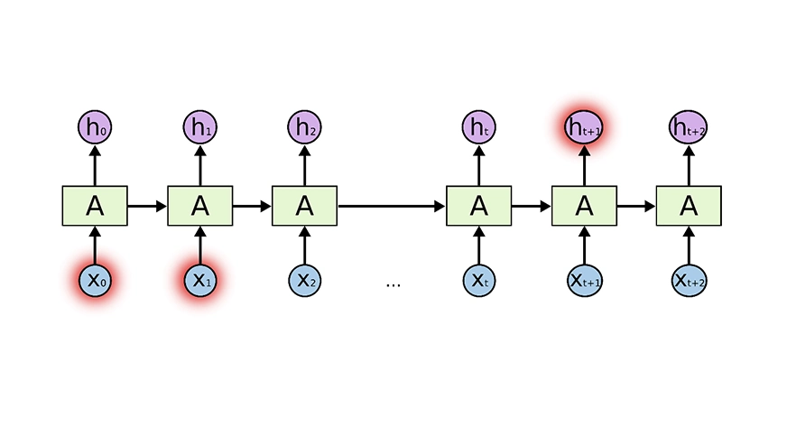
As you can see here, the gradient computed at the last time step vanishes as it reaches the initial time step.
- Training Complexity and Time: RNNs are computationally intensive and slow to train due to their sequential nature, where each step depends on the previous one.
- Difficulty Capturing Long-Term Context: Standard RNNs have limited memory, which makes them less effective in modeling long-range dependencies compared to LSTMs or Transformers.
Learn More: Fundamentals of RNN forward Propagation in Deep Learning
6. Long Short-Term Memory (LSTM) Networks
LSTM networks are a type of recurrent neural network (RNN) designed to capture long-term dependencies in sequential data. Unlike traditional feedforward networks, LSTM networks have memory cells and gates that allow them to retain or forget information over time selectively. This makes LSTMs effective in speech recognition, natural language processing, time series analysis, and translation.
However, the challenge with LSTM networks lies in selecting the appropriate architecture and parameters and dealing with vanishing or exploding gradients during training.
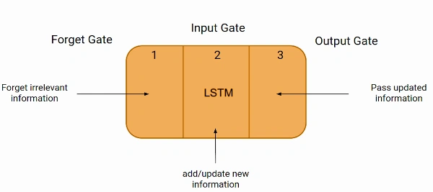
Applications of LSTM
- Natural language processing: LSTMs excel at modeling sequential data, making them highly effective in tasks like language translation, sentiment analysis, and text generation.
- Speech recognition: LSTMs are used to process audio data, enabling accurate speech recognition systems.
- Time series analysis: LSTMs can capture long-term dependencies in time series data, making them suitable for tasks like stock market prediction and weather forecasting.
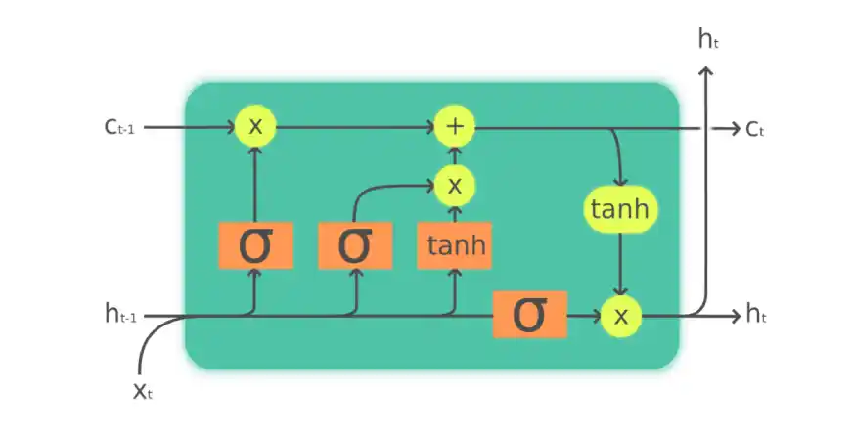
Challenges with LSTM
- Gradient vanishing/exploding: LSTMs can suffer from vanishing or exploding gradients, making it difficult to train them effectively over long sequences.
- Proper architecture design: Selecting appropriate LSTM architecture, such as the number of layers and hidden units, is crucial for achieving optimal performance.
Learn More: What is LSTM? Introduction to Long Short-Term Memory
7. Transformer Networks
Transformer networks have become one of the most important architectures in deep learning. They are especially useful in the field of NLP and machine translation. Introduced in the 2017 paper “Attention is All You Need” by Vaswani et al., the Transformer model revolutionized the way machines process sequences of data.
Key Components of Transformer Networks:
- Self-Attention Mechanism: The Transformer model’s core innovation is the self-attention mechanism, which enables the model to weigh the importance of different words in a sequence, regardless of their position. Unlike RNNs and LSTMs, which process inputs sequentially, Transformers process all words in a sentence simultaneously. This allows them to capture long-range dependencies more efficiently.
- Positional Encoding: Since Transformers don’t process data sequentially, they use positional encoding to inject information about the order of the sequence into the model. This encoding allows the model to recognize the order of words and understand the relationships between them.
- Encoder-Decoder Architecture: The Transformer consists of an encoder-decoder structure. The encoder processes the input data (like a sentence), while the decoder generates the output. Both the encoder and decoder are made up of multiple layers of self-attention and feed-forward neural networks.
- Multi-Head Attention: This is a technique used in Transformers to capture information from different positions in the sequence by using multiple attention mechanisms in parallel. The results are then concatenated and transformed, allowing the model to focus on different aspects of the input data at once.
Applications of Transformer Networks:
- Natural Language Processing (NLP): Transformers are widely used in NLP tasks like text translation, sentiment analysis, and text summarization. Models such as BERT, GPT, and T5 are all built upon the Transformer architecture.
- Image Processing: Recently, Vision Transformers (ViT) are being applied to image processing tasks, such as image classification and generation, challenging the dominance of CNNs in this area.
- Speech Recognition: Transformers are being explored for tasks in speech recognition, where the ability to capture long-term dependencies in audio data is crucial.
Challenges:
- Computational Complexity: Transformers are computationally intensive, especially when dealing with long sequences, as the self-attention mechanism scales quadratically with the length of the input sequence.
- Data Hunger: Transformer models require large amounts of training data to achieve optimal performance, making them less effective for tasks with limited data.
Learn More: Understanding Transformers: A Deep Dive into NLP’s Core Technology
8. Convolution Neural Network (CNN)
Convolutional neural networks (CNN) are all the rage in the deep learning community right now. Various applications and domains use these CNN models, and they are especially prevalent in image and video processing projects.
The building blocks of CNNs are filters a.k.a. kernels. Kernels are used to extract the relevant features from the input using the convolution operation. Let’s try to grasp the importance of filters using images as input data. Convolving an image with filters results in a feature map:

Though convolutional neural networks were introduced to solve problems related to image data, they perform impressively on sequential inputs as well.
Learn More: Demystifying the Mathematics Behind Convolutional Neural Networks (CNNs)
Enrol in this free course on CNN to learn more about them: Convolutional Neural Networks from Scratch
Advantages of Convolution Neural Network (CNN)
- Self Learning: CNN learns the filters automatically without mentioning it explicitly. These filters help in extracting the right and relevant features from the input data.
- Advanced Object Detection: It captures the spatial features from an image. Spatial features refer to the arrangement of pixels and the relationship between them in an image. They help us in identifying the object accurately, the location of an object, as well as its relation with other objects in an image.
- Parameter Sharing: CNN also follows the concept of parameter sharing. A single filter is applied across different parts of an input to produce a feature map:
Challenges with Convolution Neural Network (CNN)
- High Computation and Memory Requirements: CNNs require substantial computational power and memory, especially for deep architectures with large datasets. This makes them resource-intensive.
- Lack of Interpretability: They often act as “black boxes,” making it difficult to understand how and why a model made a specific prediction. This can be problematic in critical applications.
- Limited Temporal Understanding: CNNs excel at spatial feature extraction but struggle with sequential or temporal data unless combined with RNNs or other temporal models.
9. Deconvolutional Neural Networks
Deconvolutional Neural Networks, also known as transposed convolutional networks or upconvolutional networks, are used to perform upsampling operations. Essentially, they reverse the process of convolution by transforming lower-resolution feature maps back into higher-resolution representations. This is particularly useful in tasks where it’s necessary to generate high-resolution data from a compressed version, such as in generative models.
Applications of Deconvolutional Neural Networks
- Image Reconstruction: Deconvolutional networks can rebuild images from abstracted feature maps, making them highly effective in tasks like generating images from lower-dimensional data.
- Semantic Segmentation: They are also used in semantic segmentation tasks, where the goal is to assign a class label to each pixel in an image, such as in autonomous driving systems.
Challenges of Deconvolutional Neural Networks
- Checkerboard Artifacts: One challenge with deconvolutional networks is the potential for checkerboard artifacts, which are undesirable patterns that can emerge in the output images.
- Complexity in Design: Deconvolutional networks require careful design and tuning of the architecture to ensure that the output resolution and quality are suitable for the task at hand.
10. Autoencoders
An Autoencoder is a type of neural network used to learn efficient codings of unlabeled data. It consists of two parts: an encoder that compresses the input into a latent-space representation, and a decoder that reconstructs the input from this representation.​
Applications of Autoencoders
- Dimensionality Reduction: Reducing the number of features in data.​
- Anomaly Detection: Identifying unusual patterns in data.​
Challenges of Autoencoders
- Overfitting: Risk of learning trivial identity functions.
- Loss of Information: Compression may lead to loss of important details.​
Learn More: An introduction to Autoencoders for Beginners
11. Generative Adversarial Networks (GANs)
A Generative Adversarial Network consists of two neural networks, the generator and the discriminator, which contest with each other in a game. The generator creates fake data, while the discriminator evaluates its authenticity. This adversarial process continues until the generator produces data indistinguishable from real data.​
Applications of GANs
- Image Generation: Creating realistic images, including faces, objects, and scenes.
- Data Augmentation: Enhancing training datasets by generating new examples.​
Challenges of GANs
- Training Instability: GANs can be difficult to train, often requiring careful tuning of hyperparameters.​
- Mode Collapse: The generator may produce limited varieties of outputs, reducing diversity.
Learn More: Generative Adversarial Networks (GANs): End-to-End Introduction
12. Radial Basis Function (RBF) Neural Network
The RBF neural network is a feedforward neural network that uses radial basis functions as activation functions. RBF networks consist of multiple layers, including an input layer, one or more hidden layers with radial basis activation functions, and an output layer. RBF networks excel in pattern recognition, function approximation, and time series prediction.
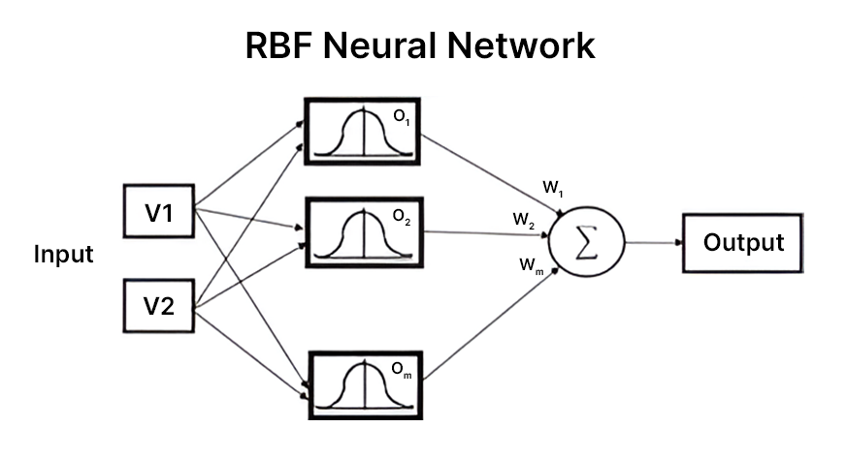
Applications of RBF Neural Network
- Function approximation: RBF networks are effective in approximating complex mathematical functions.
- Pattern recognition: RBF networks can be used for face, fingerprint, and character recognition.
- Time series prediction: RBF networks can capture temporal dependencies and make predictions in time series data.
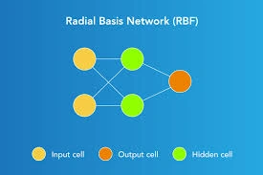
Challenges of RBF Neural Network
- Basis function selection: Choosing appropriate radial basis functions for a specific problem can be challenging.
- Determining the number of basis functions: Determining the optimal number of basis functions to use in an RBF network requires careful consideration.
- Overfitting: RBF networks are prone to overfitting, where the network learns the training data too well and fails to generalize to new, unseen data.
Comparing the Different Types of Neural Networks
Here, I have summarized some of the differences among different types of neural networks:
Neural Network Architecture | Data Type | Recurrent Connections | Parameter Sharing | Spatial Relationship | Vanishing & Exploding Gradient
Single Layer Perceptron | Tabular data | No | No | No | Yes
Multilayer Perceptrons (MLPs) | Tabular data | No | No | No | Yes
Feedforward Neural Networks (FNNs) | Tabular data | No | No | No | Yes
Artificial Neural Network (ANN) | Tabular data | No | No | No | Yes
Recurrent Neural Network (RNN) | Sequence data (Time Series, Text, Audio) | Yes | Yes | No | Yes
Long Short-Term Memory (LSTM) Networks | Sequence data (Time Series, Text, Audio) | Yes | Yes | No | Reduced
Transformer Networks | Sequence data, Image, Text | No | Yes | Yes | Mitigated
Convolution Neural Network (CNN) | Image data | No | Yes | Yes | Yes
Deconvolutional Neural Networks | Image data | No | Yes | Yes | Yes
Autoencoders | Tabular/Image/Text | No | Yes | Yes (CNN-based) | Yes
Generative Adversarial Networks (GANs) | Image/Text/Audio generation | No | Yes | Yes | Yes
Radial Basis Function (RBF) Neural Network | Tabular data | No | No | No | Yes

Why Deep Learning?
It’s a pertinent question. There is no shortage of machine learning algorithms so why should a data scientist gravitate towards deep learning algorithms? What do neural networks offer that traditional machine learning algorithms don’t?
Another common question I see floating around – neural networks require a ton of computing power, so is it really worth using them? While that question is laced with nuance, here’s the short answer – yes!
The different types of neural networks in deep learning, such as convolutional neural networks (CNN), recurrent neural networks (RNN), artificial neural networks (ANN), etc. are changing the way we interact with the world. These different types of neural networks are at the core of the deep learning revolution, powering applications like unmanned aerial vehicles, self-driving cars, speech recognition, etc.
Comparison between Machine Learning & Deep Learning
Although now we understand where and why deep learning is used, it’s natural to wonder – can’t machine learning algorithms do the same? Well, here are two key reasons why researchers and experts tend to prefer Deep Learning over Machine Learning:
- Decision Boundary
- Feature Engineering
Curious? Good – let me explain.
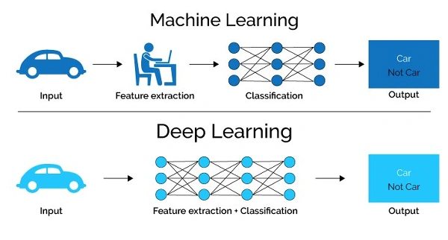
Machine Learning vs. Deep Learning: Decision Boundary
Every Machine Learning algorithm learns the mapping from an input to output. In case of parametric models, the algorithm learns a function with a few sets of weights:
Input -> f(w1,w2…..wn) -> Output
In the case of classification problems, the algorithm learns the function that separates 2 classes – this is known as a Decision boundary. A decision boundary helps us in determining whether a given data point belongs to a positive class or a negative class.
For example, in the case of logistic regression, the learning function is a Sigmoid function that tries to separate the 2 classes:
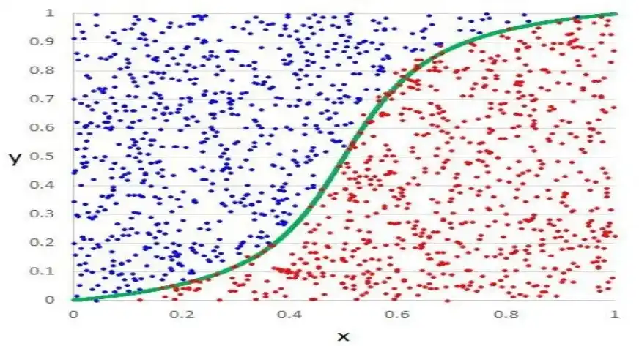
Decision boundary of logistic regression
As you can see here, the logistic regression algorithm learns the linear decision boundary. It cannot learn decision boundaries for nonlinear data like this one:
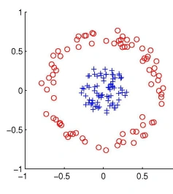
Nonlinear data
Similarly, every Machine Learning algorithm is not capable of learning all the functions. This limits the problems these algorithms can solve that involve a complex relationship. Deep learning models can find patterns and are highly complex compared to Machine Learning models. As mentioned it is a universal approximation algorithm, it can take any decision boundary as required.
Machine Learning vs. Deep Learning: Feature Engineering
Feature engineering is a key step in the model building process. It is a two-step process:
- Feature extraction
- Feature selection
In feature extraction, we extract all the required features for our problem statement and in feature selection, we select the important features that improve the performance of our machine learning or deep learning model.
Consider an image classification problem. Extracting features manually from an image needs strong knowledge of the subject as well as the domain. It is an extremely time-consuming process. Thanks to Deep Learning, we can automate the process of Feature Engineering!

