Understanding Perceptron Loss Function, Hinge Loss, Binary Cross Entropy, and the Sigmoid Function
The realm of machine learning and neural networks is vast, and understanding foundational concepts is crucial for building robust models. In this article, we will explore four fundamental concepts: the Perceptron loss function, Hinge loss, Binary Cross Entropy, and the Sigmoid function. These concepts form the backbone of many machine learning algorithms, especially in the context of classification tasks.
Perceptron Loss Function
The Perceptron is one of the simplest types of artificial neural networks and is used for binary classification tasks. The Perceptron loss function is designed to update the weights of the model based on misclassifications. Mathematically, the Perceptron loss function can be defined as:
Press enter or click to view image in full size
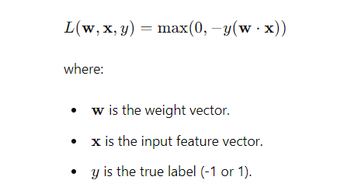
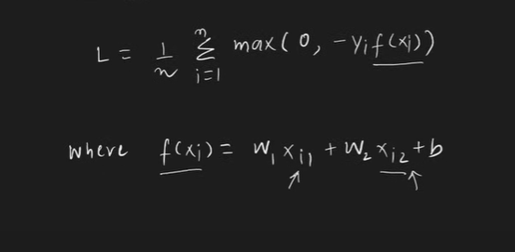

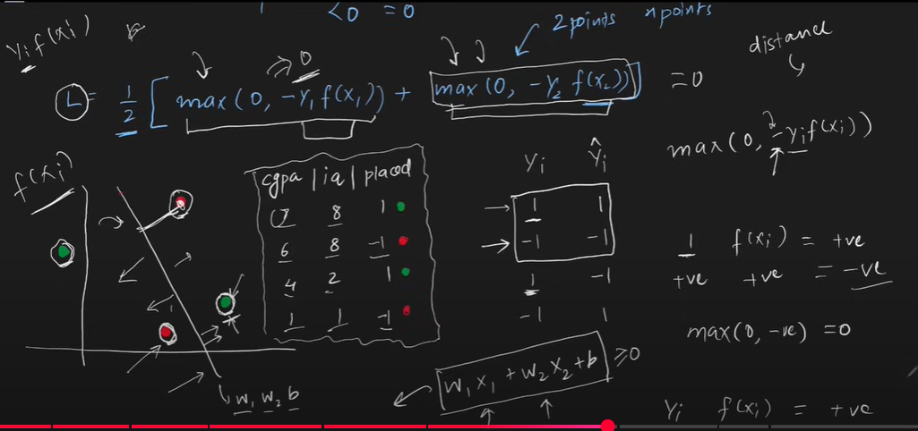

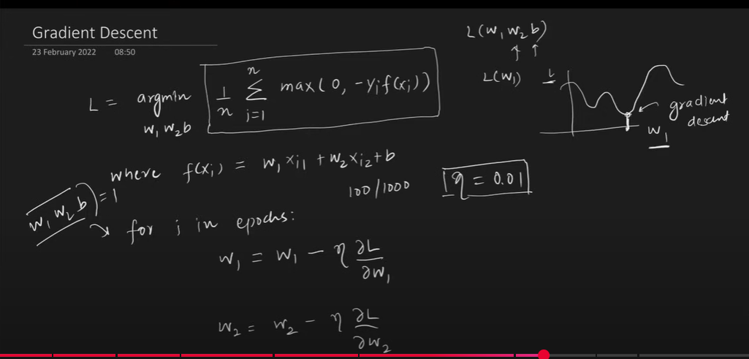

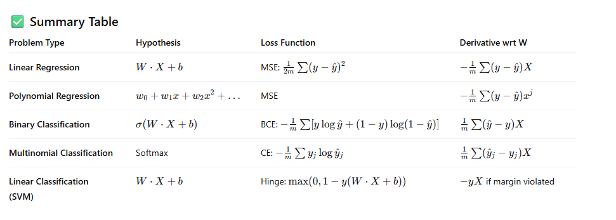

The Perceptron loss function aims to minimize the misclassifications by updating the weights in the direction that reduces the error.
Hinge Loss
Hinge loss is commonly used with Support Vector Machines (SVMs) and is designed to maximize the margin between different classes. It is particularly effective for large-margin classification. The Hinge loss function can be defined as:
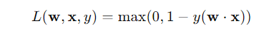
Similar to the Perceptron loss, Hinge loss penalizes misclassifications, but it also introduces a margin of 1. This means that it not only aims to classify correctly but also pushes the decision boundary away from the support vectors.
Implementing Hinge Loss in Python
Here is a simple implementation of the Hinge loss function in Python:
def hinge_loss(w, x, y):
return max(0, 1 - y * np.dot(w, x))

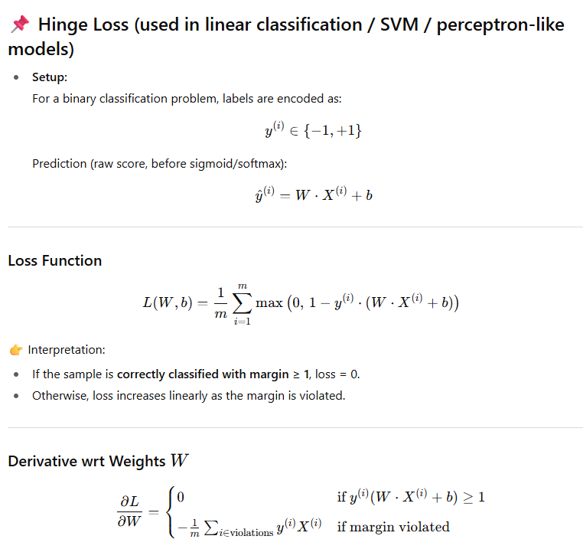

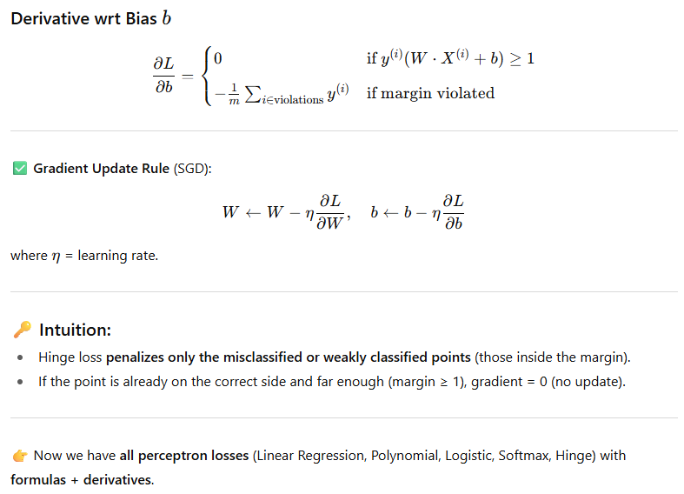

Binary Cross Entropy
Binary Cross Entropy (BCE) is a loss function used for binary classification tasks, often in the context of logistic regression and neural networks. BCE measures the difference between the predicted probability and the actual label. The BCE loss function can be defined as:
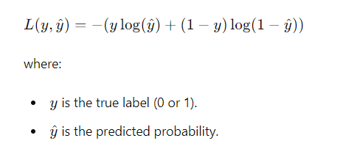
BCE is particularly useful because it provides a smooth gradient, which is essential for optimization algorithms like gradient descent.
Implementing Binary Cross Entropy in Python
Here is a simple implementation of the Binary Cross Entropy loss function in Python:
def binary_cross_entropy(y, y_hat):
return - (y * np.log(y_hat) + (1 - y) * np.log(1 - y_hat))
Sigmoid Function
The Sigmoid function is a crucial component in binary classification models, especially in logistic regression and neural networks. It transforms any real-valued number into a value between 0 and 1, making it suitable for probability estimation. The Sigmoid function can be defined as:
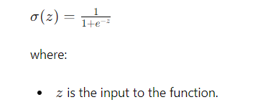
The Sigmoid function is used to convert the output of a linear model into a probability, which can then be used with BCE for optimization.
Implementing Sigmoid Function in Python
Here is a simple implementation of the Sigmoid function in Python:
def sigmoid(z):
return 1 / (1 + np.exp(-z))
Conclusion
Understanding the Perceptron loss function, Hinge loss, Binary Cross Entropy, and the Sigmoid function is essential for anyone delving into machine learning and neural networks. These concepts form the basis of many binary classification algorithms and provide a solid foundation for building more complex models. By mastering these fundamentals, you can develop a deeper understanding of how classification models work and how to optimize them effectively.

Table: Loss Function vs Activation Function vs Output Function
Aspect | Loss Function | Activation Function | Output Function
Definition | A measure of how far predictions are from actual values (error measure). | A mathematical function applied to the output of a neuron to introduce non-linearity. | The final transformation applied to the last layer’s output before comparing with the target.
Purpose | Guides optimization → tells the model how wrong it is. | Helps network learn complex patterns by making neurons non-linear. | Converts raw network scores into a usable format (probabilities, regression values, etc.).
Where used | Used during training phase with backpropagation. | Used in hidden layers and sometimes output layer. | Used at the final layer only before computing loss.
Examples | - Regression: Mean Squared Error (MSE), MAE
- Classification: Cross-Entropy, Hinge Loss | - Sigmoid (0–1)
- Tanh (-1 to 1)
- ReLU (0 to ∞)
- Leaky ReLU, GELU, Swish | - Sigmoid (binary classification)
- Softmax (multi-class classification)
- Linear (regression) |
| Output Type | A single scalar value representing total error. | Transformed hidden layer activations. | Final predicted values (probabilities or continuous outputs). |
| Optimization Role | Directly minimized by optimizers (SGD, Adam). | Helps network converge by controlling gradient flow. | Shapes predictions before loss is calculated. |

🔑 How they connect
- Output Function → Loss Function → Backpropagation.
  - The output function produces predictions.
  - The loss function compares predictions with true labels.
  - The error flows backward using gradients, and activation functions control how neurons update during learning.

👉 Example: Image Classification
- Activation Functions (hidden layers): ReLU
- Output Function (final layer): Softmax
- Loss Function: Cross-Entropy Loss

