Multilayer Perceptron (MLP)

https://playground.tensorflow.org/

What Is a Multilayer Perceptron (MLP)?
A multilayer perceptron is a type of feedforward neural network consisting of fully connected neurons with a nonlinear kind of activation function. It is widely used to distinguish data that is not linearly separable.
Components of an MLP
MLPs have been widely used in various fields, including image recognition, natural language processing, and speech recognition, among others. Their flexibility in architecture and ability to approximate any function under certain conditions make them a fundamental building block in deep learning and neural network research. Let's take a deeper dive into some of its key concepts.
Input layer
The input layer consists of nodes or neurons that receive the initial input data. Each neuron represents a feature or dimension of the input data. The number of neurons in the input layer is determined by the dimensionality of the input data.
Hidden layer
Between the input and output layers, there can be one or more layers of neurons. Each neuron in a hidden layer receives inputs from all neurons in the previous layer (either the input layer or another hidden layer) and produces an output that is passed to the next layer. The number of hidden layers and the number of neurons in each hidden layer are hyperparameters that need to be determined during the model design phase.
Output layer
This layer consists of neurons that produce the final output of the network. The number of neurons in the output layer depends on the nature of the task. In binary classification, there may be either one or two neurons depending on the activation function and representing the probability of belonging to one class; while in multi-class classification tasks, there can be multiple neurons in the output layer.
Weights
Neurons in adjacent layers are fully connected to each other. Each connection has an associated weight, which determines the strength of the connection. These weights are learned during the training process.
Bias neurons
In addition to the input and hidden neurons, each layer (except the input layer) usually includes a bias neuron that provides a constant input to the neurons in the next layer. Bias neurons have their own weight associated with each connection, which is also learned during training.
The bias neuron effectively shifts the activation function of the neurons in the subsequent layer, allowing the network to learn an offset or bias in the decision boundary. By adjusting the weights connected to the bias neuron, the MLP can learn to control the threshold for activation and better fit the training data.
Note: It is important to note that in the context of MLPs, bias can refer to two related but distinct concepts: bias as a general term in machine learning and the bias neuron (defined above). In general machine learning, bias refers to the error introduced by approximating a real-world problem with a simplified model. Bias measures how well the model can capture the underlying patterns in the data. A high bias indicates that the model is too simplistic and may underfit the data, while a low bias suggests that the model is capturing the underlying patterns well.
Activation function
Typically, each neuron in the hidden layers and the output layer applies an activation function to its weighted sum of inputs. Common activation functions include sigmoid, tanh, ReLU (Rectified Linear Unit), and softmax. These functions introduce nonlinearity into the network, allowing it to learn complex patterns in the data.
Feedforward and Backpropagation
MLPs are trained using the backpropagation algorithm, which computes gradients of a loss function with respect to the model's parameters and updates the parameters iteratively to minimize the loss.
How a Multilayer Perceptron Works: Layer by Layer
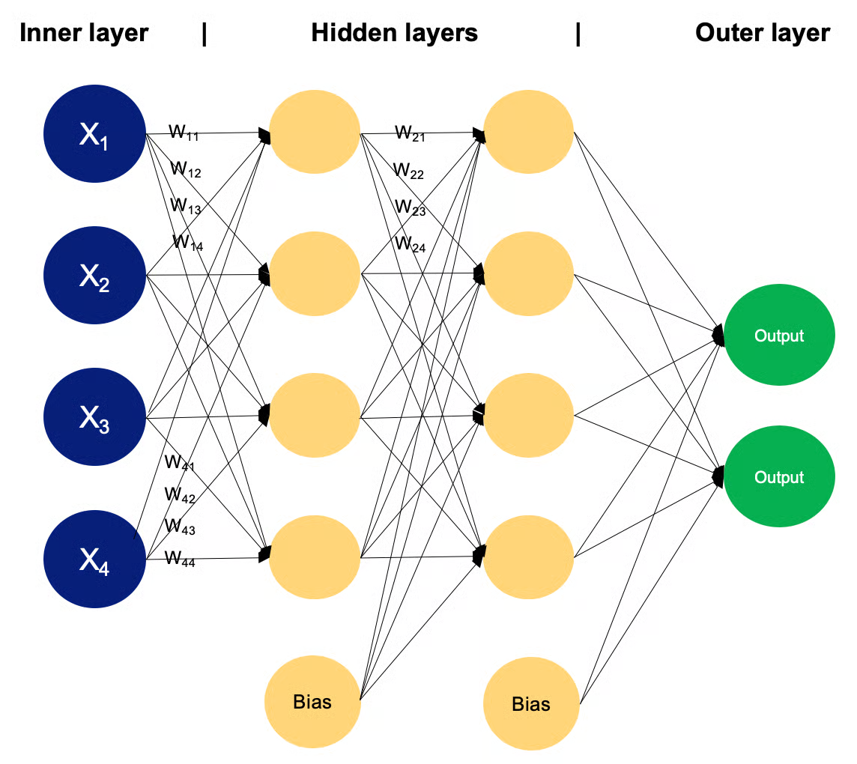
Example of an MLP with two hidden layers. Image by Author
In a multilayer perceptron, neurons process information in a step-by-step manner, performing computations that involve weighted sums and nonlinear transformations. Let's walk layer by layer to see the magic that goes within.
Input layer
- The input layer of an MLP receives input data, which could be features extracted from the input samples in a dataset. Each neuron in the input layer represents one feature.
- Neurons in the input layer do not perform any computations; they simply pass the input values to the neurons in the first hidden layer.
Hidden layers
- The hidden layers of an MLP consist of interconnected neurons that perform computations on the input data.
- Each neuron in a hidden layer receives input from all neurons in the previous layer. The inputs are multiplied by corresponding weights, denoted as w. The weights determine how much influence the input from one neuron has on the output of another.
- In addition to weights, each neuron in the hidden layer has an associated bias, denoted as b. The bias provides an additional input to the neuron, allowing it to adjust its output threshold. Like weights, biases are learned during training.
- For each neuron in a hidden layer or the output layer, the weighted sum of its inputs is computed. This involves multiplying each input by its corresponding weight, summing up these products, and adding the bias:
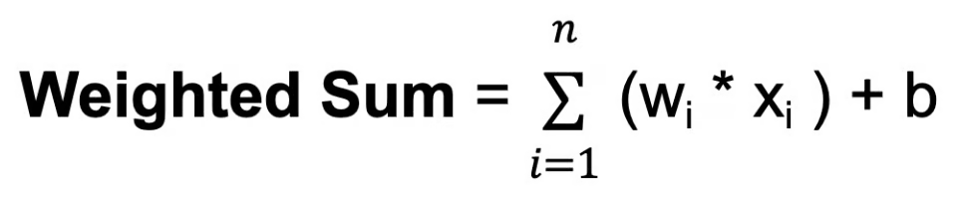
Where n is the total number of input connections, w_{i} is the weight for the i-th input, and x_{i} is the i-th input value.
- The weighted sum is then passed through an activation function, denoted as f. The activation function introduces nonlinearity into the network, allowing it to learn and represent complex relationships in the data. The activation function determines the output range of the neuron and its behavior in response to different input values. The choice of activation function depends on the nature of the task and the desired properties of the network.
Output layer
- The output layer of an MLP produces the final predictions or outputs of the network. The number of neurons in the output layer depends on the task being performed (e.g., binary classification, multi-class classification, regression).
- Each neuron in the output layer receives input from the neurons in the last hidden layer and applies an activation function. This activation function is usually different from those used in the hidden layers and produces the final output value or prediction.
During the training process, the network learns to adjust the weights associated with each neuron's inputs to minimize the discrepancy between the predicted outputs and the true target values in the training data. By adjusting the weights and learning the appropriate activation functions, the network learns to approximate complex patterns and relationships in the data, enabling it to make accurate predictions on new, unseen samples.
This adjustment is guided by an optimization algorithm, such as stochastic gradient descent (SGD), which computes the gradients of a loss function with respect to the weights and updates the weights iteratively.
Let’s take a closer look at how SGD works.
Stochastic Gradient Descent (SGD)
- Initialization: SGD starts with an initial set of model parameters (weights and biases) randomly or using some predefined method.
- Iterative optimization: The aim of this step is to find the minimum of a loss function, by iteratively moving in the direction of the steepest decrease in the function's value. For each iteration (or epoch) of training:
  - Shuffle the training data to ensure that the model doesn't learn from the same patterns in the same order every time.
  - Split the training data into mini-batches (small subsets of data).
  - For each mini-batch:
    - Compute the gradient of the loss function with respect to the model parameters using only the data points in the mini-batch. This gradient estimation is a stochastic approximation of the true gradient.
    - Update the model parameters by taking a step in the opposite direction of the gradient, scaled by the learning rate:
θₜ₊₁ = θₜ − η ∇J(θₜ)
Powered By
Where:
- θₜ represents the model parameters (e.g., weights and biases) at iteration t
- ∇J(θₜ) is the gradient of the loss function J with respect to the parameters at iteration t
- η (eta) is the learning rate, which controls the step size during optimization
- Direction of descent: The gradient of the loss function indicates the direction of the steepest ascent. To minimize the loss function, gradient descent moves in the opposite direction, towards the steepest descent.
- Learning rate: The step size taken in each iteration of gradient descent is determined by a parameter called the learning rate, denoted above as n. This parameter controls the size of the steps taken towards the minimum. If the learning rate is too small, convergence may be slow; if it is too large, the algorithm may oscillate or diverge.
- Convergence: Repeat the process for a fixed number of iterations or until a convergence criterion is met (e.g., the change in loss function is below a certain threshold).
Stochastic gradient descent updates the model parameters more frequently using smaller subsets of data, making it computationally efficient, especially for large datasets. The randomness introduced by SGD can have a regularization effect, preventing the model from overfitting to the training data. It is also well-suited for online learning scenarios where new data becomes available incrementally, as it can update the model quickly with each new data point or mini-batch.
However, SGD can also have some challenges, such as increased noise due to the stochastic nature of the gradient estimation and the need to tune hyperparameters like the learning rate. Various extensions and adaptations of SGD, such as mini-batch stochastic gradient descent, momentum, and adaptive learning rate methods like AdaGrad, RMSProp, and Adam, have been developed to address these challenges and improve convergence and performance.
You have seen the working of the multilayer perceptron layers and learned about stochastic gradient descent; to put it all together, there is one last topic to dive into: backpropagation.

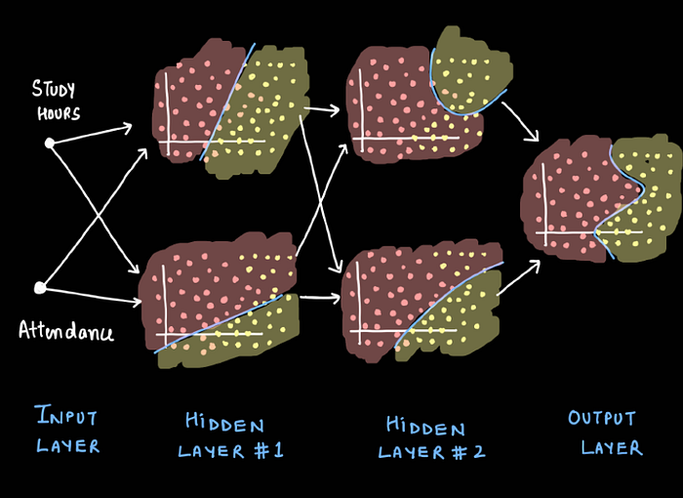
In this article, I will explain the intuitive workings behind Multi-Layer Perceptrons (MLPs), a critical concept in advanced neural networks. You’ll learn about the following:
- Limitations of the Perceptron: I will explain why a single perceptron is insufficient for handling complex data.
- The intuition behind the MLPs: You will get the essence and visualization of how the multi-layer perception works.
- Download PDF Notes: At the end, download notes to review anytime.
What is the issue with Perceptron?
The main issue with perception is that it can only learn linearly separable patterns. It works by finding a linear boundary (decision boundary) that separates the data points of different classes. If the data is not linear, then a perception won’t be able to classify the data points correctly.
Consider a student performance dataset. We use two features, study hours and attendance, to predict whether students will pass or fail their exams. Each data point represents a student’s performance. The yellow data points indicate students who passed the exam, while the pink points represent those who failed.
Press enter or click to view image in full size
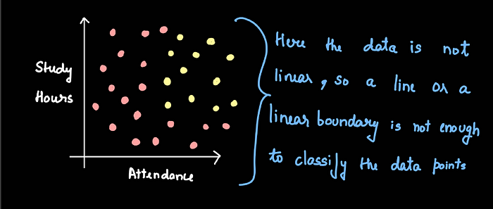
This graph shows student data points plotted by ‘Study Hours’ and ‘Attendance,’ with yellow points representing students who passed and pink points representing those who failed.
Press enter or click to view image in full size
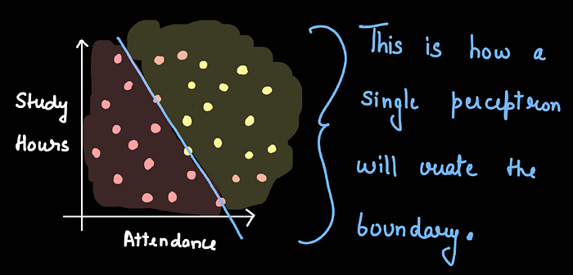
This is how a single perceptron will separate a non-linear data points.
The data is not linearly separable. Therefore, a single perceptron cannot give us an ideal decision boundary that separates the data points of the two different classes. So, we can conclude that a single perceptron will work perfectly for linear data but not for non-linear datasets.
Press enter or click to view image in full size
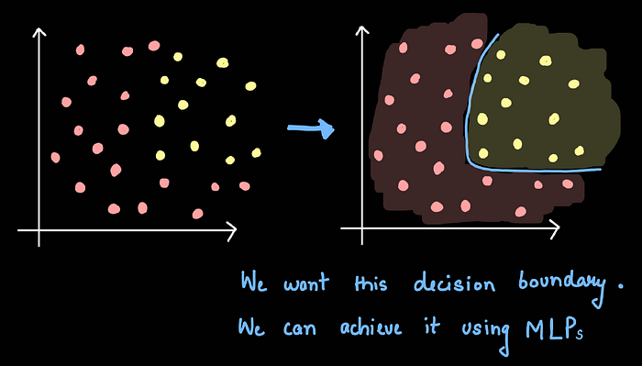
We want this decision boundary to easily separate the non-linear data points and it can only be achieved using multi-layer perceptrons.
In order to correctly classify the non-linear data points, we have to use multiple perceptrons, which we will see in the next section.
The Intuition Behind Multiple Perceptrons
We have non-linear data points, as we saw in our example. Therefore, a single perceptron won’t work. Now assume that we have two perceptrons, each creating a different decision boundary, as seen in the image below. Neither of these is able to correctly classify the data points. But what if we add or superimpose the results of perceptrons 1 and 2?
Press enter or click to view image in full size
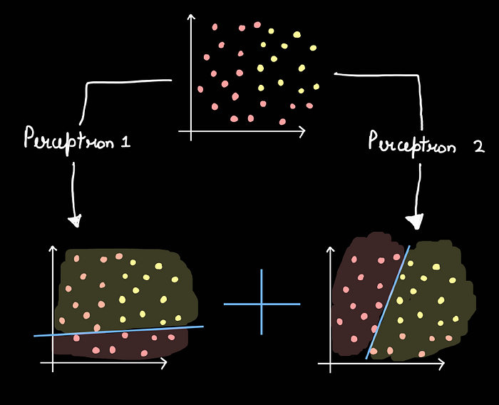
This image demonstrates two perceptrons working on the same dataset to produce different decision boundaries.
Now, let us superimpose the results of perceptron 1 and perceptron 2; the resulting graph is shown in the image below.
Press enter or click to view image in full size
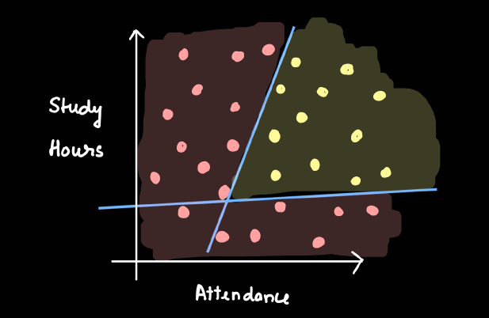
This image shows the superimposition of results of perceptron 1 and 2.
Now, let’s smoothen the curve, as shown in the image below. This is what we wanted from the start. Until now, I have explained it visually without delving into the mathematical details. In the next section, I will explain the mathematics behind it.
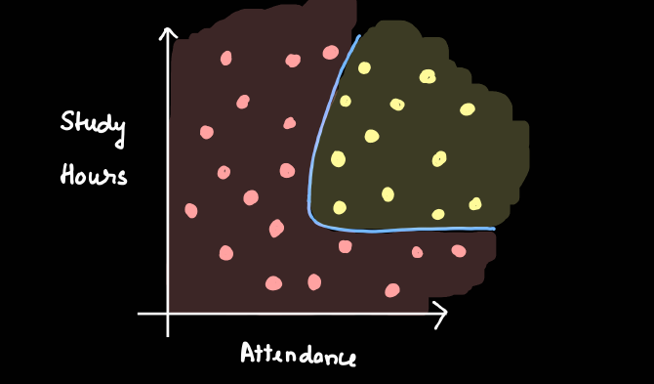
This images shows the smoothing of the curve after the superimposition of results of perceptron 1 and 2.
Mathematics Behind It
Let us now examine this mathematically. I randomly selected a student, as shown in the image below. The probability of this student passing the exam from perceptron 1 is 0.8, and from perceptron 2 is 0.7. The main question here is how we combine these probabilities. We cannot simply add them, as the result (0.7 + 0.8 = 1.5) would exceed 1. Therefore, after adding, we must apply the sigmoid function to bring it within the range of 0 to 1.
Press enter or click to view image in full size
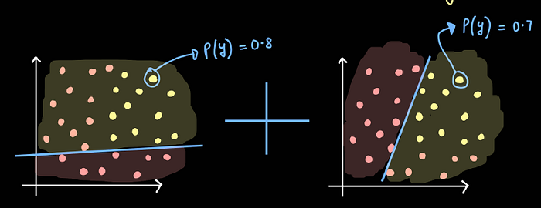
This image displays a randomly selected point along with its respective probabilities from Perceptron 1 (on the left) and Perceptron 2 (on the right).
Now, add the two probabilities
Combined probability = 0.8 + 0.7 = 1.5 (Not In the range)
Apply Sigmoid function = σ(z) = σ(1.5) = 0.82
Similarly, we have to do this for every student in the dataset to get the new decision boundary.
Press enter or click to view image in full size
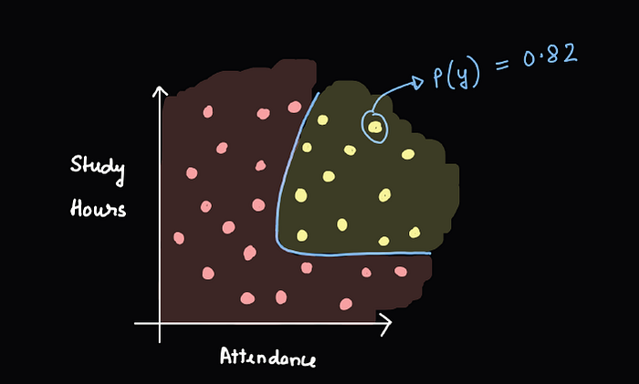
The image illustrates the combined probability of the student after we summed the individual probabilities and applied the sigmoid function.
In short, we are calculating new probabilities by combining the outputs from two perceptrons. First, we add the probabilities from each perceptron. Since the sum can exceed 1, we then apply the sigmoid function to adjust these values into a valid probability range between 0 and 1. This process of adding and adjusting with the sigmoid function is crucial as it results in the superimposition and smoothing of the decision curve.
Intuition Behind Multi-Layer Perceptron
Before we move on to the multi-layer perceptron, let’s consider what factors can affect the linear combination of perceptrons. Now, I want to add more flexibility to the linear combination of multiple perceptrons by introducing the concept of weights. What if we want the output of perceptron 1 to dominate heavily compared to that of perceptron 2? As shown in the image below, the impact of the decision boundary from perceptron 1 is greater than that from perceptron 2. How can we achieve this?
Press enter or click to view image in full size
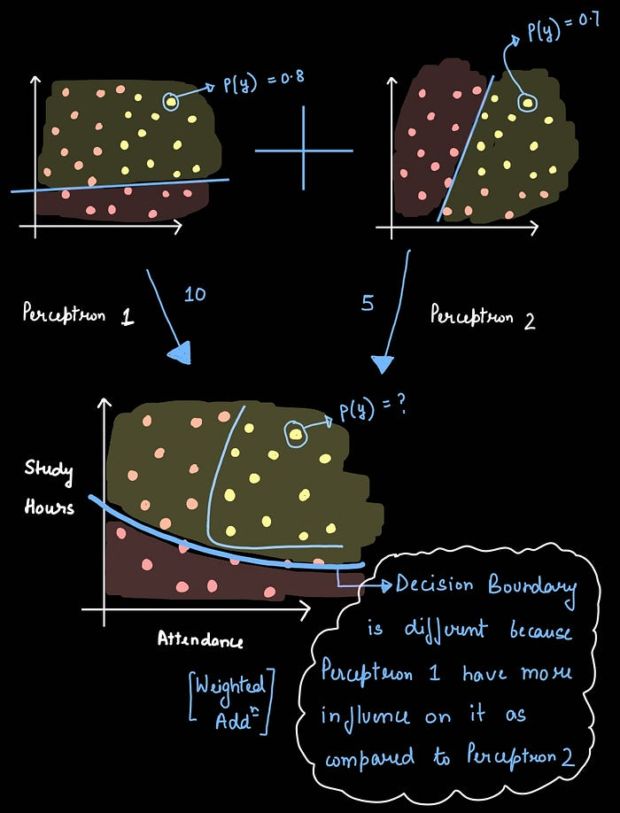
This image illustrates the role of weights in perceptrons, clearly showing that the impact of Perceptron 1 on the final decision boundary is much greater than that of Perceptron 2.
We can achieve this by performing a weighted addition of the two probabilities and assigning a specific weight to each perceptron. In our example, let’s assume the weight for perceptron 1 is 10 and for perceptron 2 is 5. After calculating the weighted sum, we apply the sigmoid function to ensure the resulting probability falls within the range of 0 to 1.
Weighted Addition : z = 10(0.8) + 5 (0.7)
Apply Sigmoid Function: σ(z)
Additionally, we can also introduce a bias to the system. Assume that the bias in the system is 3. Now, let’s perform the weighted addition again, add the bias, and then apply the sigmoid function.
Weighted Addition : z = 10(0.8) + 5 (0.7) + 3
Apply Sigmoid Function: σ(z)
Press enter or click to view image in full size
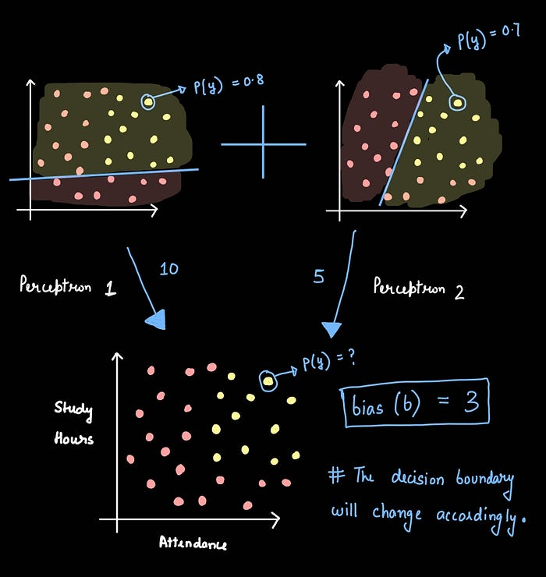
This image illustrates the role of bias in the system and how it can affect the decision boundary.
In a sense, the third white circle acts as a perceptron itself. The outputs of perceptron 1 and 2 serve as inputs for perceptron 3. Thus, we can say that we have a combination of three perceptrons, which can also be referred to as a Multi-layer Perceptron.
Press enter or click to view image in full size
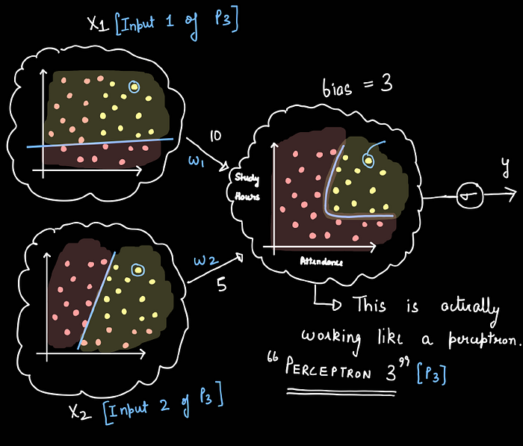
The image shows that the third white circle is actually behaving like a perceptron, with inputs coming from the outputs of Perceptron 1 and 2.
X1 is the output of perceptron 1 and W1 is the weight of the connection from perceptron 1 to perceptron 3. Similarly, X2 is the output of perceptron 2 and W2 is the weight of the connection from perceptron 1 to perceptron 2. We can also redraw the whole thing in a simple way as shown below.
Press enter or click to view image in full size
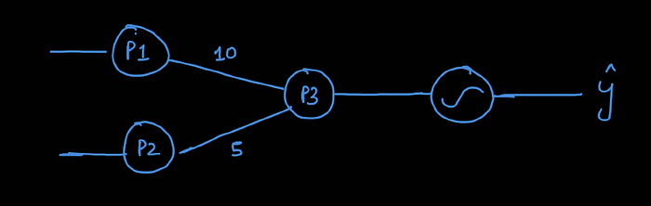
This image simplifies the concept of a multi-layer perceptron
This is essentially a linear combination of perceptrons, which we refer to as a multi-layer perceptron. For a more detailed explanation, please refer to the notes provided at the end of the article.
How can we change the architecture?
The design of a basic neural network can be altered in several different ways to suit specific requirements. The approach to modifying a neural network often depends on the specific tasks we want it to perform or the particular problems we need it to solve. Below, I have outlined multiple approaches for redesigning the network’s structure.
1) Add nodes in the Hidden layer
Increasing the number of nodes in the hidden layers is akin to adding more processing power to your network. More nodes can detect more subtle and complex features in the data, which can lead to better and more nuanced predictions.
Press enter or click to view image in full size
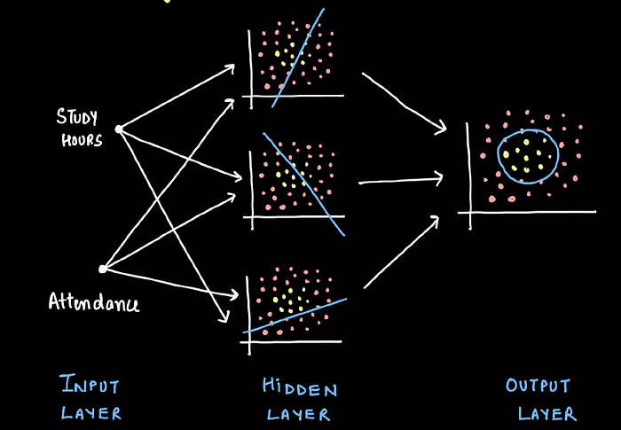
Architecture with more number of nodes in the Hidden layer
This is especially useful for complex problems where the relationships between data points are not immediately obvious.
2) Increase the number of inputs
Expanding the input layer to include more features enriches the initial data fed into the network. If we start with only two inputs, the neural network uses a simple line as a decision boundary to separate different outputs. By adding a third input, this decision boundary transforms into a plane, allowing for more complex and nuanced separations between categories.
Press enter or click to view image in full size
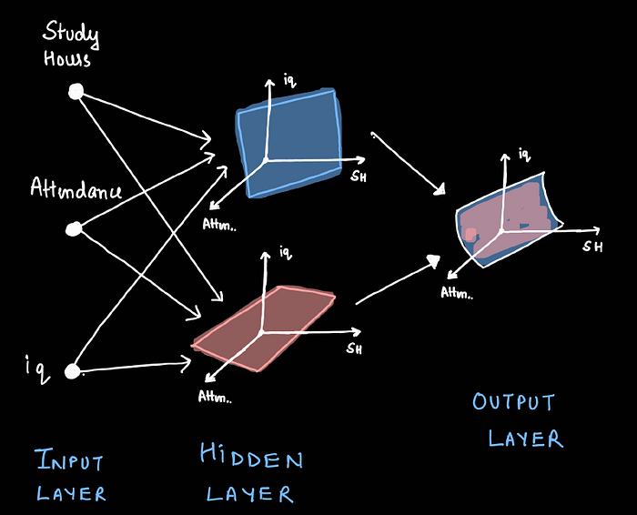
Architecture with more number of inputs features
As we continue to add more inputs, these decision boundaries evolve into multi-dimensional shapes. This enhancement significantly improves the network’s ability to classify data accurately.
3) Add nodes in the Output layer
When we add nodes to the output layer of a neural network, it allows the network to make more distinctions among the outputs it produces. Initially, if the network is designed to make simple decisions, like categorizing images as either cats or dogs, it may only need two output nodes — one for each category. However, if we want the network to differentiate between various breeds within those categories, adding more nodes to the output layer becomes necessary.
Press enter or click to view image in full size
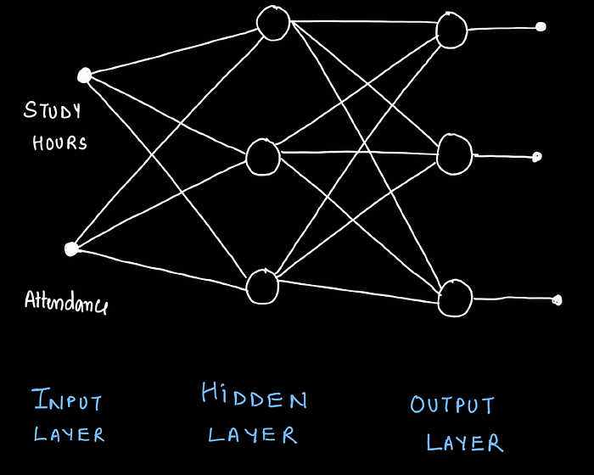
Architecture with more number of nodes in the Output layer
For example, suppose we want our network not just to recognize cats and dogs, but to identify specific breeds like Siamese, Persian, Labrador, and Golden Retriever. In this case, we would add more nodes — each one corresponding to one of these breeds. This way, each additional node can represent a new category, which allows the network to classify inputs into more specific groups.
4) Add more hidden layers
Adding more hidden layers to a neural network, as illustrated in the image below, is like adding extra levels of processing or filtering to enhance its understanding of the input data. With a single hidden layer, the network might only be able to make basic predictions based on direct relationships, such as more hours studied leads to better performance. However, by adding a second hidden layer, the network can start to understand more complex patterns, such as how consistent study habits over time, combined with regular attendance, might influence performance differently than just cramming before exams.
Press enter or click to view image in full size
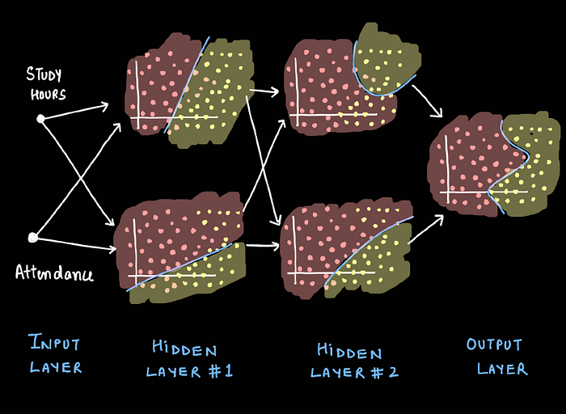
Architecture with more number of hidden layers
Each layer in a multilayer network can learn different aspects of the data. The first hidden layer might detect simple patterns, while the second layer builds on those findings to recognize more abstract concepts. This layering effect enables the network to make more nuanced decisions based on deeper insights into the data.
Adding more hidden layers can significantly increase the learning capability of the network, allowing it to solve more complex problems. However, it’s important to balance the number of layers with the available data and computational resources, as too many layers can lead to overfitting, where the model learns the training data too well but performs poorly on new, unseen data.

MLP Notations
The most difficult thing to understand while working with neural networks is the back-propagation algorithm we used to train a neural network to update weights and biases recursively and reach the highest accuracy.
Now while training a neural network, there are lots of weights and biases exits in a neural network, and a back-propagation is also a process of updating weights and biases, so notations of all different weights and biases become a pre-requisite to understanding core intuition of the back-propagation of the neural networks.
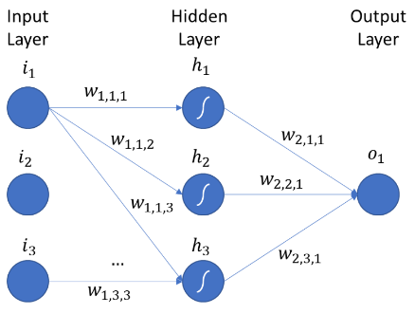Source: https://images.app.goo.gl/N26aYqQ8uTKEuX3p8
The above picture shows the Multi-layer neural network having an input layer, a hidden layer, and an output layer.
1. Notation for Weights :
Notation: W_{ij}^{h}
where,
i = From which node weight is passing to the next layer’s node.
j= To which node weight is arriving.
h = Layer in which weight is arriving.
Example:
W₁₁¹ = Weight passing into 1st node of 1st layer of 1st node of the previous layer.
W₂₃¹ = Weight passing into the 3rd node of the 1st hidden layer from the 2nd node of the previous layer.
W₄₅¹ = Weight passing into the 5th node of the 2nd hidden layer from the 4th node of the previous layer.
2. Notations for Biases :
Notation: b_{ij}
Where,
i = Layer to which a bias belongs.
j = node to which a bias belongs.
Example:
b₁₁ = biases of 1st node of 1st hidden layer.
b₂₃ = bias of 3rd of 2nd hidden layer.
b₄₁ = bias of 1st node of 4th hidden layer.
3. Notations for Outputs:
Notation: O_{ij}
Where,
i = Layer to which a bias belongs.
j = node to which a bias belongs.
Example:
O₁₁ = Output of 1st node of 1st hidden layer.
O₄₅ = Output of 5th of 4th hidden layer.
O₃₄ = Output of 4th node of 3rd hidden layer.
Calculating Total Trainable Parameters
Total Trainable Parameters for a given between 2 layers of an artificial neural network is a sum of total weights and total biases that exist between them.
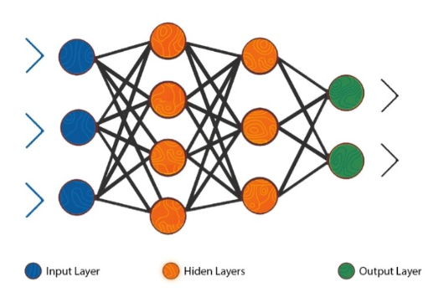Source: https://images.app.goo.gl/4WeyHPT2aTEZbh1XA
Total Trainable Parameters Between two layers in a Neural Network = [ Number of Nodes in the first layer * Number of nodes in the second layer ] (Weights) + [ Number of nodes in the second layer ] (Biases)
1. Trainable Parameters Between the Input layer and First Hidden Layer:
weights = 3 * 4 = 12
biases = 4 (4 nodes in 1st hidden layer)
Trainable Parameters = weights + biases
= 12 + 4
= 16
2. Trainable Parameters Between First Hidden layer and Second Hidden Layer:
weights = 4 * 2 = 8
biases = 2 (2 nodes in 1st hidden layer)
Trainable Parameters = weights + biases
= 8 + 2
= 10
3. Trainable Parameters Between Second Hidden layer and Output Layer:
weights = 2 * 2 = 4
biases = 2 (2 nodes in 1st hidden layer)
Trainable Parameters = weights + biases
= 4 + 2
= 6

Multilayer Perceptron (MLP)
Moving onwards, multi-layer perceptron, also known as feed-forward neural networks, consists of a sequence of layers each fully connected to the next one.
A multilayer perceptron (MLP) has one or more hidden layers along with the input and output layers, each layer contains several neurons that interconnect with each other by weight links. The number of neurons in the input layer will be the number of attributes in the dataset, neurons in the output layer will be the number of classes given in the dataset.
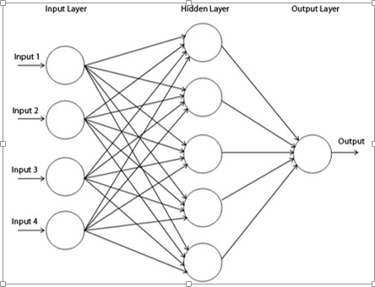 Figure 2
Figure 2 shows a multilayer perceptron where we have three layers at least and each layer is connected to the last one. To make the architecture deep, we need to introduce multiple hidden layers.

Initialization of the parameters
Initialization of the parameters, weights and biases plays an important role in determining the final model. There is a lot of literature on initialization strategy.
A good random initialization strategy can avoid getting stuck at local minima. Local minima problem is when the network gets stuck in the error surface and does not go down while training even when there is capacity left for learning.
Doing experiment by using various initialization strategies is out of the scope of this research work.
The initialization strategy should be selected according to the activation function used. For tanh the initialization interval should be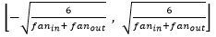 where is the number of units in the (i-1)-th layer, andis the number of units in the ith layer. Similarly for the sigmoid activation function the initialization interval should be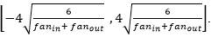. These initialization strategies ensure that information propagated upwards and backwards in the network at the early stage of training.

Activation function
https://www.v7labs.com/blog/neural-networks-activation-functions
Significance of Activation Functions in Neural Networks
Activation functions helps to map the output of a neural network within a range like (0,1) or (−1,+1). For instance, if the trend or characteristic of the output is like linear function extending from −∞ to +∞, nonlinear activation function can be used to confine it in a finite range. The output transferred to finite range are easy to understand and interpret.
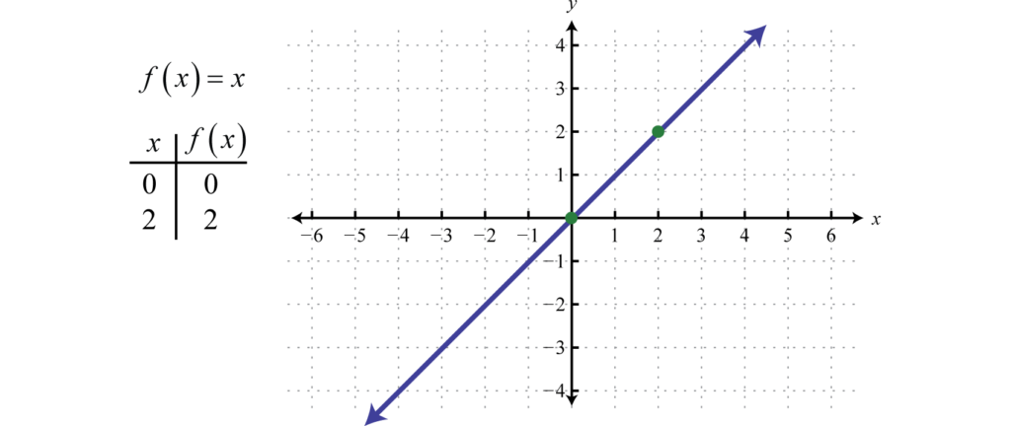
Figure 1. Output behaviour without activation function (source: saylordotorg.github.io)
The essential characteristics of activation functions are as follows:
- The activation functions should be differentiable. This means we should be able to track the change in 𝑦-axis (vertical axis) of an activation function in response to the 𝑥-axis (horizontal axis). The ratio of change in 𝑦-axis to the change in 𝑥-axis between any two distinct points on a line is called slope.
- The activation functions should be monotonic. The monotonic functions will either increase or decrease in the entire range of consideration.
The following part of this article gives a glimpse of commonly used activation functions in neural networks.

The activation function defines the output of a neuron in terms of the induced local field v as:
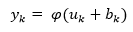
where φ(.) is the activation function. There are various types of activation functions, the following are the commonly used ones:
1. Unit step (threshold function)
The output is set at one of two levels, depending on whether the total input is greater than or less than some threshold value.
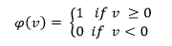
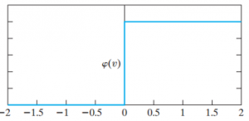
Figure 2
Figure 2 indicates that either the neuron is fully active or not. However, this function is not differentiable which is quite vital when using the back-propagation algorithm (explained later).
2. Sigmoid Function
The sigmoid function is a logistic function bounded by 0 and 1, as with the threshold function, but this activation function is continuous and differentiable.
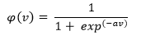
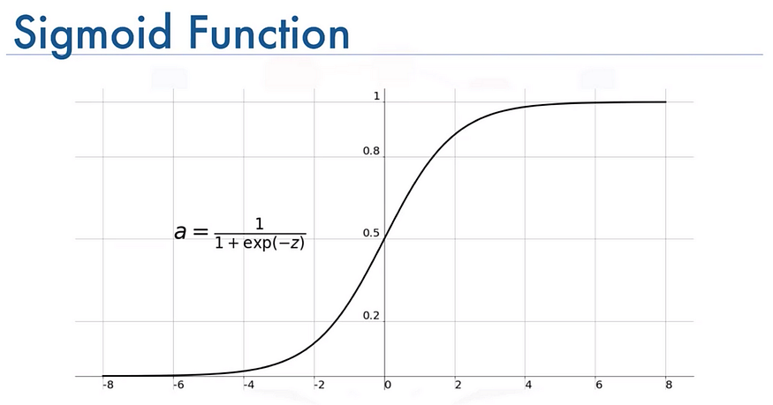

Figure 2. Sigmoid activation function (source: Wikipedia)
The sigmoid function confine to the range of 0 to 1. The probability of any outcome also belongs to the range of 0 to 1. Hence, sigmoid function serves as a suitable choice of activation function in models which are meant to predict probability.
The sigmoid function is also called logistic activation function as it is used in logistic regression for binary classification. Softmax function is more generalized version of the logistic activation function used for multiclass classification.
The softmax function is differentiable as well as monotonic in nature. However, the derivative of this function is not monotonic. The sigmoid function output is not zero-centered and often encounter vanishing gradient problem. This increases the model complexity.

where α is the slope parameter of the above function. Moreover, it is nonlinear in nature that helps to increase the performance making sure that small changes in the weights and bias causes small changes in the output of the neuron.
SoftMax function: -
Before exploring the ins and outs of the Softmax activation function, we should focus on its building block—the sigmoid/logistic activation function that works on calculating probability values.
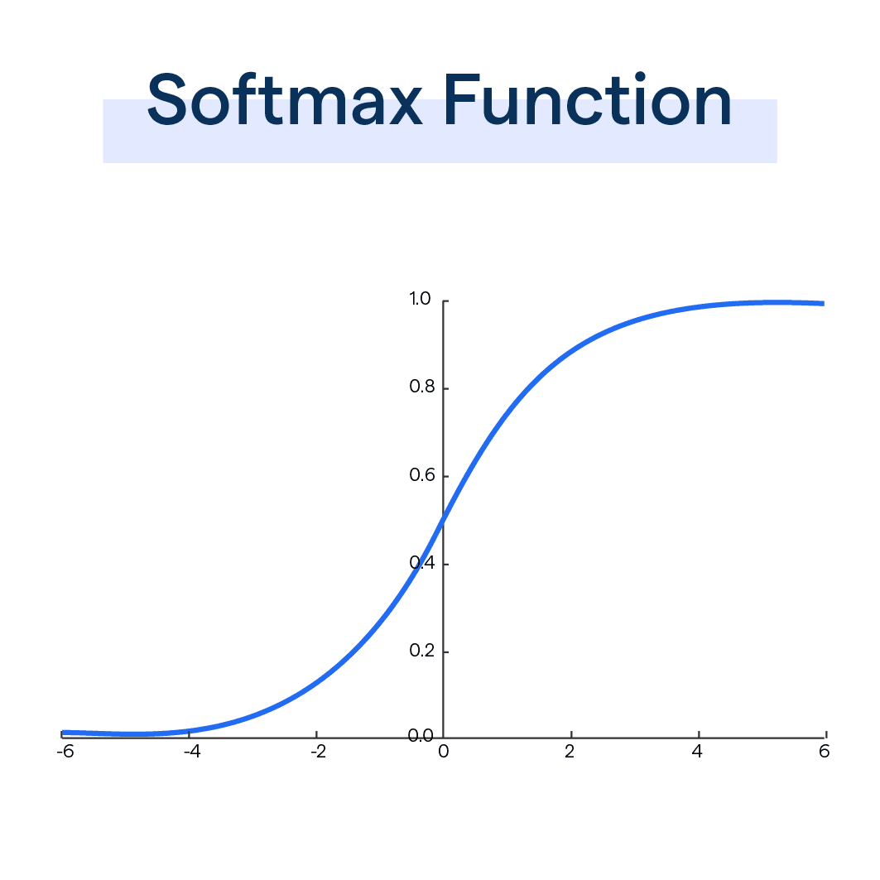

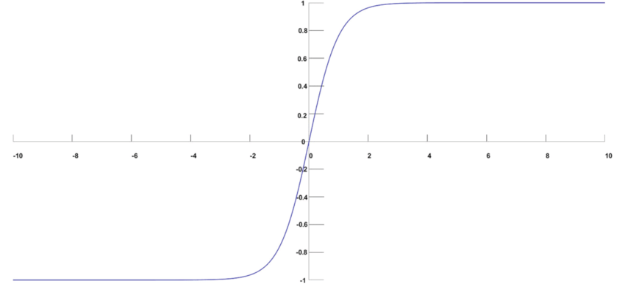

‍The output of the sigmoid function was in the range of 0 to 1, which can be thought of as probability.
But—
This function faces certain problems.
Let’s suppose we have five output values of 0.8, 0.9, 0.7, 0.8, and 0.6, respectively. How can we move forward with it?
The answer is: We can’t.
The above values don’t make sense as the sum of all the classes/output probabilities should be equal to 1.
You see, the Softmax function is described as a combination of multiple sigmoids.
It calculates the relative probabilities. Similar to the sigmoid/logistic activation function, the SoftMax function returns the probability of each class.
It is most commonly used as an activation function for the last layer of the neural network in the case of multi-class classification.
Mathematically it can be represented as:
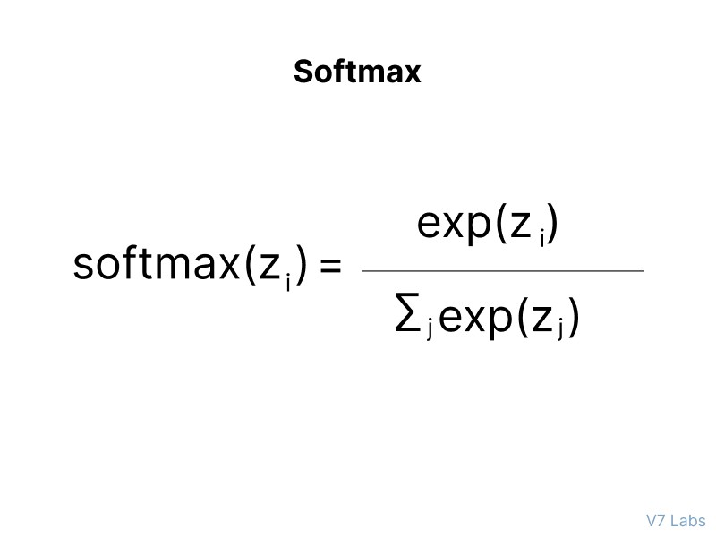
Let’s go over a simple example together.
Assume that you have three classes, meaning that there would be three neurons in the output layer. Now, suppose that your output from the neurons is [1.8, 0.9, 0.68].
Applying the softmax function over these values to give a probabilistic view will result in the following outcome: [0.58, 0.23, 0.19].
The function returns 1 for the largest probability index while it returns 0 for the other two array indexes. Here, giving full weight to index 0 and no weight to index 1 and index 2. So the output would be the class corresponding to the 1st neuron(index 0) out of three.
You can see now how softmax activation function make things easy for multi-class classification problems.

When is the Softmax Function Used?
The Softmax Function comes into its own when dealing with multi-class classification tasks in machine learning. In these scenarios, you need your model to predict one out of several possible outcomes.
Softmax is typically applied in the final layer of a neural network during the training phase, converting raw output scores from previous layers into probabilities that sum up to one.

The Benefit of Softmax
The key advantage of the Softmax function is that it highlights the largest values and suppresses values which are significantly below the maximum value.
This behavior is very useful in multiclass classification problems where the model needs to be confident in its predictions, hence the extensive use of the Softmax function in deep learning for normalizing the output layer.

3. Hyperbolic Tangent Function
φ (v) = tanh (v)
Hyperbolic tangent (Tanh)
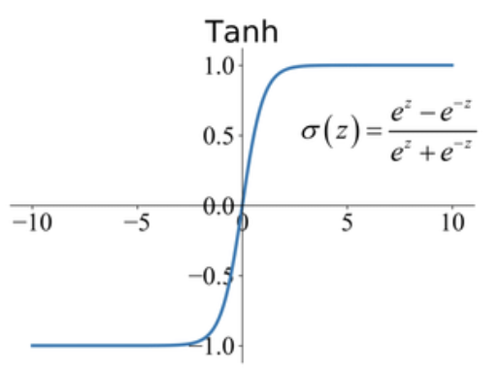
Figure 5. Tanh activation function (source: Papers With Code)
Tanh is an activation function with S-shaped response as in the figure in the range −1 to +1. It is mainly used for classification purposes. The Tanh activation function maps the zero input values to nearly zero values and the negative values in input data to strongly negative values.
The Tanh function is monotonic in response and differentiable. However, the derivative of the Tanh function is not monotonic. The Tanh function is more similar to the sigmoid function and hence this function is computationally expensive.

This function enables activation functions to range from -1 to +1.
4. Rectified Linear Activation function (ReLU)

Rectified Linear Unit (ReLU)
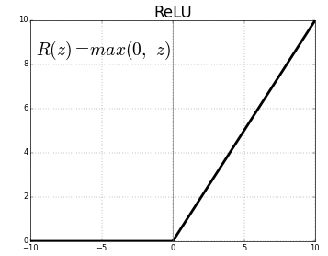
Figure 3. ReLU activation function (source: Analytics Vidhya)
As the name suggests, ReLU follows a partially rectified pattern as demonstrated in Fig.3. ReLU is nowadays a favorite choice of activation function in most convolutional neural networks. The range of ReLU is 0 to infinity. The function as well as its derivative is monotonic in its characteristic behaviour.
ReLU fails to fit the entire data if it is a mix of positive as well as negative values. As rightly demonstrated in Fig.3. , 𝑅⁡(𝑧) is zero for 𝑧 values less than zero. This implies ReLU converts the negative input values to zero which in turn results in inappropriate mapping of negative data points. This situation is called the dying ReLU problem. Leaky ReLU is an activation function with slight modification to ReLU to overcome the dying ReLU problem.
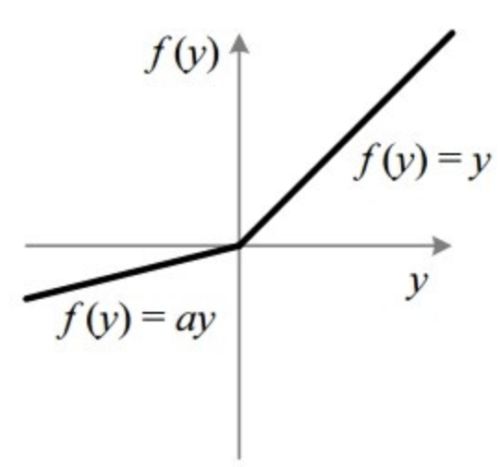
Figure 4. Leaky ReLU activation function (source: Papers With Code)
The range of leaky ReLU function is from −∞ to +∞. As evident in Figure 4., while using the leaky ReLU function, the function 𝑓⁡(𝑦) will not dye out for negative input values of 𝑦.
The typical value of the coefficient “𝑎” is 0.01. In some problems, 𝑎 is assigned with random values different from the value 0.01. Such ReLU functions with randomly assigned “𝑎” values are called Randomized ReLU. ReLU functions and its derivatives in general are monotonic.

5. Maxout function
In 2013, Goodfellow found out that the Maxout network using a new activation function is a natural companion to dropout.
Maxout units facilitate optimization by dropout and improve the accuracy of dropout’s fast approximate model averaging technique. A single maxout unit can be interpreted as making a piece wise linear approximation to an arbitrary convex function.
Maxout networks learn not just the relationship between hidden units, but also the activation function of each hidden unit. Below is the graphical depiction of how this works:
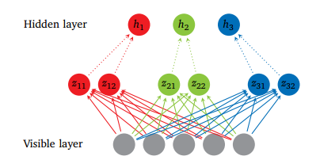
Figure 4
Figure 4 shows the Maxout network with 5 visible units, 3 hidden units and 2 pieces for each hidden unit.
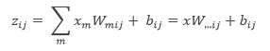
where is the mean vector of size of the input obtained by accessing the matrix W ∈ at the second coordinate i and third coordinate j . The number of intermediate units ( k ) is called the number of pieces used by the Maxout nets.

Backpropagation Algorithm
The back-propagation algorithm can be used to train feed forward neural networks or multilayer perceptrons. It is a method to minimize the cost function by changing weights and biases in the network. To learn and make better predictions, a number of epochs (training cycles) are executed where the error determined by the cost function is backward propagated by gradient descent until a sufficiently small error is achieved.

Gradient descent
1. Mini-Batch Gradient Descent
Let’s say in 100-sized mini-batch, 100 training examples are shown to the learning algorithm and weights are updated accordingly. After all mini-batches are presented sequentially, the average of accuracy levels and training cost levels are calculated for each epoch.
2. Stochastic Gradient Descent
Stochastic gradient descent is used in the real-time on-line processing, where the parameters are updated while presenting only one training example, and so average of accuracy levels and training costs are taken for the entire training dataset at each epoch.
3. Full batch Gradient Descent
In this method all the training examples are shown to the learning algorithm and the weights are updated.

Cost Function
There are various cost functions. Below are some examples:
1. Mean Squared Error Function
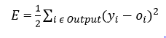
where is the predicted output is the actual output
2. Cross-Entropy Function
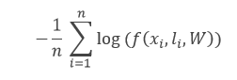
where the f function is the model’s predicted probability for the input label to be, W are its parameters, and n is the training-batch size.
3. Negative Log-Likelihood Loss (NLL) function
NLL is the cost function used in all the experiments of the report.
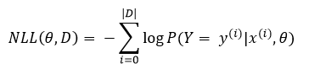
where is the value of the output is, is the value of the feature input, θ is the parameters and D is the training set.

Learning rate
Learning rate controls the change in the weight from one iteration to another. As a general rule, smaller learning rates are considered as stable but cause slower learning. On the other hand higher learning rates can be unstable causing oscillations and numerical errors but speed up the learning.
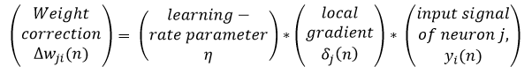

Momentum
Momentum provides inertia to escape local minima; the idea is to simply add a certain fraction of the previous weight update to the current one, helping to avoid becoming stuck in local minima.
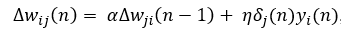
where α is the momentum.

Softmax
Softmax is a neural transfer function that is generalized form of logistic function implemented in the output layer that turns the vectors into the probabilities that add up and constraint to 1.
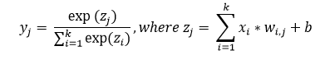

Summary of Multilayer Perceptron (MLP)
For classification, a softmax function may be incorporated in the output layer that will give the probability of each occurring class. Activation function is used to compute the predicted output of each neuron in each layer by using inputs, weights and bias.
The back propagation method trains the multilayer neural network by modifying its synaptic connection weights between the layers to improve model performance based on the error correction learning function which needs to be continuous and differentiable. The following parameters have been evaluated in the experiments:
- Number of hidden layers.
- Number of neurons in the hidden layers.
- Learning rate and Momentum.
- Types of Activation function.

Overview of Deep Learning
Before 2006, various failed attempts at training deep supervised feed forward neural networks were made that resulted in over-fitting of the performance on the unseen data i.e. training error reduces while validation error increases.
A deep network usually means an artificial neural network that has more than one hidden layer. Training the deep hidden layers required more computational power. Having a greater depth seemed to be better because intuitively neurons can make the use of the work done by the neuron in the layer below resulting in distributed representation of the data.
Bengio suggests that the neurons in the hidden layers are seen as feature detectors learned by the neuron in the below layer. This result in better generalization that is a subset of neurons learns from data in a specific region of the input space.
Moreover deeper architectures can be more efficient as fewer computational units are needed to represent the same functions, achieving greater efficiency. The core idea behind the distributed representation is the sharing of statistical strengths where different components of the architecture are re-used for different purposes.
Deep neural architectures are composed of multiple layers utilizing non-linear operations, such as in neural nets with many hidden layers. There are often various factors of variation in the dataset, like aspects of the data separately and often independently may vary.
Deep Learning algorithms can capture these factors that explain the statistical variations in the data, and how they interact to generate the kind of data we observe. Lower level abstractions are more directly tied to particular observations; on the other hand higher level ones are more abstract because their connection to perceived data is more remote.
The focus of deep architecture learning is to automatically discover such abstractions, from low level features to the higher level concepts. It is desirable for the learning algorithms to enable this discovery without manually defining necessary abstractions.
Training samples in the dataset must be at least as numerous as the variations in the test set otherwise the learning algorithm cannot generalize. Deep Learning methods aim to learn feature hierarchies, composing lower level features into higher level abstractions.
Deep neural nets with a huge number of parameters are very powerful machine learning systems. However, over-fitting is a serious problem in deep networks. Over-fitting is when the validation error starts to go up while the training error declines. Dropout is one of the regularization techniques for addressing this problem which is discussed later.
Today one of the most important factors for the increased success of Deep Learning techniques is advancement in the computing power. Graphical Processing Units (GPU) and cloud computing are crucial for applying Deep Learning to many problems.
Cloud computing allows clustering of computers and on demand processing that helps to reduce the computation time by paralleling the training of the neural network. GPU’s, on the other hand, are special purpose chips for high performance mathematical calculations, speeding up the computation of matrices.
In 2006-07, three papers revolutionized the deep learning discipline. The key principles in their work were that each layer can be pre-trained by unsupervised learning, done one layer at a time. Finally supervised training by back-propagation of the error is used to fine-tune all the layers, effectively giving better initialization by unsupervised learning than by random initialization.

Restricted Boltzmann Machine and Deep Belief Networks
One of the unsupervised algorithms is Restricted Boltzmann Machines (RBM) that is used to pre-train deep belief network. The RBM is a simplified version of the Boltzmann Machine, inspired by statistical mechanics, which models energy based probabilities for the underlying distributions of the given data sets from which conditional distributions can be derived.
Boltzmann Machines are bidirectionally connected networks of stochastic processing units of visible units and hidden units. The raw data corresponds to the ‘visible’ neurons and samples to observed states and the feature detectors correspond to ‘hidden’ neurons. In a Boltzmann Machine, visible neurons provide the input to the network and the environment in which it operates. During training visible neurons are clamped (set to a defined value) determined by the training data. Hidden neurons on the other hand operate freely.
However, Boltzmann Machine are difficult to train because of its connectivity. An RBM has restricted connectivity to make learning easier; there are no connections between hidden units in a single layer forming a bipartite graph, depicted in figure 2. The advantage of this is that the hidden units are updated independently and in parallel given the visible state.
These networks are governed by an energy function that determines the probability of the hidden/visible states. Each possible joint configuration of the visible and hidden units has a Hopfield energy determined by the weights and biases. The energies of the joint configurations are optimized by Gibbs sampling that learns the parameters by minimizing the lowest energy function of the RBM.
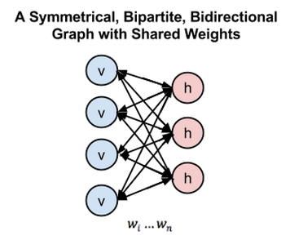
Figure 5
In figure 5, left layer represents the visible layer and right layer represents the hidden layer.
In Deep Belief Network (DBN), RBM is trained by input data with important features of the input data captured by stochastic neurons in the hidden layer. In the second layer the activations of the trained features are treated as input data. The learning process in the second RBM layer can be viewed as learning feature of features. Every time a new layer of features is added to the deep belief network, a variational lower bound on the log-probability of the original training data is improved.
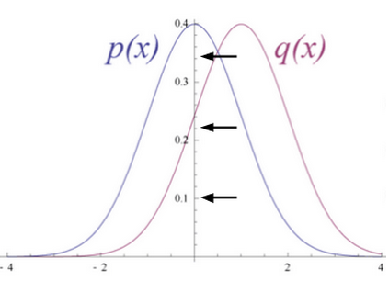
Figure 6
Figure 6 shows RBM converts its data distribution into a posterior distribution over its hidden units.
The weights of the RBM are randomly initialized causing the difference in the distribution of p(x) and q(x). During learning, weights are iteratively adjusted to minimize the error between p(x) and q(x). In figure 2 q(x) is the approximate of the original data and p(x) is the original data.
The rule for adjusting the synaptic weight from neuron one and another is independent of whether both the neurons are visible or hidden or one of each. The updated parameters by the layers of RBM are used as initialization in DBN’s that fine-tunes all the layers by supervised training of backpropagation.
For the IDS data of KDD Cup 1999, it is appropriate to use multimodal (Bernoulli-Gaussian) RBM as KDD Cup 1999 consists of mixed data types, specifically continuous and categorical. In multimodal RBM there are two different channel input layers used in the RBM, one is Gaussian input unit used for continuous features and the other one is Bernoulli input unit layer where binary features are used. Using multimodal RBM is beyond the scope of this research work.

Dropout
Recent developments have introduced powerful regularizers to deep networks to reduce over-fitting. In machine learning, regularization is additional information usually introduced in the form of a penalty to penalize complexity of the model that leads to over-fitting.
Dropout is a regularization technique for deep neural networks introduced by Hinton which consists of preventing co-adaptation of feature detectors by randomly turning oﬀ a portion of neurons at every training iteration but using the entire network (with weights scaled down) at test time.
Dropout reduces over-ﬁtting by being equivalent to training an exponential number of models that share weights. There exists an exponential number of diﬀerent dropout conﬁgurations for a given training iteration, so a diﬀerent model is almost certainly trained every time. At test time, the average of all models is used, which acts as a powerful ensemble method.
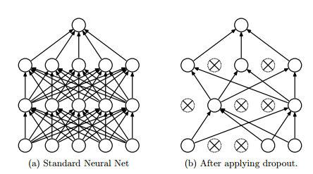
Figure 7
In figure 7, dropout randomly drops the connections between the neural network layer
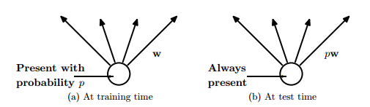
Figure 8
In figure 8, at training time the connections are dropped with probability, while at the test time weights are scaled to ρw
Averaging many models usually has been the key for many winner of the machine learning competitions. Many different types of model are used and then combined to make predictions at test time.
Random forest is a very powerful bagging algorithm which is created by averaging many decision trees giving them different training sample sets with replacement. It is well known that the decision trees are easy to fit to data and fast at test time so averaging different individual trees by giving them different training sets is affordable.
However, using the same approach with deep neural networks will prove to be very computationally expensive. It is already costly to train individual deep neural networks and training multiple deep neural networks and then averaging seems to be impractical. Moreover a single network that is efficient at test time is needed rather than having lots of large neural nets.
Dropout is an efficient way to average many large neural nets. Each time while training the model hidden units can be omitted with some probability as in figure 8, which is usually ρ= 0.5, when the training example is presented. As a result a ‘mean network’ model that has all the outgoing weights halved is used at test time as in figure 4. The mean network is equivalent to taking the geometric mean of the probability distributions over labels predicted by all possible networks with a single hidden layer of units and ‘softmax’ output layer.
As per the is mathematical proof of how dropout can be seen as an ensemble method.
is the prediction of the “ensemble” using the geometric mean.
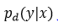is the prediction of a single sub model.
d is the binary vector that tells which inputs to include into the softmax classifier.
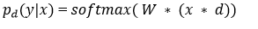
Suppose there are different units. There will be 2^N possible assignments to d, and so;
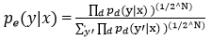 where y is the single and is the vector of the classes index.
The sum of the probabilities of the output by a single sub-model is used to normalize
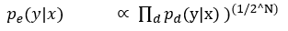
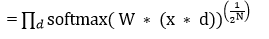, as per the definition of softmax
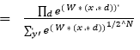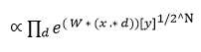
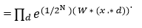
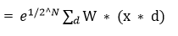
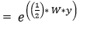
So, the predicted probability must be proportional to this. To re-normalize the above expression, it is divided by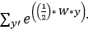 which means the predicted probability distribution is 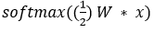
Another way to view dropout is that, it is able to prevent co-adaption among the feature detectors. Co-adaption of the feature detector means that if a hidden unit knows which other hidden units are present, it can co-adapt with them on the training data. However, on the test dataset complex co-adaptions are likely to fail to generalize.
Dropout can also be used in the input layer at a lower rate, typically 20% probability. The concept here is the same as de-noising auto encoders developed. In this method some of the inputs are omitted. This hurts the training accuracy but improves generalization acting in a similar way as adding noise to the dataset while training.
In 2013 a variant of dropout is introduced called Drop connect. Instead of dropping hidden units with certain probability weights are randomly dropped with certain probability. It has been shown that a Drop connect network seemed to perform better than dropout on the MNIST data set.

Techniques to deal with class imbalance
A class imbalance problem arises when one of the classes (minority class) is heavily under-represented in comparison to the other classes (majority class). This problem has real world significance where it is costly to misclassify minority classes such as detecting anomalous activities like fraud or intrusion. There are various techniques to deal with the class imbalance problem such as explained below:

SMOTE: Synthetic Minority Over-sampling Technique
One widely used approach to address the class imbalance problem is resampling of the data set. The sampling method involves pre-processing and balances the training data set by adjusting the prior distribution for minority and majority classes. SMOTE is an over-sampling approach in which the minority class is over-sampled by creating “synthetic” examples rather than by over-sampling with replacement.
It has been suggested that oversampling the minority class by replacement does not improve the results significantly rather it tends to over-fit the classification of the minority class. Instead the SMOTE algorithm operates in ‘feature space’ rather than ‘data space’. It creates synthetic samples by oversampling the minority class which tends to generalize better.
The idea is inspired by creating extra training data by operating on real data so that there is more data that helps to generalize prediction.
In this algorithm firstly nearest neighbours are computed for the minority class. Then, synthetic samples of the minority class are computed in the following manner: a random number of nearest neighbours is chosen and distance between that neighbour and the original minority class data point is taken.
This distance is multiplied by a random number between 0 and 1 and adds the result to the feature vector of the original minority class data as an additional sample, thus creating synthetic minority class samples.

Cost-sensitive learning in neural networks
Cost sensitivity learning seems to be quite an effective way to address the class imbalance for classification problems. Three cost sensitive methods have been described that are specific to neural networks.
Incorporate the prior probabilities of the class in the output layer of the neural network while testing unseen examples
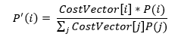
Adjusted learning rates based on the costs. Higher learning rates should be assigned to examples with high misclassifications costs making a larger impact on the weight changes for those examples
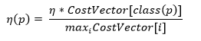
Modifying the mean square error function. As a result, the learning done by backpropagation will minimize misclassification costs. The new error function is:
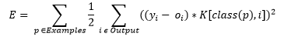
with the cost factor being K[i,j].
This new error function results in a new delta rule used in the updating of the weights of the network: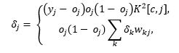
where the first equation represents the error function for output neurons and the second equation represents the error function for hidden neurons.

